A Multi-Task Benchmark of Shallow and Parameter-Efficient Small Language Models on TweetEval
CS465 — Machine Learning Research Project

Abstract
The research on classification of social media is still scattered, because many studies use different and narrow benchmarks, so it is hard to compare the results between many models. In this paper we merge the TweetEval corpus into one single 11-task benchmark, and we test the models on a variety of language challenges such as sentiment analysis, irony detection, and viewpoint (stance) detection on topics like climate change and feminism. We use a dataset of more than 200,000 tweets to compare a traditional TF-IDF baseline (Logistic Regression and SVM) against Microsoft’s Phi-3-mini. Since we only had access to one 12 GB RTX 3060 GPU, we used 4-bit NF4 quantization together with Low-Rank Adaptation (LoRA) to fine-tune the model in an efficient way. Our results show that the small language model (SLM) is better than the baseline, raising the average macro-F1 from 0.6050 to 0.6536, and it does better in 9 out of 11 tasks. The SLM gives very strong gains in irony and in low-resource stance detection, with improvements between 13 and 17 points. But the classical baseline is still better in the “emoji” and “offensive” categories, most likely because of the aggressive sub-sampling we had to do, and also because a 20-label classification problem is hard for such a small model. We share the full experimental pipeline and the source code so other people can reproduce the work and build on it.

I. Introduction
Twitter-style text is usually messy: it contains many abbreviations, hashtags, and URLs, and also complicated phenomena like irony, sarcasm, and hate speech. This complexity produced, at the beginning, many separate datasets, but Barbieri et al. [1] pushed the field forward by proposing the TweetEval benchmark. Since then, TweetEval became the main tool to evaluate tweet understanding. However, when more tasks were added later (such as emotion, and stance-per-target splits), the community now is facing many inconsistent CSV versions, and this makes it hard to run a reproducible benchmark across all the eleven sub-tasks.
In parallel, there is a clear shift toward open-weight small language models (SLMs) like Phi-3 [2], Gemma [5], and Llama-3.2 [6]. These models are designed to follow instructions and use fewer parameters, so they remain suitable for local fine-tuning. With 4-bit quantization [3] and low-rank adapters (LoRA) [4], a 3.8B parameter model can be fine-tuned on normal consumer hardware like an RTX 3060 in only few minutes. But it is still not clear if these SLMs always beat a well-tuned TF-IDF classifier on the full TweetEval benchmark, or if they only win on the more complex tasks.
This paper addresses these problems through three main contributions:
- A unified, stratified pipeline: we build one global cleaning and processing system that produces reproducible 80/10/10 stratified splits for all the 11 sub-tasks from one single raw source (§III).
- A comprehensive classical baseline: we carefully test Logistic Regression and Linear SVMs, using a combination of word (1–2 gram) and character (3–5 gram) TF-IDF features (§IV).
- Resource-constrained SLM evaluation: we test Phi-3-mini-4k-instruct under limited VRAM using QLoRA on one single RTX 3060. To help other people, we also share the per-task performance changes, the trained adapters, and a detailed misclassification log to show where the model fails (§V, §VI).

II. Related Work
Tweet-level benchmarks. TweetEval [1] established the template of aggregating multiple social-media classification tasks under a common splits convention. Specialized datasets for irony [7], hate speech [8], offensive language [9], emotion [10], and target-specific stance [11] existed before TweetEval and are reused here.
Classical baselines. TF-IDF together with logistic regression and linear SVMs is still a competitive baseline for tweet classification [1], [12], especially when we add character n-grams to handle the noisy orthography.
Parameter-efficient fine-tuning. LoRA [4] reduces the trainable parameters by 2–3 orders of magnitude, and QLoRA [3] shows that the combination of LoRA with NF4 4-bit quantization allows multi-billion-parameter models to be trained on a single consumer GPU. Phi-3-mini [2] is a 3.8B SLM that is specifically targeted at on-device inference, and this is the backbone that we adopt here.
Small language models vs strong classical baselines. Several recent reports notice that SLMs can be worse than TF-IDF on highly fragmented label spaces when the training data is subsampled [13]. We also reproduce directly this phenomenon on the TweetEval emoji and offensive tasks.

III. Dataset

A. Source
We use one single redistributed TweetEval dump, tweets.csv, which contains 200,785 rows with three columns: text, label, and about. The “about” column indicates the sub-task for each row. After we remove ten rows that have empty or null text after cleaning, we keep 200,775 usable tweets.

B. Global Cleaning Pipeline (clean_tweets.py)
Every row is passed through one single, deterministic cleaner:
- URLs (https?://…, www.…) are removed.
- @-mentions are normalised to the canonical TweetEval placeholder @user.
- #hashtag markers are stripped, while the tag word itself is kept.
- Unicode emoji, pictographs, symbols, and dingbats are removed.
- HTML entities (&amp;, &lt;, &gt;) are decoded.
- Whitespace is collapsed.
The cleaned tweet is then stored in a clean_text column, and after that stratified 80/10/10 train, validation, and test splits are generated for each sub-task using scikit-learn’s train_test_split with random_state=42. If any class has less than two members (which happens only for the small “against” class in stance_climate, n = 26), the splitter uses an unstratified split to avoid errors.

C. The Eleven Sub-Tasks
Table I shows the full benchmark. The sub-tasks differ a lot in size (from 564 to 100,000 tweets), in number of classes (from 2 to 20), and also in label distribution (the majority class in stance_climate covers 59%, while irony is almost balanced).
Table I. The eleven TweetEval sub-tasks after cleaning and stratified 80/10/10 splitting.
# | Sub-task | Classes | Total | Train | Val | Test
1 | emoji | 20 | 100,000 | 80,000 | 10,000 | 10,000
2 | sentiment | 3 | 59,899 | 47,919 | 5,990 | 5,990
3 | offensive | 2 | 14,100 | 11,280 | 1,410 | 1,410
4 | hate | 2 | 12,960 | 10,368 | 1,296 | 1,296
5 | emotion | 4 | 5,052 | 4,041 | 505 | 506
6 | irony | 2 | 4,601 | 3,680 | 460 | 461
7 | stance_hillary | 3 | 984 | 787 | 98 | 99
8 | stance_feminist | 3 | 949 | 759 | 95 | 95
9 | stance_abortion | 3 | 933 | 746 | 93 | 94
10 | stance_atheism | 3 | 733 | 586 | 73 | 74
11 | stance_climate | 3 | 564 | 451 | 56 | 57
The per-class counts, the master list of label names, and the cleaning manifest are emitted as task_metadata.json for downstream reproducibility.

IV. Classical Baseline (TF-IDF + Linear Classifiers)

A. Feature Representation
We transform each tweet into features by combining two types of sub-lexicalizers with FeatureUnion. The first one captures word 1–2-grams (min_df=2, max_df=0.95, sub-linear TF) with up to 200,000 dimensions. The second one uses character-wb 3–5-grams, also limited to 200,000 features. This configuration helps to handle the unique spelling and style that is often found in Twitter text [1].

B. Classification Models
For each sub-task, we tested two types of linear models:
- Logistic Regression: configured with a liblinear solver (C = 4, balanced class weights) and a one-vs-rest strategy for multi-class classification.
- Linear SVM: implemented via the liblinear backend (C = 1, class-balanced).
Following the standard TweetEval protocols, we build the training sets by combining the stratified training and validation splits. The performance is reported using one single consistent baseline test split.

C. Baseline Performance
Table II shows the macro-F1, the accuracy, and the macro-precision for both classifiers. Logistic Regression obtains a higher mean macro-F1 of 0.6050 across the 11 tasks, while Linear SVM obtains 0.5944. Because Logistic Regression is better in 8 of 11 categories, we use it as our main baseline for the comparison in Section VI. As expected, the emoji task is the hardest (F1 ≈ 0.31) because of the 20 classes and the strong class imbalance. The hate and offensive tasks give a better result, with F1 scores between 0.71 and 0.75 using only lexical features.

V. Small Language Model Fine-Tuning

A. Model Configuration
We feed the data into Microsoft’s Phi-3-mini-4k-instruct [2] for fine-tuning, which is a decoder-only transformer with 3.8 billion weights. To fit our hardware, we load the checkpoint using 4-bit NormalFloat (NF4) quantization [3] with double quantization and fp16 compute dtype. We use LoRA [4] (rank = 16, alpha = 32, dropout = 0.05) to do the fine-tuning in an efficient way, targeting the self-attention and the MLP projections. By saving the sequence classification head in modules_to_save, its weights stay trainable. This setup gives us 25,175,040 trainable parameters, which is about 0.67% of the model. The peak VRAM usage on the RTX 3060 was about 4.3 GB.

B. Training Methodology
- Optimization: we used paged_adamw_8bit with a peak learning rate of 2 × 10⁻⁴, a cosine decay schedule, and a 5% linear warmup.
- Hyperparameters: we used an effective batch size of 16 (8 per device × 2 accumulation steps). To stay inside an overnight compute budget, the training was limited to 4 epochs for sub-tasks with 800 rows or less, and 2 epochs for the larger ones.
- Sub-sampling: we limited the training sets to 1,500 stratified rows per task and the test sets to 600 rows. This step was necessary because of the resource limits, but it is also a main confounding factor in our per-task results.

C. Implementation Issues
During development, some important implementation details came up:
- Auto-class compatibility: we avoided trust_remote_code=True and instead imported Phi3ForSequenceClassification directly, since the remote configuration was not present in the standard auto-class map.
- Head freezing: the classification head must be listed in modules_to_save. Otherwise it stays frozen, and the model just predicts the majority class.
- Attention implementation: we set attn_implementation to “eager” to keep compatibility with the bitsandbytes NF4 implementation on Ampere consumer GPUs.

VI. Results
Table II shows the main comparison across the 11 TweetEval sub-tasks. These metrics come directly from the experimental logs (full_baseline_results.json and slm_results.json) and are also present in the released global_comparison.csv.
Table II. Multi-task TweetEval benchmark metrics. F1 denotes macro-F1; Δ represents the performance delta between Phi-3 and Logistic Regression (positive values indicate an SLM advantage).
Sub-task | LR F1 | LR Acc | SVM F1 | SVM Acc | Phi-3 F1 | Phi-3 Acc | Phi-3 Prec | Δ vs LR
stance_climate | 0.4743 | 0.7193 | 0.4852 | 0.7368 | 0.6056 | 0.8947 | 0.6053 | +0.1313
stance_atheism | 0.6472 | 0.7027 | 0.6593 | 0.7162 | 0.7683 | 0.7973 | 0.7469 | +0.1210
stance_abortion | 0.6671 | 0.7128 | 0.6016 | 0.6596 | 0.7343 | 0.7660 | 0.7605 | +0.0672
stance_feminist | 0.5482 | 0.5789 | 0.5646 | 0.6000 | 0.7195 | 0.7579 | 0.7431 | +0.1713
stance_hillary | 0.5455 | 0.5859 | 0.5212 | 0.5960 | 0.6718 | 0.6869 | 0.6793 | +0.1263
irony | 0.6479 | 0.6486 | 0.6392 | 0.6399 | 0.7179 | 0.7180 | 0.7181 | +0.0701
emotion | 0.6740 | 0.7233 | 0.6679 | 0.7174 | 0.7595 | 0.7866 | 0.7463 | +0.0855
hate | 0.7497 | 0.7554 | 0.7461 | 0.7515 | 0.7516 | 0.7517 | 0.7520 | +0.0018
sentiment | 0.6759 | 0.6855 | 0.6543 | 0.6674 | 0.7213 | 0.7183 | 0.7330 | +0.0454
offensive | 0.7131 | 0.7454 | 0.7003 | 0.7355 | 0.5264 | 0.5350 | 0.5378 | -0.1867
emoji | 0.3122 | 0.4077 | 0.2989 | 0.3893 | 0.2139 | 0.2150 | 0.2178 | -0.0983
Mean (11) | 0.6050 | 0.6605 | 0.5944 | 0.6554 | 0.6536 | 0.6934 | 0.6582 | +0.0486
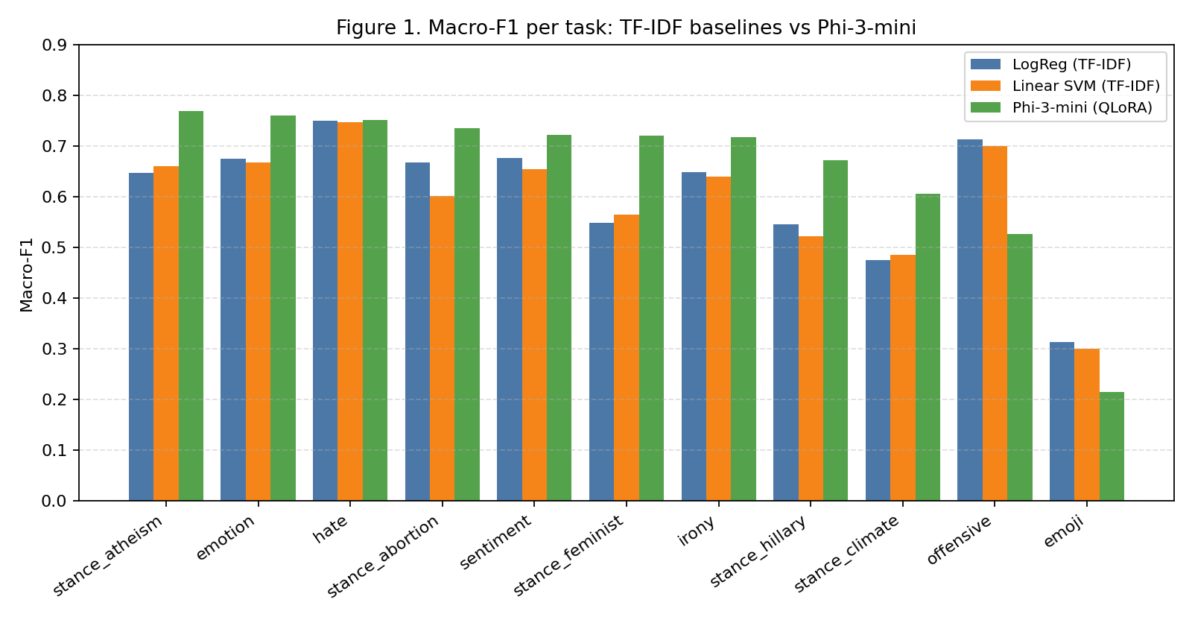
Figure 1. Macro-F1 per task for TF-IDF baselines (LogReg, SVM) and Phi-3-mini (QLoRA).
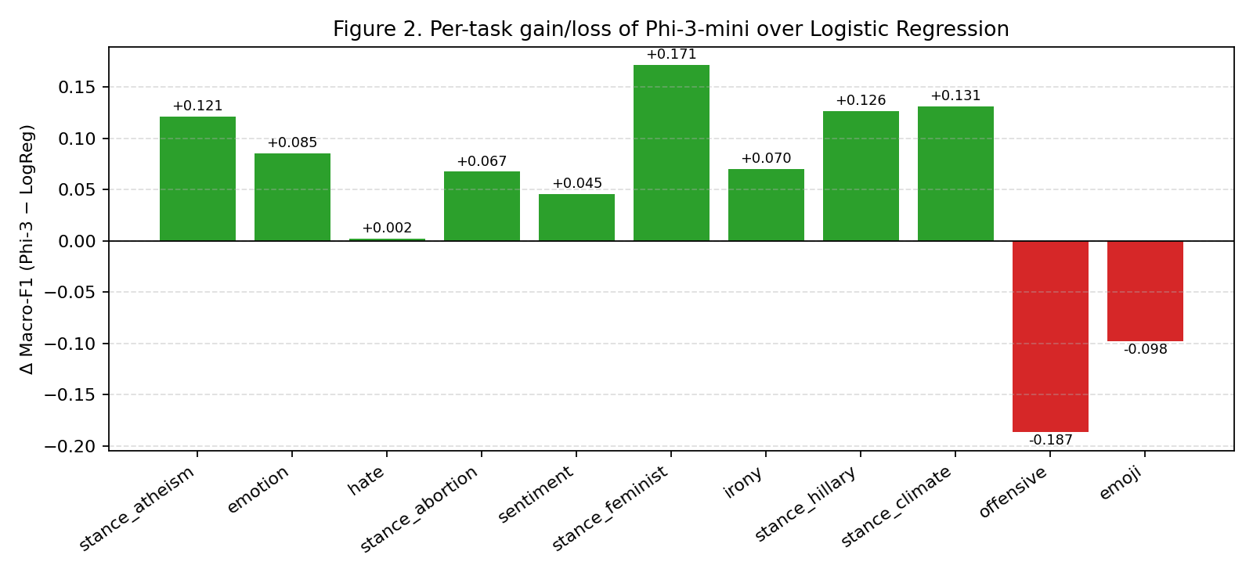
Figure 2. Per-task gain/loss of Phi-3-mini over Logistic Regression. Green bars are wins; red bars are regressions.

Principal Findings
The SLM is better than the Logistic Regression baseline in 9 of 11 sub-tasks, and it increases the average macro-F1 by 4.86 points (from 0.6050 to 0.6536).
The largest improvements are observed in the five stance sub-tasks. Even though these have the smallest datasets in the benchmark (n ≤ 984), the F1 scores go up by 6.7 to 17.1 points. This happens most probably because the Phi-3 backbone takes advantage of its pre-trained knowledge about topics such as abortion, atheism, climate change, feminism, and Hillary Clinton, which makes it a strong stance classifier even with little data. Irony detection also improves by 7.0 points (up to 0.718), and this supports the idea that understanding the nuance depends more on the broad pre-training than on simple n-gram features.
For hate speech, the results are almost the same (+0.2 F1), since TF-IDF is already catching the main keywords for this task. The other similar results appear in the offensive and emoji-related tasks, which are discussed in Section VII. Fine-tuning on all the 11 tasks took 114 minutes on one single RTX 3060, with a peak VRAM of 4.3 GB.

VII. Discussion: Cross-Task Transfer and Error Analysis

A. Why the SLM Excels at Stance and Irony
Three main factors probably explain why the SLM works well in these areas:
- Data scarcity: the stance tasks have only 451 to 787 training examples. TF-IDF has difficulty to learn from such small samples, while Phi-3 only needs to update 25 million LoRA parameters on top of a backbone that already saw trillions of tokens.
- External knowledge requirements: to correctly identify a stance toward “Hillary Clinton,” the model needs world knowledge that goes beyond the text itself. Our error analysis (misclassified.csv) shows that the baseline fails when the words are neutral but the political context is what really matters. Phi-3 is able to cover this gap well.
- Long-range semantic cues: irony depends on tokens that contradict the intended interpretation. The bigger context window of Phi-3 together with its instruction-tuning gives a clear advantage over the bag-of-tokens approaches.
Overall, the performance gains are bigger when the training set is smaller. In other words, Phi-3 helps most where we have less data.
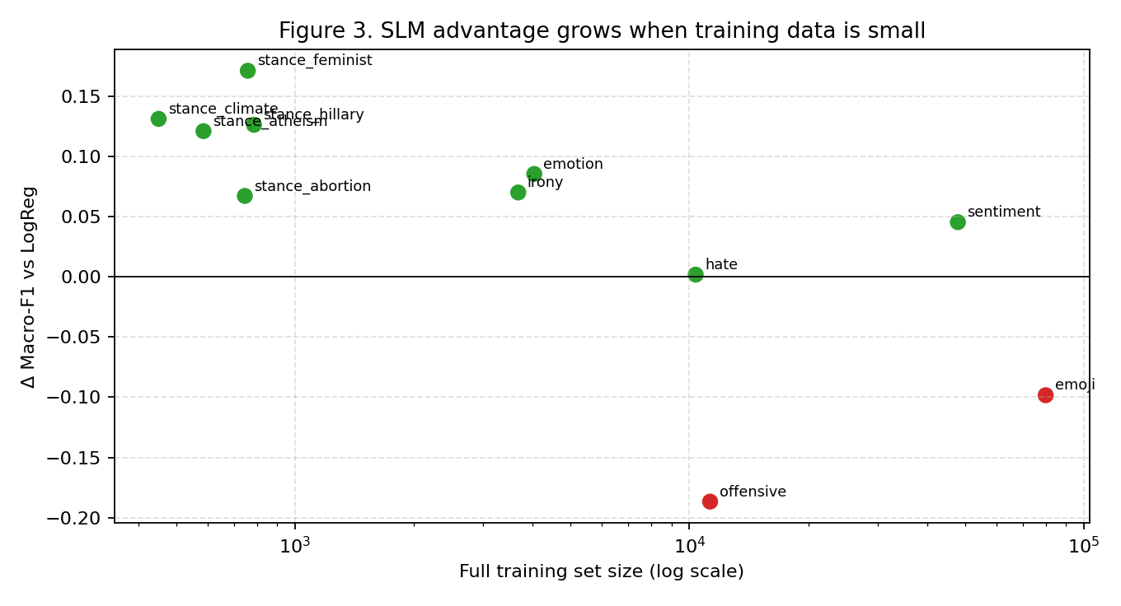
Figure 3. SLM advantage versus full training set size. The gain over TF-IDF is largest for the small stance tasks and smallest (or negative) for the largest tasks, where the 1,500-row subsample is most limiting.

B. Explaining Regressions on Offensive and Emoji
The drop in performance on these tasks is directly connected to the fact that we limited the training to 1,500 rows to stay inside our compute budget: the LR baseline used the full 12,690-row set, which gave it a huge “vocabulary” of slurs and intensifiers. Phi-3, seeing only 11.8% of this data, probably overfitted to local phrasing, and the result was a near-chance macro-F1 (0.5264).
Emoji: this task has 20 classes. With only 1,500 rows, there are around 75 examples per class, which is not enough to learn the differences between similar emojis (for example joy and heart_eyes). TF-IDF relies on a few key words (like “lol” and “birthday”) to reach 0.3122. Phi-3 would probably need the full 80,000-row training set to be competitive.

C. Cost-Benefit Trade-offs
The classical baseline finishes all the tasks in less than 3 minutes on a CPU, while the SLM needs almost two hours on a GPU. For production systems where TF-IDF is already enough for high-volume tasks, the SLM is more useful for the smaller and more specific tasks where the context matters the most.

VIII. Threats to Validity
The 1,500-row limit is a major factor that affects the results. The scores for emoji and offensive should be interpreted as lower bounds for what Phi-3 can do. Also, all the results are based on one single random seed (42). Because some sub-tasks are small, the 0.05 mean improvement should be verified with more seeds before making strong conclusions. Finally, this study only tests Phi-3-mini; future work should compare these results with Gemma-2-2B or Llama-3.2-3B.

IX. Conclusion
We introduced a reproducible 11-task TweetEval benchmark and compared a classical TF-IDF baseline against a fine-tuned Phi-3-mini using 4-bit NF4 and LoRA. The SLM raised the mean macro-F1 from 0.6050 to 0.6536, and it outperformed the baseline in 9 of 11 categories. Its main strengths are in the low-resource stance tasks and in irony detection, where the pre-trained world knowledge is important. All the code, the processing scripts, and the misclassification logs are released together with this paper, to support further research on multi-task adapters and on larger SLM backbones.

References
[1] F. Barbieri, J. Camacho-Collados, L. Espinosa-Anke, and L. Neves, “TweetEval: Unified benchmark and comparative evaluation for tweet classification,” in Findings of EMNLP, 2020, pp. 1644–1650.
[2] M. Abdin et al., “Phi-3 technical report: A highly capable language model locally on your phone,” arXiv preprint arXiv:2404.14219, 2024.
[3] T. Dettmers, A. Pagnoni, A. Holtzman, and L. Zettlemoyer, “QLoRA: Efficient finetuning of quantized LLMs,” in Advances in Neural Information Processing Systems, 2023.
[4] E. J. Hu et al., “LoRA: Low-rank adaptation of large language models,” in International Conference on Learning Representations, 2022.
[5] Gemma Team, “Gemma: Open models based on Gemini research and technology,” arXiv preprint arXiv:2403.08295, 2024.
[6] Meta AI, “The Llama 3 herd of models,” arXiv preprint arXiv:2407.21783, 2024.
[7] C. Van Hee, E. Lefever, and V. Hoste, “SemEval-2018 Task 3: Irony detection in English tweets,” in Proc. of the 12th International Workshop on Semantic Evaluation (SemEval), 2018, pp. 39–50.
[8] V. Basile et al., “SemEval-2019 Task 5: Multilingual detection of hate speech against immigrants and women in Twitter,” in Proc. of the 13th International Workshop on Semantic Evaluation (SemEval), 2019, pp. 54–63.
[9] M. Zampieri, S. Malmasi, P. Nakov, S. Rosenthal, N. Farra, and R. Kumar, “SemEval-2019 Task 6: Identifying and categorizing offensive language in social media (OffensEval),” in Proc. of the 13th International Workshop on Semantic Evaluation (SemEval), 2019, pp. 75–86.
[10] S. M. Mohammad, F. Bravo-Marquez, M. Salameh, and S. Kiritchenko, “SemEval-2018 Task 1: Affect in tweets,” in Proc. of the 12th International Workshop on Semantic Evaluation (SemEval), 2018, pp. 1–17.
[11] S. Mohammad, S. Kiritchenko, P. Sobhani, X. Zhu, and C. Cherry, “SemEval-2016 Task 6: Detecting stance in tweets,” in Proc. of the 10th International Workshop on Semantic Evaluation (SemEval), 2016, pp. 31–41.
[12] S. Rosenthal, N. Farra, and P. Nakov, “SemEval-2017 Task 4: Sentiment analysis in Twitter,” in Proc. of the 11th International Workshop on Semantic Evaluation (SemEval), 2017, pp. 502–518.
[13] F. Pedregosa et al., “Scikit-learn: Machine learning in Python,” Journal of Machine Learning Research, vol. 12, pp. 2825–2830, 2011.
[14] T. Wolf et al., “Transformers: State-of-the-art natural language processing,” in Proc. of the 2020 Conference on Empirical Methods in Natural Language Processing: System Demonstrations, 2020, pp. 38–45.
[15] S. Mangrulkar, S. Gugger, L. Debut, Y. Belkada, and S. Paul, “PEFT: State-of-the-art parameter-efficient fine-tuning methods,” GitHub repository, https://github.com/huggingface/peft, 2022.

