Ex1
Given the following class:

public class CheckingAccount {

public int amount;

public CheckingAccount(int amount) {
this.amount = amount;
}

public int getAmount() {
return amount;
}

public void changeAmount(int x) {
amount += x;
}
}

And given the following main method, located in another class:

public static void main(String[] args){
CheckingAccount acct = new CheckingAccount((int)(Math.random() * 1000));
//line n1
System.out.println(acct.getAmount());
}
Which three lines, when inserted independently at line n1, cause the program to print a 0 balance?

A. this.amount = 0;
B. amount = 0;
C. acct(0);
D. acct.amount = 0;
E. acct.getAmount() = 0;
F. acct.changeAmount(0);
G. acct.changeAmount(-acct.amount);
H. acct.changeAmount(-acct.getAmount());
Ex2
Given the code fragment:

public static void main(String[] args) {
int ii = 0;
int jj = 7;
for (ii = 0; ii < jj - 1; ii = ii + 2) {
System.out.print(ii + " ");
}
}

What is the result?

A. 2 4
B. 0 2 4 6
C. 0 2 4
D. Compilation fails
Ex3
Given:
int i, j = 0;
i = (3 * 2 + 4 + 5);
j = (3 * ((2 + 4) + 5));
System.out.println("i:" + i + "\nj:" + j);

What is the result?

A.
i:16
j:33

B.
i.15
j:33

C.
i:33
j:23

D.
i:15
j:23
Ex4
Given the code fragment:

float x = 22.00f % 3.00f;
int y = 22 % 3;
System.out.print(x + ", " + y);

What is the result?

A. 1.0, 1
B. 1.0f, 1
C. 7.33, 7
D. Compilation fails
E. An exception is thrown at runtime
Ex5
Given the code fragment:

System.out.println(28 + 5 <= 4 + 29);
System.out.println((28 + 5) <= (4 + 29));

What is the result?

A.
28false29
true

B.
285 < 429
true

C.
true
true

D. compilation fails
Ex6
Given the code fragment:
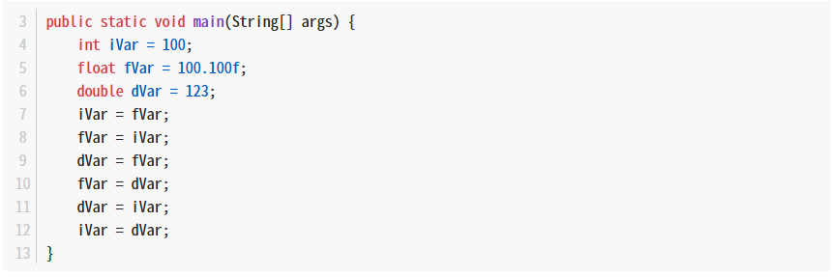
Which three lines fail to compile?

A. Line 7
B. Line 8
C. Line 9
D. Line 10
E. Line 11
F. Line 12
Ex7
Given the content of three files:
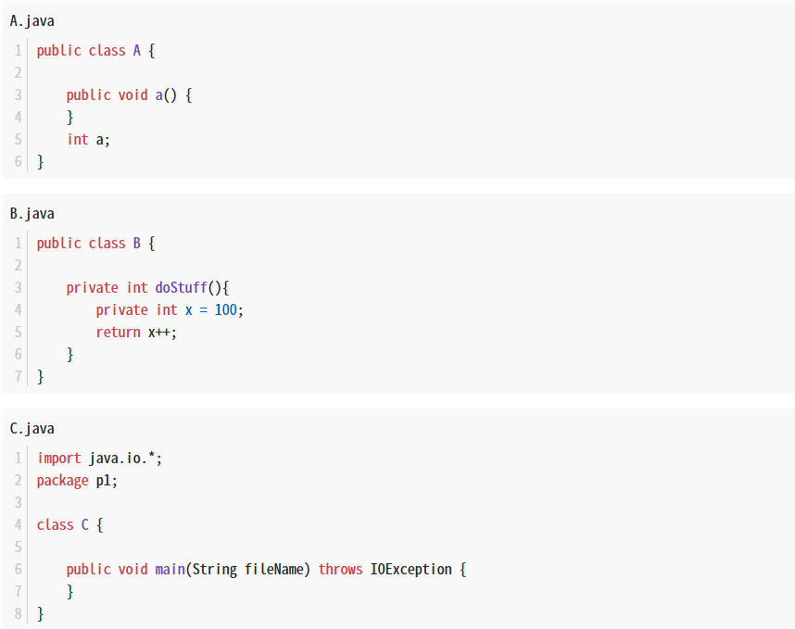
Which statement is true?

A. Only the A.java file compiles successfully.
B. Only the B.java file compiles successfully.
C. Only the C.java file compiles successfully.
D. The A.Java and B.java files compile successfully.
E. The B.java and C.java files compile successfully.
F. The A.Java and C.java files compile successfully.
Ex8
What is the proper way to defined a method that take two int values and returns their sum as an int value?

A. int sum(int first, int second) { first + second; }
B. int sum(int first, second) { return first + second; }
C. sum(int first, int second) { return first + second; }
D. int sum(int first, int second) { return first + second; }
E. void sum (int first, int second) { return first + second; }
Ex9
View the exhibit:
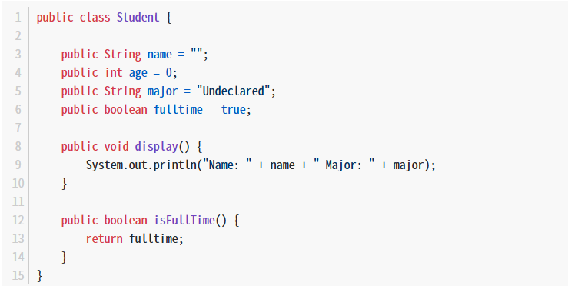
Which line of code initializes a student instance?

A. Student student1;
B. Student student1 = Student.new();
C. Student student1 = new Student();
D. Student student1 = Student();
Ex10
Given:
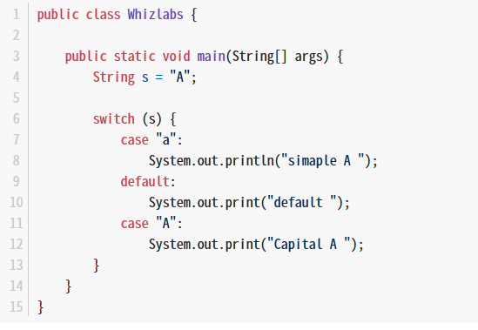
What is the result?

A. simaple A
B. Capital A
C. simaple A default Capital A
D. simaple A default
E. Compilation fails.

