CHAPTER 3

METHODS AND PROCEDURES OF THE STUDY
This chapter describes the research methods, research design, locale, respondents, instruments, data gathering procedure, analysis tools, statistical treatment, proof of concept, and software development model for LogiCade. LogiCade is an adaptive gamified learning application for Computer Programming 1 (CP1). It combines curriculum-bound HTML5 Canvas activities, verified challenge generation, learner progression, and pseudonymous gameplay records. Formal learning assessments, gameplay performance, software evaluation, and exploratory machine learning are treated as separate sources of evidence.

3.1 Methods of Research Used
The study combines developmental research and descriptive-evaluative research, which are identified in the available LogiCade manuscripts. Developmental research addresses the design, implementation, verification, and refinement of the learning application. It covers the learner interface, curriculum-to-stage mapping, activity packages, challenge verifier, progression rules, data synchronization, and administrator functions. The developmental work produces an operational prototype and documented implementation evidence.
Descriptive-evaluative research addresses the characteristics of system use and the evaluations provided by participating learners and qualified evaluators. Gameplay records describe interaction with the application, while questionnaire responses describe perceptions of the implemented system. These observations do not, by themselves, demonstrate learning effectiveness or establish that LogiCade caused a change in achievement.
The learning-outcome evaluation will follow [insert approved evaluation design]. Matched pretest and posttest records will support analysis of within-participant changes where the approved protocol requires both assessments. Learning analytics will describe attempts, scored submissions, hints, timing, completion, and difficulty transitions. The machine-learning work will examine whether pre-decision gameplay evidence can classify an expert-defined recommendation for the next stage. No predictive result is assumed in advance.

3.2 Research Design
The approved research design is [insert approved research design]. The available LogiCade manuscripts describe different designs: the manuscript titled N.THESIS describes a pretest-posttest comparison with a control group, whereas the revised methodology describes a stratified single-group pretest-posttest design. The number of groups, assignment procedure, and comparison condition will therefore be specified as [insert approved group structure and assignment procedure].
The implementation period will be [insert study duration], conducted during [insert academic term and dates]. The nine curriculum weeks are content regions in the application; their existence does not establish that each region will be delivered over one calendar week. Session frequency, session length, required exposure, attendance procedures, and completion criteria will be [insert approved intervention schedule and completion criteria].
For a matched evaluation, the participant identifier will connect baseline assessment, system exposure, and posttest records. Pretest and posttest scores will use comparable content coverage and a documented scoring scale. The unit of analysis for learning gain is the participant. The unit for operational gameplay description may be a stage run, scored submission, or session, with its denominator stated. The unit for difficulty-model development is one participant at one next-stage decision, using only information observed before that decision.
Research strata, if retained in the approved design, will be Knowledgeable, Moderate, and Minimal. They describe baseline groups for sampling or analysis and are excluded from the live difficulty rule. Their score boundaries and allocation are [insert approved stratum cutoffs and allocation]. Differences across strata will be interpreted with attention to unequal exposure, missing records, baseline differences, and regression to the mean. A single-group design cannot isolate the application effect from instruction, practice, maturation, or other concurrent influences.
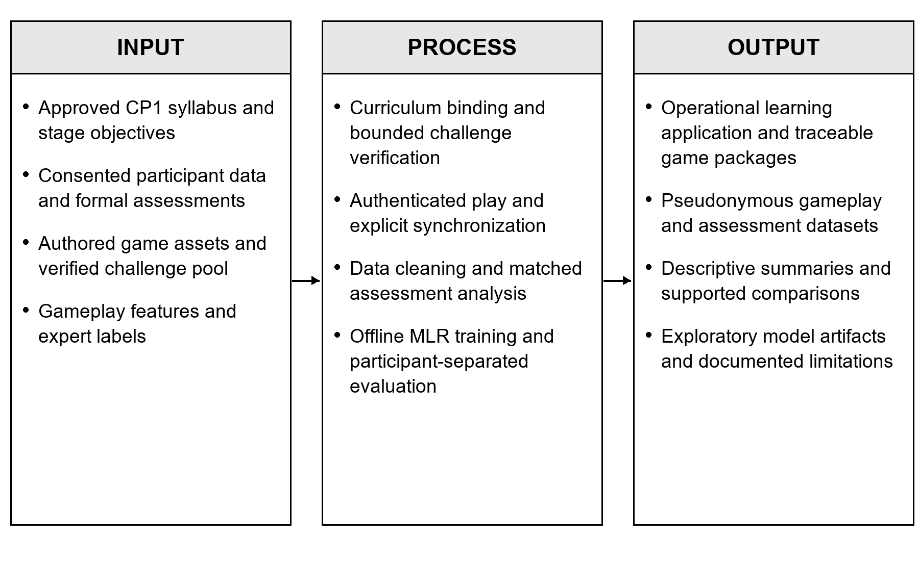
Figure 3.1 Input Process Output framework for LogiCade
The inputs include curriculum requirements, approved instruments, reusable content, and learner evidence. Application processing and research analysis produce traceable records and supported summaries. A model artifact is an exploratory research output until validated and approved for live use.

3.3 Locale of the Study
The study will be conducted at [insert loc]. The participating institution, campus, department, and class setting are [insert institution campus and department]. The learning environment will provide access to CP1 instruction and the devices and connectivity required by the approved study procedure. Details of classroom or laboratory access, supervision, and available equipment are [insert study facilities and access arrangements].
The development environment verified for this project is a Windows laptop with a 13th-generation Intel Core i5-13420H processor, 16 GB installed memory, and an NVIDIA GeForce RTX 4050 Laptop GPU with approximately 6 GB dedicated graphics memory. This is development hardware and does not establish the study venue or a deployed server specification. The final hosting arrangement and minimum learner-device requirements are [insert approved hosting and learner-device specifications].

3.4 Respondents of the Study
The respondents will be [insert student affiliation], with a total number of [insert total respondents]. Their year level, degree program, and CP1 enrollment status will be [insert eligible year level program and course enrollment]. Participation will be voluntary and governed by the approved consent procedure.
The sampling technique will be [insert approved sampling technique]. The accessible population, recruitment frame, sample-size justification, and recruitment dates are [insert accessible population sampling frame sample-size basis and recruitment dates]. A plan to retain 100 account records or serve a limited number of players daily is an operational plan and will not substitute for an approved research sample or evidence of actual recruitment.
Eligibility will include enrollment in the relevant CP1 learning context, willingness to participate, ability to access the application under the study arrangements, and completion of [insert required consent or assent process]. Additional inclusion criteria and exclusions are [insert approved inclusion and exclusion criteria]. Withdrawal, attrition, and replacement procedures are [insert approved withdrawal and replacement policy]. Withdrawn participants will not be treated as if a replacement were the same paired observation.
Table 3.1 Proposed respondent and evaluator allocation
Group | Basis | Number
Student participants | [insert student affiliation] | [insert total respondents]
Knowledgeable stratum if used | [insert approved pretest range] | [insert allocation]
Moderate stratum if used | [insert approved pretest range] | [insert allocation]
Minimal stratum if used | [insert approved pretest range] | [insert allocation]
Programming instructors | [insert qualifications and selection basis] | [insert evaluator count]
Software or IT evaluators | [insert qualifications and selection basis] | [insert evaluator count]

Faculty and software evaluators will assess only the areas appropriate to their expertise and assigned tasks. Their evaluations will be reported separately from learner achievement scores. Recruitment reporting will distinguish individuals invited, consenting, enrolled, completing the required exposure, and providing matched assessment data.

3.5 Research Instruments

3.5.1 Pretest and posttest
The proposed pretest and posttest will measure the selected CP1 competencies independently of game rewards or activity accuracy. The test blueprint, approved item bank, number of items, scoring scale, administration time, and content-validation evidence are [insert approved assessment blueprint item count scoring scale administration time and validation evidence]. Comparable assessments will cover the same intended outcomes; the policy on repeated items will be [insert approved equivalent-form or repeated-item policy].
The database provides assessment records with pretest, posttest, and other phases. An instructor-controlled examination endpoint also exists, but it requires a separately approved private item bank. That examination is recorded under the other phase and does not automatically constitute the research pretest or posttest. Neither database support nor an endpoint demonstrates that a validated instrument has already been administered.

3.5.2 Background and software evaluation questionnaires
The methodology draft proposes a baseline background questionnaire and a post-use questionnaire concerning engagement, motivation, satisfaction, and the learning experience. The approved statements, administration procedure, construct definitions, and validation records are [insert approved questionnaires and validation records]. Where the proposed five-point agreement format is retained, responses are coded from 1 for Strongly Disagree to 5 for Strongly Agree. Item-specific response anchors and composite scoring will follow [insert approved questionnaire scoring rules].
The draft software evaluation selects functional suitability, usability, reliability, performance efficiency, security, and maintainability. These are a selected subset of the ISO/IEC 25010:2011 product quality model. ISO identifies that edition as withdrawn and replaced by newer standards; therefore, the study will specify [insert approved ISO standard edition and selected characteristics] before finalizing the instrument. A questionnaire based on selected characteristics will not be represented as certification of full standards compliance (ISO/IEC, 2011, 2023).

3.5.3 Gameplay event and telemetry records
The instrumented application stores pseudonymous participant, stage, attempt, and event identifiers; curriculum week and stage; assigned and served difficulty; attempt status; scored submissions; correct submissions; hints; question and activity retries; timing; and challenge provenance. The current research views expose attempt-level measures, stage outcomes, topic evidence, and learner sessions. Historical uninstrumented values remain missing rather than being reconstructed as zero.
Table 3.2 Operational definitions of recorded gameplay signals
Signal | Operational definition and interpretation
Mistake count | Incorrect scored submissions. One failed evaluated Run or Check counts once even when several internal test cases fail.
Hint usage | Hints actually revealed during the attempt. Availability and affordability must be known before zero hints is interpreted as independent performance.
Completion time | Foreground active play time on a successful run. Host pauses and the initial game guide are excluded by the instrumentation.
Attempt count | Distinct stage runs, retaining completed, failed, abandoned, restarted, and incomplete outcomes separately.
Accuracy | Correct scored submissions divided by scored submissions. Native game accuracy and its original basis are retained separately.
First-try success | Completion on the first evaluated run. An exit before evaluation is not automatically a scored failure; the orientation video is excluded.
Failure rate | Failed runs divided by completed plus failed runs. The ML window uses the last five comparable runs and requires at least three evaluated runs.
Retry count | Additional submissions to the same task or activity within a run, distinct from a level restart or a completed full-level replay.
Topic mastery evidence | The live reporting view aggregates first-evaluated submission correctness by objective. The ML builder instead uses first-try success across distinct comparable tasks; these measures must retain different names.
Response time | Instrumented prompt-to-submission active time. Attempt reports expose a mean; the ML workflow uses the median of first measured responses per task when events are available.
Session duration | Elapsed time of an authenticated browser-tab session through the saved checkpoint; different tabs create separate sessions.
Inactivity time | The session tracker marks visible time more than 60 seconds after an observed interaction as inactivity. Hidden time is separate. Lack of input may include attentive reading and is not proof of disengagement.

Session snapshots are scheduled every 30 seconds and at relevant visibility or account changes. Abrupt closure can lose time since the latest checkpoint. The supplied difficulty rubric refers to pause or hidden time as inactivity, whereas the implemented session tracker distinguishes these intervals. The finalized research data dictionary will use [insert approved inactivity definition] and preserve the available components. Interaction tracking does not capture the content of individual keystrokes.

3.5.4 Student performance scoring rubric
The supplied Student Performance Assessment Rubric proposes a 100-point score: 70 points for functional correctness, 20 for distinct concept-application checks, and 10 for required deliverables. The proposed score is 70(P/T) + 20(C/K) + 10(D/R), where P/T is the fraction of approved tests passed, C/K the fraction of nonduplicative concept checks satisfied, and D/R the fraction of required artifacts completed. Denominators and any modality-specific alternative must be approved before scoring.
This rubric remains a proposed instrument, not an established automatic grading feature of every current game. Its ten-level Week 1 aggregation conflicts with the implemented two-stage orientation region. The revised level coverage, weights, criteria, assessor procedure, and weekly aggregation rule are [insert approved scoring rubric and weekly aggregation rule]. The orientation video is unscored. Incomplete participation will include assessed-stage counts and missingness rather than an invented completed weekly grade.
$$S = 70\frac{P}{T} + 20\frac{C}{K} + 10\frac{D}{R} (3.1)$$
Where S is the proposed challenge score; P and T are passed and total approved tests; C and K are satisfied and total distinct concept checks; and D and R are completed and required deliverables. Each denominator must be positive and approved before the task is scored.
Table 3.3 Interpretation of the proposed performance score
Result | Permitted interpretation
0 to 100 | A rubric score for one assessed challenge when all scoring criteria and denominators are approved.
Missing | No evaluated submission, an invalidated task, or unavailable required evidence. Missing is not zero.
Week summary | Use only the approved aggregation and report the number of valid assessed stages.
Proficiency or grade band | [insert approved score cutoffs and proficiency interpretations]

3.5.5 Adaptive difficulty labeling rubric
The supplied difficulty rubric treats signal bands as review cues. They are not automatically averaged or converted into the final label. Independent instructors will review pseudonymous evidence available before each decision, with automated recommendations and later outcomes concealed. Reviewer identities, evidence notes, disagreements, adjudication, and rubric version will be retained. Reviewer recruitment and adjudication arrangements are [insert approved reviewer and adjudication procedure].
Table 3.4 Proposed expert labels for the next stage
Label | Evidence described in the supplied rubric
Needs Support | Across at least two comparable tasks, repeated prerequisite misconception or need for stepwise guidance. One slow response or failure is insufficient.
Standard | Across at least two comparable tasks, independent work on familiar prerequisites or error correction with a brief prompt.
Advanced | Across at least three distinct tasks, independent prerequisite application including a transfer example.
Insufficient evidence | Sparse, unevaluated, or unclear relevant history. Leave the training target missing; this is a workflow state, not a fourth prediction class.

The training scripts normalize the three model labels to needs_support, standard, and advanced. Stage difficulty describes an instructional treatment for the upcoming task and will not be interpreted as a permanent learner label. The minimum evidence, band boundaries, and treatment associated with each category require [insert instructor validation and pilot approval].
Table 3.5 Provisional interpretation bands for scored gameplay features
Feature | Needs Support | Standard | Advanced
Mistakes | 3 or more | 1 or 2 | 0
Revealed hints | 3 or more | 1 or 2 | 0
Completion time relative to matched median | More than 125% | 75% to 125% | Below 75%
Level-run attempts | 3 or more | 2 | 1
Submission accuracy | Below 60% | 60% to below 80% | 80% to 100%
First evaluated run success | No | No middle band | Yes
Failure rate across last five comparable runs | Above 50% | Above 0% to 50% | 0%
Additional submissions or retries | 3 or more | 1 or 2 | 0
ML topic mastery proxy | Below 50% | 50% to below 80% | 80% to 100%
Response time relative to matched median | More than 125% | 75% to 125% | Below 75%

These bands reproduce the supplied difficulty rubric and offline trainer. They remain provisional review cues rather than a validated student-classification scale. Zero hints is interpretable only when assistance was accessible; failure-rate and mastery bands require at least three comparable observations. Timing medians are fitted on training participants only. Session duration and inactivity remain context measures. The overall label is assigned from combined expert-reviewed evidence rather than by counting or averaging band votes.

3.6 Data Gathering Procedure
1. Obtain approval. Secure [insert institutional permission and ethics approval details]. Confirm the research design, sampling procedure, venue, schedule, instruments, consent documents, and participant-data handling plan before recruitment.
2. Prepare curriculum and instruments. Review the CP1 syllabus and stage objectives with [insert subject validators]. Approve the pretest and posttest, questionnaires, difficulty rubric, and any performance scoring rubric. Document pilot procedures and revisions as [insert pilot details].
3. Prepare the application. Record the source revision, curriculum version, schema migrations, model tag and digest, software dependencies, and hosting configuration. Check registration, account uniqueness, access controls, progression, reward idempotency, challenge verification, and synchronization using non-study records.
4. Recruit and obtain consent. Invite eligible [insert student affiliation] using the approved recruitment and sampling procedure. Assign pseudonymous research identifiers and keep identifying account information separately restricted.
5. Collect baseline evidence. Administer the approved background questionnaire and pretest before the required system exposure. Apply stratum cutoffs only if the approved sampling and analysis plan requires them.
6. Conduct system exposure. Deliver [insert approved session schedule and exposure]. Learners register, log in using student numbers, complete initial setup when required, select CP1, enter the world map, and progress through available stages. Observe support and accessibility arrangements without replacing the learner response with researcher answers.
7. Capture and synchronize gameplay. Store instrumented attempts and events locally before sending the outbox to the authenticated server. Confirm parent records before child records and acknowledge successful server storage. Reconcile pending uploads, duplicated identifiers, missing attempt sequences, incomplete runs, and challenge revisions before analysis.
8. Collect endpoint evaluations. Administer the approved posttest after [insert exposure completion criterion]. Obtain the post-use learner questionnaire and role-appropriate software evaluations. Record missing responses, withdrawals, and deviations with reasons where available.
9. Prepare research data. Export permitted pseudonymous tables. Match assessments by participant, verify score scales and timestamps, preserve original status and accuracy basis, exclude duplicate event identities, and retain a missingness report. Limit each ML row to evidence preceding its decision.
10. Label and analyze. Apply the approved expert-label workflow, calculate descriptive and paired statistics, and run the exploratory ML workflow when its data requirements are met. Report the actual number of participants and decisions used in every analysis.
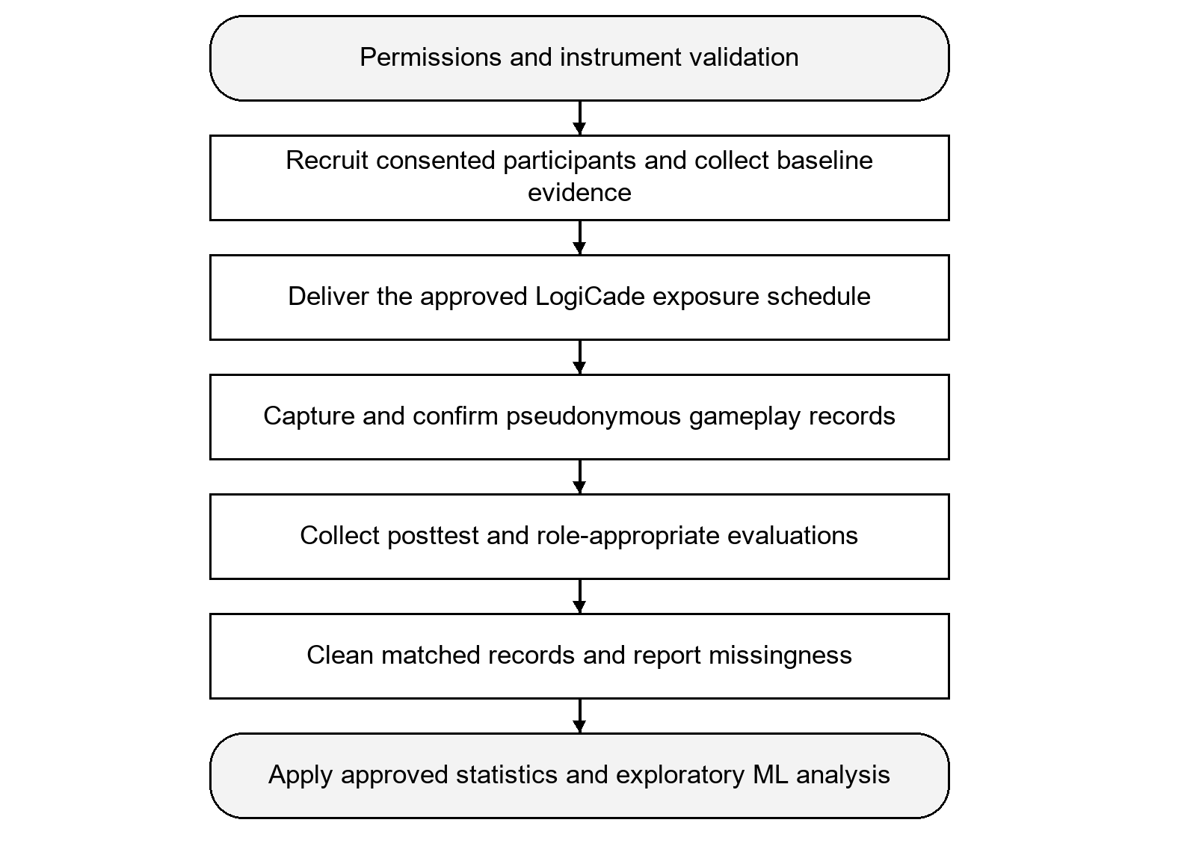
Figure 3.2 Data gathering and research record preparation flow
Recruitment, baseline assessment, system exposure, endpoint assessment, and analysis follow the approved protocol. The flow does not establish a sample size or research design; those fields remain subject to the placeholders in Sections 3.2 and 3.4.

3.6.1 Consent and data management
Consent procedures will state the purpose of the study, activities, records collected, access arrangements, and withdrawal options. For participants requiring guardian consent or assent, the applicable process is [insert consent and assent requirements]. Approval identifiers, data custodian, access roles, retention period, backup location, and disposal procedure are [insert ethics approval custodian access retention backup and disposal details].
The system separates private account credentials from pseudonymous gameplay data, hashes participant passwords, and routes privileged writes through authenticated server operations. Research exports use pseudonymous identifiers by default. Hosting location and external data flows will be documented in the approved deployment plan. Local LLM inference does not mean that no data will leave the laptop if the application or database is later deployed to cloud infrastructure.

3.7 Data Analysis Tools
The available implementation uses Python with pandas and NumPy for data preparation; scikit-learn for the exploratory multinomial logistic regression and clustering scripts; PostgreSQL/Supabase for storage and aggregate views; and the administrator panel for inspection and permitted exports. The export implementation includes CSV, Excel, PDF, and Word outputs, although a fully configurable research report builder is not assumed. The inferential statistical package and final versions are [insert approved statistical software and version].
Table 3.6 Data analysis and implementation tools
Tool | Use in this project
React and Vite | Learner views, stage selection, mission and result states.
HTML5 Canvas and authored JavaScript | Reusable game controllers and bounded teaching simulations.
Python and FastAPI | Authenticated APIs, data validation, package handling and generator operations.
PostgreSQL and Supabase | Synchronized research tables, ledger records and aggregate views.
IndexedDB | Local attempt and event records with an explicit retrying outbox.
pandas and NumPy | Offline feature construction and numeric data preparation.
scikit-learn | L2 multinomial logistic regression, preprocessing, evaluation and exploratory clustering.
Ollama | Local, configuration-dependent candidate parameter generation.
Approved inferential package | [insert statistical software version and analysis environment]

3.7.1 Multinomial logistic regression workflow
The project contains a synthetic-data generator, a real-export feature builder, and an offline trainer for L2-regularized multinomial logistic regression (MLR). The classifier estimates probabilities for the three expert-defined categories from multiple signals jointly. The target is an adjudicated recommendation, not a pretest stratum, a final grade, or the output of the existing rule-based picker. Multinomial logistic regression supports class-probability estimation through a softmax model (scikit-learn developers, n.d.).
Each row contains one next-stage decision. The raw-feature workflow retains relevant numeric values, opportunity denominators, missingness, objective identity, and prior difficulty. A second workflow encodes the interpretation bands. Session duration and inactivity remain contextual fields rather than predictors. Hints are withheld as a model feature when hint-opportunity data are absent; measured hints remain available for reporting. Response-time medians require instrumented event exports.
The trainer uses a participant-separated holdout with a target fraction of 25% and seed 2026. It requires all three classes in training and evaluation, and searches group splits for class coverage. The code guard of four participants and twelve labeled decisions is only an execution minimum, not evidence of an adequate research sample. All imputation, scaling, encoding, and matched-time baselines are fitted on training participants before holdout evaluation. The final research artifact is refitted on eligible labeled rows after evaluation and is not deployed automatically.
The synthetic generator defaults to 600 decisions from 120 fictional participants. It generates feature patterns and labels together and marks their origin. Such data can check the software pipeline, but model scores from them do not establish predictive validity for students. Synthetic data will not be merged with participant records or reported as research respondents. Production use of a trained model requires [insert real-data validation acceptance criteria and deployment approval].
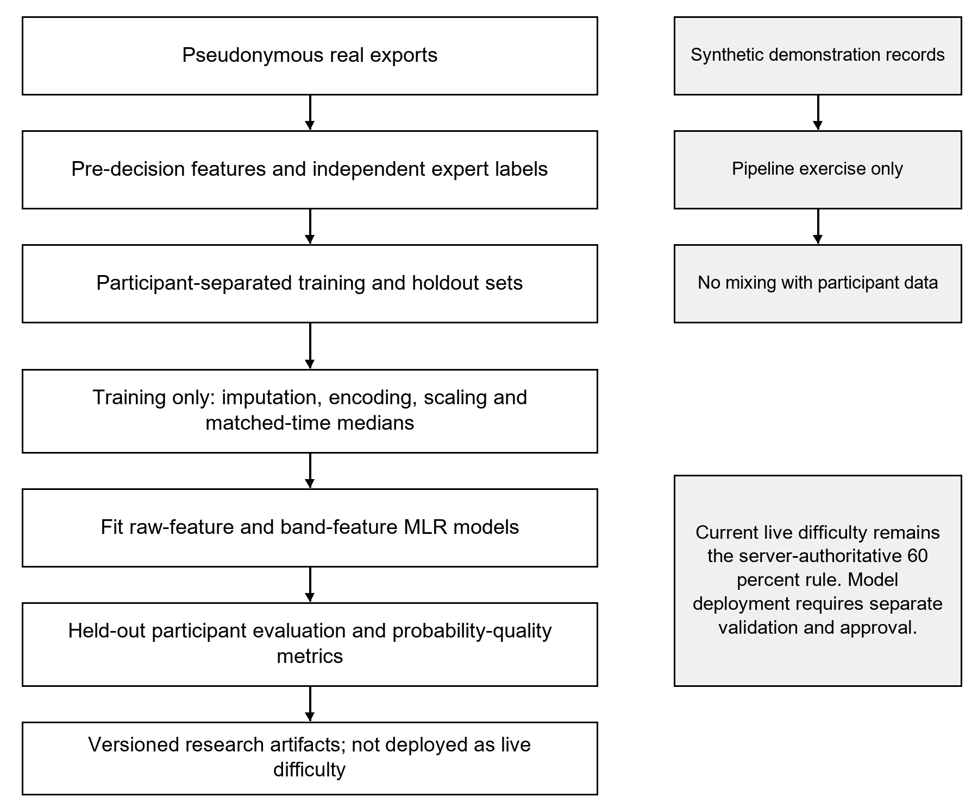
Figure 3.3 Offline MLR feature preparation training and evaluation pipeline
Only participant histories available before each decision enter the real-data workflow. Synthetic demonstration records remain separate. Grouped evaluation estimates performance for held-out participants; it does not make the resulting model a live selector.
$$z_{ij} = \frac{x_{ij} − μ_{j}}{σ_{j}} (3.2)$$
Where xij is a numeric feature for decision i, μj is its training-set mean, and σj is its training-set standard deviation. The fitted scaler is applied to evaluation records without refitting on them.
Table 3.7 Interpretation of standardized numeric features
Value | Meaning
z = 0 | At the training-set mean for that feature.
z > 0 | Above that feature’s training-set mean.
z < 0 | Below that feature’s training-set mean.
Magnitude of z | Distance expressed in training standard deviations, not an educational mastery rating.
Missing raw measurement | Retain missingness; use only the fitted training-data imputation pipeline.

$$Pr(Y = k | x) = \frac{exp(β_{k0} + β_{k}^{T}x)}{\sum_{j=1}^{3}{exp(β_{j0} + β_{j}^{T}x)}} (3.3)$$
Where k is one of Needs Support, Standard, and Advanced; x contains the transformed pre-decision features; and β contains the fitted model coefficients. The three class probabilities sum to one. This equation describes the offline model, not the current live rule.

3.7.2 Exploratory learner profiling
An optional K-Means script reads student summaries and uses mean first-attempt score, levels played, total errors, total recorded time, total hints, and overall repeat rate. It standardizes features and compares candidate cluster counts using silhouette scores where the sample allows. The current script fills missing feature values with zero and has limited small-sample safeguards. Consequently, any use in the study will require [insert approved missing-data exposure-normalization and cluster-validation procedure]. No clusters or learner-profile results are assumed, and clusters will not be forced to match the research strata.

3.8 Statistical Treatment of the Data
The available revised methodology identifies frequency, percentage, mean, standard deviation, median, paired assessment differences, a paired t-test or conditional nonparametric alternative, and effect size. The final analysis will use only measurements supported by the collected records and the approved research design. Every result will identify its analytical unit, denominator, exclusions, and missing values.

3.8.1 Descriptive statistics and questionnaire responses
For categorical records, percentage = 100f/N, where f is the observed category count and N is the valid denominator. For continuous measurements, the arithmetic mean is the sum of observations divided by n, and sample standard deviation is the square root of the summed squared deviations divided by n − 1. Median and interquartile range will accompany skewed timing and attempt distributions. Timing summaries will specify whether they describe completed runs, failed runs, or all instrumented runs.
$$Percentage = \frac{f}{N} × 100 (3.4)$$
Where f is an observed frequency and N is the valid denominator for the stated analytical unit.
$$x̄ = \frac{Σx_{i}}{n} (3.5)$$
Where xi is an observed numeric measurement and n is the number of valid observations in the defined analysis.
$$s = \sqrt{\frac{\sum_{i=1}^{n}{{(x_{i} − x̄)}^{2}}}{n − 1}} (3.6)$$
Where s is the sample standard deviation, defined only when at least two valid observations are available.
For five-point questionnaire responses, the frequency-weighted item mean is the sum of response values multiplied by their frequencies, divided by the number of valid responses. Response distributions and missing counts will also be retained. Composite scales, reverse coding, verbal interpretation intervals, reliability procedures, and validation thresholds are [insert approved questionnaire aggregation and reliability plan]. Ordinal agreement responses will not be presented as direct measures of learning achievement.
$${x̄}_{w} = \frac{Σf_{j}r_{j}}{Σf_{j}} (3.7)$$
Where rj is the assigned response value and fj is the number of valid respondents selecting it. This is a response-frequency weighted item mean, not an assumed weighted composite of different constructs.
Table 3.8 Proposed verbal interpretation of five-point item means
Unrounded mean interval | Interpretation
4.20 to 5.00 | Strongly Agree
3.40 to below 4.20 | Agree
2.60 to below 3.40 | Neutral
1.80 to below 2.60 | Disagree
1.00 to below 1.80 | Strongly Disagree

These proposed intervals are inherited from the supplied revised LogiCade methodology. Their use requires instrument approval. Classify the unrounded mean and round only for display; adjacent half-open intervals avoid gaps caused by reporting to two decimal places. Do not apply this agreement scale to test scores or ML metrics.

3.8.2 Learning gain and paired comparisons
For participant i, learning gain is posttest score minus pretest score on the same scoring basis. Paired analysis includes only valid matched records and reports the number excluded for missing or incompatible scores. A positive difference indicates a higher observed posttest score; it does not by itself identify the cause of the change.
$$g_{i} = {Post}_{i} − {Pre}_{i} (3.8)$$
Where gi is an individual paired score difference on the same assessment scale. Only matched valid scores contribute to paired analysis.
Table 3.9 Interpretation of paired learning gain
Difference | Interpretation
g > 0 | Observed posttest score is higher than pretest score.
g = 0 | No observed score difference on the specified scale.
g < 0 | Observed posttest score is lower than pretest score.
One assessment missing | No paired difference; exclude from paired calculations and report missingness.

If the approved design supports a within-participant comparison and assumptions for the difference scores are reasonable, the paired t statistic is the mean difference divided by its standard error, t = mean(d)/(s(d)/sqrt(n)), with n − 1 degrees of freedom. The revised draft specifies a significance level of 0.05. The final prespecified hypotheses and decision rule are [insert approved hypotheses and analysis plan]. A Wilcoxon signed-rank procedure may be used when its paired-data and distributional assumptions fit the measurements; the alternative will not be chosen merely to obtain significance.
$$t = \frac{d̄}{\frac{s_{d}}{\sqrt{n}}} (3.9)$$
Where d̄ is the mean paired difference, sd is the standard deviation of paired differences, and n is the number of valid pairs. Degrees of freedom are n − 1. Use only when the approved design and assumptions support this test.
The proposed paired effect size is Cohen’s dz = mean(d)/s(d), reported with [insert approved confidence-interval procedure]. If the three named strata are analyzed separately as one family of tests, the revised draft proposes Bonferroni adjustment, 0.05/3 = 0.0167. This adjustment will apply only if those subgroup tests are prespecified. A group-comparison or interaction analysis requires the approved group structure and a separately documented model.
$$d_{z} = \frac{d̄}{s_{d}} (3.10)$$
Where dz is the mean paired change in units of the standard deviation of differences. Its sign indicates direction; magnitude must be interpreted with a confidence interval and the educational context.
Table 3.10 Interpretation rules for inferential statistics
Quantity | Interpretation rule
Prespecified alpha | The source draft proposes 0.05; final hypotheses and analysis require approval.
p below alpha | Evidence against the specified null under the test assumptions. It is not the probability that LogiCade caused improvement.
p at or above alpha | Insufficient evidence to reject the specified null; not proof of no effect.
Three prespecified stratum tests | The source draft proposes Bonferroni alpha 0.05 / 3, approximately 0.0167.
Effect size and confidence interval | Report direction, magnitude and uncertainty; acceptance cutoffs are [insert approved effect-size interpretation].

3.8.3 Gameplay and generation indicators
Stage completion rate is the count of completed eligible runs divided by the declared eligible-run denominator. Failure rate is failed evaluated runs divided by completed plus failed evaluated runs. Submission accuracy is correct scored submissions divided by all scored submissions. Incomplete, abandoned, restarted, and replayed activity will retain distinct categories; unrecorded activity will not be counted as a successful completion.
$$Submission accuracy = \frac{Correct scored submissions}{All scored submissions} (3.11)$$
Where the denominator must be positive. This submission-based research measure is retained separately from test-case accuracy or a game’s native goal score.
$$Failure rate = \frac{Failed evaluated runs}{Completed evaluated runs + Failed evaluated runs} (3.12)$$
Where abandoned, restarted, or unevaluated runs are retained separately rather than being silently added to the evaluated denominator.
$$Time ratio = \frac{Measured active task time}{Training-only matched-task median} (3.13)$$
Where the completion measure requires a successful run; the response measure uses the available first-response samples. A ratio of 1 is the matched median, not a mastery cutoff.
AI quality indicators will identify generation requests, verification passes, rejections, retries, publication success, fallback use, and recorded latency where available. Rates will state whether the denominator is a request, a candidate proposal, or a consumed pool slot. Retained local job history is bounded and database generation logging is best effort; neither will be called a complete lifetime total without reconciliation. Synchronization analysis will distinguish locally pending data from server-confirmed rows.

3.8.4 Machine learning evaluation
The trainer reports classification accuracy, macro F1, recall by class, a confusion matrix, multiclass log loss, and multiclass Brier score on the participant-separated holdout. Accuracy is the proportion of correctly classified rows. Macro F1 averages the class F1 values equally; class recall is the fraction of true members of a class recovered by the model. The confusion matrix will retain the stated class order. Log loss and Brier score describe probability predictions and are not proof of calibration by themselves.
$$Accuracy = \frac{Correct class predictions}{All evaluated decisions} (3.14)$$
Where each row is one eligible next-stage decision. Report the number of distinct evaluation participants as well as the number of rows.
$${Precision}_{k} = \frac{{TP}_{k}}{{TP}_{k} + {FP}_{k}}; {Recall}_{k} = \frac{{TP}_{k}}{{TP}_{k} + {FN}_{k}} (3.15)$$
Where TPk, FPk and FNk are true positives, false positives and false negatives when class k is treated as the positive class. The trainer reports class recall; precision can be calculated from the confusion matrix for F1 interpretation.
$${F1}_{k} = \frac{2 {Precision}_{k} {Recall}_{k}}{{Precision}_{k} + {Recall}_{k}}; Macro F1 = \frac{{F1}_{1} + {F1}_{2} + {F1}_{3}}{3} (3.16)$$
Where macro F1 assigns equal importance to the three classes. The current trainer assigns zero when an F1 or recall denominator is undefined; class supports and the confusion matrix must remain visible.
$$Log loss = −\frac{1}{N}\sum_{i=1}^{N}{\sum_{k=1}^{3}{y_{ik} ln(p_{ik})}} (3.17)$$
Where yik equals 1 for the actual class and 0 otherwise; pik is the predicted probability. Lower loss is better and confident incorrect predictions are penalized strongly.
$$Brier = \frac{1}{N}\sum_{i=1}^{N}{\sum_{k=1}^{3}{{(p_{ik} − y_{ik})}^{2}}} (3.18)$$
Where this is the unscaled multiclass definition used in the training script, with range 0 to 2. A score of zero represents perfect probabilities on the evaluated rows.
Table 3.11 Interpretation of MLR evaluation outputs
Metric | Meaning and direction
Accuracy | 0 to 1; higher means more correct class predictions. Read alongside class distribution.
Macro F1 | 0 to 1; higher indicates better balance of precision and recall across classes. No validated Excellent or Poor cutoffs are established.
Recall by class | 0 to 1; higher means fewer actual members of that class were missed.
Confusion matrix | Rows are actual classes and columns are predicted classes; inspect every off-diagonal error.
Log loss | Zero is ideal; lower is better. The upper bound is unbounded.
Multiclass Brier score | 0 to 2 for the implemented formula; lower is better. This is not a standalone proof of calibration.
Production acceptance | [insert approved performance uncertainty and safety criteria]

Instructor agreement before adjudication will be evaluated using [insert approved agreement statistic and weighting]. The supplied rubric proposes weighted kappa alongside a confusion table, but reviewer data are required. Uncertainty intervals, a fair rule-based comparison, calibration diagnostics, any ordinal-model comparison, and further participant-grouped validation are [insert approved model evaluation extensions]. The current single holdout remains exploratory, particularly where classes or participants are sparse.

3.9 Proof of Concept

3.9.1 Application architecture
The proof of concept is the implemented LogiCade application. React and Vite manage the learner journey; FastAPI provides authenticated account, progression, difficulty, package, synchronization, and administrator operations; shared HTML5 Canvas controllers render the activities; and Supabase/PostgreSQL stores synchronized records. IndexedDB and its outbox provide local persistence for pending gameplay data. Ollama supplies candidate challenge parameters to a separate verification and publication pipeline.
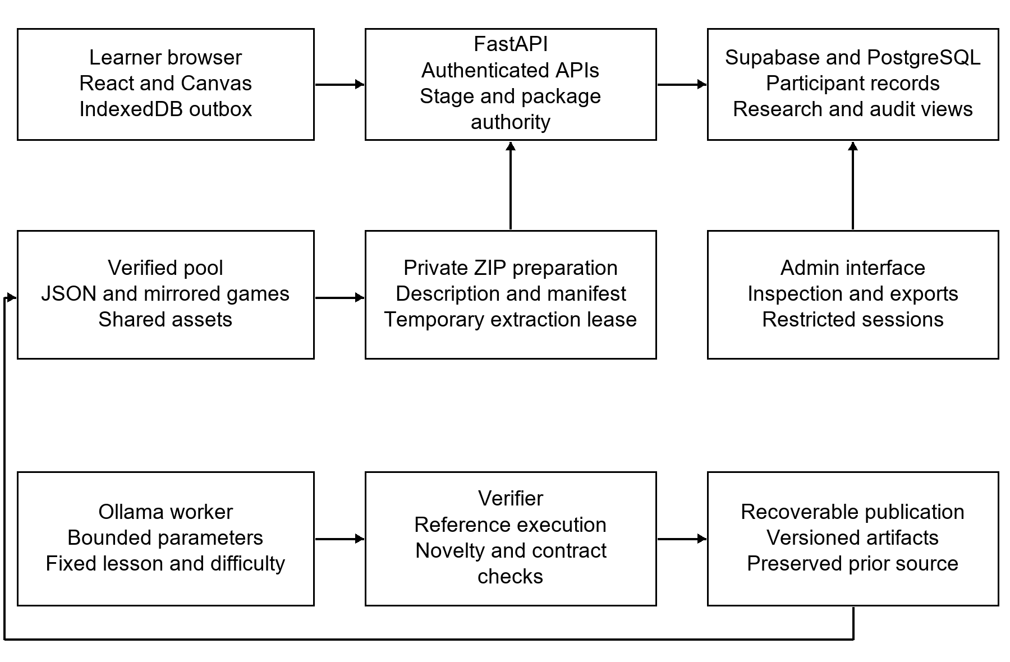
Figure 3.4 LogiCade application and verified generation architecture
The learner host controls identity, rewards and persistence. A private package binds a selected challenge revision to its game. Background generation proposes content within a fixed lesson, while verification and recoverable publication protect the usable pool.
Table 3.12 Application layers and verified responsibilities
Layer | Responsibilities
Learner interface | Loading and landing views, registration and student-number login, initial character selection, subject selection, prologue, world map, stage selection, mission modal, game frame, Oracle guidance, pause and result states.
FastAPI application | Authenticated serving, stage-difficulty resolution, private package leases, participant-scoped synchronization, coin operations, content and research administration, and permitted exports.
Canvas runtime | Reusable flowcharts, circuit workbenches, connected C-program nodes, hidden-object history cases, factory tasks, and code-controlled adventures.
Persistent research records | Account and pseudonymous participant records, enrollment metadata, levels, attempts, events, coins, decisions, assessments, sessions, generation records, and audit records.
Background authoring | Bounded LLM parameter proposal, semantic and executable verification, duplicate detection, recoverable publication, revision retention, and retry scheduling.

A participant owns multiple stage records and attempts; events refer to the appropriate stage and attempt. The private account record links to a pseudonymous student identifier. Assessment and session records link to that identifier without requiring identifying account values in research exports. Schema migrations also define research views and server access controls. Migration-file presence does not establish which migrations have been applied to a particular hosted database.
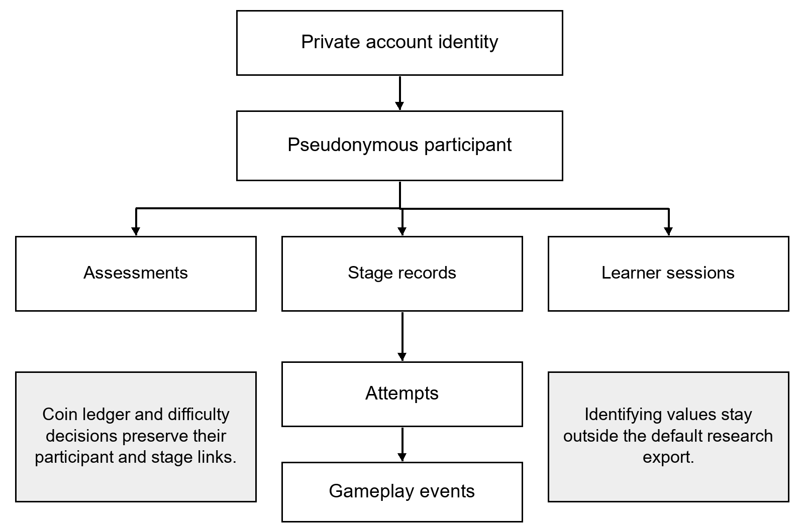
Figure 3.5 Logical relationships among participant research records
The diagram shows logical research relationships, not a claim that every displayed edge is a physical database foreign key. One participant can own many stage records, attempts, sessions and assessments. Account identity is separated from the default pseudonymous research dataset.

3.9.2 Curriculum and activity organization
The current catalog contains 2,700 canonical challenge slots, derived from nine weeks, ten source levels, three difficulty categories, and ten variations per category. Week 1 exposes only two stages, so 240 historical slots are unavailable to learners. The registry consequently lists 2,460 playable records over 82 stage positions. These are parameterized challenges sharing authored controllers, not 2,700 independent game engines. The earlier approved 90-activity target and the implemented 82-stage sequence require an explicit mapping of [insert approved research activity count and completion mapping].
Table 3.13 Current curriculum regions and game presentations
Week | Lesson focus | Current presentation
1 | Orientation and interface practice; two available stages | Welcome video followed by a guided drag-and-drop flowchart puzzle.
2 | Flowcharting | Circuit-presented executable charts with sequence, input/output, decisions, loops, and synthesis.
3 | Algorithms | Connected terminal nodes for input/output, ordering, state traces, arithmetic, repair, and bounded execution.
4 | Introduction to C, history, characteristics, and classification | Hidden-object archive cases. Each game presents five artifacts with evidence cards and topic-specific checks.
5 | C components, reserved words, preprocessing, and source organization | Factory and source-assembly activities, including production routing and controllers.
6 | Creating simple C programs and program structure | Code-controlled programming adventures with approved C-subset tasks and map goals.
7 | Basic C parts and variable declarations | Connected C-program terminal nodes, typed variables, arithmetic, characters, and integer division.
8 | Local and global variables | Scope-aware C circuit workbenches with branching, merging, and bounded feedback behavior.
9 | Review of Weeks 2 to 8 | Stage-specific flowchart, terminal, archive, factory, adventure, and scope review; Stage 10 is a cumulative expedition.

Each stage binds its pool to a stable learning objective and source lesson. Variation changes inputs, values, questions, layouts, or routing while preserving the assigned objective and difficulty. This prevents a random activity from replacing the required level topic. Week 9 uses an explicit source-level blueprint and a cumulative capstone rather than treating every review stage as the same exercise.

3.9.3 Selection packaging and challenge replacement
After stage selection, the server resolves the participant’s assigned difficulty and selects an existing verified JSON from the matching week, level, and difficulty folder. Its description supplies the stage details and mission information. Preparing the mission compiles a small ZIP containing the launcher and selected game data, then extracts a private temporary lease. The shared Canvas code and assets remain outside the per-stage archive. Starting opens that lease in the sandboxed game frame.
Completion, Exit, and Repeat release the active extracted copy and consume the compiled revision. The canonical source remains usable while a background replacement is attempted. Repeat can therefore select another existing verified challenge without waiting for model inference. The model proposes bounded parameters for the same objective and difficulty; authored templates construct the executable challenge. Arbitrary generated JavaScript, HTML, shell commands, and asset URLs are excluded from this native authoring contract.
The verifier checks the binding, constraints, novelty, executable reference behavior, and rejection of an invalid solution. A passing candidate replaces the source, mirrored definition, ZIP, description, and manifest through a recoverable publication process. A single worker serializes generation, attempts a proposal up to three times, and then schedules another attempt after five minutes if needed. Failure preserves the last verified content. The welcome video is excluded from regeneration. Model identity is configuration-dependent; the exact tag, digest, generation settings, and availability for the study will be [insert deployed model tag digest and generation configuration].
Shared sprites and interface audio reference the existing Kenney asset collection. The C execution environment is a bounded teaching interpreter rather than a complete native C compiler. Supported constructs and helpers are restricted, and program execution has budgets. Consequently, successful in-game execution will not be represented as full ISO C conformance or arbitrary-code compilation.
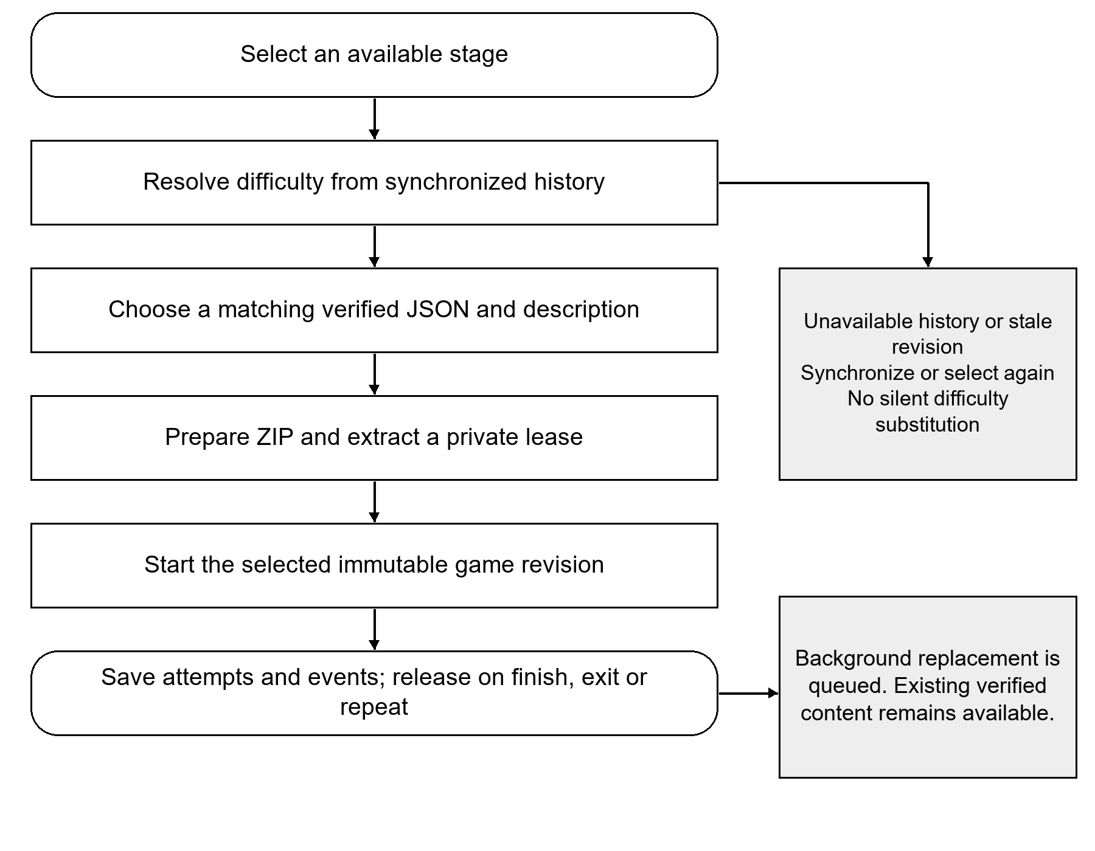
Figure 3.6 Stage selection preparation play and cleanup flow
The selected stage retains its objective and assigned difficulty from preview to start. Missing evidence or a stale revision triggers recovery. Consuming a played build queues later replacement while preserving the last verified source.
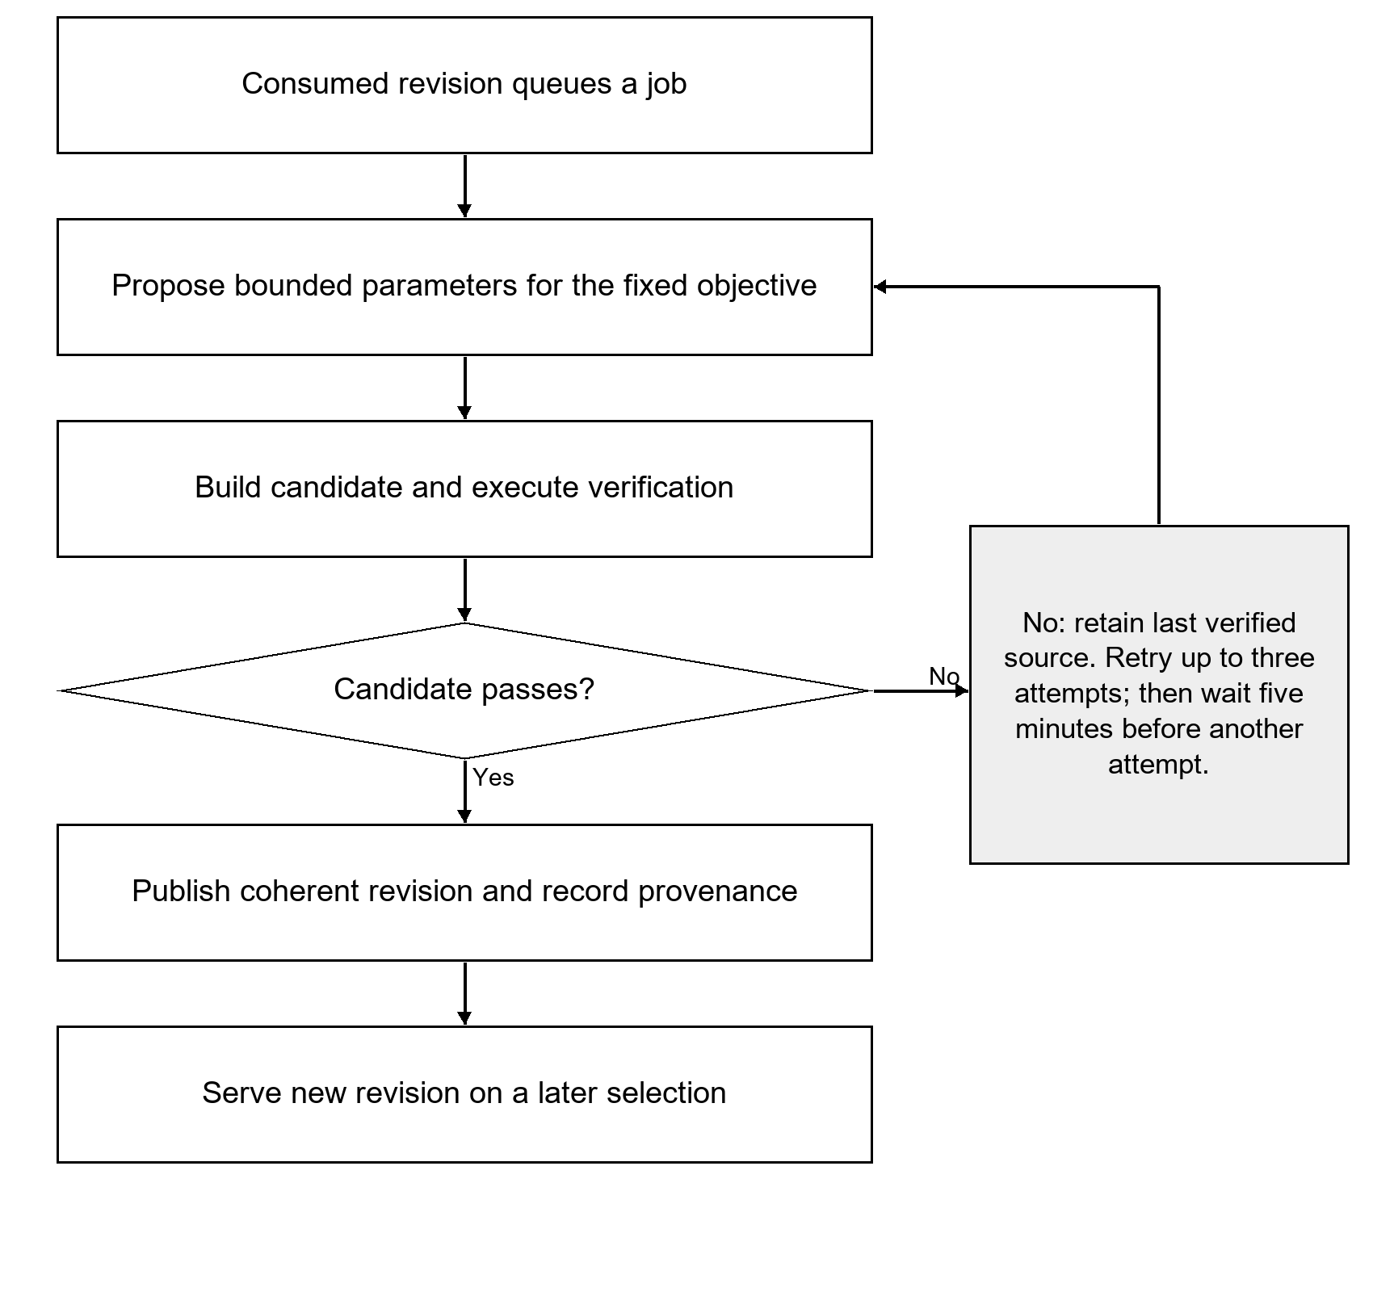
Figure 3.7 Background challenge generation verification and retry flow
A failing or unavailable generator does not publish unverified content. Bounded retries use the same stage objective and difficulty. Publication is recoverable and does not alter an active extracted game revision.

3.9.4 Current difficulty selection and proposed MLR integration
The live engine uses rule version cp1-60-v2. It uses the first evaluated completed or failed run of the preceding stage and the number of completed full-level replays after the first clear. Exits, incomplete runs, and restarts before evaluation do not establish a scored zero. Errors are retained in records but do not affect the current threshold table. Week 1 Stage 2 begins at Standard; subsequent region boundaries carry forward eligible preceding-stage evidence. The video provides no scored adaptation evidence.
Table 3.14 Implemented next-stage difficulty rule
First evaluated accuracy | Completed full-level replays | Next category
Below 60% | Any | Needs Support
60% to below 80% | Two or more | Needs Support
60% to below 80% | Zero or one | Standard
80% or higher | Two or more | Standard
80% or higher | Zero or one | Advanced

The server enforces the assignment when serving and preparing a stage, while selected and actual served difficulty are stored separately. A verified start freezes the served decision. The MLR scripts described in Section 3.7 are offline research tools and do not replace this live table. If model-controlled selection is included in the final study, its integration, approved fallback for insufficient evidence, model version, and acceptance evidence are [insert validated MLR integration and approval details].

3.9.5 Rewards synchronization and operational verification
New accounts receive an initial balance of 20 coins through an auditable ledger, and an Oracle hint costs 6 coins. First-clear rewards are issued once, with the learner interface showing 10 coins and 50 experience points for a first clear. Coin operations use server authority and idempotent transactions rather than accepting a student-supplied balance. Experience, coins, and gameplay progress are engagement measures and are separate from formal learning-outcome scores.
The local outbox uploads records explicitly; Supabase does not synchronize arbitrary IndexedDB records automatically. Unique event and attempt identities, ownership validation, parent-before-child upload, and server acknowledgments support repeat-safe synchronization. Administrator views expose synchronized information, which can lag behind unsent local records. Full offline downloading of all game packages and distributed multi-worker publication are not established capabilities of this release.
The verification procedure will cover account uniqueness and access, first-clear and hint transactions, restart versus retry versus replay semantics, difficulty boundaries and carryover, objective binding, package preparation and cleanup, rejected model proposals, revision consistency, missing-data recovery, and export reconciliation. Existing project tests and reports provide development evidence, but study-specific execution dates, selected build, observed defects, and acceptance results are [insert study-build verification and acceptance records].

3.9.6 System snapshots
The following figures are archived development captures from the project screenshot collection. The main interface set was captured on November 5, 2026; additional game captures document the later activity presentations available in the workspace. Accounts, assessments, and operational states in these previews may use demonstration fixtures. They illustrate interfaces and program execution only and do not provide participant findings, measured learning gains, or a production acceptance record.

Figure 3.8 Landing interface
The landing screen introduces CP1 learning and provides the entry action to account access.
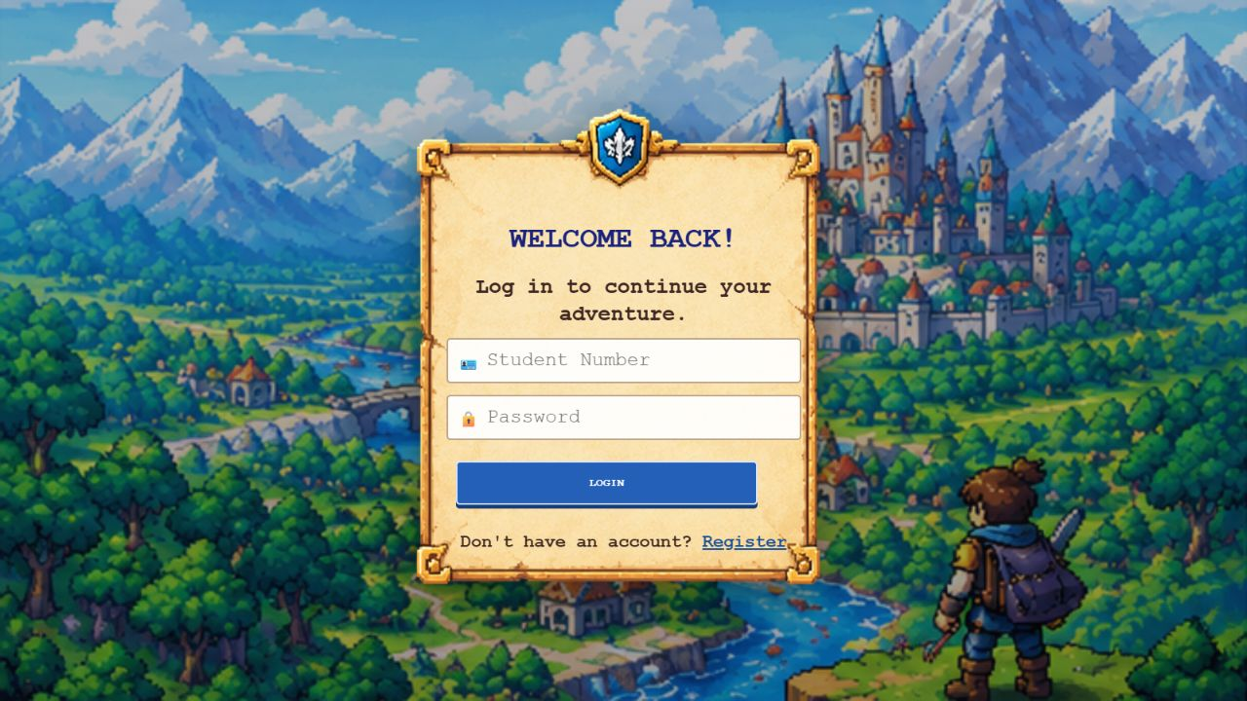
Figure 3.9 Student number login interface
The learner login uses a student number and password. This capture is from a development preview.
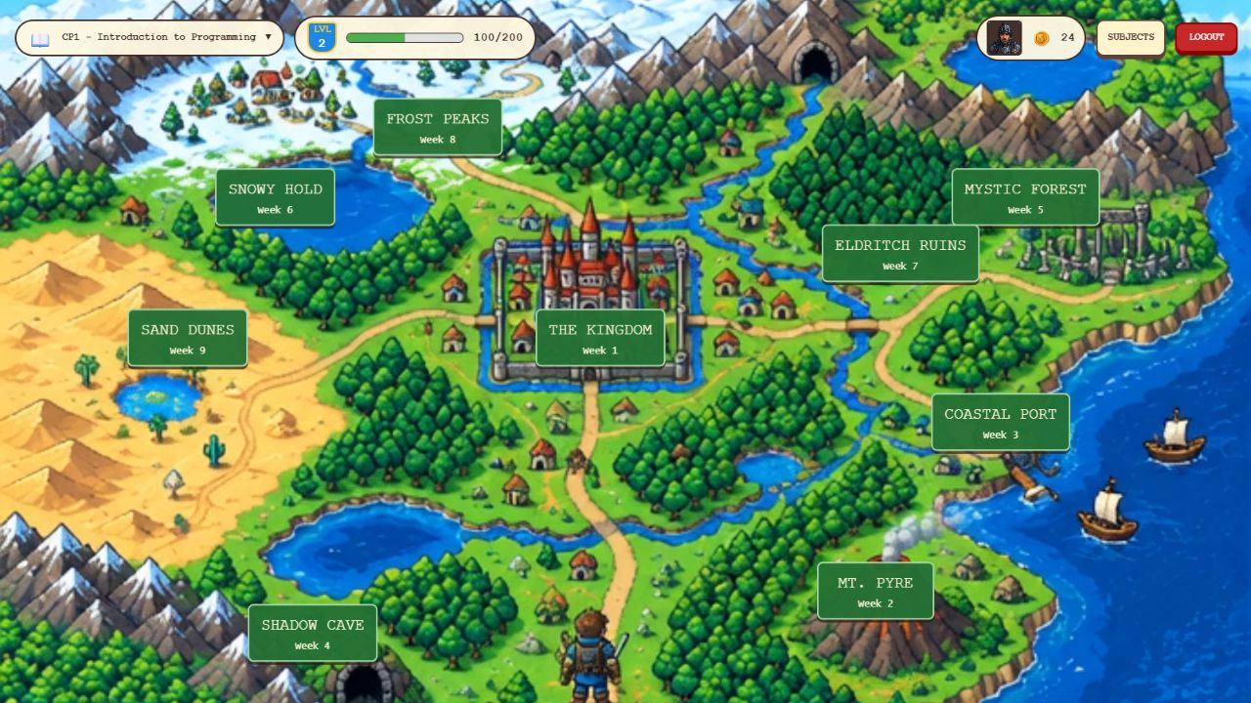
Figure 3.10 World map and curriculum regions
The map presents the nine curriculum regions and the available navigation controls.
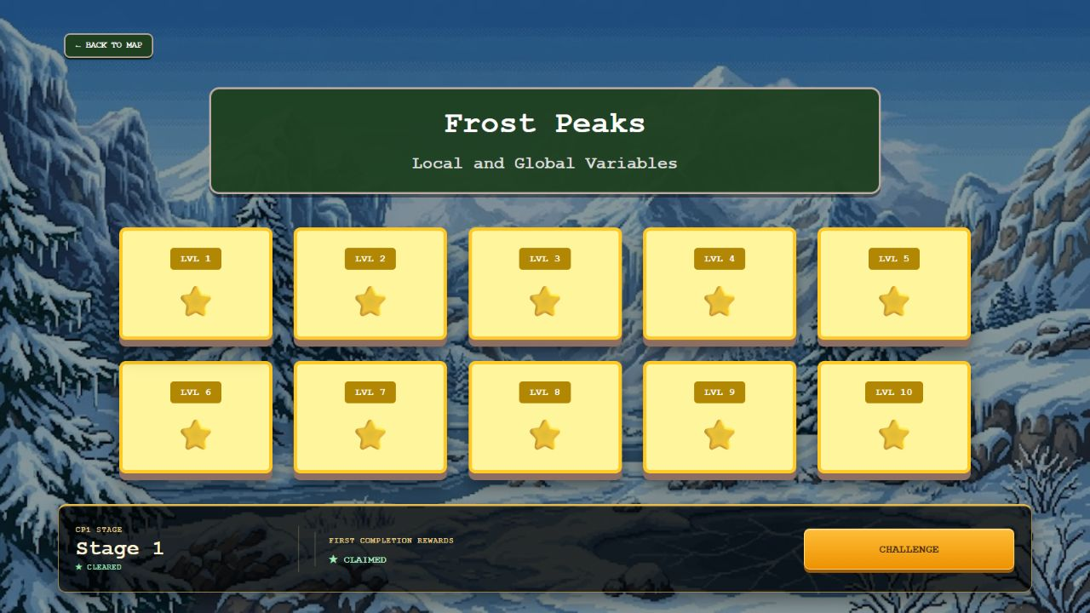
Figure 3.11 Stage selection and first clear reward display
The level selection view connects stage availability, completion state, and the Challenge action.
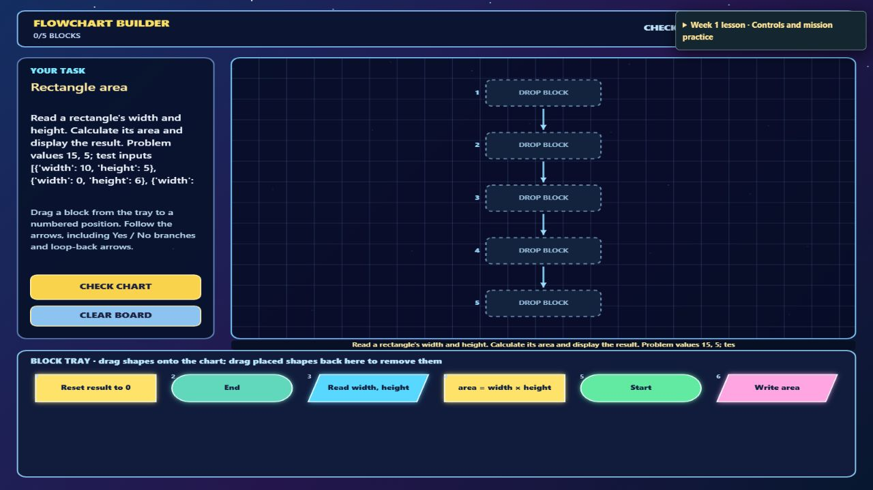
Figure 3.12 Guided drag and drop flowchart practice
The orientation activity introduces chart assembly before the main Week 2 flowchart region.
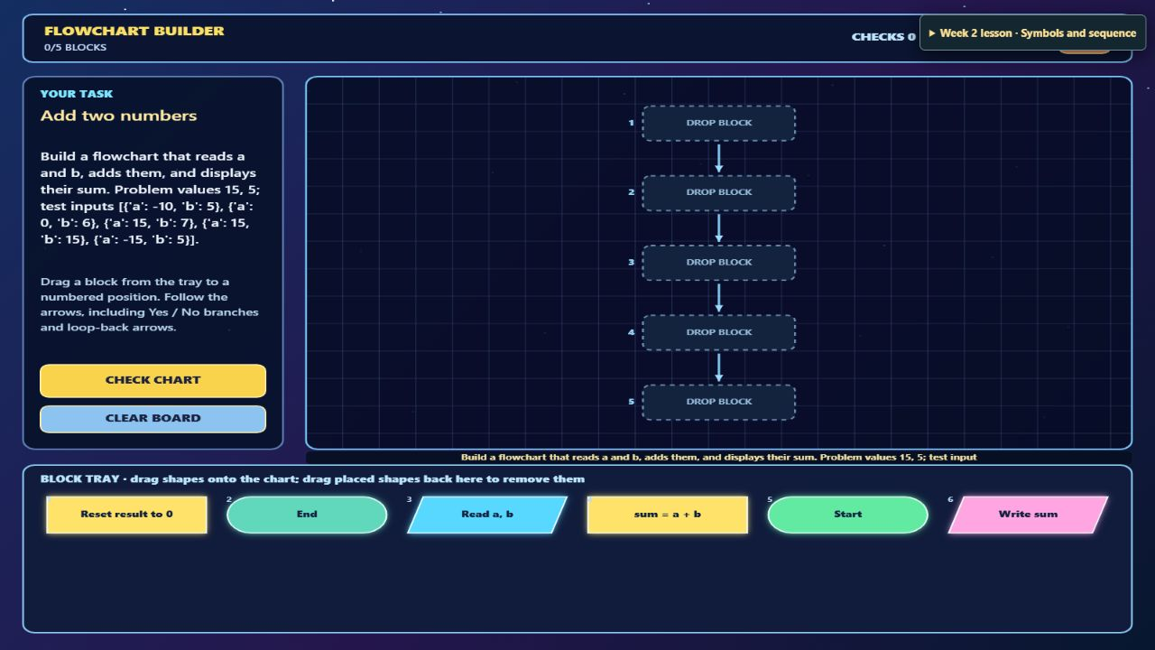
Figure 3.13 Flowchart circuit workbench
The circuit presentation associates the selected lesson with executable flowchart tasks.
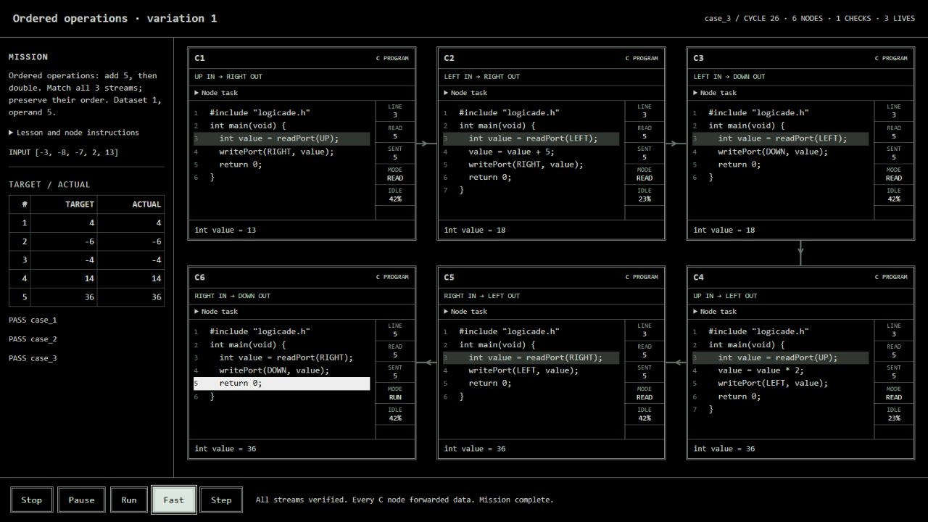
Figure 3.14 Connected C program nodes
Multiple C teaching nodes exchange values. The current learner presentation hides diagnostic output selectors.

Figure 3.15 C history hidden object investigation
This isolated local capture shows the current five-artifact archive case. It uses the authored game and temporary package data without writing participant records.
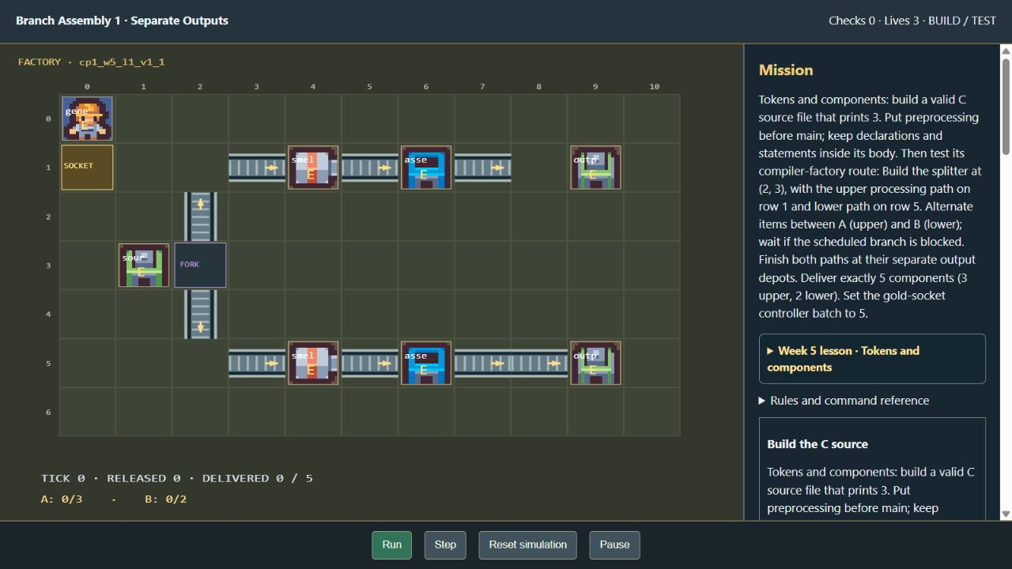
Figure 3.16 Factory and source assembly activity
The factory presentation connects routing and source-building tasks to the assigned C components lesson.
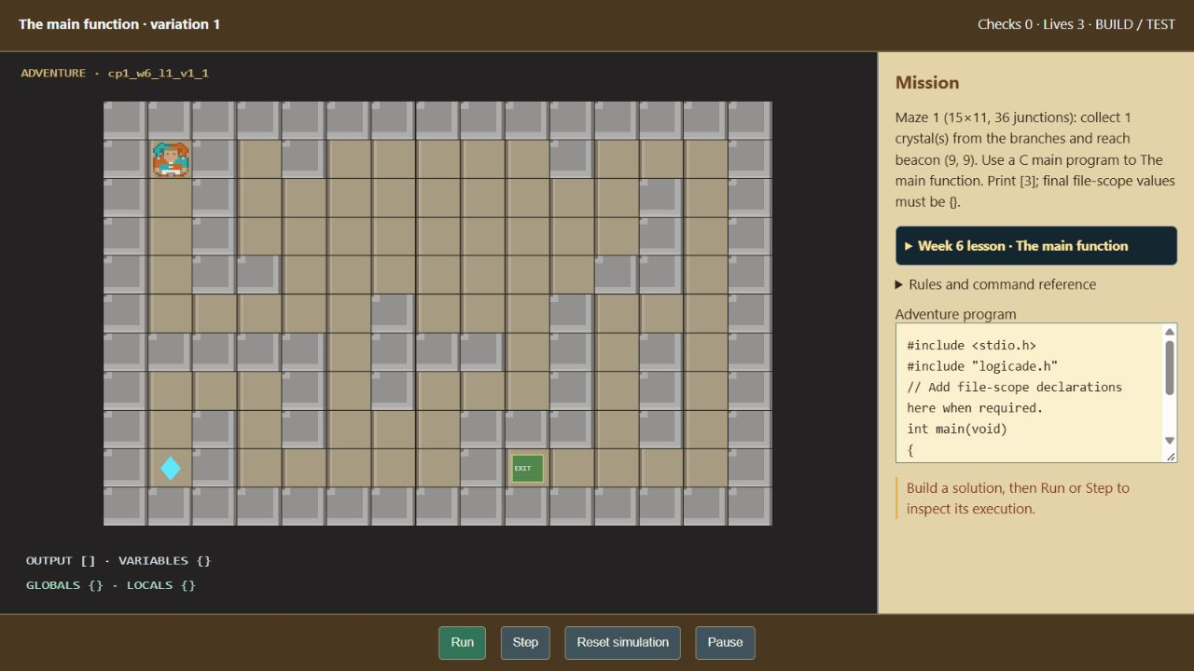
Figure 3.17 Code controlled programming adventure
The adventure combines a bounded C task with map goals, local execution feedback, and navigation.
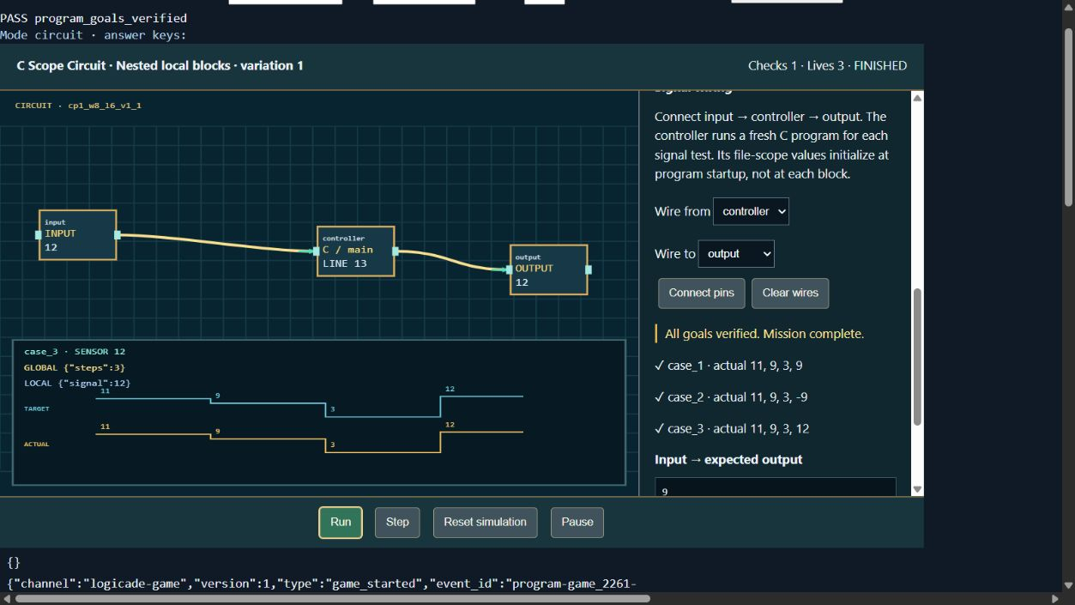
Figure 3.18 Local and global variable circuit activity
The scope workbench documents program state and signal routing in a development execution preview.
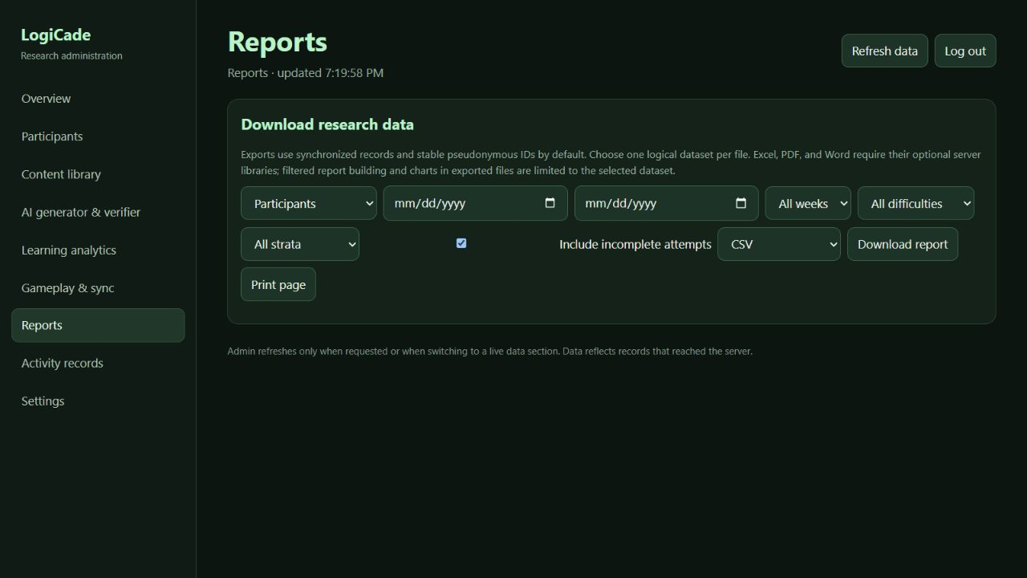
Figure 3.19 Administrator research export interface
Authorized users select a synchronized dataset, filters, and export format. This interface capture is not a report of actual study results.

3.10 Software Model
The available LogiCade methodology specifies an Agile iterative development approach. The application is developed through repeated planning, design, implementation, verification, review, and refinement rather than treating the first prototype as the final study build. Iteration records and formal review dates are [insert development iteration and review records]. The evaluated release will be [insert application source revision schema curriculum and instrument versions].
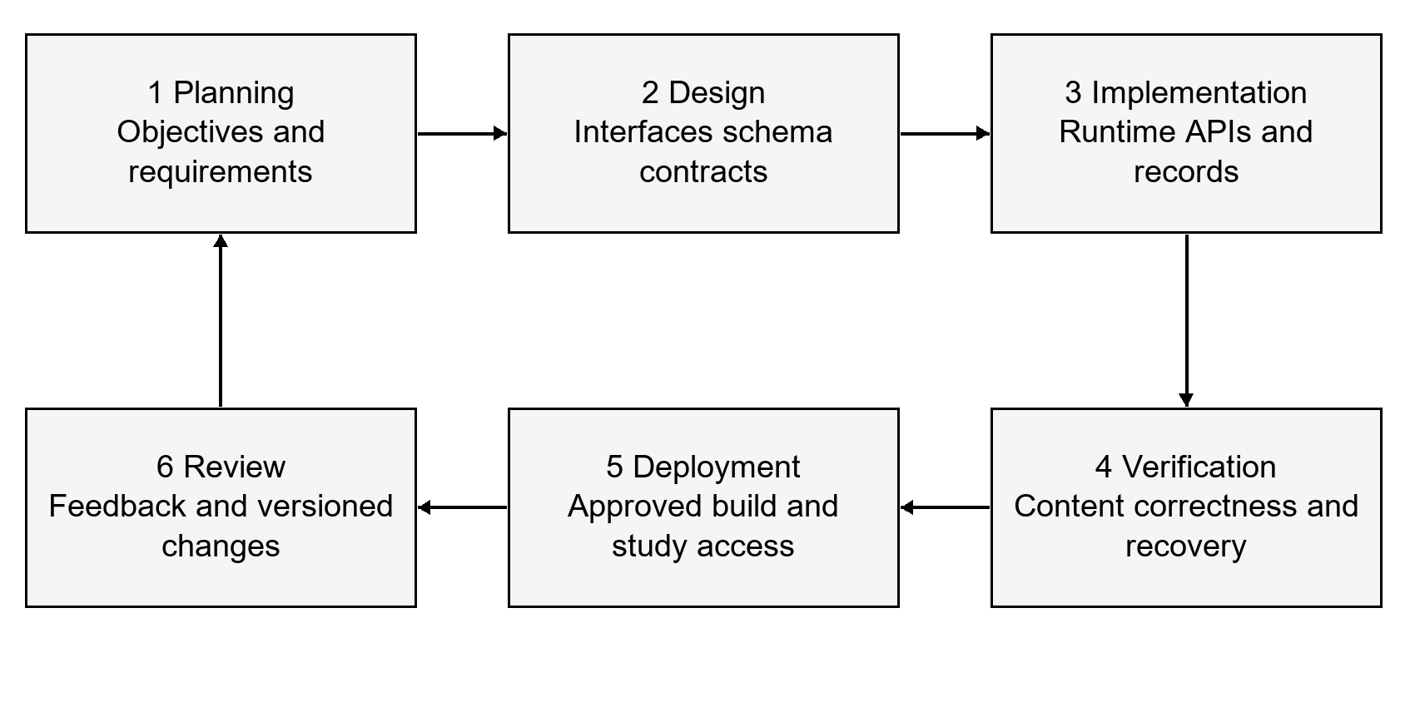
Figure 3.20 Agile development iteration for LogiCade
The development cycle connects planning, design, implementation, verification, deployment, and review. Study data collection uses an identified approved release; later changes require documented version control.
1. Planning. Map CP1 learning outcomes to regions and stage objectives, define the learner and administrator requirements, and resolve the research-design and instrument approvals.
2. Design. Specify the interface journey, schema relationships, shared Canvas controllers, bounded challenge contract, package lifecycle, difficulty authority, and research data dictionary.
3. Implementation. Build the learner and administrator functions, reusable activities, verification and replacement queue, ledger, local outbox, server access controls, and offline ML tooling.
4. Verification. Review curriculum alignment and instruments with qualified evaluators, execute relevant software checks, inspect failure recovery and exports, and document limits of the C interpreter and content generator.
5. Deployment. Freeze the approved build and configuration, document [insert production hosting and backup arrangements], complete operational acceptance, and orient participants using the approved procedure.
6. Review and refinement. Record defects and feedback, evaluate data completeness and model limitations, and version any approved change. Preserve the study-build identity so results from different instruments or algorithms are not combined without explanation.

References and Source Materials
ISO/IEC. (2011). ISO/IEC 25010:2011 Systems and software engineering — Systems and software Quality Requirements and Evaluation — System and software quality models. https://www.iso.org/standard/35733.html
ISO/IEC. (2023). ISO/IEC 25010:2023 Systems and software engineering — Systems and software Quality Requirements and Evaluation — Product quality model. https://www.iso.org/standard/78176.html
scikit-learn developers. (n.d.). LogisticRegression. scikit-learn documentation. Retrieved November 8, 2026, from https://scikit-learn.org/stable/modules/generated/sklearn.linear_model.LogisticRegression.html
Atienza, S. S., Berwega, N. H., Revilla, K. C., & Saliwan, J. B. (2027). LogiCade Development of a Gamified Learning Application for Fundamental Programming Courses Among CCS Students Using Machine Learning [Unpublished thesis manuscript; file titled N.THESIS [1] (2).pdf]. The year reproduces the manuscript title page and does not establish publication.
LogiCade project. (n.d.). Chapter 3 Methodology LogiCade Revised Adaptation Rules [Unpublished working methodology].
LogiCade project. (n.d.). Adaptive Difficulty Classification Rubric [Instrument for instructor validation; supplied Word document].
LogiCade project. (n.d.). Student Performance Assessment Rubric [Instrument for instructor validation; supplied Word document].
LogiCade project. (n.d.). SYLLABI [Supplied course document].
LogiCade project. (2026). Application source and research documentation [Local project snapshot reviewed November 8, 2026].

Implementation evidence
The implementation descriptions are supported by data/curriculum.json; games/registry.json; scripts/build_canvas_games.py; server/main.py; server/stage_difficulty.py; server/difficulty_engine.py; server/course_assessments.py; server/canvas_replacements.py; client-react/src/App.jsx; supabase/migrations/001 through 017; and the shared games/runtime modules. Model-development procedures are supported by scripts/build_mlr_difficulty_dataset.py, scripts/generate_synthetic_mlr_dataset.py, scripts/train_difficulty_mlr.py, and analysis/profile_clusters.py.

