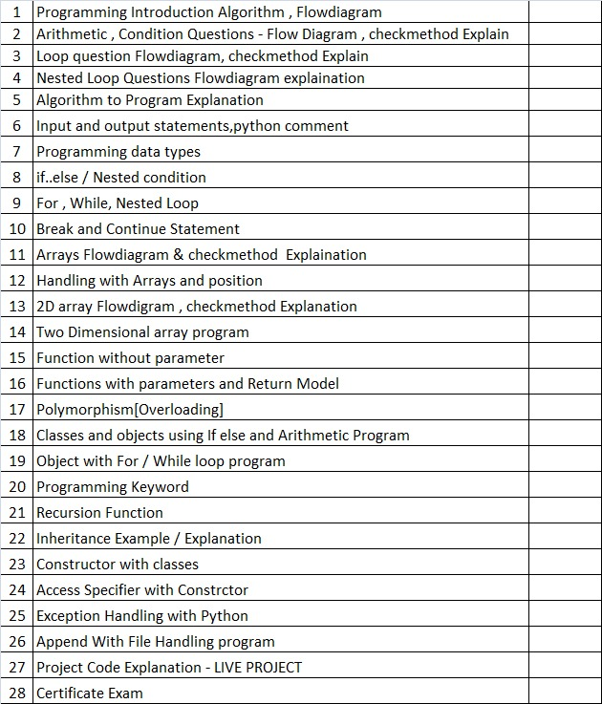**PROGRAMMING TOPICS**

**[C++,JAVA,PYTHON,C#,DART,JAVASCRIPT,NODEJS]**

**Arithmetic**

1. #input salary find 5%gst
2. input a number find square and cube
3. input three number find its sum and average
4. input a number find 100s , 10's, 1's

**Condition**

1. input a number find divisible or not
2. input two number find largest
3. input salary find gst [if salary <20K - 3%, salary>20K - 5%]
4. input three numbers find largest
5. input a number find armstrong or not

**Loop**

1. input a number find its factorial
2. input a number find factors
3. input n value find 1+2+3+....n
4. input a, b find apower b
5. input a number print the multiple table
6. perfect or not

**Nested Loop**

1. input a number find 1!+2!+3!+4!+.......
2. input a number find 1^1+2^2+....n^n
3. pattern 1,2,3,4,5,6

**Arrays**

1. input 5 nuber find sum
2. input five numbers find searching of array
3. input 5 number find sort
4. input 5 number find largest of number

**2D array**

1. input 2x2 matrix print the matrix
2. input 4x4 matrix print the sum of diagonal values
3. input 3x3 matrix print upper triangle matrix
4. input 4x4 matrix print the even numbers only
5. input a number find its factorial
6. input a number find factors

**Without Function**

1. finput a number find its factorial
2. input a number find factors
3. input a number find divisible or not
4. input two number find largest
5. input a number find 1!+2!+3!+4!+.......
6. pattern 1,2,3

**With Return**

1. finput a number find its factorial
2. Input salary find 3% gst
3. Input a,b find a^b
4. input a number find the sum of factors

**Without params**

1. input a number find its factorial
2. input a number find factors
3. input a number find divisible or not
4. input two number find largest
5. input a number find 1!+2!+3!+4!+.......
6. pattern 1,2,3..

**With Params**

1. add 2nos
2. input a number fints its factors
3. input 3 number find largest

**Overloading**

1. A.m 2 QUestions
2. Condition 2 Question
3. Loop 2 Questions[while,for]
4. Nested loop 2 Questions[while,for]
5. Nested if 2 questions

**Classes And Object**

1. A.m 2 QUestions
2. Condition 2 Question
3. Loop 2 Questions[while,for]
4. Nested loop 2 Questions[while,for]
5. Nested if 2 questions

**Inheritance**

1. A.m 2 QUestions
2. Condition 2 Question
3. Loop 2 Questions[while,for]
4. Nested loop 2 Questions[while,for]
5. Nested if 2 questions

**Constructor**

1. A.m 2 QUestions
2. Condition 2 Question
3. Loop 2 Questions[while,for]
4. Nested loop 2 Questions[while,for]
5. Nested if 2 questions