Orbital resonances are a key feature in the architecture and evolution of planetary systems. This paper introduces ResonanceX, a web-based application that enables users to explore and simulate orbital resonances in exoplanetary systems using real NASA data. The app integrates resonance detection algorithms, N-body simulations, and interactive visualizations to support both educational and research applications. Discussed the scientific foundations of orbital resonance, the computational methods used, and the implications of resonance patterns observed in exoplanetary systems.

1. Introduction
The discovery of thousands of exoplanets has revealed a rich diversity of planetary systems, many of which exhibit orbital configurations suggestive of gravitational interactions. Among these, orbital resonances—where planetary orbital periods are near-integer ratios—stand out as signatures of dynamical evolution and migration processes. Resonances can stabilize planetary systems, trigger orbital excitation, or provide clues about their formation history [1][2].

ResonanceX is a Streamlit-based web application designed to make these complex dynamics accessible. It allows users to upload or select exoplanet datasets, detect resonant pairs, simulate planetary motion, and visualize orbital architectures interactively.

2. Scientific Background
2.1 Orbital Resonance Theory
Orbital resonance occurs when two orbiting bodies exert periodic gravitational influence on each other due to their orbital periods being in a ratio of small integers (e.g., 2:1, 3:2). These configurations can lead to enhanced stability or instability depending on the system's mass distribution and eccentricities [3].

2.2 Resonance Chains and Migration
Resonant chains—where multiple planets are linked by sequential resonances—are particularly informative. The TRAPPIST-1 system, for example, exhibits a complex 8-body resonance chain, likely formed through convergent migration in a dissipative protoplanetary disk [4].

2.3 Observational Evidence
Statistical studies of Kepler and TESS data show that first-order resonances (e.g., 2:1, 3:2) are overrepresented compared to random distributions, suggesting that resonance capture is a common outcome of planetary formation [5].

3. Application Architecture
3.1 Data Handling
The app loads exoplanet data from NASA’s Exoplanet Archive or user-uploaded CSVs. It extracts key parameters such as orbital period, planetary mass, and host star identifiers.

3.2 Resonance Detection
The core algorithm compares orbital periods of planets within the same system. If the ratio of two periods is within a user-defined tolerance of a rational number (e.g., 2:1 ± 5%), the pair is flagged as resonant.

3.3 N-Body Simulation
The app includes a simplified N-body simulator that models gravitational interactions between selected planets. It uses numerical integration (e.g., Euler or Runge-Kutta methods) to compute positions over time, enabling users to visualize orbital dynamics and potential resonance locking.

3.4 Visualization
- Plotly 3D animations show planetary orbits in motion, with optional trails and dynamic scaling.
- Matplotlib plots visualize resonance pairs and period ratios.
- Streamlit UI allows users to configure simulations, upload data, and explore results interactively.

4. Case Study: TRAPPIST-1
The TRAPPIST-1 system contains seven Earth-sized planets in a near-resonant chain. Using ResonanceX, users can simulate this system and observe the resonance relationships (e.g., 8:5:3:2:1 ratios) that suggest a history of disk-driven migration and dynamical damping [6].

5. Educational and Research Applications
ResonanceX serves as a bridge between theoretical astrophysics and public engagement. It is particularly useful for:
- Teaching orbital mechanics and resonance concepts
- Exploring real exoplanet data in classrooms
- Hypothesis testing for resonance detection algorithms
- Outreach and visualization for science communication

6. Conclusion
ResonanceX provides a novel, interactive platform for exploring the gravitational choreography of exoplanetary systems. By combining real data, simulation, and visualization, it empowers users to uncover the hidden harmonies of distant worlds and contributes to the broader understanding of planetary system dynamics.
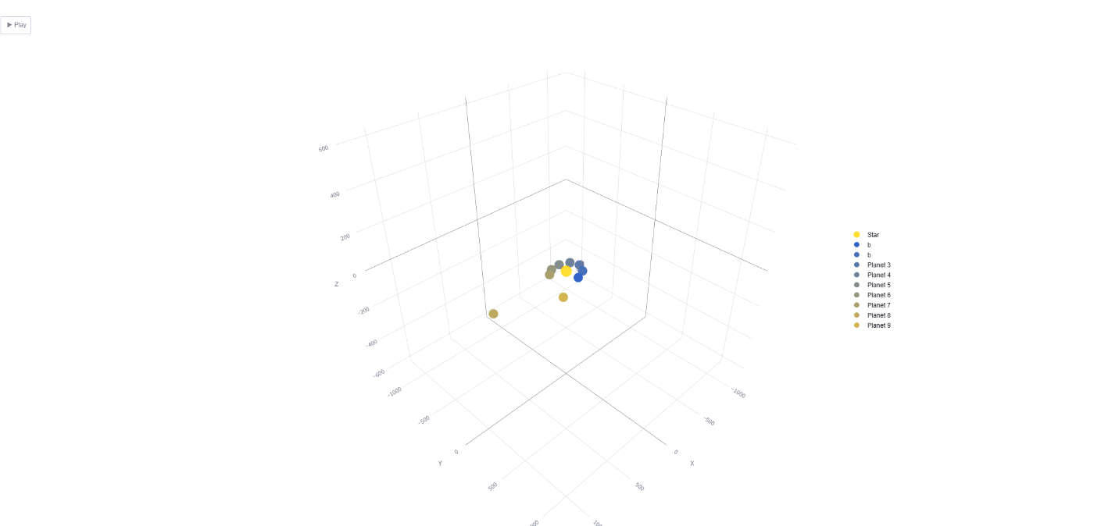
https://resonancex-exoplanets.streamlit.app/

References
[1] Murray, C. D., & Dermott, S. F. (1999). Solar System Dynamics. Cambridge University Press. [2] Lithwick, Y., & Wu, Y. (2012). Resonant Repulsion of Kepler Planet Pairs. The Astrophysical Journal Letters, 756(2), L11. [3] Malhotra, R. (1993). The Origin of Pluto's Orbit: Implications for the Solar System Beyond Neptune. Nature, 365, 819–821. [4] Luger, R. et al. (2017). A seven-planet resonant chain in TRAPPIST-1. Nature Astronomy, 1, 0129. [5] Fabrycky, D. C. et al. (2014). Architecture of Kepler’s Multi-transiting Systems. The Astrophysical Journal, 790(2), 146. [6] Tamayo, D. et al. (2017). Convergent Migration Renders TRAPPIST-1 Long-lived. The Astrophysical Journal Letters, 840(2), L19

