

**Project-Object Oriented Programming**

Kartish was the head of department for sports and games in a college. He wants to create an application for students to register for the sports they’re interested in to participate without any extra paperwork. Help Kartish in making this possible by using GUI. Events included: Basketball, Volleyball, Badminton, Tennis, Table tennis. Each game can have single or double participation if availabale

**Progrram:**

import javax.swing.*;

import java.awt.*;

import java.awt.event.*;

import java.sql.*;

import java.util.*;

class RegistrationForm extends JFrame implements ItemListener

{

static JFrame f;

static JLabel l;

// combobox

static JComboBox c1;

public static void main(String [] args) throws Exception

{

f=new JFrame();

Container c;

JLabel title,name,mno,gender,add,res;

JTextField tname,tmno;

JRadioButton male,female;

ButtonGroup gengp;

JTextArea tadd,resadd,tout;

JCheckBox term;

JButton sub,reset;

f.setTitle("RegistrationForm");

f.setBounds(200,80,1150,700);

f.setDefaultCloseOperation(JFrame.EXIT_ON_CLOSE);

f.setResizable(false);

c=f.getContentPane();

c.setLayout(null);

//label-title

title=new JLabel("RegistrationForm");

title.setFont(new Font("Arial",Font.PLAIN,30));

title.setSize(400,30);

title.setLocation(420,20);

c.add(title);

//label-name

name=new JLabel("Name");

name.setFont(new Font("Arial",Font.PLAIN,30));

name.setSize(200,30);

name.setLocation(50,70);

c.add(name);

//label-mno

mno=new JLabel("ID Number");

mno.setFont(new Font("Arial",Font.PLAIN,30));

mno.setSize(300,30);

mno.setLocation(50,120);

c.add(mno);

//TextField-name

tname=new JTextField();

tname.setFont(new Font("Arial",Font.PLAIN,30));

tname.setSize(120,30);

tname.setLocation(275,70);

c.add(tname);

//TextField-mno

tmno= new JTextField();

tmno.setFont(new Font("Arial",Font.PLAIN,30));

tmno.setSize(120,30);

tmno.setLocation(275,120);

c.add(tmno);

//Label-Gender

gender= new JLabel("Gender");

gender.setFont(new Font("Arial",Font.PLAIN,30));

gender.setSize(300,30);

gender.setLocation(50,170);

c.add(gender);

//RadioButton-male

male=new JRadioButton("male");

male.setFont(new Font("Arial",Font.PLAIN,30));

male.setSelected(true);

male.setSize(100,20);

male.setLocation(255,170);

c.add(male);

//RadioButton-female

female=new JRadioButton("female");

female.setFont(new Font("Arial",Font.PLAIN,30));

female.setSelected(true);

female.setSize(200,20);

female.setLocation(395,170);

c.add(female);

//ButtonGroup

gengp=new ButtonGroup();

gengp.add(male);

gengp.add(female);

//Label address

add=new JLabel("Address");

add.setFont(new Font("Arial",Font.PLAIN,30));

add.setSize(3500,30);

add.setLocation(50,230);

c.add(add);

//TextArea-address

tadd=new JTextArea();

tadd.setFont(new Font("Arial",Font.PLAIN,30));

tadd.setSize(300,30);

tadd.setLocation(275,230);

tadd.setLineWrap(true);

c.add(tadd);

//Checkbox- terms and conditionn

term= new JCheckBox("Accept Terms and conditions");

term.setFont(new Font("Arial",Font.PLAIN,30));

term.setSize(450,20);

term.setLocation(110,320);

c.add(term);

//Button-Reset

reset=new JButton("Reset");

reset.setFont(new Font("Arial",Font.PLAIN,30));

reset.setSize(150,25);

reset.setLocation(370,410);

c.add(reset);

//Button-submit

sub=new JButton("Submit");

sub.setFont(new Font("Arial",Font.PLAIN,30));

sub.setSize(150,25);

sub.setLocation(100,410);

c.add(sub);

//Label-result

res=new JLabel("");

res.setFont(new Font("Arial",Font.PLAIN,30));

res.setSize(500,30);

res.setLocation(50,515);

c.add(res);

//TextArea- result

resadd=new JTextArea();

resadd.setFont(new Font("Arial",Font.PLAIN,30));

resadd.setSize(200,30);

resadd.setLocation(275,510);

c.add(resadd);

//Printing details

tout=new JTextArea();

tout.setFont(new Font("Arial",Font.PLAIN,30));

tout.setSize(450,500);

tout.setLocation(650,80);

tout.setLineWrap(true);

tout.setEditable(false);

f.setVisible(true);

c.add(tout);

//ActionListener for submit button

sub.addActionListener(new ActionListener()

{

public void actionPerformed(ActionEvent e)

{

if(term.isSelected())

{

String data,data1,data2,data3;

data="Name:"+tname.getText() + "\n" + "ID Number:"+tmno.getText() + "\n";

if(male.isSelected())

data1="Gender:"+male.getText() + "\n";

else

data1="Gender:"+female.getText() + "\n";

data2="Address:"+tadd.getText()+"\n";

data3="Sports:"+c1.getSelectedItem();

tout.setText(data+data1+data2+data3);

tout.setEditable(false);

res.setText("Registration successfully....");

}

else

{

// resadd.setText("null");

tout.setText("Please accept the terms and conditions");

}

}});

reset.addActionListener(new ActionListener()

{

public void actionPerformed(ActionEvent e)

{

tname.setText("");

tadd.setText("");

tmno.setText("");

res.setText("");

tout.setText("");

term.setSelected(false);

//resadd.setText("");

}

});

RegistrationForm s = new RegistrationForm();

// array of string contating cities

String s1[] = { "Kabaddi", "Cricket", "Volley Ball", "Basket Ball", "Hockey" };

// create checkbox

c1 = new JComboBox(s1);

// add ItemListener

c1.addItemListener(s);

// create labels

l = new JLabel("select your game ");

// set color of text

l.setForeground(Color.red);

f.add(l);

// add combobox to panel

f.add(c1);

l.setSize(150,25);

l.setLocation(100,450);

c1.setSize(150,25);

c1.setLocation(100,470);

}

public void itemStateChanged(ItemEvent e)

{

}

}

**Output:**

**Before Entering Of Data**

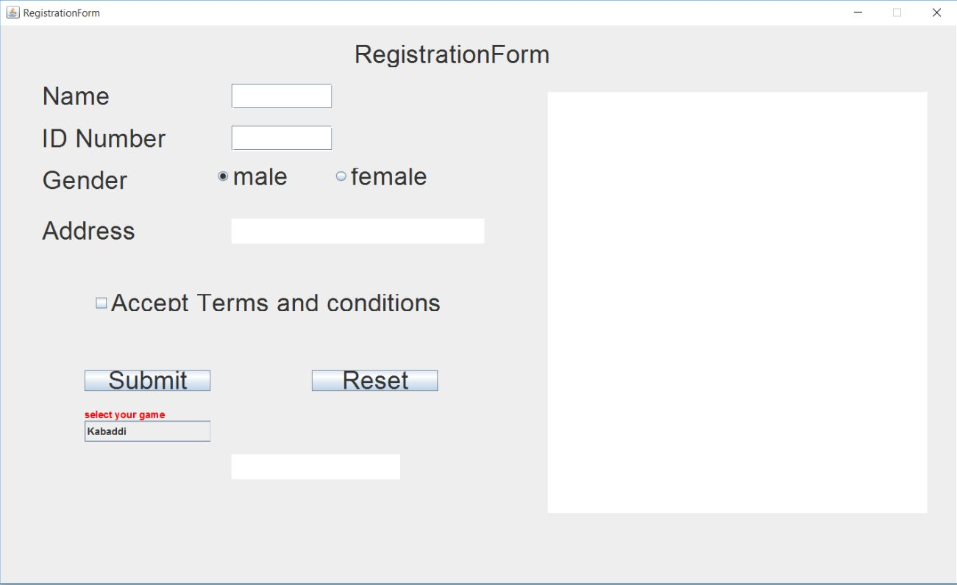

**After Entering Of Data**

