Script Controlled ACL
Restrict Record Access Based on Field Values

1. Brainstorming & Ideation Phase Objective
The objective of the brainstorming and ideation phase is to identify a practical record-security problem in ServiceNow and propose a solution using a Scripted Access Control List (ACL). The project is based on restricting access to records according to the values stored in selected fields. The idea is to make record access more specific than simple role-based permission checks.
Activities Performed
- Identify the requirement for restricting selected records instead of giving the same access to every user.
- Study how a field value can be used as a condition for deciding whether a record should be accessible.
- Identify the ServiceNow table and the field whose value will control access.
- Consider different user scenarios such as permitted records, restricted records, and records with other field values.
- Identify Scripted ACL as the suitable security mechanism for evaluating record information dynamically.
- Define the basic access decision: when the field value satisfies the configured condition, access is allowed; otherwise, access is restricted.
- Discuss the need for positive and negative test cases before final implementation.
- Plan to document the ACL configuration, script logic, screenshots, and testing results.
Implementation / Detailed Description
In this phase, the project is handled in a structured manner so that the security requirement can be clearly configured and verified. The selected record field acts as an important input to the access decision. The ACL evaluates the current record during the access request and applies the configured condition. This approach makes it possible to distinguish between records that satisfy the security rule and records that do not satisfy it. The configuration should be validated carefully so that only the intended records are restricted.
Expected / Produced Output
The expected output of this phase is a clearly defined project idea: use a Scripted ACL to restrict record access based on field values. The idea provides the foundation for the requirement, design, implementation, and testing phases.
Screenshots / Evidence
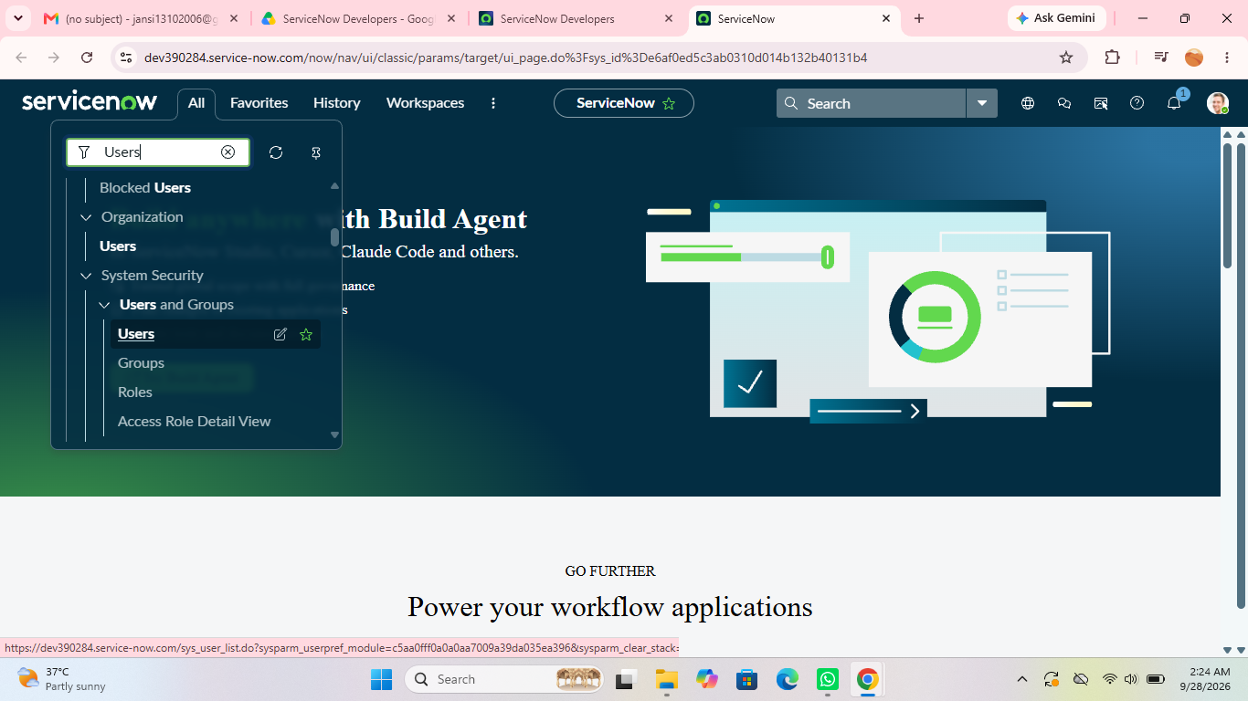

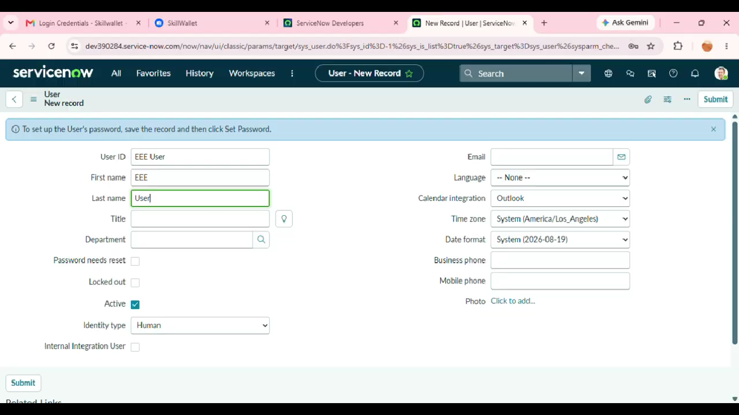

Result
The phase is completed after the configured activity is verified against the project requirement. The screenshots and test observations can be inserted in the spaces provided above as implementation evidence.

