Script Controlled ACL
Restrict Record Access Based on Field Values

2. Requirement Analysis Phase Objective
The requirement analysis phase identifies what the Scripted ACL must protect, who will access the records, which field will be evaluated, and what result should occur for different field values. This phase converts the initial idea into clear functional and security requirements.
Activities Performed
- Identify the target ServiceNow table containing the records that need protection.
- Identify the field that will be used as the access-control condition.
- Define the field value or values that should permit access.
- Define the field values for which access should be restricted.
- Identify the ACL operation, such as Read or Write, that needs to be controlled.
- Identify the users, roles, or test accounts used to verify the ACL behaviour.
- Define the expected result when the record satisfies the condition.
- Define the expected result when the record does not satisfy the condition.
- Prepare positive test cases for allowed access and negative test cases for denied access.
- Identify the documentation and screenshot evidence required for the final project.
Implementation / Detailed Description
In this phase, the project is handled in a structured manner so that the security requirement can be clearly configured and verified. The selected record field acts as an important input to the access decision. The ACL evaluates the current record during the access request and applies the configured condition. This approach makes it possible to distinguish between records that satisfy the security rule and records that do not satisfy it. The configuration should be validated carefully so that only the intended records are restricted.
Expected / Produced Output
The produced requirement is a clear security workflow: User requests access → ACL is evaluated → Script checks the record field value → Condition satisfied: access allowed → Condition not satisfied: access restricted.
Screenshots / Evidence:
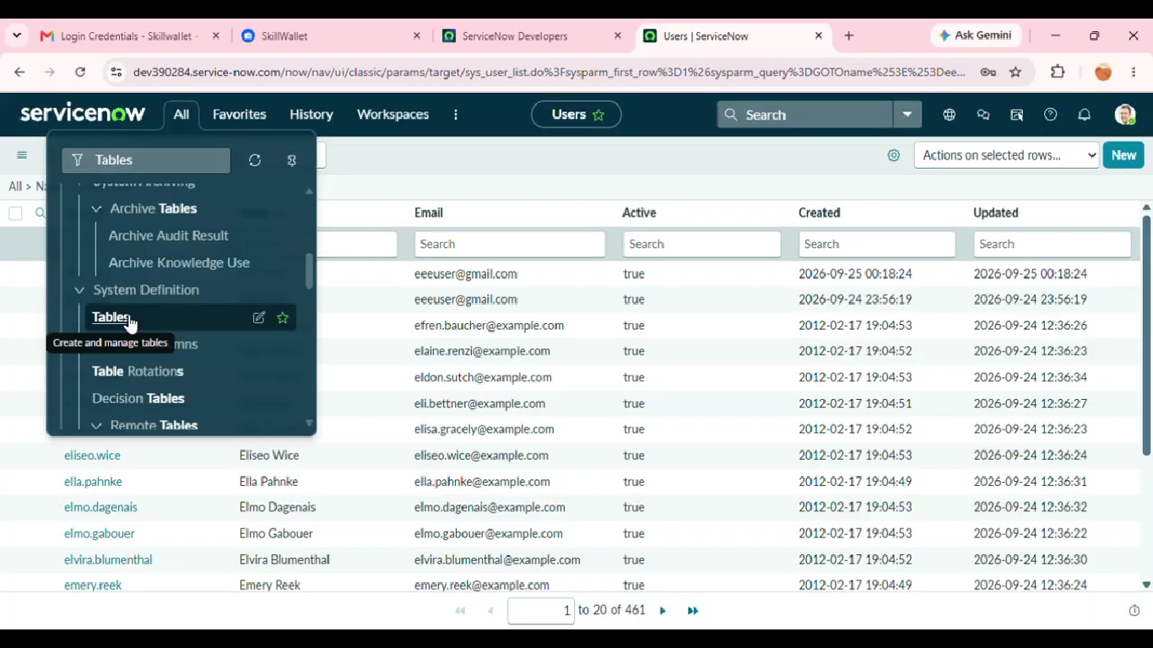

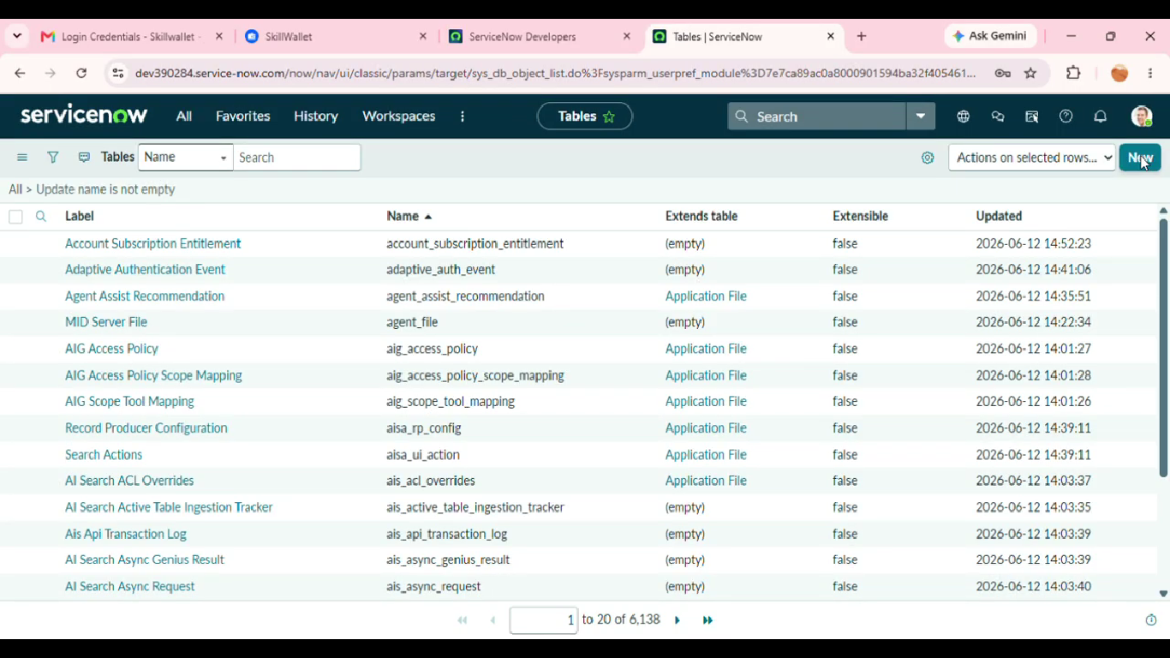

Result
The phase is completed after the configured activity is verified against the project requirement. The screenshots and test observations can be inserted in the spaces provided above as implementation evidence.

