Script Controlled ACL
Restrict Record Access Based on Field Values

3. Project Design Phase
objective
The project design phase converts the requirements into a logical security structure. The design explains how the ACL will be triggered, what information will be checked, how the script will make the decision, and how the result will be observed during testing.
Activities Performed
- Select the ServiceNow table where the ACL will be applied.
- Select the appropriate ACL operation such as Read or Write.
- Identify the exact field that will control record access.
- Define the permitted field value or values.
- Design the script to inspect the current record during ACL evaluation.
- Design the condition so that the script returns a successful access result when the field value matches the requirement.
- Design the restriction path for records whose field value does not satisfy the requirement.
- Plan test records containing both permitted and non-permitted field values.
- Plan the screenshots required to prove ACL configuration and execution.
- Define the final demonstration sequence from record access request to access decision.
Implementation / Detailed Description
In this phase, the project is handled in a structured manner so that the security requirement can be clearly configured and verified. The selected record field acts as an important input to the access decision. The ACL evaluates the current record during the access request and applies the configured condition. This approach makes it possible to distinguish between records that satisfy the security rule and records that do not satisfy it. The configuration should be validated carefully so that only the intended records are restricted.
Expected / Produced Output
The high-level design is: User Access Request → Scripted ACL Trigger → Current Record Evaluation → Field Value Comparison → Allow Access / Restrict Access.
Screenshots / Evidence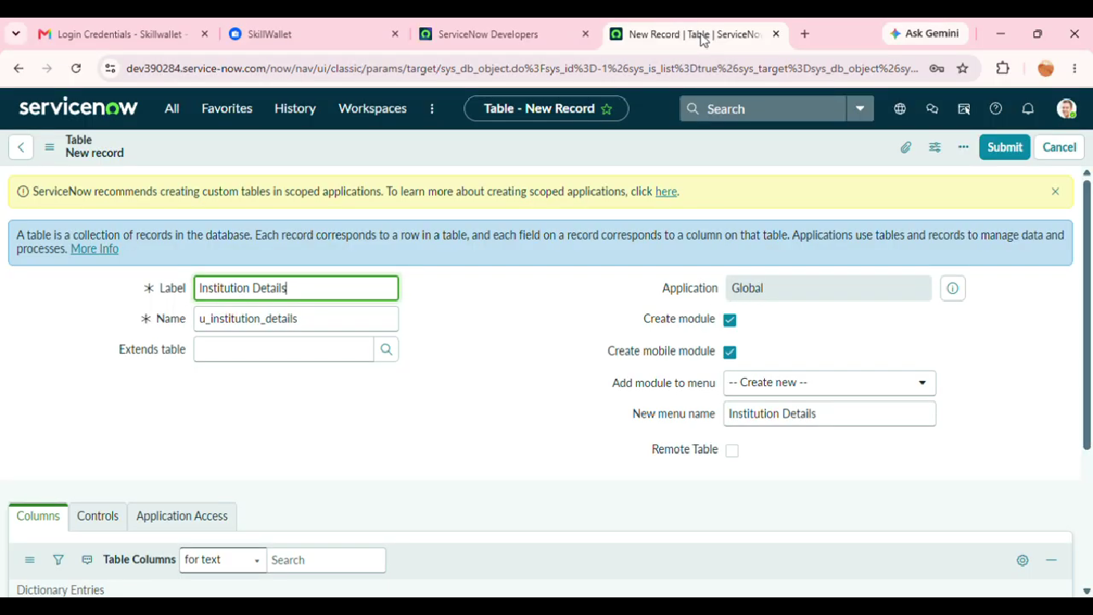

Result
The phase is completed after the configured activity is verified against the project requirement. The screenshots and test observations can be inserted in the spaces provided above as implementation evidence.

