Script Controlled ACL
Restrict Record Access Based on Field Values

5. Project Development Phase
Objective
The development phase implements the Scripted ACL in ServiceNow. The ACL is configured for the required table and operation, and a script is used to evaluate the selected field value. The script controls whether the current record can be accessed according to the project requirement.
Activities Performed
- Open the required ServiceNow table and verify the records used for testing.
- Create the Access Control rule for the required table and operation.
- Configure the required table, operation, and any applicable roles or conditions.
- Identify the field whose value will control record access.
- Add the Scripted ACL logic to evaluate the current record.
- Compare the selected field value with the permitted value defined in the requirement.
- Configure the script logic to allow access when the condition is satisfied.
- Configure the script logic to restrict access when the condition is not satisfied.
- Save the ACL configuration.
- Validate the ACL configuration and check for configuration or script errors.
- Test the configuration using records with different field values.
- Capture screenshots showing the ACL configuration and working result.
Implementation / Detailed Description
In this phase, the project is handled in a structured manner so that the security requirement can be clearly configured and verified. The selected record field acts as an important input to the access decision. The ACL evaluates the current record during the access request and applies the configured condition. This approach makes it possible to distinguish between records that satisfy the security rule and records that do not satisfy it. The configuration should be validated carefully so that only the intended records are restricted.
Expected / Produced Output
The produced output is a working Scripted ACL. It evaluates the selected record field and provides the configured access decision according to the field value.
Screenshots / Evidence
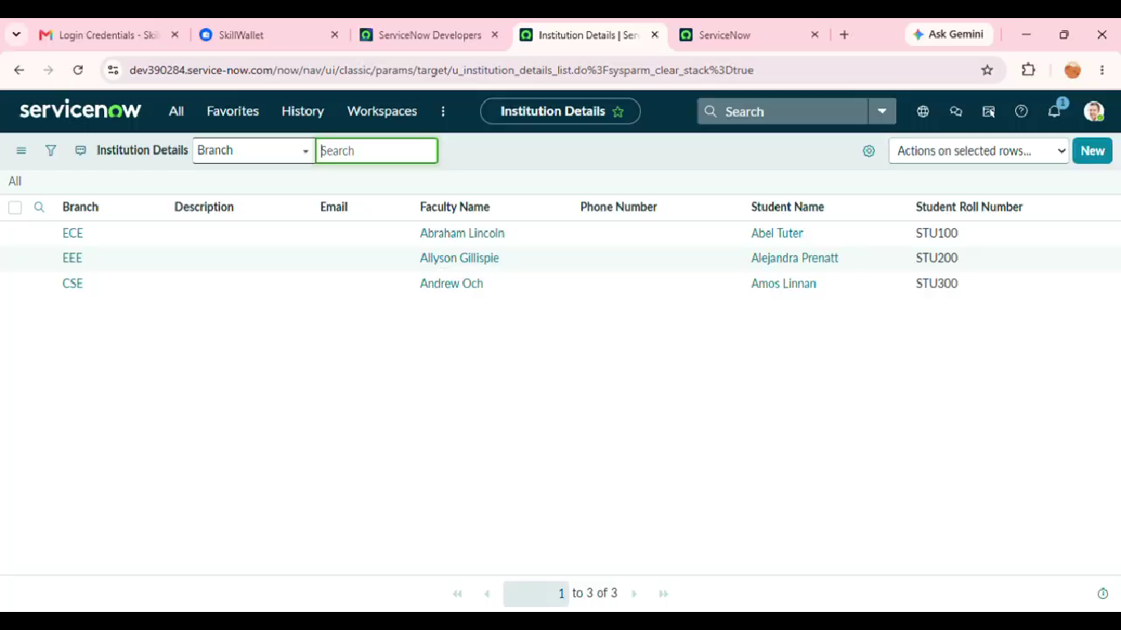
Result
The phase is completed after the configured activity is verified against the project requirement. The screenshots and test observations can be inserted in the spaces provided above as implementation evidence.

