Script Controlled ACL
Restrict Record Access Based on Field Values

6. Project Testing Phase
Objective
The testing phase verifies that the Scripted ACL behaves correctly for different record conditions. Testing is performed using records with permitted and restricted field values so that both successful and denied access scenarios can be demonstrated.
Activities Performed
- Test a record containing the permitted field value.
- Verify that the intended user can access the record when the condition is satisfied.
- Test a record containing a different or restricted field value.
- Verify that access is restricted when the condition is not satisfied.
- Test the selected ACL operation separately where required.
- Verify that records that should remain accessible are not incorrectly blocked.
- Verify that records that should be restricted are not unintentionally exposed.
- Test the ACL with the intended user or role configuration.
- Check whether the ACL produces the expected behaviour consistently.
- Record the expected and observed results for each test case.
- Identify and correct configuration or script issues if a test fails.
- Repeat the tests after corrections and capture final evidence.
Implementation / Detailed Description
In this phase, the project is handled in a structured manner so that the security requirement can be clearly configured and verified. The selected record field acts as an important input to the access decision. The ACL evaluates the current record during the access request and applies the configured condition. This approach makes it possible to distinguish between records that satisfy the security rule and records that do not satisfy it. The configuration should be validated carefully so that only the intended records are restricted.
Expected / Produced Output
The expected testing result is that permitted records follow the allowed-access path, while records that fail the field-value condition follow the restricted-access path. The final test evidence confirms the intended ACL behaviour.
Screenshots / Evidence
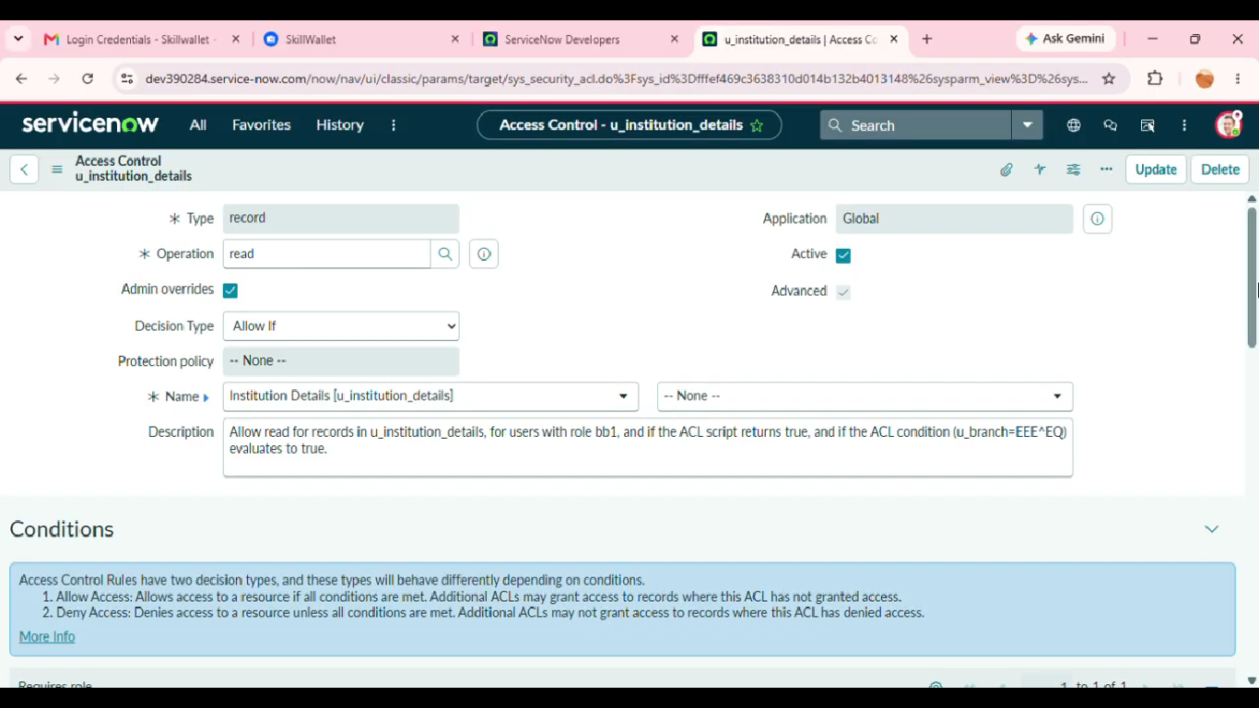
Result
The phase is completed after the configured activity is verified against the project requirement. The screenshots and test observations can be inserted in the spaces provided above as implementation evidence.

