Script Controlled ACL
Restrict Record Access Based on Field Values

7. Project Documentation Phase
Objective
The documentation phase records the complete project process in a structured format. It provides evidence of the requirement, design, ACL configuration, script logic, testing, and final outcome so that the implementation can be explained and reproduced.
Activities Performed
- Document the project title and objective.
- Document the problem statement and reason for using field-value-based access control.
- Document the table, field, ACL operation, and access condition.
- Describe the project requirements in a clear sequence.
- Document the design of the Scripted ACL.
- Explain the role of the script in evaluating the record field.
- Document the ACL configuration and important settings.
- Include screenshots showing the ACL configuration.
- Include screenshots showing permitted and restricted access results.
- Document positive and negative test scenarios.
- Record observed results and any corrections made during testing.
- Document the final outcome and possible future enhancements.
Implementation / Detailed Description
In this phase, the project is handled in a structured manner so that the security requirement can be clearly configured and verified. The selected record field acts as an important input to the access decision. The ACL evaluates the current record during the access request and applies the configured condition. This approach makes it possible to distinguish between records that satisfy the security rule and records that do not satisfy it. The configuration should be validated carefully so that only the intended records are restricted.
Expected / Produced Output
The produced documentation provides a reusable record of the Scripted ACL implementation, including requirements, design, development, testing evidence, and final outcome.
Screenshots / Evidence
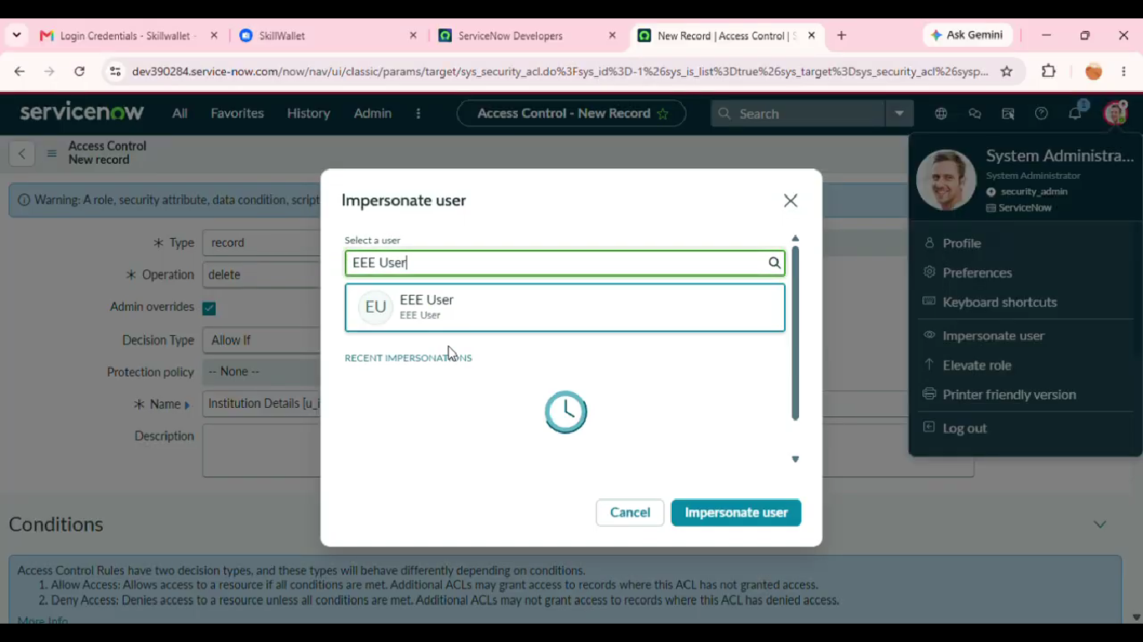
Result
The phase is completed after the configured activity is verified against the project requirement. The screenshots and test observations can be inserted in the spaces provided above as implementation evidence

