Script Controlled ACL
Restrict Record Access Based on Field Values

8. Project Demonstration Phase
Objective
The demonstration phase presents the completed Scripted ACL project from beginning to end. The demonstration explains the security requirement, shows the configuration, and proves that access changes according to the value stored in the selected field.
Activities Performed
- Introduce the project title and explain the objective.
- Explain the need for restricting record access based on field values.
- Show the target ServiceNow table and relevant records.
- Identify the field used as the access-control condition.
- Show the configured Scripted ACL and selected operation.
- Explain the script logic in simple terms.
- Open or attempt to access a record whose field value satisfies the condition.
- Demonstrate that the permitted record can be accessed.
- Attempt to access a record whose field value does not satisfy the condition.
- Demonstrate that the restricted record is not accessible as configured.
- Show screenshots or test evidence for both scenarios.
- Summarize the final result and possible future enhancements.
Implementation / Detailed Description
In this phase, the project is handled in a structured manner so that the security requirement can be clearly configured and verified. The selected record field acts as an important input to the access decision. The ACL evaluates the current record during the access request and applies the configured condition. This approach makes it possible to distinguish between records that satisfy the security rule and records that do not satisfy it. The configuration should be validated carefully so that only the intended records are restricted.
Expected / Produced Output
The final demonstration should show a complete security lifecycle: Record Access Request → ACL Evaluation → Field Value Check → Access Granted or Access Restricted.

Screenshots / Evidence

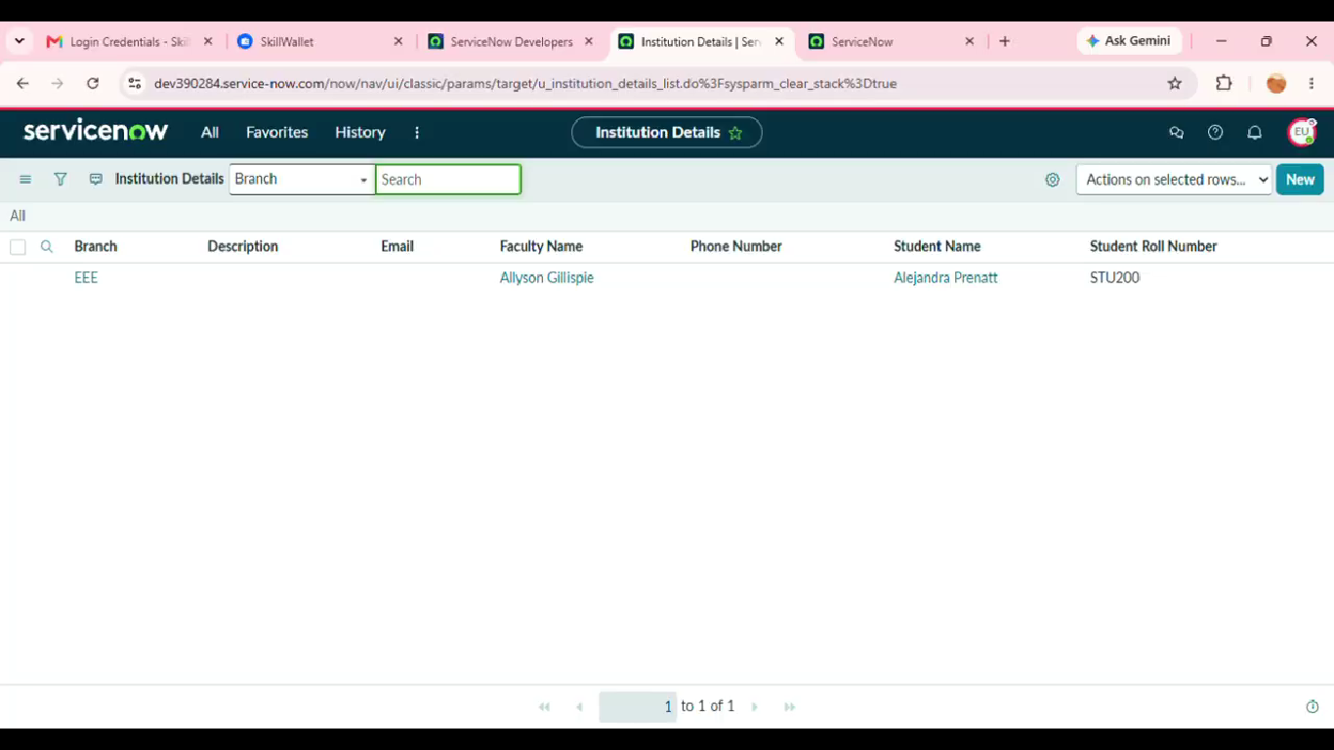
Result
The phase is completed after the configured activity is verified against the project requirement. The screenshots and test observations can be inserted in the spaces provided above as implementation evidence.

