Script Controlled ACL - Restrict Record Access Based on Field Values
A Project Report Submitted in Partial Fulfillment of the Requirement for the Award of the Degree in
BACHELOR OF COMPUTER APPLICATIONS
Submitted by
V. Sugi Brighty 24082070500112142
A . Ashika 24082070500112105
S . Selva Muthu Mari 24082070500112136


Govindammal Aditanar College for women
Tiruchendur - 628215
(Affiliated to Manonmaniam Sundaranar University, Tirunelveli)

DECLARATION

I hereby declare that the project titled “Script Controlled ACL - Restrict Record Access Based on Field Values” is an academic project carried out to understand and implement record-level access control using ServiceNow Access Control Lists (ACLs) and scripting.
The project focuses on restricting access to records based on field values. The implementation demonstrates how a scripted ACL can evaluate record data and allow or deny access according to the configured business rule.

ABSTRACT

The project “Script Controlled ACL - Restrict Record Access Based on Field Values” focuses on implementing field-value-based record security in ServiceNow. Access Control Lists (ACLs) are used to control whether users can read or modify records. In this project, a scripted ACL checks a selected field value in a record and decides whether access should be granted.
The main purpose of the project is to demonstrate how scripting can make access control more flexible than a simple role-based condition. The ACL evaluates the record at runtime and permits or restricts access according to the configured field value. The final output demonstrates controlled record access using a Scripted ACL.

Table Of Contents

S. No. | Phase | Page No.
1 | Brainstorming & Ideation Phase | 1
2 | Requirement Analysis Phase | 3
3 | Project Design Phase | 4
4 | Project Planning Phase | 6
5 | Project Development Phase | 8
6 | Project Testing Phase | 10
7 | Project Documentation Phase | 11
8 | Project Demonstration Phase | 13
9 | Conclusion | 14

1. Brainstorming & Ideation Phase
Objective
To identify a practical ServiceNow security requirement and propose a scripted ACL solution for restricting record access based on field values.
Activities Performed
- The project idea was developed around controlling access to records according to the value stored in a selected field.
- The need for field-level or record-level restrictions was considered in addition to normal role-based access.
- A Scripted ACL was identified as a suitable approach because it can evaluate record data before granting access.
- The proposed solution focuses on a clear and testable field-value condition.
Expected / Produced Output
The project concept: when a user attempts to access a protected record, the ACL evaluates the configured field value and allows or denies access accordingly.
Screenshots:
____________________________________________________________
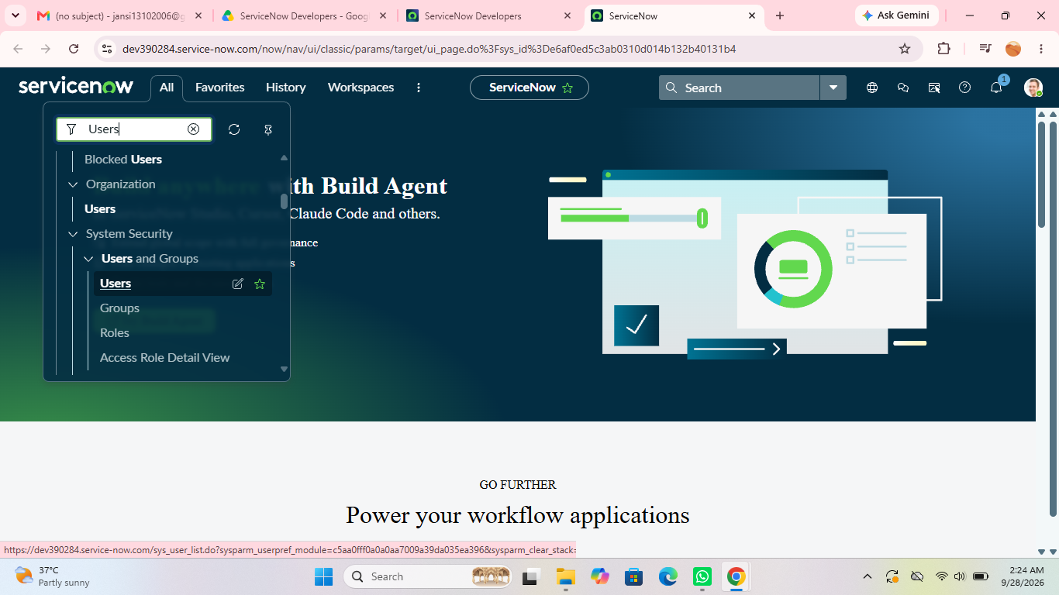

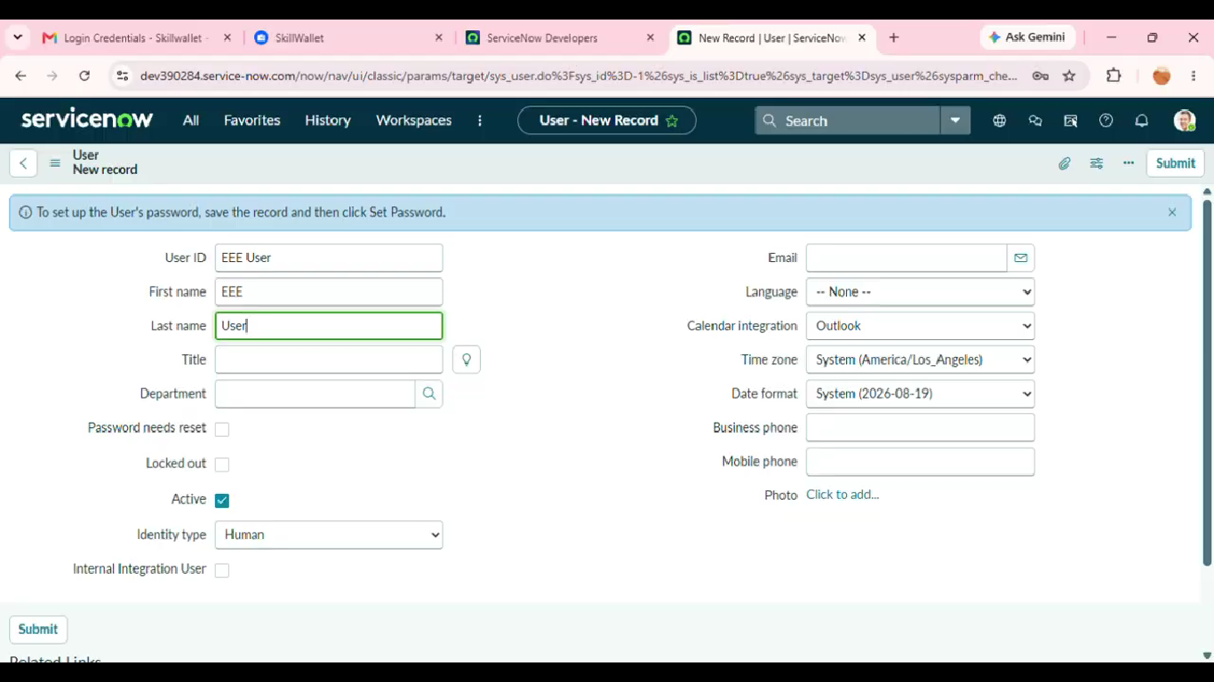
2. Requirement Analysis Phase
Objective
To understand the users, protected records, field values, ACL type, access operation, and expected security behaviour.
Activities Performed
- Identify the table and records that require protection.
- Identify the field whose value will control access.
- Define the field values that should permit or restrict access.
- Determine the ACL operation, such as read, write, create, or delete.
- Identify the roles or users involved in testing access.
- Define positive and negative access scenarios.
Expected / Produced Output
The requirement analysis results in a clear security rule: User Request → ACL Evaluation → Field-Value Check → Allow Access / Deny Access.
Screenshots:

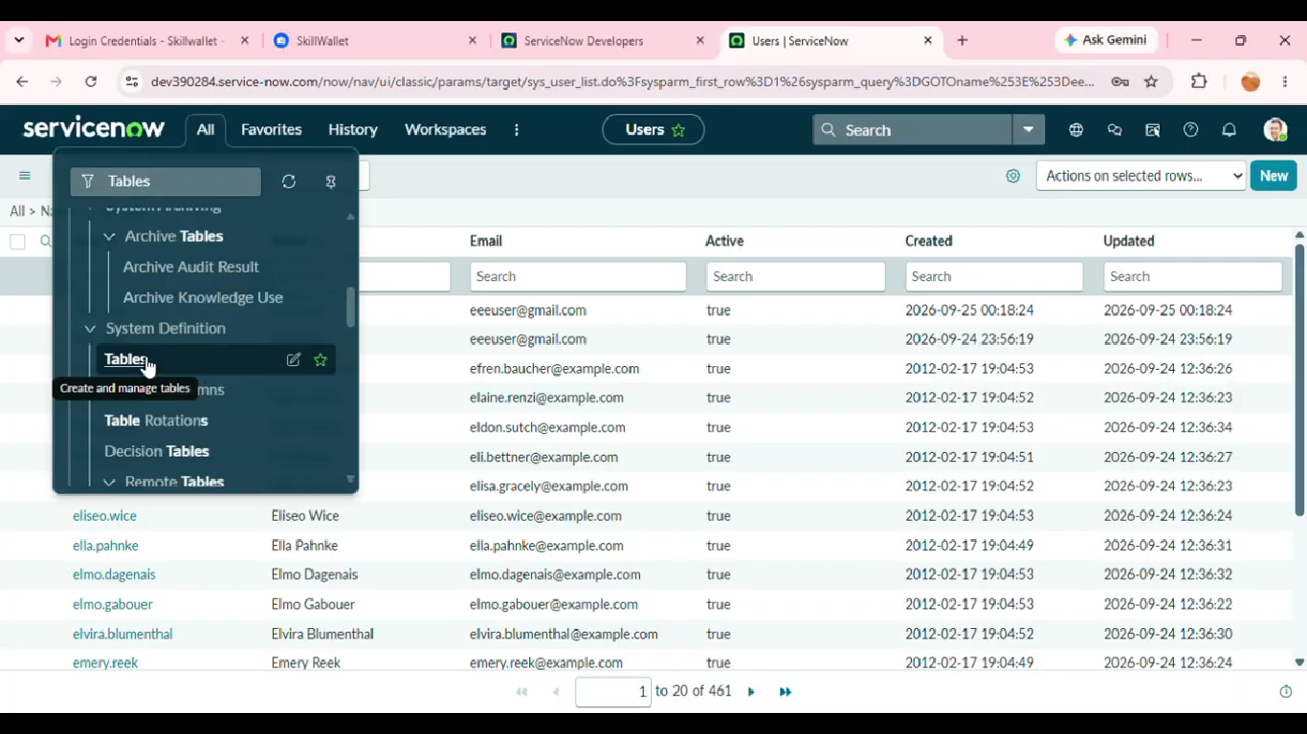_____________________________
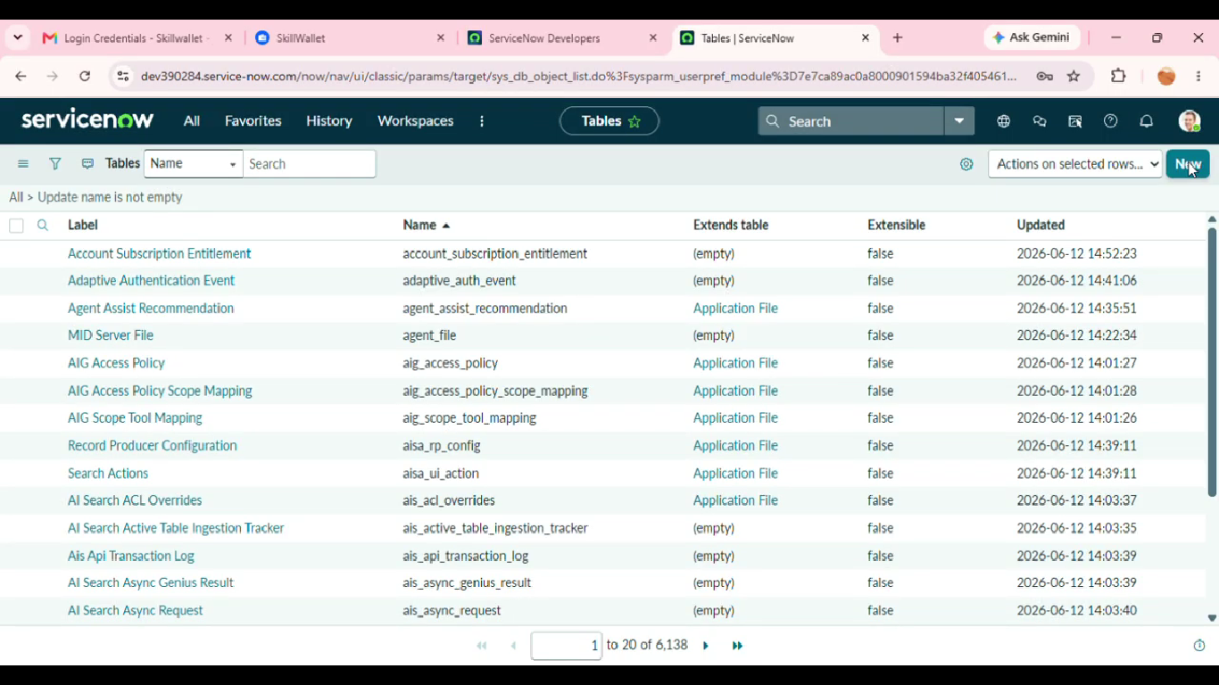
3. Project Design Phase
Objective
To design the logical security rule before implementing the Scripted ACL in ServiceNow.
Activities Performed
- Select the target table and ACL operation.
- Define the field used for the access decision.
- Design the condition that compares the record field value with the permitted value.
- Plan the scripted logic using the current record.
- Define the expected result for matching and non-matching field values.
- Plan test users and sample records for validation.
Expected / Produced Output
High-level security design: User Access Request → ACL Trigger → Script Checks Field Value → Access Granted or Access Denied.
Screenshots:
____________________________________________________________
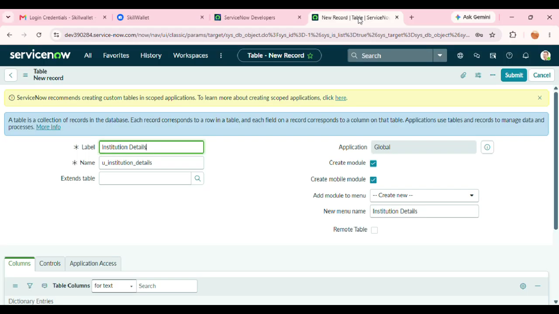

4. Project Planning Phase
Objective
To organize the ACL implementation into manageable activities and define the sequence of work.
Activities Performed
- Review the project objective and finalize the access-control scope.
- Prepare the required ServiceNow table, records, users, and roles.
- Select the field that controls record access.
- Create the ACL with the required operation.
- Configure the scripted condition and prepare test data.
- Prepare positive and negative test scenarios.
- Capture screenshots and prepare the final documentation.
Expected / Produced Output
The planned implementation follows a structured sequence from environment preparation to ACL development, testing, documentation, and demonstration.
Screenshots:
____________________________________________________________
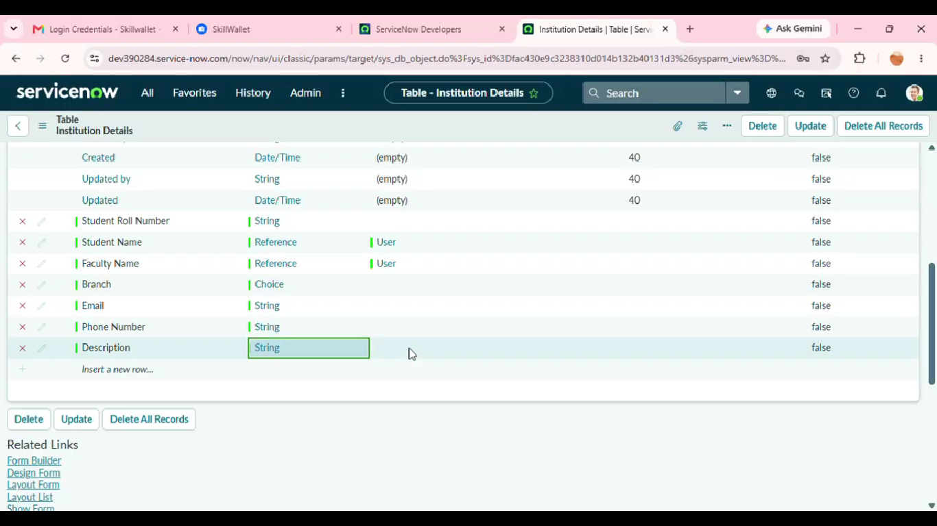

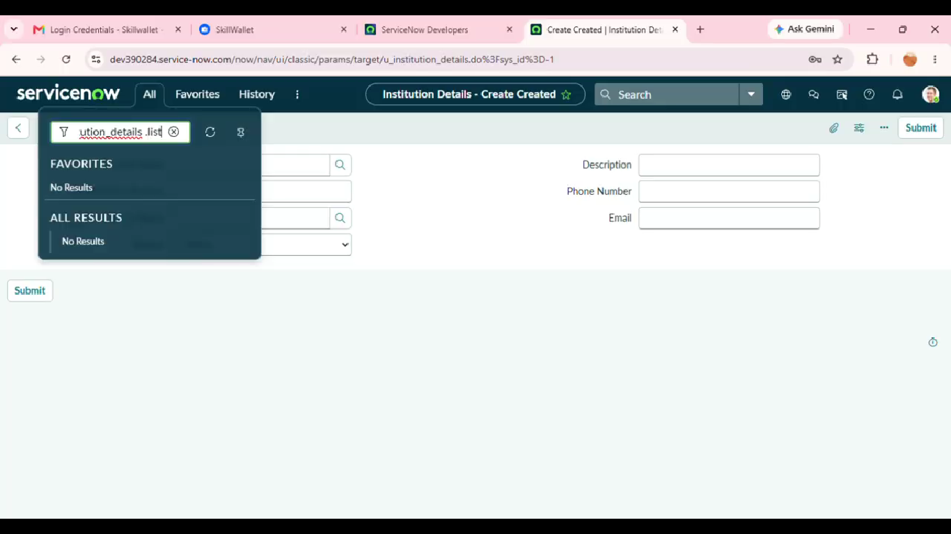
5. Project Development Phase
Objective
To implement the Scripted ACL in ServiceNow and enforce record access based on a field value.
Activities Performed
- Open the required table and identify the record field used for access control.
- Create the appropriate Access Control rule for the required operation.
- Configure the required table, field, operation, and roles if applicable.
- Add the script that checks the value of the selected field.
- Configure the script to return true when the access condition is satisfied.
- Configure the script to return false when the access condition is not satisfied.
- Save and validate the ACL configuration.
- Test the ACL with records having different field values.
Expected / Produced Output
A working Scripted ACL that grants access for the configured field value and restricts access when the condition is not satisfied.
Screenshots:
____________________________________________________________
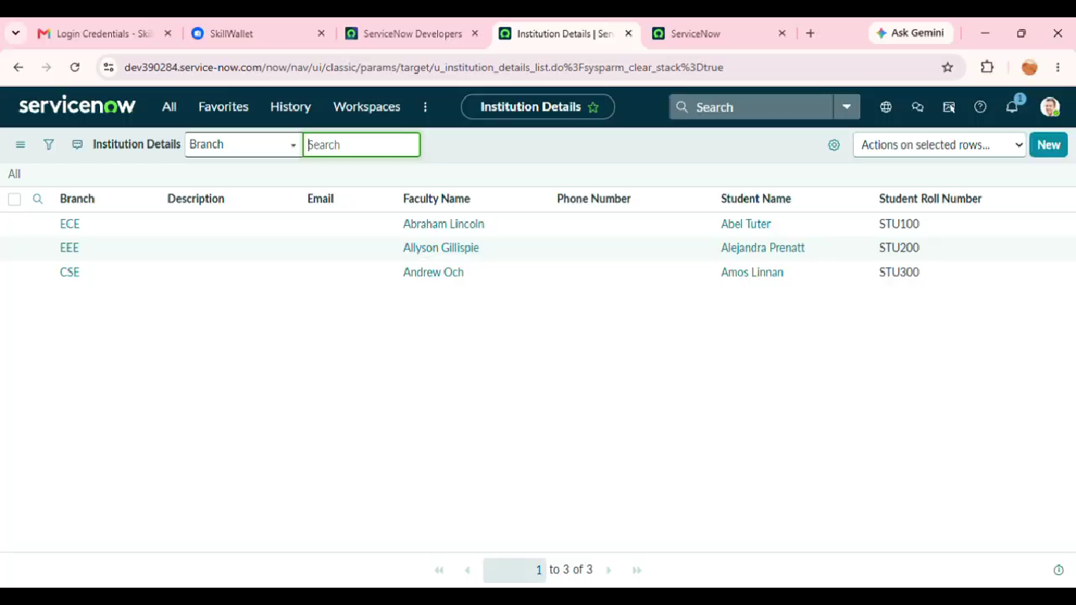
6. Project Testing Phase
Objective
To verify that the Scripted ACL correctly allows and restricts access for different record conditions.
Activities Performed
- Test a record with the permitted field value.
- Verify that the user can access the record when the condition is satisfied.
- Test a record with a restricted or different field value.
- Verify that access is denied when the condition is not satisfied.
- Test the ACL with the selected operation such as Read or Write.
- Verify that unrelated records are not incorrectly blocked.
- Record issues and correct the ACL script or configuration before the final demonstration.
Expected / Produced Output
The ACL should grant access for valid test cases and restrict access for records that do not satisfy the configured field-value condition.
Screenshots:
____________________________________________________________
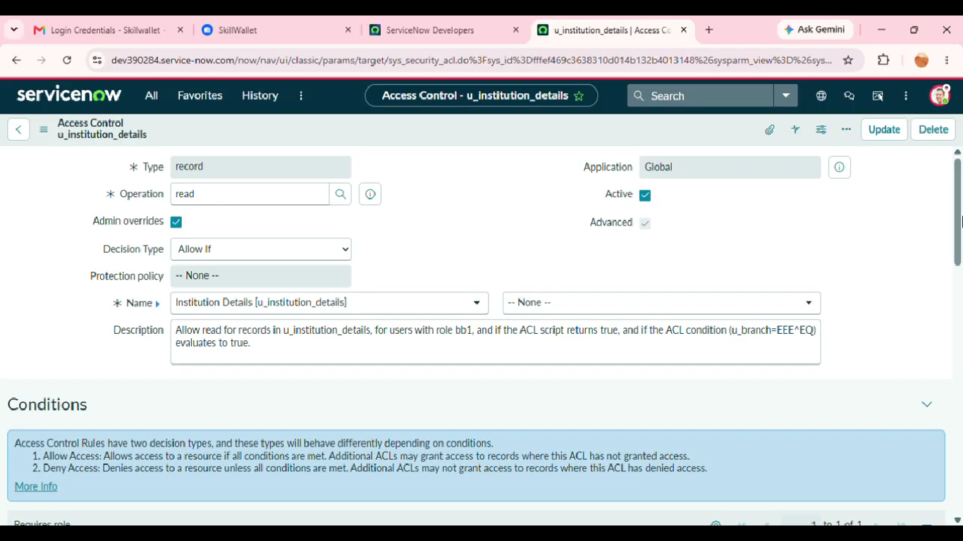
7. Project Documentation Phase
Objective
To record the complete ACL configuration, testing evidence, and final outcome in a clear and reusable format.
Activities Performed
- Document the project title, objective, scope, and problem statement.
- Document the requirements and field-value access rule.
- Describe the ACL design and scripted logic.
- Document the ServiceNow configuration and important security steps.
- Include screenshots as evidence for configuration and execution.
- Document positive and negative test scenarios and observed results.
- Record the final outcome, limitations, and possible future enhancements.
Expected / Produced Output
This document provides the phase-wise record of the Scripted ACL project and can be used as the final project documentation.
Screenshots:
____________________________________________________________
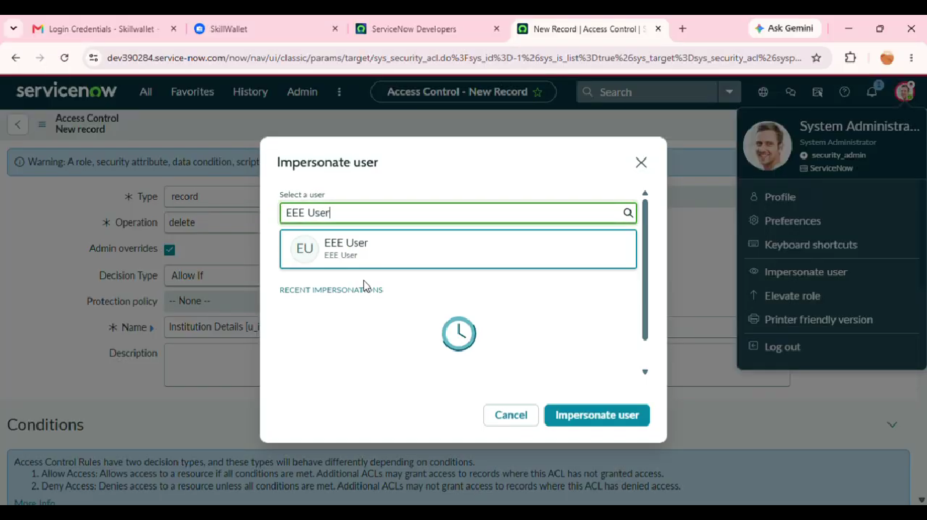
8. Project Demonstration Phase
Objective
To demonstrate the completed Scripted ACL and explain how field-value-based access control works.
Activities Performed
- Introduce the security problem and project objective.
- Show the target table and the field used for access control.
- Show the configured ACL and its operation.
- Explain the script condition in simple terms.
- Demonstrate access to a record whose field value satisfies the condition.
- Demonstrate restricted access to a record whose field value does not satisfy the condition.
- Show the test results and explain the difference between allowed and denied access.
Expected / Produced Output
The demonstration should show a complete access-control lifecycle from user request to ACL evaluation and final access decision.
Screenshots:

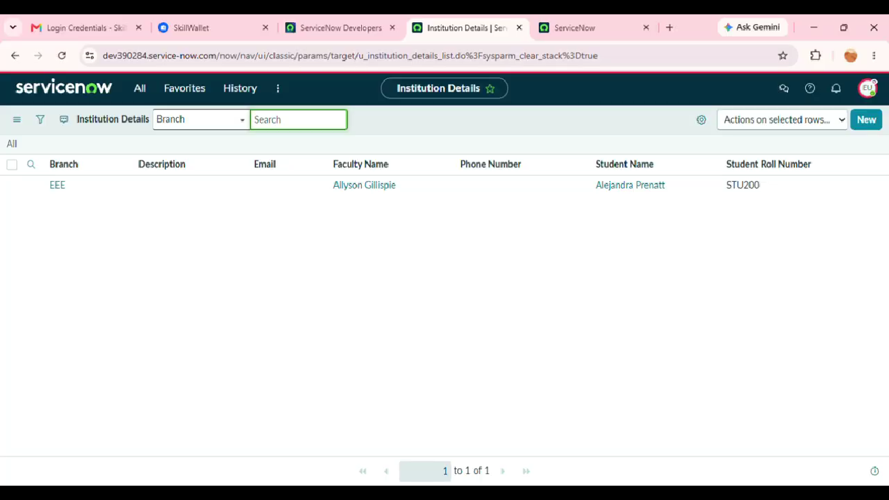
__________________________

9. Conclusion
The project demonstrates how ServiceNow Scripted ACLs can be used to restrict record access based on field values. By evaluating a record field during access control processing, the system can provide more specific security behaviour for different records.
The phase-wise approach covers idea generation, requirement analysis, design, planning, development, testing, documentation, and demonstration. The same approach can be extended to other tables, fields, and access operations where record-level security is required.
Future Enhancements
- Extend the ACL logic to support multiple field-value conditions.
- Combine field-value checks with user roles or groups for more detailed access control.
- Create separate ACLs for Read, Write, Create, and Delete operations where required.
- Add more test users and test records to validate different security scenarios.
- Improve the script logic with reusable security rules for larger applications.
- Maintain clear documentation of ACL conditions and security requirements.

