File Location: /etc/filebeat/filebeat-config.yml

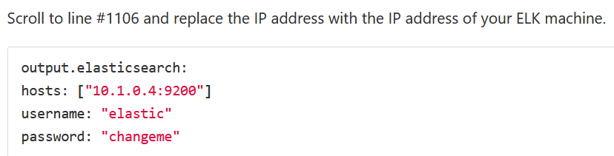

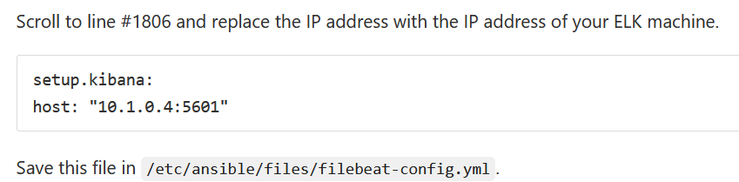

Run the file with this command:

ansible-playbook filebeat-playbook.yml.

To verify

Open http://[your.VM.IP]:5601/app/kibana on your browser go to step 5 and click check data.

