# **Project Title:** Personal Travel Blog on IBM Cloud Static Web Apps

This project involves designing the blog structure, creating appealing content, setting up the IBM Cloud Static Web Apps environment, and ensuring the blog's ease of maintenance and updates.

1. **Phase 1: Content Planning**
   * Define the blog's structure, including the following sections:
     + **Travel Stories:** Share personal travel experiences and narratives. Place they saw the miracles and architecture etc., sharing thrilling and excitements also sharing their food experience and climatic conditions of different places.
     + **Travel Tips:** Provide practical advice and tips for fellow travellers example: Beware of public wi-fi, Beware of surroundings ,keep your friends and family updated, make copies of important document, safeguard your hotel room etc.
     + **Photos Gallery:** Curate a visually appealing collection of travel photos which makes memory of visiting the place, the nature which brings silence, photo speaks more than words hence the collection of photos stay memory with us.
   * Plan content categories, tags, and navigation for seamless user experience.
2. **Phase 2: Content Creation**
   * Research and compile engaging travel stories from personal experiences.
   * Create informative and well-structured travel tips and advice articles.
   * Curate high-quality and captivating photos to accompany the content.
   * Ensure consistent voice and style across all blog posts.
3. **Phase 3: Website Design**
   * Design the blog layout using HTML and CSS, ensuring responsiveness.

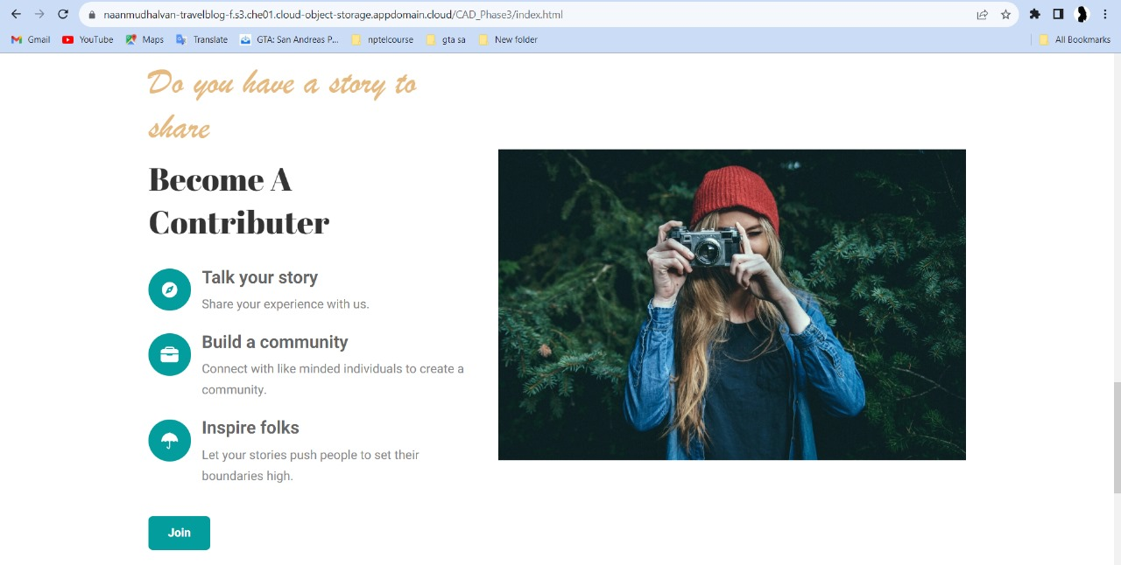

* + Implement interactive elements such as the interactive map using JavaScript.
  + Design an aesthetically pleasing and responsive layout for the blog using HTML and CSS.

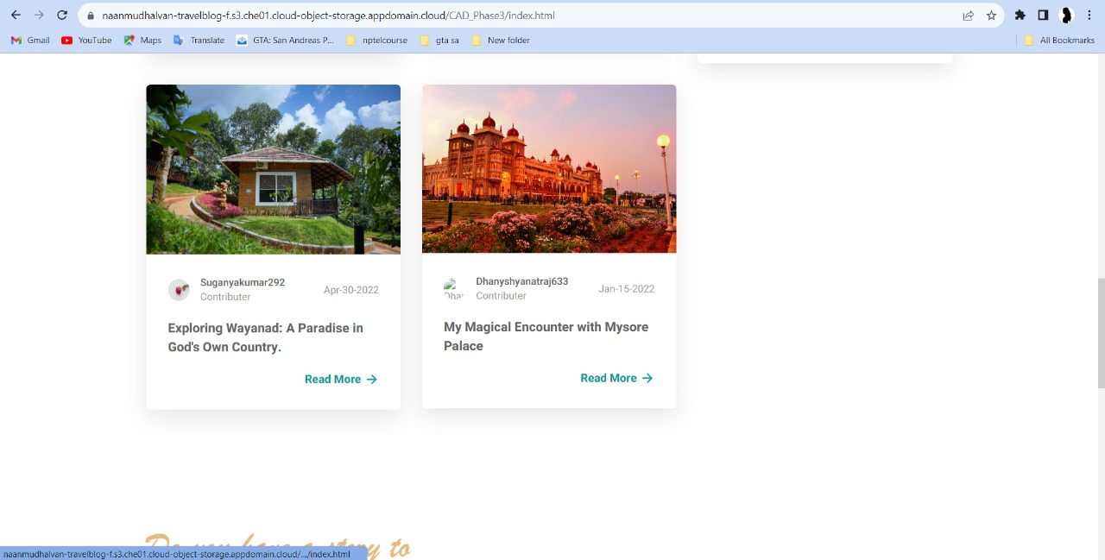

* + Implement interactive elements using JavaScript (e.g., for the interactive map).
  + Prioritize user-friendly navigation and readability.

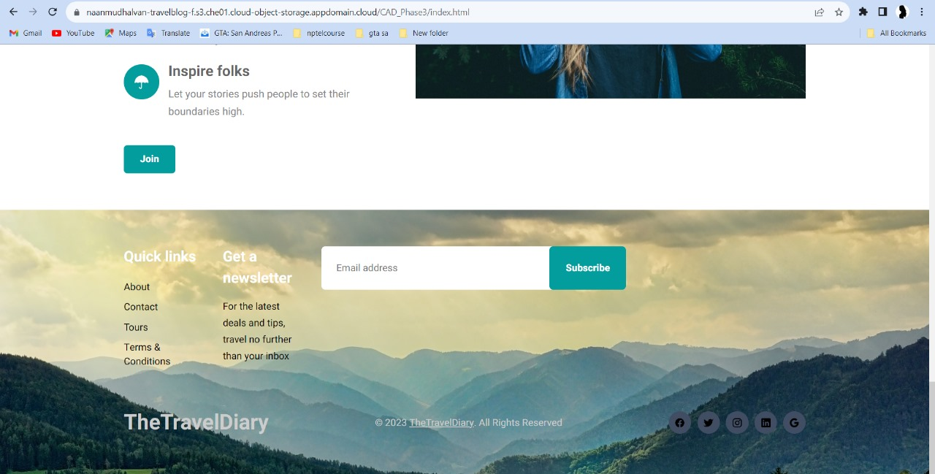

* + Ensure the blog is optimized for various devices and screen sizes.

1. **Phase 4: IBM Cloud Setup**
   * Create an IBM Cloud account if not already done.
   * Or go to IBM login page and enter email address
   * Register a domain name (if necessary) and configure DNS settings.
   * Set up a Static Web App environment on IBM Cloud to host the blog.
   * Complete the remaining fields with your information
   * Configure domain settings and ensure secure HTTPS access.
   * Establish a reliable and scalable hosting infrastructure.
   * Confirm your account by clicking the link in the confirmation email that is sent to your provided email address
2. **Phase 5: Content Management**

* Review and approve your assets
* Publish and distribute your content
* Maintain, audit and archive you content

* + Choose an appropriate Content Management System (CMS) or static site generator to streamline content updates.
  + A content management system has two parts.
  + Jekyll Docker is used in git to help manage the contents
  + A workflow is created in git Actions
  + The pipelines are created using the Ci/Cd of the Git
  + Implement a user-friendly admin panel or content editing workflow.
  + IBM cloud is used to deploy the static web page
  + Storage Object of IBM cloud is used. Bucket is created and the instances are made.
  + The files are stored in these instance.
  + A cloud-based CMS is hosted and managed by a third-party provider. Users access the CMS and manage their content via the internet

* + Enable version control for tracking changes and revisions.
  + Set up regular backups and content archiving for data security.