**Centralized Database Setup Guide**

**Steps to DB setup:**

1. Create new database.
2. Deploy the database scripts.
3. Schedule the job for data migrate from EPIC to Centralized DB.

**Database Setup**

1. Create new database in Sql Server management studio with name of **“HIBOutlookPlugin”.**
2. Copy and paste the DB objects in local ( SQL server machine - where the new database is created). Please refer the folder structures .

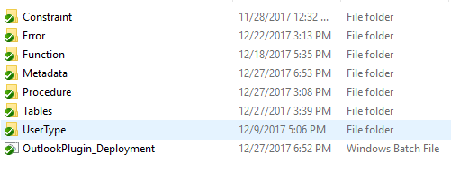

1. Run the Windows batch file (**OutlookPlugin_Deployment**). It contains all the DB objects( Tables, Stored Procedure, Function, User Type, Constraints and Metadata.
2. Necessary inputs will ask when click the Windows batch file (DB Server Name , User Name,Password, DB Name, Path of the DB objects (Step2) and make sure to proceed or not.

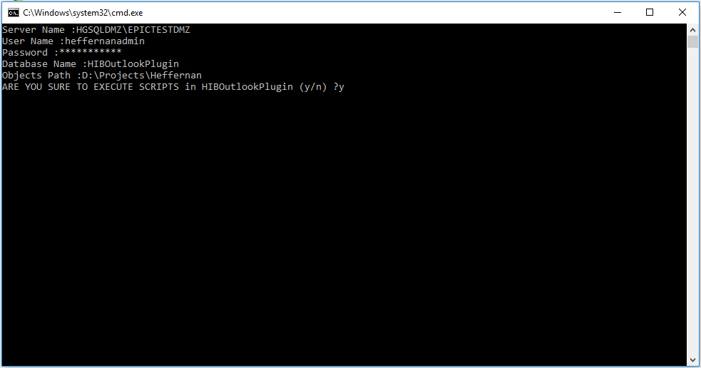

1. Deployment errors will log in the error folder . Please verify all error folders before move into next step. If no errors then proceed with next step.
2. Create new user “Heffernan” and give read and write access for that user. This user will refer in the application.
3. Create one new Job and schedule below stored procedures.It should run daily /hourly as per user requirement. Purpose of this job is data pulling from the EPIC database and push into the centralized database(HIBOutlookplugin).
4. HIBOPEpicSyncClient_SP
5. HIBOPEpicSyncPolicyLineType_SP.

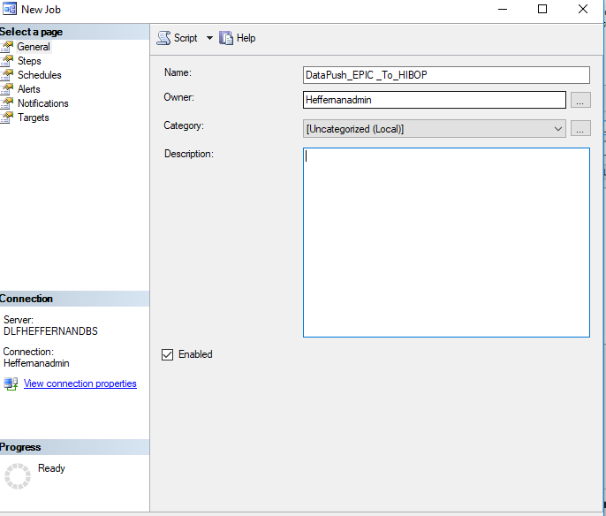

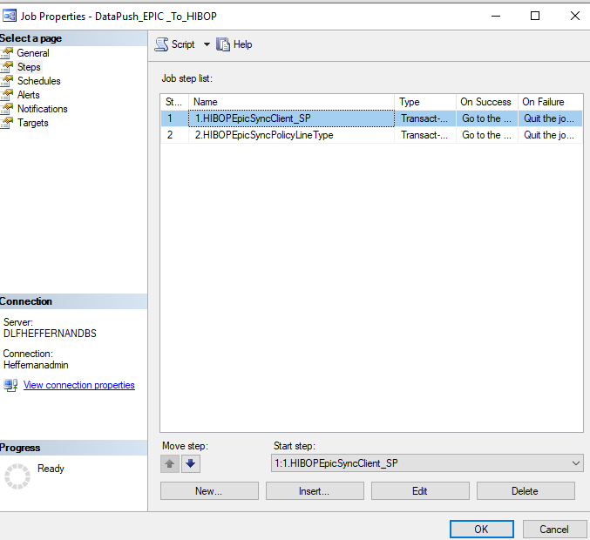

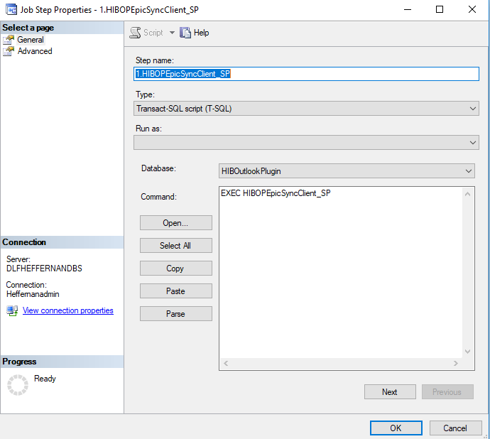

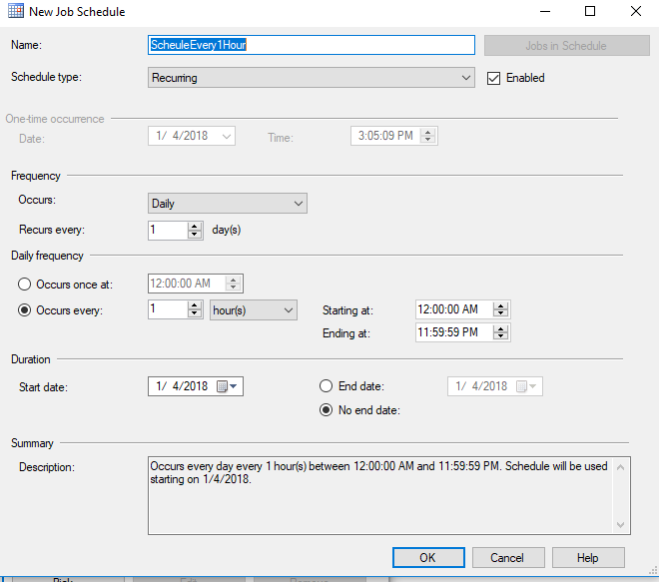

1. The above Job will take to complete approximately 15 to 20 minutes very first time. Incremental runs will take 1 to 2 minutes.
2. Please verify the procedures (HIBOPEpicSyncClient_SP & HIBOPEpicSyncPolicyLineType_SP) if any data issues in the centralized database.