**Sentiment Analysis for marketing**

**812821205057: Sugumar.S**

**Phase 3 submission document**

**Project Title:** Sentiment Analysis for marketing

**Phase 3: Development**

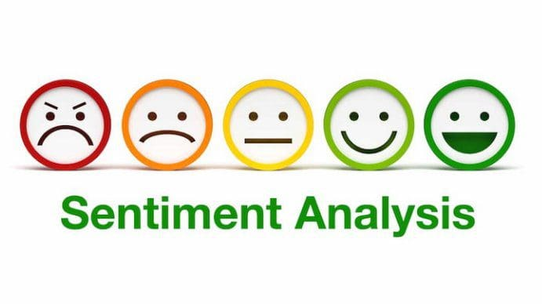

**Sentiment Analysis for marketing**

**Introduction:**

* In a world inundated with data, understanding and harnessing the power of public sentiment is paramount. Whether you're an industry professional gauging customer opinions or a data enthusiast looking to unlock insights, the journey begins with the analysis of textual data. Our project, "Sentiment Analysis on Twitter Airline Data," embarks on this journey, aiming to provide valuable insights into public sentiment regarding airline services.
* The aviation industry relies on passenger satisfaction and feedback to adapt and thrive. Airlines continually monitor social media platforms, including Twitter, to gain an understanding of how passengers perceive their services. Sentiment analysis, a subfield of artificial intelligence, equips us to quantify and analyze the emotions and opinions expressed in these texts.
* In this project's initial phase, we will access and preprocess the Twitter Airline Sentiment dataset from Kaggle. The dataset encompasses a trove of tweets that express passengers' sentiments towards various airlines. We will extract, clean, and format this textual data, making it suitable for sentiment analysis. Key preprocessing steps include text cleaning, tokenization, and feature extraction, ensuring that the data is primed for further analysis.
* Our project's ultimate goal is to build a sentiment analysis model capable of categorizing tweets as positive, negative, or neutral based on the sentiment they convey. This model will serve as a valuable tool for airlines to gain insights into passenger sentiments, adapt their services, and ultimately enhance the travel experience.
* By delving into the realm of sentiment analysis, we embark on a data-driven exploration that opens doors to understanding the emotions and opinions that shape industries. The project leverages the power of AI and data to interpret the sentiments of the Twitterverse, and in doing so, strives to provide valuable insights for both the aviation industry and data enthusiasts alike.

**Given data set:**

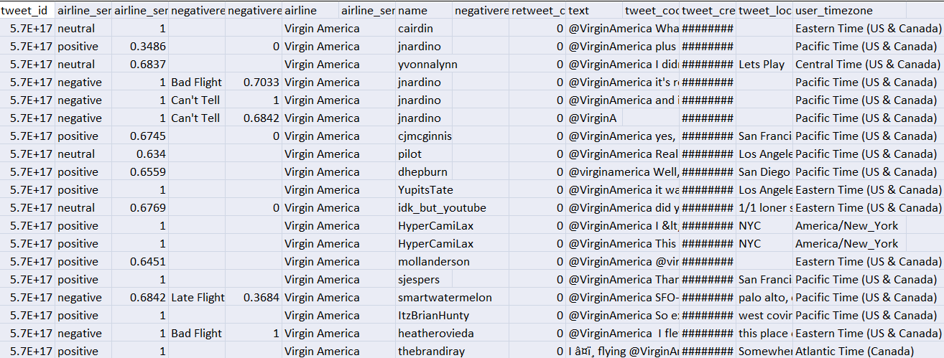

**Necessary step to follow:**

**1. Data Loading:**

Import necessary libraries.

Load the Twitter Airline Sentiment dataset.

**Program:**

import pandas as pd

# Load the dataset from the provided link

dataset_url = "https://www.kaggle.com/datasets/crowdflower/twitter-airline-sentiment"

df = pd.read_csv(dataset_url)

**2. Data Preprocessing:**

Handle missing values if any.

Clean and preprocess the text data, including removing special characters, hashtags, and mentions.

Tokenize the text (split into words or tokens).

**Program:**

# Handle missing values

df.dropna(inplace=True)

# Clean and preprocess text data

df['text'] = df['text'].apply(lambda x: preprocess_text(x))

# Tokenize the text

df['tokens'] = df['text'].apply(lambda x: tokenize_text(x))

**3. Data Exploration:**

- Explore the dataset to understand its structure.

- Visualize the distribution of sentiment labels (positive, negative, neutral).

**program:**

# Explore dataset structure

print(df.head())

# Visualize sentiment distribution

import matplotlib.pyplot as plt

df['sentiment'].value_counts().plot(kind='bar')

plt.show()

**4. Feature Extraction:**

- Convert text data into numerical features using techniques like TF-IDF or word embeddings.

**program:**

from sklearn.feature_extraction.text import TfidfVectorizer

tfidf_vectorizer = TfidfVectorizer()

tfidf_matrix = tfidf_vectorizer.fit_transform(df['text'])

**5. Sentiment Analysis Model:**

- Build a sentiment analysis model using machine learning or deep learning techniques.

- Train and evaluate the model.

**program:**

from sklearn.model_selection import train_test_split

from sklearn.svm import SVC

from sklearn.metrics import accuracy_score, classification_report

X = tfidf_matrix

y = df['sentiment']

X_train, X_test, y_train, y_test = train_test_split(X, y, test_size=0.2, random_state=42)

model = SVC()

model.fit(X_train, y_train)

predictions = model.predict(X_test)

accuracy = accuracy_score(y_test, predictions)

print("Accuracy:", accuracy)

print(classification_report(y_test, predictions))

**6. Interpret Results:**

- Analyze the model's performance and interpret the results.

**program:**

# Analyze results

misclassified = df.loc[y_test.index][y_test != predictions]

print("Misclassified examples:")

print(misclassified[['text', 'sentiment']])

**Importance of loading and processing dataset:**

Loading and processing the dataset in sentiment analysis for marketing is like preparing the ingredients for a recipe. It's essential to ensure that the data is clean, relevant, and in the right format. Just as a chef carefully selects and preps the best ingredients, marketers need to clean and structure their data to get accurate insights from customer feedback. This step helps filter out irrelevant information, handle different types of data (like text, images, and videos), and customize the analysis to meet specific marketing goals, ultimately enabling better decision-making and effective marketing strategies.

**Loading and preprocessing a sentiment analysis dataset for marketing involves several challenges:**

* **Data Volume:** Marketing datasets can be vast, especially if they encompass social media or e-commerce platforms. Handling and processing large volumes of data efficiently can be challenging, often requiring specialized tools and hardware.
* **Data Variety:**Marketing data is often diverse, including text, images, videos, and structured data. Processing such diverse data types requires adapting preprocessing techniques to each data modality.
* **Data Quality:** Ensuring data quality is a significant challenge. Marketing data may contain noise, missing values, or inconsistencies that can affect sentiment analysis accuracy. Robust data cleaning and validation processes are necessary.
* **Multilingual Content:** In a global market, marketing data often involves multiple languages. Handling and processing multilingual content for sentiment analysis can be complex due to linguistic nuances and language-specific sentiment expressions.
* **Context Understanding:** Understanding the context in which sentiments are expressed is essential. Preprocessing should consider factors like sarcasm, irony, or cultural references, as these can greatly impact sentiment interpretation.
* **Imbalanced Datasets:** Sentiment datasets in marketing may be imbalanced, with a disproportionate number of positive or negative sentiments. Addressing class imbalance is critical to avoid biased sentiment analysis results.
* **Entity Recognition:**Identifying entities, such as products, brands, or specific aspects of a service, is important in marketing sentiment analysis. Preprocessing should include entity recognition to attribute sentiments accurately.
* **Anonymization and Privacy:** Privacy concerns may require the removal of personally identifiable information (PII) from the dataset. This anonymization must be performed without compromising the analysis's quality.
* **Customization:** Marketing teams often need to customize sentiment analysis for specific goals, such as assessing the impact of a particular marketing campaign. Adapting the preprocessing to meet these custom requirements can be a challenge.
* **Real-time Processing:**In some cases, sentiment analysis needs to be conducted in real-time to respond promptly to customer feedback or social media trends. Implementing real-time preprocessing and analysis pipelines can be technically complex.
* **Feature Extraction:**Deciding which features to extract from the data is crucial for sentiment analysis. Choosing the right set of features that capture sentiment expressions effectively can be challenging.
* **Scalability:**The ability to scale preprocessing and analysis as data volumes grow is a challenge, especially in dynamic marketing environments where data streams in continuously.

**How to overcome the challenges of loading and preprocessing sentiment analysis for marketing dataset:**

* **Data Cleaning:**This step is critical to ensure that the data is free from noise and inconsistencies, which can significantly affect the accuracy of sentiment analysis results. Removing spam, irrelevant content, and duplicates using data cleaning techniques is vital.
* **Efficient Data Handling:** Efficiently managing large datasets is essential, especially in marketing, where data volume can be substantial. Using data storage solutions and cloud-based platforms for effective data handling can make the process more manageable.
* **Data Privacy Compliance:**Compliance with data privacy regulations, such as GDPR or HIPAA, is of utmost importance when dealing with customer data. Ensuring that sensitive information is anonymized, encrypted, and that your data storage and processing methods adhere to legal requirements is crucial to avoid legal and ethical issues.

To load a dataset using machine learning in Python, you can follow the general steps you've described, which include identifying the dataset, loading the dataset, and preprocessing it. Here's a step-by-step guide on how to do this:

**Loading the dataset:**

* **Identify the Dataset:**

Determine the source of your dataset. It could be stored locally as a file (e.g., CSV, Excel), in a database, or hosted on a cloud storage service. Make sure you know the location and format of your dataset.

* **Load the Dataset:**

Depending on the dataset's source and format, you can use different libraries and methods to load it into your machine learning environment. Here's how to load a dataset from a CSV file using the popular Pandas library

**Program:**

import pandas as pd

# Replace 'c/:tweets.csv' with the actual dataset file path

dataset = pd.read_csv('Tweets.csv')

If the dataset is stored in a different format or location, you may use other libraries and methods, such as `pymysql` for database retrieval or cloud storage SDKs for cloud-hosted datasets.

* **Preprocess the Dataset:**

Data preprocessing is a crucial step to clean and prepare your dataset for machine learning. Common preprocessing steps include:

Handling missing values.

Removing duplicates.

Encoding categorical variables.

Scaling or normalizing features.

Splitting the data into training and testing sets.

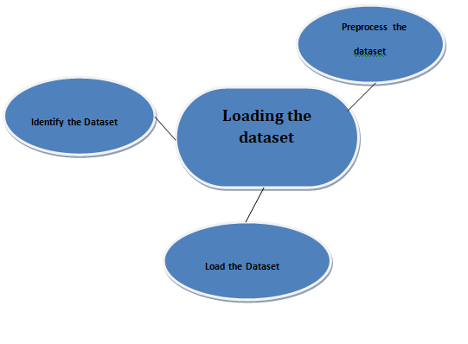

**Program:**

import pandas as pd

import numpy as np

import seaborn as sns

import matplotlib.pyplot as plt

from sklearn.model_selection import train_test_split

from sklearn.feature_extraction.text import CountVectorizer

from sklearn.metrics import accuracy_score, classification_report

from sklearn.naive_bayes import MultinomialNB

from sklearn.svm import SVC

from sklearn.ensemble import RandomForestClassifier

from sklearn.tree import DecisionTreeClassifier

from sklearn.preprocessing import LabelEncoder

import warnings

warnings.filterwarnings("ignore")

%matplotlib inline

sentiment_data = pd.read_csv('c:/tweets.csv')

X = sentiment_data['text_column']

y = sentiment_data['label_column']

le = LabelEncoder()

y = le.fit_transform(y)

X_train, X_test, y_train, y_test = train_test_split(X, y, test_size=0.2, random_state=42)

vectorizer = CountVectorizer()

X_train_vectorized = vectorizer.fit_transform(X_train)

X_test_vectorized = vectorizer.transform(X_test)

model = MultinomialNB()

model.fit(X_train_vectorized, y_train)

y_pred = model.predict(X_test_vectorized)

accuracy = accuracy_score(y_test, y_pred)

print(f"Accuracy: {accuracy:.2f}")

print(classification_report(y_test, y_pred))

**Loading Dataset:**

dataset = pd.read_csv('c:/tweets.csv')

**Data Exploration:**

**Dataset:**

**Output:**

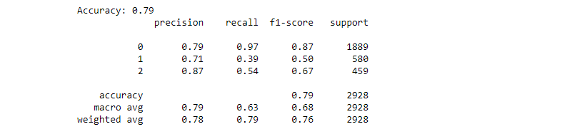

**Preprocessing the dataset:**

Preprocessing the dataset in sentiment analysis for marketing involves several critical tasks. Initially, the dataset must be loaded and organized, including the cleaning of noisy or irrelevant data points. Textual data often requires tasks such as text cleaning, tokenization, and the removal of stopwords and special characters. Following this, the data needs to be transformed into a format suitable for analysis, which typically involves vectorization using techniques like TF-IDF or word embeddings. Furthermore, it's essential to address class imbalances and ensure that the data is split into training and testing sets. Lastly, preprocessing may encompass handling missing data and dealing with multilingual or multichannel data sources, all with the aim of preparing the dataset for accurate sentiment analysis in marketing.

**Visualisation and Pre-Processing of Data:**

In [1]:

sns.countplot(data=df, x='airline_sentiment')

Out[1]:

<AxesSubplot:xlabel='airline_sentiment', ylabel='count'>

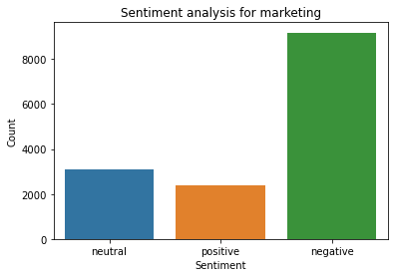

In[2]:

sns.countplot(data=df, x='airline_sentiment', palette='Blues')

out[2]:

<AxesSubplot:xlabel='airline_sentiment', ylabel='count'>

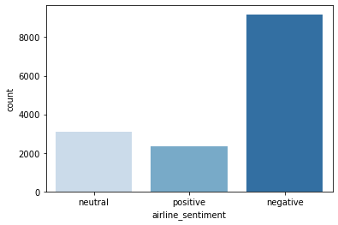

In[3]:

sns.jointplot(data=df, x='retweet_count', y='airline_sentiment_confidence', kind='scatter')

out[3]:

<seaborn.axisgrid.JointGrid at 0x1be62d44220>

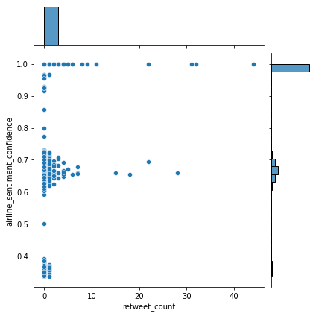

In[4]:

columns_of_interest =['retweet_count','airline_sentiment_confidence']

sns.pairplot(df[columns_of_interest])

out[3]:

<seaborn.axisgrid.PairGrid at 0x1be5f5aa760>

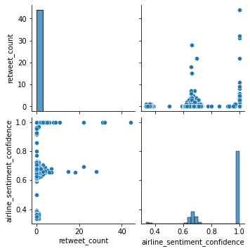

In[4]:

import pandas as pd

import matplotlib.pyplot as plt

selected_columns = [

'airline_sentiment_confidence',

'retweet_count'

]

for column_name in selected_columns:

plt.figure(figsize=(10, 8))

plt.hist(df[column_name], bins=20, edgecolor='k')

plt.xlabel(column_name)

plt.ylabel('Frequency')

plt.title(f'Histogram of {column_name}')

plt.show()

out[4]:

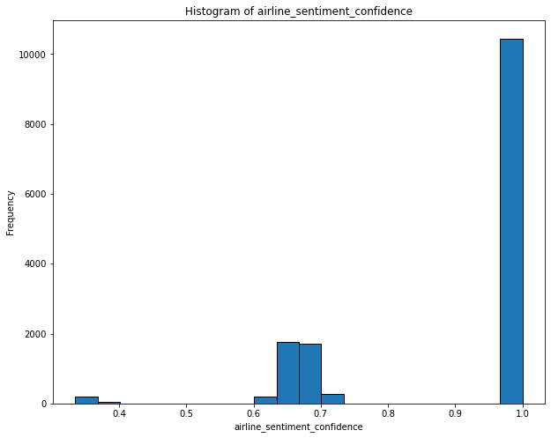

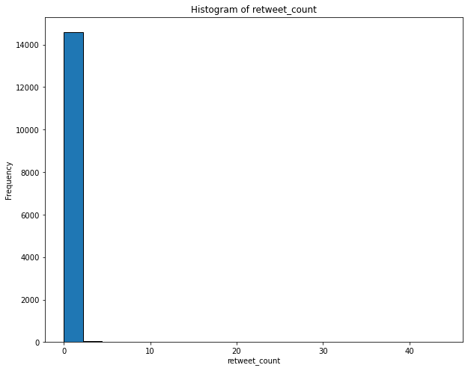

In[5]:

numeric_cols = df.select_dtypes(include=['number'])

correlation_matrix = numeric_cols.corr()

print(correlation_matrix)

out[5]:

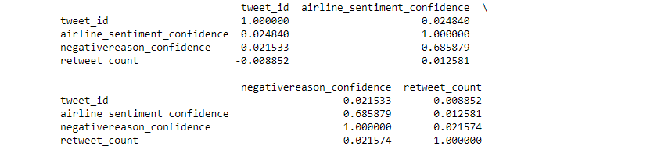

In[6]:

sns.heatmap(correlation_matrix, annot=True, cmap='coolwarm')

out[6]:

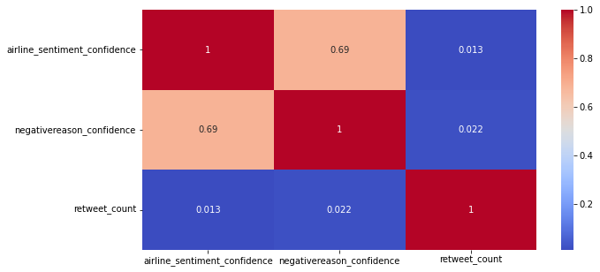

**Some common data preprocessing tasks include:**

* **Data Cleaning:**

**Remove Special Characters:** Remove any special characters or symbols that are not relevant to your analysis.

**Handling Missing Values:** Deal with missing data by either removing rows with missing values or filling in missing values using techniques like imputation.

**Text Cleaning:** For text-based data like social media posts or customer reviews, perform text cleaning tasks like removing HTML tags, punctuation, and converting text to lowercase.

**Spell Checking and Correction:** Correct spelling mistakes to ensure accurate sentiment analysis.

**Remove Duplicates:** Eliminate duplicate records to avoid bias and redundant information.

* **Text Preprocessing for Sentiment Analysis:**

**Tokenization:** Split text data into words or tokens to facilitate analysis.

**Stopword Removal:** Eliminate common words (stopwords) that don't carry much sentiment information.

**Stemming or Lemmatization:** Reduce words to their base or root form for consistency.

**Feature Extraction:** Convert text data into numerical vectors using techniques like TF-IDF (Term Frequency-Inverse Document Frequency) or word embeddings like Word2Vec or GloVe.

* **Data Transformation:**

**Normalization/Scaling:** Normalize numerical features to a consistent range.

**Categorical Encoding:** Convert categorical variables into numerical format using one-hot encoding or label encoding.

* **Data Sampling and Splitting:**

**Balancing Classes:** In sentiment analysis, balance the dataset if there's a class imbalance.

**Train-Test Split:** Split the data into training and testing sets to evaluate model performance.

* **Feature Engineering:**

**Create Derived Features:** Generate new features that might be relevant to the analysis, like sentiment scores or sentiment lexicons.

* **Data Visualization:**

**Exploratory Data Analysis (EDA):** Visualize the data to understand its distribution and patterns. For marketing, this could include plotting customer behavior or analyzing sentiment trends over time.

* **Removing Outliers:**

**Outlier Detection:** Identify and handle outliers in the data if they exist.

**data preprocessing**

**Program:**

import pandas as pd

import matplotlib.pyplot as plt

import seaborn as sns

from sklearn.feature_extraction.text import TfidfVectorizer

from sklearn.model_selection import train_test_split

from sklearn.compose import ColumnTransformer

from sklearn.pipeline import Pipeline

from sklearn.preprocessing import StandardScaler

from sklearn.preprocessing import OneHotEncoder

**# Step 1: Load the dataset:**

data = pd.read_csv ('C:\dataset\Tweets.csv')

**# Step 2: Exploratory Data Analysis (EDA):**

plt.figure(figsize=(6, 4))

sns.countplot(data=df, x='airline_sentiment', palette='Blues')

plt.title('Distribution of Sentiment')

plt.xlabel('Sentiment')

plt.ylabel('Count')

plt.show()

plt.figure(figsize=(10, 6))

sns.countplot(data=df, x='airline', palette='Set2')

plt.title('Distribution of Airlines')

plt.xlabel('Airline')

plt.ylabel('Count')

plt.xticks(rotation=45)

plt.show()

plt.figure(figsize=(10, 6))

sns.countplot(data=df, x='airline', hue='airline_sentiment', palette='Set1')

plt.title('Sentiment by Airline')

plt.xlabel('Airline')

plt.ylabel('Count')

plt.xticks(rotation=45)

plt.show()

**# Step 3: Feature Engineering**

df['text_tokens'] = df['text'].apply(lambda x: x.split()) # Split text into tokens

tfidf_vectorizer = TfidfVectorizer(max_features=1000) # You can adjust the number of features

tfidf_matrix = tfidf_vectorizer.fit_transform(df['text'])

tfidf_df = pd.DataFrame(data=tfidf_matrix.toarray(), columns=tfidf_vectorizer.get_feature_names_out())

features = pd.concat([tfidf_df, df[['feature1', 'feature2', 'feature3']]], axis=1)

target = df['airline_sentiment']

**# Step 4: Data Splitting**

X_train, X_test, y_train, y_test = train_test_split(features, target, test_size=0.2, random_state=42)

X_train, X_val, y_train, y_val = train_test_split(X_train, y_train, test_size=0.2, random_state=42)

**# Step 5: Preprocessing and Feature Scaling using Pipeline**

categorical_cols = ['categorical_feature1', 'categorical_feature2']

numerical_cols = ['numerical_feature1', 'numerical_feature2']

categorical_transformer = Pipeline(steps=[

('onehot', OneHotEncoder(handle_unknown='ignore'))

])

numerical_transformer = Pipeline(steps=[

('scaler', StandardScaler())

])

preprocessor = ColumnTransformer(

transformers=[

('cat', categorical_transformer, categorical_cols),

('num', numerical_transformer, numerical_cols)

])

pipeline = Pipeline(steps=[

('preprocessor', preprocessor),

('model', YourMachineLearningModel())

])

pipeline.fit(X_train, y_train)

y_pred = pipeline.predict(X_test)

**Output:**

**Exploratory Data Analysis:**

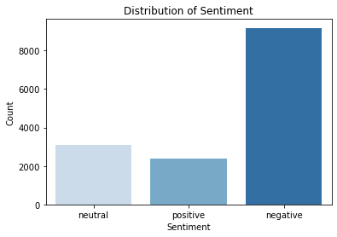 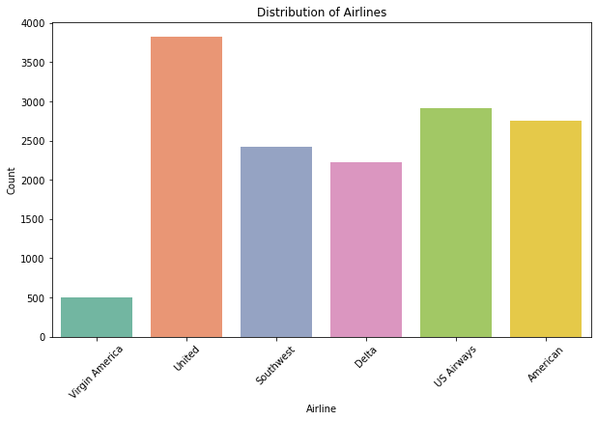 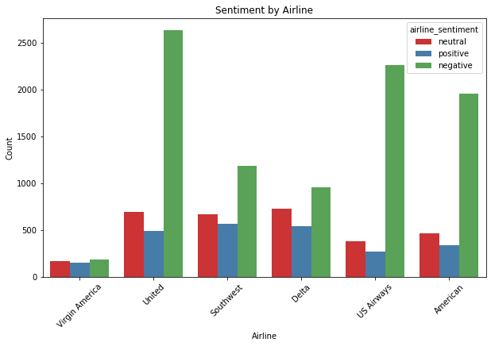

**conclusion:**

* In the realm of data analysis, thorough data preprocessing is the cornerstone of all subsequent analytical efforts. It's the essential foundation that empowers me to extract valuable insights, patterns, and knowledge from my data. This groundwork becomes even more crucial when i am embarking on a journey in sentiment analysis or aiming to drive effective marketing strategies.
* In this series of questions, we've thoroughly explored the critical steps involved in data preprocessing, making sure that my data is cleansed, transformed, and optimized for analysis. This comprehensive process encompasses a wide array of tasks, including cleaning data by removing noise and inconsistencies, preparing text data for sentiment analysis, and transforming categorical variables into a numerical format that can be used by machine learning algorithms.
* The importance of these data preprocessing steps cannot be overstated. They lay the groundwork for subsequent analysis and modeling, ensuring that i can make data-driven decisions with confidence. As my embark on my analytical journey, whether it's in sentiment analysis, marketing, or any other domain, the quality of my results will be profoundly influenced by the rigor with which i approach data preprocessing.
* So, with my data now well-prepared and primed for further analysis, Iam equipped to dive deeper into sentiment analysis for marketing or any other data-driven endeavour.