# Problem Statement

You are given the following two Math questions (Refer Base questions). Your goal is to create similar questions using LLM.

Things to consider:  
1. A question can have equations and formulas in LaTeX format, and it should be preserved.

2. A question can have images and we need to create appropriate image in the new question

Feel free to use AI editors such as cursor.ai or any of your favorites.

# Expected Output

A Word document/Google doc link along with Github link to be sent in the chat. The word document should have two newly-generated questions in Question Output format (refer next section).

# Question Output Format

@title Assessment title, can be a meaningful name

@description assessment description

// Use this block for each question when adding Multiple Choice Questions (MCQ)

@question **Write your question here**

@instruction Write instruction here

@difficulty ***easy,moderate,hard***

@Order **Question number**

@option **write first** **option here**

@option **Write second option here**

@@option **Correct Answer**

@option **option**

@explanation

**Write your question explanation here**

@subject **Write subject of the question here**

@unit **Write unit of the subject**

@topic Write topic of the question

@plusmarks 1

The subject, unit and topic is a hierarchy and they should strictly come from the curriculum and should be chosen by the LLM for each question.

# Curriculum

|  |  |  |
| --- | --- | --- |
| **subject** | **unit** | **topic** |
| Quantitative Math | Problem Solving | Numbers and Operations |
| Quantitative Math | Problem Solving | Algebra |
| Quantitative Math | Problem Solving | Geometry |
| Quantitative Math | Problem Solving | Problem Solving |
| Quantitative Math | Problem Solving | Probability and Statistics |
| Quantitative Math | Problem Solving | Data Analysis |
| Quantitative Math | Algebra | Algebraic Word Problems |
| Quantitative Math | Algebra | Interpreting Variables |
| Quantitative Math | Algebra | Polynomial Expressions (FOIL/Factoring) |
| Quantitative Math | Algebra | Rational Expressions |
| Quantitative Math | Algebra | Exponential Expressions (Product rule, negative exponents) |
| Quantitative Math | Algebra | Quadratic Equations & Functions (Finding roots/solutions, graphing) |
| Quantitative Math | Algebra | Functions Operations |
| Quantitative Math | Geometry and Measurement | Area & Volume |
| Quantitative Math | Geometry and Measurement | Perimeter |
| Quantitative Math | Geometry and Measurement | Lines, Angles, & Triangles |
| Quantitative Math | Geometry and Measurement | Right Triangles & Trigonometry |
| Quantitative Math | Geometry and Measurement | Circles (Area, circumference) |
| Quantitative Math | Geometry and Measurement | Coordinate Geometry |
| Quantitative Math | Geometry and Measurement | Slope |
| Quantitative Math | Geometry and Measurement | Transformations (Dilating a shape) |
| Quantitative Math | Geometry and Measurement | Parallel & Perpendicular Lines |
| Quantitative Math | Geometry and Measurement | Solid Figures (Volume of Cubes) |
| Quantitative Math | Numbers and Operations | Basic Number Theory |
| Quantitative Math | Numbers and Operations | Prime & Composite Numbers |
| Quantitative Math | Numbers and Operations | Rational Numbers |
| Quantitative Math | Numbers and Operations | Order of Operations |
| Quantitative Math | Numbers and Operations | Estimation |
| Quantitative Math | Numbers and Operations | Fractions, Decimals, & Percents |
| Quantitative Math | Numbers and Operations | Sequences & Series |
| Quantitative Math | Numbers and Operations | Computation with Whole Numbers |
| Quantitative Math | Numbers and Operations | Operations with Negatives |
| Quantitative Math | Data Analysis & Probability | Interpretation of Tables & Graphs |
| Quantitative Math | Data Analysis & Probability | Trends & Inferences |
| Quantitative Math | Data Analysis & Probability | Probability (Basic, Compound Events) |
| Quantitative Math | Data Analysis & Probability | Mean, Median, Mode, & Range |
| Quantitative Math | Data Analysis & Probability | Weighted Averages |
| Quantitative Math | Data Analysis & Probability | Counting & Arrangement Problems |
| Quantitative Math | Reasoning | Word Problems |

# Base Questions

1. Each student at Central Middle School wears a uniform consisting of 1 shirt and 1 pair of pants. The table shows the colors available for each item of clothing. How many different uniforms are possible?

**## Uniform Choices**

| Shirt Color | Pants Color |

| :---: | :---: |

| Tan | Black |

| Red | Khaki |

| White | Navy |

| Yellow |  |

(A) Three

(B) Four

(C) Seven

(D) Ten

(E) Twelve

2. The top view of a rectangular package of 6 tightly packed balls is shown. If each ball has a radius of 2 centimeters, which of the following are closest to the dimensions, in centimeters, of the rectangular package?

![](https://cdn.mathpix.com/cropped/2025_07_31_dc2e3d22c70b1617b86dg-33.jpg?height=451&width=307&top_left_y=1130&top_left_x=280)

(A) $2 \times 3 \times 6$

(B) $4 \times 6 \times 6$

(C) $2 \times 4 \times 6$

(D) $4 \times 8 \times 12$

(E) $6 \times 8 \times 12$

# Question 1

@title Counting Outfit Combinations

@description Determine the number of different outfits possible from given clothing options.

@question A sports club gives each player a uniform consisting of 1 jersey and 1 pair of shorts. The table below shows the available colors for each item. How many different uniforms can be made?

|  |  |
| --- | --- |
| Jersey Color | Shorts Color |
| Blue | Black |
| Green | White |
| Red | Gray |
| Yellow | Navy |

(A) Four

(B) Six

(C) Eight

@@option Twelve

(E) Sixteen

@instruction Select the correct number of possible uniform combinations.

@difficulty easy

@Order 1

@option Four

@option Six

@@option Twelve

@option Sixteen

@explanation The total combinations are found by multiplying the number of jersey choices (4) by the number of shorts choices (3), giving \( 4 imes 3 = 12 \).

@subject Quantitative Math

@unit Problem Solving

@topic Numbers and Operations

@plusmarks 1

# Question 2

@title Dimensions of a Box Holding Cylinders

@description Determine the dimensions of a box containing tightly packed cylindrical cans.

@question A rectangular box contains 8 identical cylindrical cans arranged in two rows of 4 as shown below. Each can has a radius of 3 cm and a height of 12 cm. What are the approximate dimensions of the box, in centimeters?

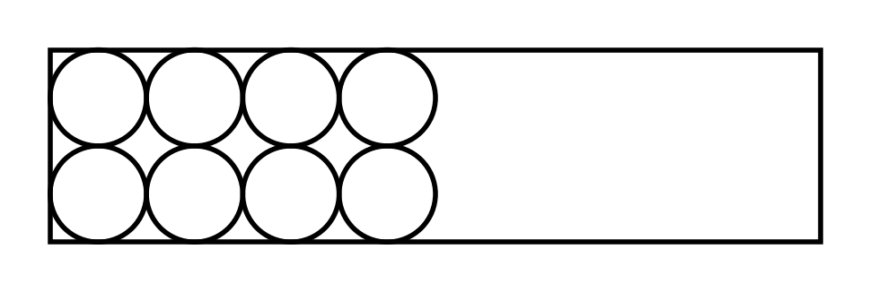

(A) $6 \times 12 \times 12$

(B) $12 \times 24 \times 12$

(C) $6 \times 24 \times 12$

@@option $12 \times 24 \times 12$

(E) $9 \times 18 \times 12$

@instruction Select the option that best matches the dimensions of the box.

@difficulty moderate

@Order 2

@option $6 \times 12 \times 12$

@option $12 \times 24 \times 12$

@@option $12 \times 24 \times 12$

@option $9 \times 18 \times 12$

@explanation The diameter of each can is $2 \times 3 = 6$ cm. Four cans side-by-side give $4 \times 6 = 24$ cm in length. Two rows give $2 \times 6 = 12$ cm in width. The height is 12 cm. Therefore, the dimensions are $12 \times 24 \times 12$.

@subject Quantitative Math

@unit Geometry and Measurement

@topic Solid Figures (Volume of Cubes)

@plusmarks 1