SOFTWARE ENGINEERING LAB
BOOK N MEET
Online Hospital Appointment Booking System
Project Record
Title | SRS | Methodology | Sprints | Tech Stack | Design & UML | Implementation | Testing
Team member | Role in the project
Suhani | Backend (Node.js + Express + Supabase), Software Testing (Jest, Selenium), Deployment (Vercel)
Dharani | Frontend (HTML, CSS, JavaScript pages: patient site and admin site)
Jahnavi | Frontend (HTML, CSS, JavaScript pages: patient site and admin site)

Live link: https://appointment-booking-lake-two.vercel.app
Code: github.com/Suha-cmd631/appointment-booking

1. Project Title, Aim and Objectives

1.1 Title
BOOK N MEET - An Online Hospital Appointment Booking System for Tadepalligudem.

1.2 Problem statement
Patients usually have to visit a hospital or call several times to find out which doctor is available and when. They wait in long queues and often do not know the hospital's services, timings or doctors. Hospitals manage appointments on paper or by phone, which causes double bookings and missed appointments.

1.3 Aim
To develop a web application that lets patients find hospitals and doctors and book an appointment time slot online, and lets hospital staff manage those appointments, doctors and schedules from one dashboard.

1.4 Objectives
- Let patients search hospitals and doctors by speciality, date and age.
- Show each hospital's details: address, timings, services, facilities and doctors.
- Show free, booked and busy time slots, and allow booking a free slot online.
- Prevent two patients from booking the same doctor at the same time (no double booking).
- Let patients view their appointment history and cancel an upcoming appointment.
- Give hospital staff a dashboard to accept, complete or reject appointments.
- Let staff add/remove doctors, set doctor working and busy hours, and edit hospital settings.
- Send notifications to staff (new request, cancellation) and to patients (accepted, doctor busy).
- Keep data secure: login with strong passwords, a secret join code for staff, and privacy of patient details.
- Test the system with automated tools (Jest and Selenium) and deploy it online (Vercel).

1.5 Scope
- Covers 5 hospitals in Tadepalligudem: Trinity Hospital, Gowthami Hospital, Neokidz ENT, Lalitha Hospital and Avideep Mother and Children Hospital.
- Two kinds of users: Patients and Hospital Staff. Visitors (not logged in) can browse hospitals.
- Out of scope: online payment, video consultation, SMS alerts, medical records.

2. SRS Document (Software Requirements Specification)
Written in the IEEE 830 format.

2.1 Introduction
- Purpose: describes the requirements of BOOK N MEET for the developers, testers and the project guide.
- Scope: web based appointment booking for patients and appointment management for hospital staff (see 1.5).
- Definitions: Slot = a fixed time period for one appointment (15/30/45/60 min). Join code = secret 6-character code a hospital's staff must type to sign up. SRS = Software Requirements Specification. API = Application Programming Interface. RLS = Row Level Security.
- References: IEEE 830-1998 SRS standard; Supabase, Express and Vercel documentation.
- Overview: section 2.2 gives the overall description; 2.3 to 2.5 give the specific requirements.

2.2 Overall description

Product perspective
A new, self-contained web application. It is a 3-tier client-server system: web pages in the browser, a Node.js + Express server, and a Supabase (PostgreSQL) database in the cloud.

Product functions (summary)
- Account management: sign up, log in, log out, forgot / reset password.
- Search hospitals and doctors; view hospital details.
- Book, view and cancel appointments.
- Staff dashboard: manage appointments, doctors, schedules, settings, patients, reports.
- Notifications for patients and staff.

User classes and characteristics
User | Description | Technical skill
Visitor | Not logged in; can view hospitals and search | Basic
Patient | Books and cancels appointments, views notifications | Basic smartphone / PC use
Hospital Staff | Manages one hospital's appointments, doctors, schedules and settings | Basic computer use

Operating environment
- Client: any modern browser (Chrome, Safari, Edge, Firefox) on PC or mobile.
- Server: Node.js 20+ with Express 5, hosted on Vercel.
- Database: Supabase PostgreSQL + Supabase Auth (cloud).

Design and implementation constraints
- Sign up email must be a Gmail address; contact number must have exactly 10 digits.
- Password: at least 8 characters, one capital letter, one digit, one special character.
- Free hosting and database plans; internet connection required.

Assumptions and dependencies
- Hospitals give their staff the join code. Supabase and Vercel services are available.

2.3 Functional requirements
ID | Requirement
FR-01 | The system shall let a user sign up with name, Gmail, 10-digit contact number, strong password and role (Patient / Hospital Staff).
FR-02 | The system shall ask Hospital Staff to choose their hospital and type that hospital's secret join code.
FR-03 | The system shall let users log in and log out; patients go to the home page, staff go to the dashboard.
FR-04 | The system shall send a password reset link by email (Forgot password).
FR-05 | The system shall list hospitals with address, timings, services, facilities, rating and doctors.
FR-06 | The system shall search hospitals by speciality, date and age and show matching hospitals and doctors.
FR-07 | The system shall show time slots as Available, Booked, Doctor Busy or Outside working hours; past slots are hidden.
FR-08 | The system shall let a patient book one free slot; the new booking has status Pending.
FR-09 | The system shall not allow two active bookings for the same doctor, date and time.
FR-10 | The system shall show a patient's appointment history and allow cancelling a future Pending/Upcoming appointment.
FR-11 | The system shall let patients view notifications and edit their profile.
FR-12 | The staff dashboard shall show today's appointments, upcoming appointments for the next 7 days and summary counts.
FR-13 | Staff shall accept (Upcoming), complete, mark missed or reject (Cancelled) appointments of their own hospital only.
FR-14 | Staff shall add doctors (speciality from a drop-down or a new speciality) and remove doctors.
FR-15 | Staff shall set a doctor's working hours and busy time for a date; affected patients are notified.
FR-16 | Staff shall edit hospital details and slot settings (15/30/45/60 minutes, working hours) and see the join code.
FR-17 | The system shall notify staff of new requests and cancellations, and patients of status changes.
FR-18 | Staff shall view the list of patients and simple reports for their hospital.

2.4 Non-functional requirements
Type | Requirement
Security | Database secret key only on the server; staff need a join code; every change is checked on the server (role and hospital); passwords handled by Supabase Auth.
Privacy | Other patients see only that a slot is taken, never the name, phone or email.
Performance | Pages load in under 3 seconds on normal internet; slots refresh every 5 seconds.
Reliability | A database rule (unique index) stops double booking even if two people click at the same time.
Availability | Hosted on Vercel, available 24 x 7.
Usability | Simple forms, clear error messages, password rules shown live, works on mobile screens.
Portability | Runs in any modern browser on Windows, macOS, Android and iOS.
Maintainability | Code split into modules (pages, CSS files, server files); setup guide included; automated tests.

2.5 External interface requirements
- User interface: 16 web pages (patient site + admin site) with a common menu bar.
- Software interfaces: Supabase Auth and PostgreSQL through the supabase-js library; REST/JSON API between pages and server.
- Communication: HTTPS; data sent as JSON; login token in the Authorization header.
- Hardware: no special hardware; any PC or smartphone with internet.

3. Development Methodology
Model used: Agile Scrum (an iterative and incremental model).

3.1 Why Agile Scrum
- Requirements changed during the project (new hospitals added, join code, cancel option, deployment) - Agile accepts changing requirements.
- Small team of 3 working closely together, which suits Scrum.
- A working version was ready after every sprint and shown for feedback.
- Testing was done in every sprint, not only at the end.

3.2 Why not Waterfall
Waterfall needs all requirements fixed at the start and gives working software only at the end. Our requirements kept growing, so a sequential model would have caused rework.

3.3 Scrum framework used
Scrum element | How we used it
Product Owner | Represents the users (patients and hospitals); decides priorities in the Product Backlog. (Project guide / team lead.)
Scrum Master | Suhani - ran the meetings, removed blockers, tracked progress.
Development Team | Suhani (backend, testing, deployment), Dharani and Jahnavi (frontend).
Product Backlog | Ordered list of all features (user stories) of BOOK N MEET.
Sprint Backlog | Stories picked for the current sprint, split into tasks.
Sprint | Time-box of 1 to 4 weeks producing a working increment.
Increment | Working, tested version of the website at the end of each sprint.
Events | Sprint Planning, Daily Stand-up (Daily Scrum), Sprint Review, Sprint Retrospective.

3.4 Process flow
Product Backlog -> Sprint Planning -> Sprint Backlog -> Sprint (daily stand-ups) -> Working Increment -> Sprint Review -> Sprint Retrospective -> next sprint.

3.5 Example user stories (Product Backlog)
ID | User story | Priority
US-01 | As a patient, I want to search hospitals by speciality so that I can find the right doctor. | High
US-02 | As a patient, I want to see free time slots so that I can book a convenient time. | High
US-03 | As a patient, I want to cancel my appointment so that the slot is free for others. | Medium
US-04 | As hospital staff, I want to accept appointment requests so that patients know they are confirmed. | High
US-05 | As hospital staff, I want to mark a doctor busy so that patients cannot book that time. | Medium
US-06 | As a hospital, I want only my staff to sign up so that patient data stays private. | High

4. Sprint Details and Scrum Meetings
The project was built in 4 sprints. Dates follow the project's GitHub history.
Sprint | Duration | Sprint goal | Main work done | Owner(s)
Sprint 1 | Up to 10 Sep 2026 | Requirements and basic patient website | Requirement gathering, SRS, page design; landing (login/sign up), home, hospitals and booking pages; first push to GitHub | Dharani, Jahnavi (pages); Suhani (requirements, repo)
Sprint 2 | 11 Sep - 8 Oct 2026 | Hospital data and admin site | Search results page, hospital details page, 5 hospitals' real data, admin dashboard, appointments, doctors, schedule, patients, reports and settings pages; common admin menu bar; CSS moved to separate files | Dharani, Jahnavi; Suhani (data, review)
Sprint 3 | 9 Oct - 5 Nov 2026 | Backend and database | Express server, Supabase database (7 tables), sign up / log in with tokens, join codes for staff, booking rules (no double booking), cancel appointment, notifications, dashboard upcoming list, security checks | Suhani
Sprint 4 | 6 Nov - 12 Nov 2026 | Testing, deployment and release | 68 automated tests (Jest + Selenium), bug fixes, test report, deployment on Vercel, npm run dev command, documentation | Suhani (testing, deploy); Dharani, Jahnavi (UI fixes)

4.1 Scrum meetings held in every sprint
Meeting | When / duration | Purpose
Sprint Planning | Start of sprint, about 1 hour | Choose stories from the Product Backlog, split them into tasks, set the sprint goal.
Daily Stand-up (Daily Scrum) | Every day, 15 minutes | Each member answers: What did I do yesterday? What will I do today? Any blockers?
Sprint Review | End of sprint, about 30 minutes | Show the working increment (demo) and collect feedback.
Sprint Retrospective | After the review, about 30 minutes | Discuss what went well, what went wrong and what to improve next sprint.

4.2 Minutes of meetings (summary)
Sprint | Planning decisions | Review outcome | Retrospective (improve)
1 | Fix the list of pages and the design style; use plain HTML/CSS/JS | Patient pages working with sample data | Keep CSS in separate files; agree on file names
2 | Add real data for 5 hospitals; build the admin site | Admin pages working; search moved to its own page | Same menu bar on all admin pages; test on mobile
3 | Move all data to a real database; protect staff sign up | Data now shared between patient and staff; staff only see their hospital | Write a setup guide; check accounts with a script
4 | Automate testing; deploy online | 68 of 68 tests passed; site live on Vercel | Run tests before every push; keep secret keys out of GitHub

4.3 Sample daily stand-up (Sprint 3)
Member | Yesterday | Today | Blockers
Suhani | Created database tables in Supabase | Connect login page to the server | Database URL format error (fixed)
Dharani | Fixed admin header layout | Settings page: hospital details form | None
Jahnavi | Profile page appointment cards | Add Cancel button on profile | Needs cancel API from backend

4.4 Tools for project management
- GitHub repository for version control and sharing code (git add, commit, push, pull).
- Task list / backlog tracked in a shared document; communication on WhatsApp.
- Burndown idea: remaining tasks counted each day of the sprint to see progress.

5. Technology Stack and Tools Used
Layer | Technology / tool | Why it was used
Frontend | HTML5, CSS3, JavaScript (ES6) | Build the 16 web pages, layout and page behaviour without heavy frameworks
Frontend | Google Fonts (Inter, Space Grotesk) | Clean, professional text style
Backend | Node.js (v20+) | Run JavaScript on the server
Backend | Express.js 5 | Create the REST API (sign up, log in, sync data, settings)
Backend | cors, dotenv | Allow the pages to call the server; read secret keys from the .env file
Database | Supabase (PostgreSQL) | Store hospitals, doctors, schedules, bookings, notifications, profiles
Authentication | Supabase Auth | Secure accounts, passwords, login tokens, password reset email
Library | supabase-js | Connect the Express server to Supabase
Version control | Git and GitHub | Track changes and share code in the team
Editor | Visual Studio Code (+ Live Server) | Write and run the code
Package manager | npm | Install packages; run scripts (npm run dev, npm test)
Testing | Jest 29 | Unit / API (integration) testing of the server - JavaScript equivalent of JUnit
Testing | Selenium WebDriver 4 + ChromeDriver | Automated UI testing in a real Chrome browser
Testing | jest-html-reporter, Playwright | HTML test report; screenshots and quick checks
Deployment | Vercel | Free hosting; auto deploy on every git push
Diagrams | Mermaid / draw.io style UML | Use case, class, sequence, activity, component, deployment diagrams

6. System Design and UML Diagrams

6.1 Architecture
3-tier client-server architecture (presentation, application and data tiers):
- Presentation tier: web pages in the browser (public folder) - patient site and admin site.
- Application tier: Node.js + Express server - checks login, applies rules, sends JSON.
- Data tier: Supabase PostgreSQL database and Supabase Auth.

6.2 Design principles followed
- Modularity: separate pages, CSS files and server modules (server.js for accounts, data.js for data).
- High cohesion: each module does one job (for example sync.js only talks to the server).
- Low coupling: pages talk to the server only through the API; the database is never opened from the browser.
- Information hiding / abstraction: secret keys and database details are hidden inside the server.

6.3 Database design (7 tables)
Table | Key columns | Relation
hospitals | id (PK), name, address, timings, join_code, appointment_duration, working_start, working_end | 1 hospital has many doctors
profiles | id (PK, = Supabase user id), name, email, contact, role, hospital | 1 profile per account
doctors | id (PK), hospital_id (FK), name, speciality, experience, available, removed | many doctors to 1 hospital
doctor_schedules | id (PK), doctor_id (FK), date, working_from/to, status, busy_from/to | 1 doctor has many schedules
bookings | id (PK), hospital_id (FK), doctor_id (FK), patient_user_id (FK), date, slot, status | unique (doctor, date, slot) for active bookings
staff_notifications | id (PK), hospital_id (FK), title, message, read | many to 1 hospital
patient_notifications | id (PK), patient_email, title, message, read | many to 1 patient
Booking status life cycle: Pending -> Upcoming (accepted) -> Completed / Missed; Pending or Upcoming -> Canceled.

6.4 Use case diagram
Shows the actors (Visitor, Patient, Hospital Staff) and what each can do. Book appointment and Accept appointment include Log in.
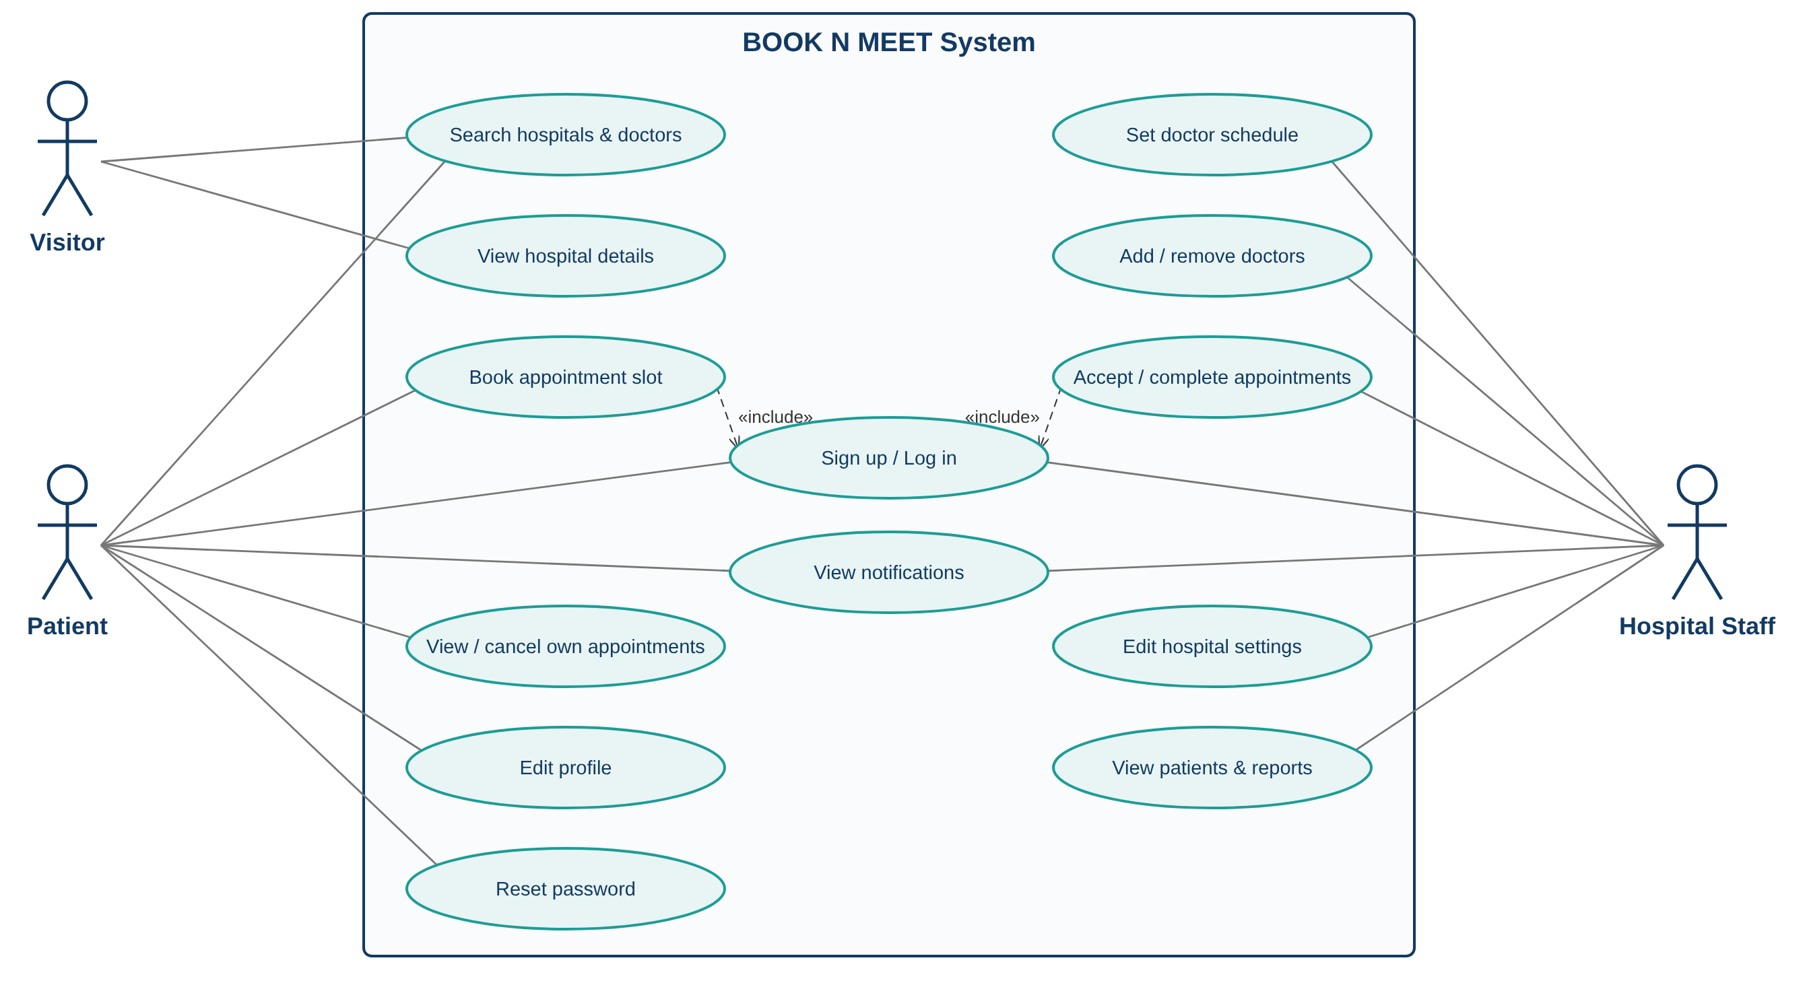
Figure 6.1: Use case diagram

6.5 Class diagram
Shows the main classes, their attributes and operations and the relations. Patient and HospitalStaff inherit from User (generalisation); Hospital is composed of Doctors (composition).
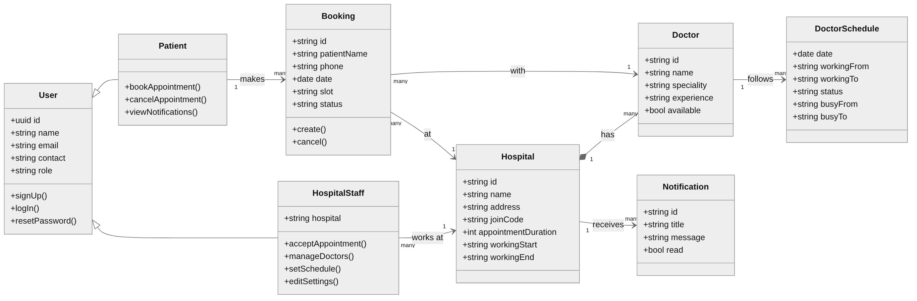
Figure 6.2: Class diagram

6.6 Sequence diagram - Book an appointment
Shows the messages between objects in time order when a patient books a slot.
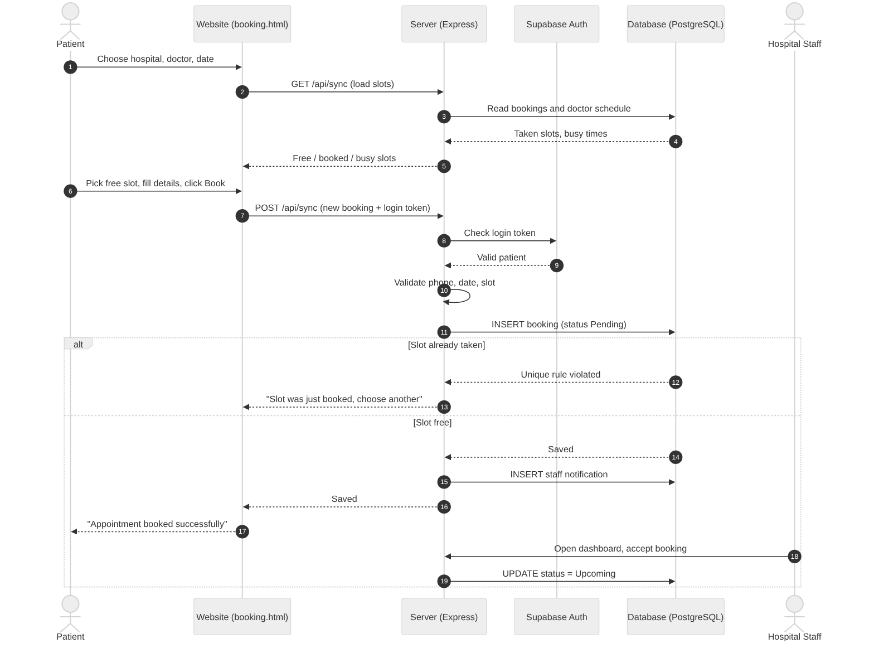
Figure 6.3: Sequence diagram for booking an appointment

6.7 Activity diagram - Booking process
Shows the flow of activities with decisions (diamonds) from opening the website to the staff accepting the booking.
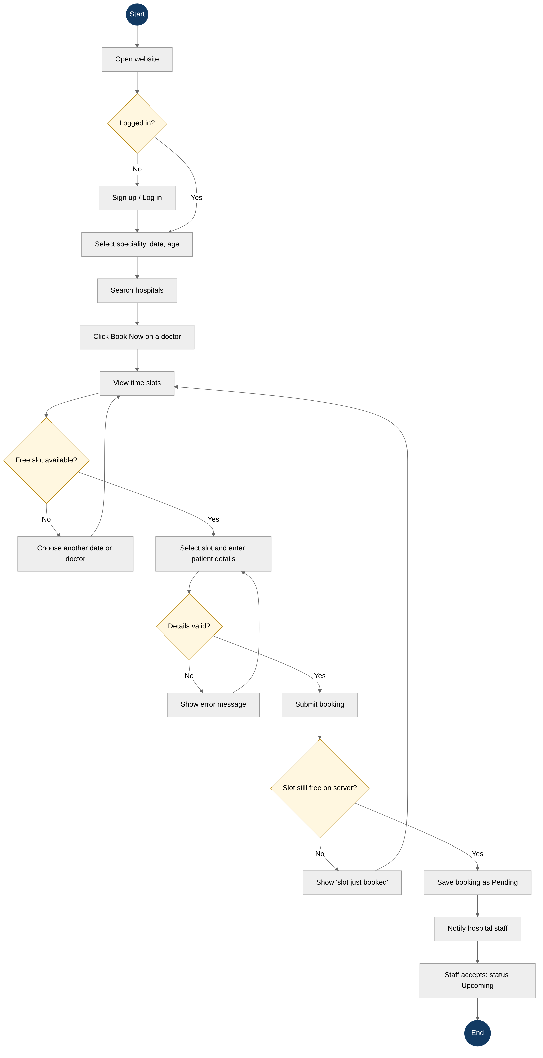
Figure 6.4: Activity diagram for booking

6.8 Component diagram
Shows the software components and how they connect.
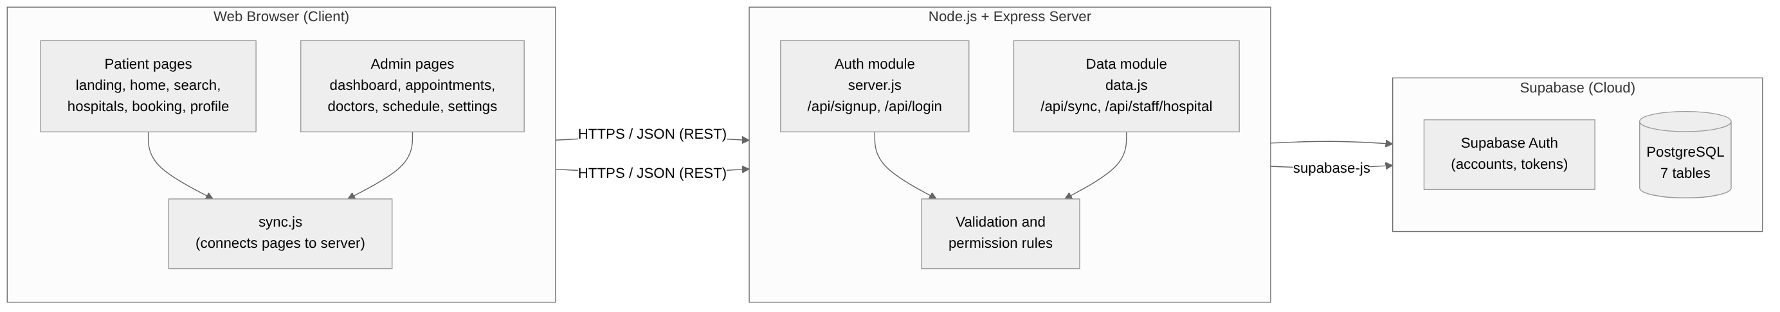
Figure 6.5: Component diagram

6.9 Deployment diagram
Shows the physical nodes (devices and servers) where the system runs.
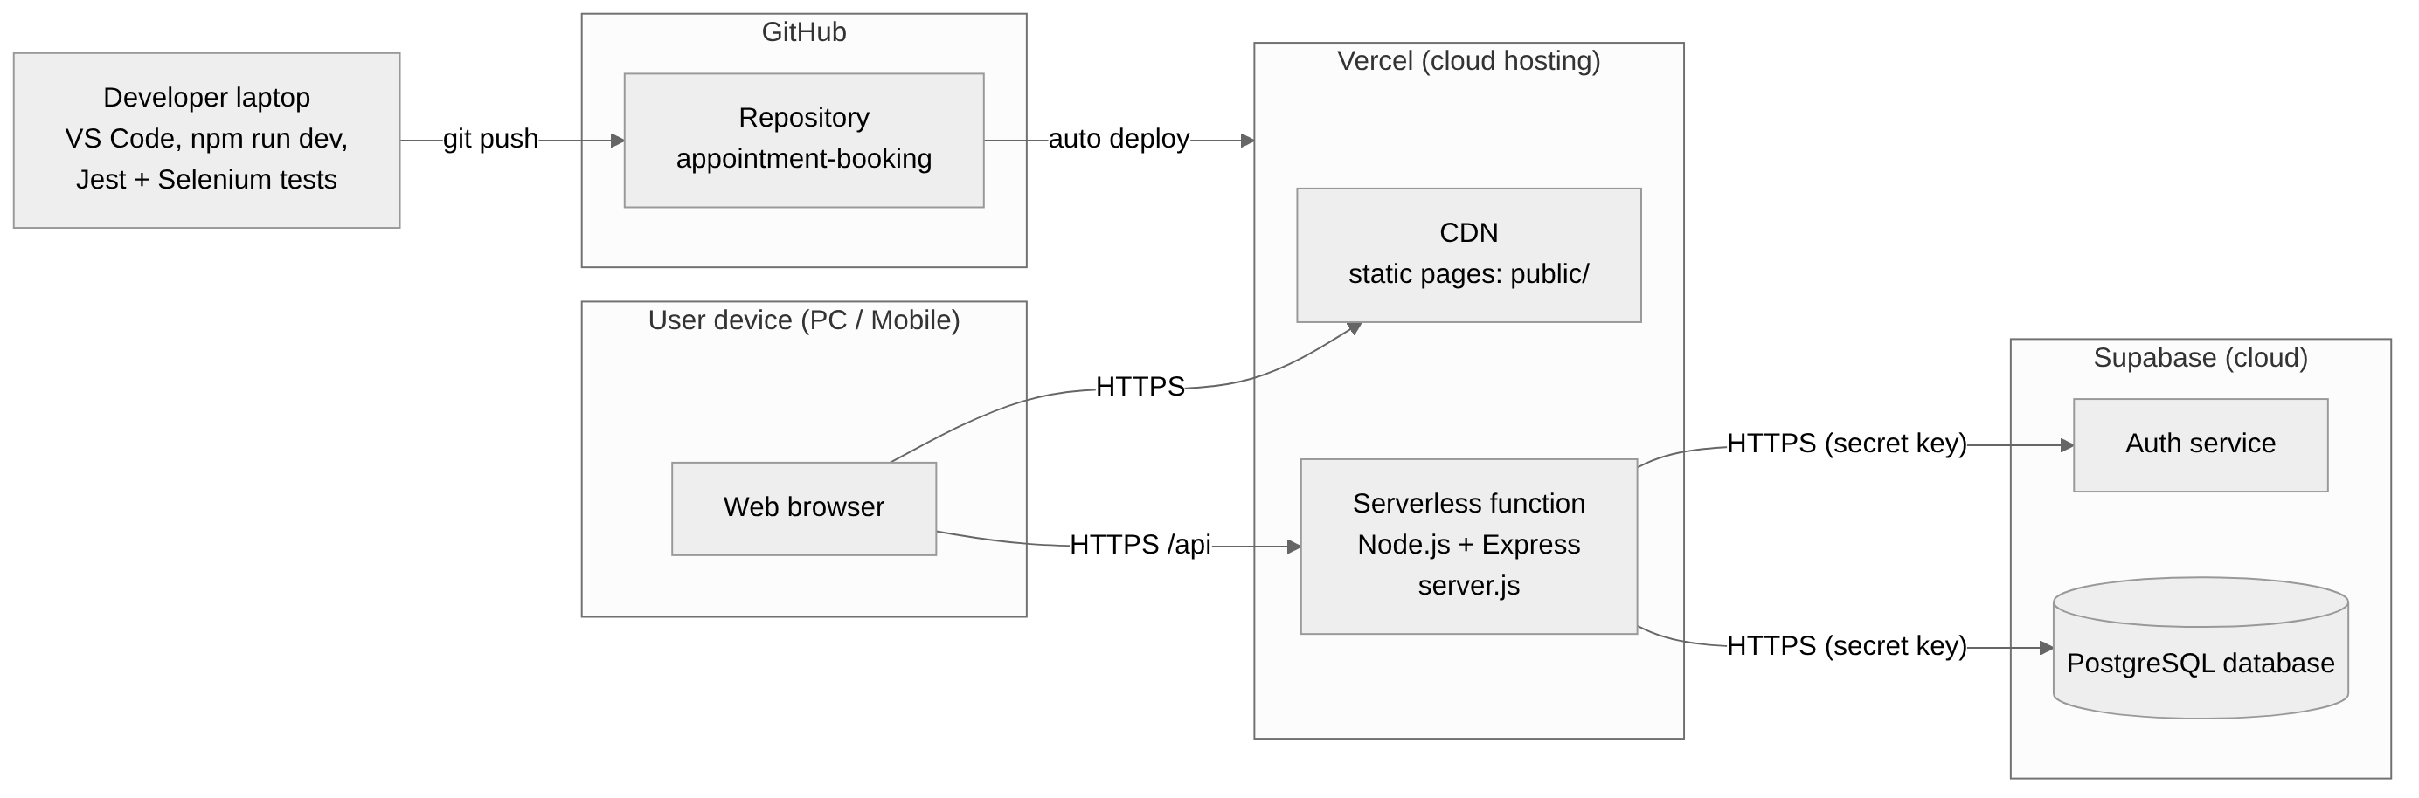
Figure 6.6: Deployment diagram

7. Implementation and Modules

7.1 Modules
No. | Module | Pages / files | What it does
1 | Authentication | landing.html, reset-password.html, backend/server.js | Sign up (patient/staff with join code), log in, log out, forgot and reset password, password rules, show/hide password
2 | Hospital & doctor directory | first.html, hospitals.html | Home page with top hospitals and doctors; hospital details (services, timings, doctors)
3 | Search | search.html | Search by speciality, date and age; matching hospitals and doctors with Book Now
4 | Appointment booking | booking.html, backend/data.js | Shows slots (available / booked / busy / outside hours), validates details, saves booking as Pending, blocks double booking
5 | Patient profile | profile.html | Personal details, edit profile, appointment history, cancel appointment
6 | Notifications | notifications.html, admin-notifications.html | Patient and staff notifications with unread dot
7 | Staff dashboard | admin.html | Today's and upcoming appointments, counts, doctor availability
8 | Appointment management | appointments.html | Accept, complete, mark missed, reject
9 | Doctor management | doctors.html | Add doctor (speciality drop-down or new speciality), remove doctor
10 | Doctor schedule | doctor-schedule.html | Working hours and busy time per date; notifies affected patients
11 | Patients & reports | patients.html, reports.html | List of patients and simple statistics for the hospital
12 | Settings | settings.html | Hospital details, slot length, working hours, staff join code
13 | Sync (data link) | js/sync.js | Loads data from the server when a page opens, saves changes, refreshes every 5 seconds
14 | Database | backend/database/setup.sql | Creates the 7 tables and adds the 5 hospitals and 13 doctors

7.2 Main server API
Method | Address | Use
POST | /api/signup | Create an account (checks Gmail, password rule, join code)
POST | /api/login | Log in; returns a login token
POST | /api/forgot-password, /api/reset-password | Password reset by email
GET | /api/sync | Get hospitals, doctors, schedules, bookings and notifications the user may see
POST | /api/sync | Save changes (booking, cancel, doctor, schedule) after checking permissions
PUT | /api/staff/hospital | Staff update their hospital's details and slot settings
GET | /api/health | Check that the server is running

7.3 Implementation techniques used
- Structured and modular programming: each page has its own HTML, CSS and JS; shared code in js/ files.
- Client-side + server-side validation: forms check input at once; the server checks again so wrong data can never be saved.
- REST API with JSON: pages and server communicate through clear addresses (endpoints).
- Token-based authentication: after login, every request carries a token that the server verifies.
- Role-based access control: patients and staff get different permissions; staff only see their own hospital.
- Database constraints: primary/foreign keys and a unique index prevent bad or duplicate data.
- Version control: Git and GitHub; every change is committed and pushed.
- Coding standards: clear names, comments in plain English, consistent indentation, separate CSS files.
- Continuous deployment: Vercel deploys automatically after every git push.

7.4 How to run
- On a laptop: npm install, then npm run dev (starts the server and opens the website).
- Online: open https://appointment-booking-lake-two.vercel.app
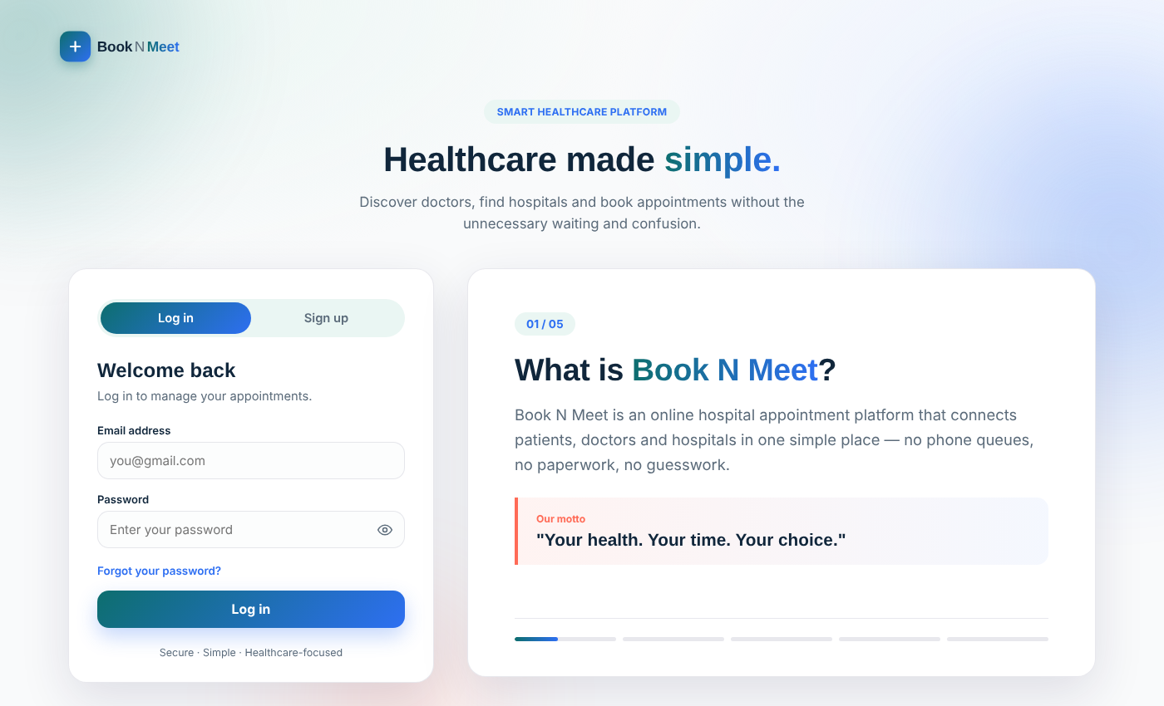
Figure 7.1: Login page of BOOK N MEET

8. Software Testing and Test Cases

8.1 Testing tools
Tool | Type | Used for
Selenium WebDriver | Automated UI / functional / system testing | Opens Chrome and clicks through the website like a real user (20 test cases)
Jest | Unit and integration (API) testing | Checks every server feature with valid and invalid input (48 test cases). Jest is for JavaScript what JUnit is for Java.
JUnit (theory) | Unit testing framework for Java | Not used because our code is JavaScript; Jest gives the same features (test cases, assertions, suites)
jest-html-reporter | Test reporting | HTML report of all test results
ChromeDriver | Browser driver | Lets Selenium control Google Chrome

8.2 Levels of testing done
Level | What was tested in BOOK N MEET
Unit testing | Single server rules: password rule, Gmail check, 10-digit phone, date not in the past, valid slot time
Integration testing | Website + server + database together, e.g. a booking saved by the server appears for the staff and creates a notification
System testing | Complete flows in the browser with Selenium: sign up -> search -> book -> cancel -> logout; staff login -> dashboard
Acceptance testing | Team and friends used the live site as patients and staff (user acceptance / beta testing)
Regression testing | All 68 tests run again after every change (npm test)

8.3 Test design techniques
- Black box - Equivalence partitioning: valid vs invalid emails (Gmail / non-Gmail), valid vs invalid roles.
- Black box - Boundary value analysis: password length 7 / 8 characters; phone 9 / 10 / 11 digits; slot length 15, 30, 45, 60 allowed and 20 refused.
- Black box - Decision table: who may change a booking (owner patient, same-hospital staff, other staff, other patient).
- White box: tests written to cover each branch of the booking rules (new booking, accept, cancel, refuse).
- Security / negative testing: fake token, no login, wrong join code, other hospital's data.

8.4 Sample test cases
ID | Test scenario | Input / steps | Expected result | Result
TC-01 | Patient sign up | Valid name, Gmail, 10-digit phone, Test@1234 | Account created | Pass
TC-02 | Non-Gmail email | someone@yahoo.com | Error: must end with @gmail.com | Pass
TC-03 | Weak password | abc123 | Error: password rule | Pass
TC-04 | Staff without join code | Role staff, no code | Sign up refused | Pass
TC-05 | Wrong password login | Wrong@1234 | Invalid email or password | Pass
TC-06 | Book free slot | Future date, 10:30 AM | Saved, status Pending | Pass
TC-07 | Double booking | Same doctor, date, time by another patient | Refused: slot just booked | Pass
TC-08 | Past date | Date 3 days ago | Refused | Pass
TC-09 | Privacy | Other patient views bookings | Sees slot only, no name/phone | Pass
TC-10 | Other hospital staff | Gowthami staff accepts Trinity booking | Refused | Pass
TC-11 | Patient cancels | Cancel own Pending booking | Status Canceled, staff notified | Pass
TC-12 | Invalid slot length | 20 minutes | Refused: 15/30/45/60 only | Pass
TC-13 (UI) | Search without speciality | Click Search | Pop-up: select a speciality | Pass
TC-14 (UI) | Book in browser | Pick free slot, Select, Book | Booked successfully pop-up | Pass
TC-15 (UI) | Patient opens staff page | Go to appointments.html | Sent away from the page | Pass

8.5 Test summary
Suite | Tool | Cases | Passed | Failed
Accounts (sign up, log in) | Jest | 16 | 16 | 0
Appointments, privacy, notifications | Jest | 19 | 19 | 0
Hospital staff (doctors, schedule, settings) | Jest | 13 | 13 | 0
Website user journeys | Selenium | 20 | 20 | 0
Total |  | 68 | 68 | 0
Result: all 68 test cases passed (100%). Full test cases are in the separate document "BOOK-N-MEET-Testing-and-Test-Cases.docx".

8.6 Conclusion
BOOK N MEET meets its objectives: patients can find hospitals and book, view and cancel appointments online; hospital staff manage appointments, doctors, schedules and settings securely; and the system is tested with 68 automated tests and deployed live on Vercel.

8.7 Future enhancements
- SMS / WhatsApp reminders, online payment, video consultation, Google sign-in, more hospitals and cities.

