BOOK N MEET
Online Hospital Appointment Booking System
Software Testing and Test Cases
Testing tools: Selenium WebDriver | Jest | jest-html-reporter
68 automated test cases - 68 passed, 0 failed
Team members: ______________________________
Date of test run: 11 November 2026

1. Introduction
BOOK N MEET lets patients find hospitals and doctors in Tadepalligudem and book appointment slots online, and lets hospital staff manage their appointments, doctors, schedules and hospital details. The website is built with HTML, CSS and JavaScript, the server with Node.js and Express, and all data is stored in a Supabase (PostgreSQL) database.
Testing was done to check that every feature works as expected, that wrong input is refused with a clear message, and that one user can never see or change data that belongs to another user or another hospital. All tests are automated, so the whole system can be re-tested with a single command after every change.

2. Testing tools used
Tool | Type of testing | What it was used for
Selenium WebDriver 4.52 (JavaScript) | Automated UI / functional testing | Opens a real Google Chrome window and clicks through the website like a real user: sign up, log in, search, book a slot, cancel, logout, staff dashboard. 20 test cases.
Jest 29.7 | Unit and integration (API) testing | Calls every server feature directly and checks the answer: sign up and log in rules, booking, double-booking, privacy, permissions, doctors, schedules, settings, join codes. 48 test cases. Jest is the JavaScript equivalent of JUnit (JUnit is used for Java).
jest-html-reporter 3.10 | Test reporting | Makes an HTML test report (test-report.html) with every test, its time and its result.
Google Chrome + ChromeDriver | Browser for UI tests | Selenium controls Chrome through ChromeDriver. Selenium Manager downloads the matching driver automatically.
Supabase (PostgreSQL) | Test data | Tests run against the real database. Test accounts start with "bnmtest." and everything the tests create is deleted after the run.
Playwright | Development checks | Used while building the project for quick end-to-end checks and screenshots of pages.

Why Jest instead of JUnit
JUnit is a testing framework for Java programs. BOOK N MEET is written in JavaScript (Node.js), so JUnit cannot run its code. Jest does the same job for JavaScript: tests are written as test cases with expected results (expect ... toBe ...), grouped into suites, and run with one command that reports pass or fail for each case, exactly like JUnit.

3. Types of testing performed
- Unit / API testing (Jest): each server feature tested on its own with valid and invalid input.
- Functional UI testing (Selenium): complete user journeys tested in a real browser.
- Negative testing (validation): wrong email, weak password, past dates, wrong phone numbers, empty fields and invalid times are all refused.
- Security and permission testing: visitors cannot save, patients cannot use staff features, staff can only manage their own hospital, staff sign-up needs a secret join code, and patient details are hidden from other patients and other hospitals.
- Integration testing: website, server and database tested together (booking made in the browser appears in the database, the staff dashboard and the notifications).
- Regression testing: the full suite of 68 tests is re-run after every change with npm test.
- Black-box testing: test cases are written from what the user should see, without depending on the code inside.

4. Test environment
Item | Details
Operating system | macOS (development laptop) and Linux
Runtime | Node.js 22
Browser | Google Chrome (driven by ChromeDriver)
Server | Node.js + Express, started automatically by the tests (npm run dev)
Database | Supabase (PostgreSQL + Supabase Auth)
Website address during tests | http://localhost:5501 (server: http://localhost:5050)
Test location in project | tests/api (Jest), tests/ui (Selenium), settings in jest.config.js

5. How to run the tests
In the main appointment-booking folder:
- npm install - first time only, installs Jest and Selenium.
- npm test - runs all 68 tests (the server starts by itself).
- npm run test:api - only the 48 Jest server tests.
- npm run test:ui - only the 20 Selenium website tests (a Chrome window opens and you can watch).
Results appear in the terminal, in test-report/test-report.html and as a screenshot of every website test in test-report/screenshots.

6. Test cases - Server (Jest)
48 test cases. Each one sends a request to the server and checks the answer.
Test ID | Module | Test scenario | Steps / test data | Expected result | Actual result
TC-API-01 | Server | Server is running | GET /api/health | 200 OK, success = true | Pass
TC-API-02 | Sign up | Patient signs up with valid details | Name, @gmail.com email, 10-digit contact, strong password, role Patient | 201 Created, account made | Pass
TC-API-03 | Sign up | Empty fields | Only an email, other fields empty | 400, "All required fields must be filled" | Pass
TC-API-04 | Sign up | Email not ending in @gmail.com | someone@yahoo.com | 400, email must end in @gmail.com | Pass
TC-API-05 | Sign up | Weak password | Password abc123 | 400, password rule message | Pass
TC-API-06 | Sign up | Contact number not 10 digits | Contact 12345 | 400, "exactly 10 digits" | Pass
TC-API-07 | Sign up | Name with numbers | Name Ravi123 | 400, "only alphabets and spaces" | Pass
TC-API-08 | Sign up | Same email used twice | Sign up again with the TC-API-02 email | 400, refused | Pass
TC-API-09 | Sign up | Staff without join code | Role Staff, Trinity Hospital, no code | 400, join code message | Pass
TC-API-10 | Sign up | Staff with wrong join code | Join code WRONG1 | 400, join code message | Pass
TC-API-11 | Sign up | Staff with correct join code (small letters) | Trinity's real code typed in lowercase | 201 Created | Pass
TC-API-12 | Sign up | Staff with a hospital that does not exist | Hospital "Fake Hospital" | 400, "select your hospital" | Pass
TC-API-13 | Log in | Correct email and password | Account from TC-API-02 | 200, login token, role = patient | Pass
TC-API-14 | Log in | Wrong password | Password Wrong@1234 | 401, "Invalid email or password" | Pass
TC-API-15 | Log in | Empty fields | Empty body | 400 | Pass
TC-API-16 | Security | Fake login token | GET /api/sync with token "fake-token" | 401, please log in again | Pass
TC-API-17 | Public view | Visitor sees hospitals and doctors | GET /api/sync without login | All 5 hospitals and their doctors listed | Pass
TC-API-18 | Security | Visitor tries to save a booking | POST /api/sync without login | 401, refused | Pass
TC-API-19 | Booking | Patient books a free slot | Trinity doctor, future date, 10:30 AM | Saved, status Pending | Pass
TC-API-20 | Booking | Double booking | Second patient, same doctor, date and time | Refused, "slot was just booked" | Pass
TC-API-21 | Booking | Date in the past | Date 3 days ago | Refused, "today or a future date" | Pass
TC-API-22 | Booking | Invalid phone number | Phone 12ab | Refused, phone message | Pass
TC-API-23 | Booking | No time slot | Slot empty | Refused, "select a time slot" | Pass
TC-API-24 | Booking | Staff tries to book | Staff token | Refused, "Only patients can book" | Pass
TC-API-25 | Privacy | Other patient views the booking | Second patient loads data | Sees slot only, no name / phone / email | Pass
TC-API-26 | Privacy | Same-hospital staff view the booking | Trinity staff loads data | Full patient details visible | Pass
TC-API-27 | Privacy | Other-hospital staff view the booking | Gowthami staff loads data | Patient name hidden | Pass
TC-API-28 | Notifications | Hospital told about new booking | Trinity staff notifications | "New appointment request" with patient name | Pass
TC-API-29 | Permissions | Other-hospital staff accept booking | Gowthami staff sets status Upcoming | Refused, "own hospital" | Pass
TC-API-30 | Permissions | Other patient cancels booking | Second patient sets status Canceled | Refused | Pass
TC-API-31 | Booking | Staff accept booking | Trinity staff sets status Upcoming | Saved, patient sees Upcoming | Pass
TC-API-32 | Booking | Patient cancels own booking | Patient sets status Canceled | Saved, status Canceled | Pass
TC-API-33 | Notifications | Hospital told about cancellation | Trinity staff notifications | "Appointment cancelled by patient" | Pass
TC-API-34 | Booking | Cancelled slot is free again | Book same doctor, date, time again | Saved | Pass
TC-API-35 | Validation | Unknown status | Staff sets status "Hacked" | Refused, "Unknown appointment status" | Pass
TC-API-36 | Doctors | Patient adds a doctor | Patient token | Refused, "Only hospital staff" | Pass
TC-API-37 | Doctors | Doctor without speciality | Name only | Refused, speciality message | Pass
TC-API-38 | Doctors | Staff add a doctor | Dr. Test Kumar, Cardiology | Saved, doctor listed under Trinity | Pass
TC-API-39 | Permissions | Other-hospital staff edit that doctor | Gowthami staff token | Refused, "own hospital" | Pass
TC-API-40 | Schedule | Mark doctor busy | Working 09:00-17:00, busy 11:00-12:00 | Saved | Pass
TC-API-41 | Schedule | End time before start time | Working 17:00-09:00 | Refused, end time message | Pass
TC-API-42 | Permissions | Other-hospital staff remove doctor | Gowthami staff token | Refused | Pass
TC-API-43 | Doctors | Staff remove the doctor | Trinity staff token | Doctor in removed list | Pass
TC-API-44 | Settings | Patient changes hospital details | PUT /api/staff/hospital with patient token | 403 Forbidden | Pass
TC-API-45 | Settings | Invalid appointment length | 20 minutes | 400, "15, 30, 45 or 60 minutes" | Pass
TC-API-46 | Settings | Working hours end before start | 18:00 to 09:00 | 400 | Pass
TC-API-47 | Join code | Staff see own join code | Trinity staff loads data | Join code shown for Trinity | Pass
TC-API-48 | Join code | Others never see the join code | Patient and Gowthami staff load data | No join code for Trinity | Pass

7. Test cases - Website (Selenium)
20 test cases. Selenium opens Chrome and performs each step on the real website.
Test ID | Module | Test scenario | Steps / test data | Expected result | Actual result
TC-UI-01 | Login page | Login page opens | Open landing.html | Title "Book N Meet", login form visible | Pass
TC-UI-02 | Login page | Empty login | Click Login with empty fields | "Please enter your email and password" | Pass
TC-UI-03 | Login page | Wrong password | Type an email and Wrong@1234, click Login | "Invalid email or password" | Pass
TC-UI-04 | Sign up | Live password rules | Type abc, then Test@1234 | Rules red for abc, all green for Test@1234 | Pass
TC-UI-05 | Sign up | Staff fields | Choose role Hospital Staff | Hospital and join code fields appear | Pass
TC-UI-06 | Sign up | Staff without join code | Fill all fields except the join code | Sign Up button stays disabled | Pass
TC-UI-07 | Sign up | Patient signs up | Fill the form, role Patient, click Sign Up | "Account created!" | Pass
TC-UI-08 | Login page | Patient logs in | Email pre-filled, type password, click Login | Home page (first.html) opens | Pass
TC-UI-09 | Home page | Top hospitals shown | Look at the home page | Hospital cards are listed | Pass
TC-UI-10 | Search | Search without speciality | Click Search Hospitals | Pop-up "Please select a speciality" | Pass
TC-UI-11 | Search | Search by speciality | Cardiology, a date, age 30, click Search | Search results page with hospitals | Pass
TC-UI-12 | Booking | Book Now | Click Book Now on the first result | Booking page with hospital and doctor filled | Pass
TC-UI-13 | Booking | Book without a slot | Fill details, click Book Appointment | "Please select an available time slot" | Pass
TC-UI-14 | Booking | Book an appointment | Click a free slot, Select, Book Appointment | Pop-up "Appointment booked successfully", back to home | Pass
TC-UI-15 | Profile | Appointment on profile | Open My Profile | Card with the doctor and status Pending | Pass
TC-UI-16 | Profile | Cancel appointment | Click Cancel appointment, confirm | Status Canceled, Cancel button gone | Pass
TC-UI-17 | Security | Patient opens a staff page | Go to appointments.html | Sent away from the staff page | Pass
TC-UI-18 | Logout | Patient logs out | Click Logout | Login page opens | Pass
TC-UI-19 | Staff | Staff log in | Staff email and password, click Login | Dashboard opens showing Trinity Hospital | Pass
TC-UI-20 | Staff | Join code on Settings | Open Settings | Staff Join Code is shown | Pass

8. Test summary
Test suite | Tool | Test cases | Passed | Failed
Accounts (sign up, log in) | Jest | 16 | 16 | 0
Appointments, privacy, notifications | Jest | 19 | 19 | 0
Hospital staff (doctors, schedule, settings, join codes) | Jest | 13 | 13 | 0
Website user journeys | Selenium | 20 | 20 | 0
Total |  | 68 | 68 | 0

Result: all 68 test cases passed (100%). The full run takes about 25 seconds.
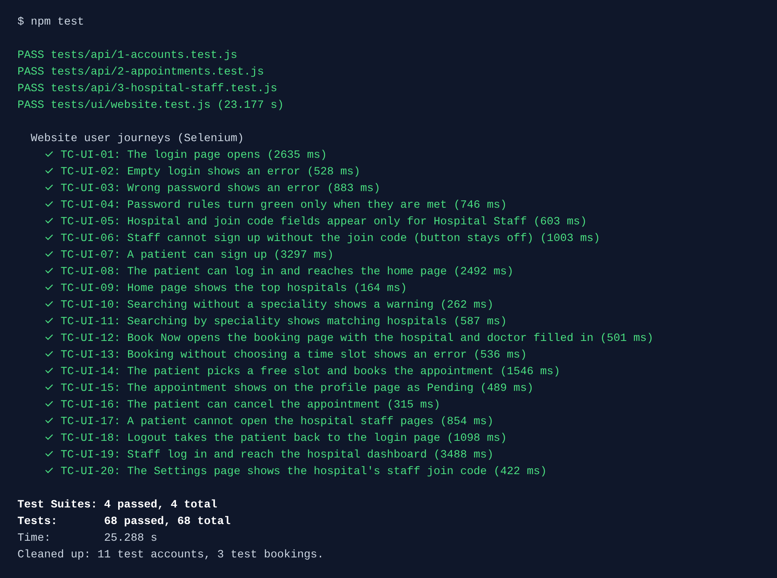
Figure 1: npm test output in the terminal (68 passed)
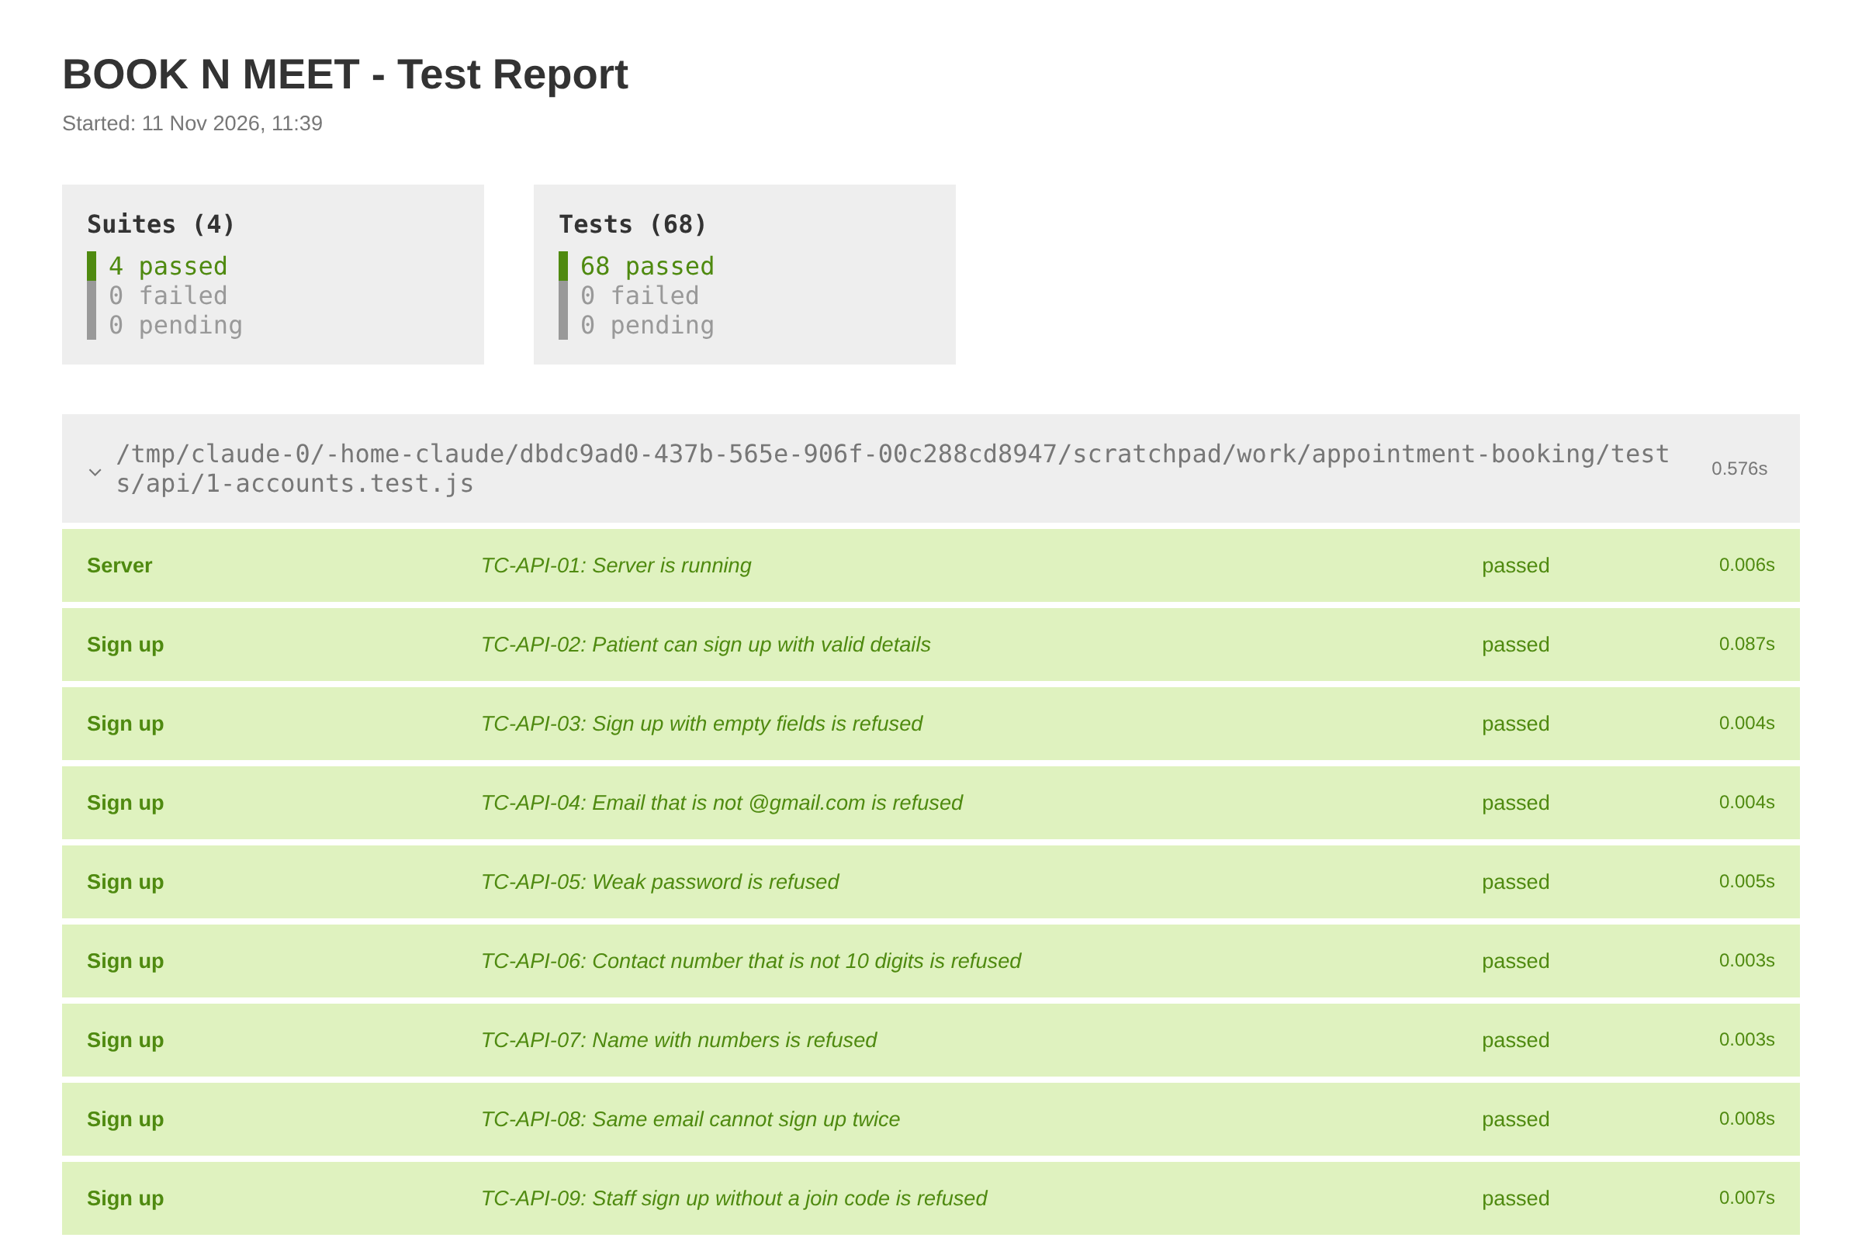
Figure 2: HTML test report made by jest-html-reporter

9. Selenium screenshots
Screenshots taken automatically by Selenium during the website tests.
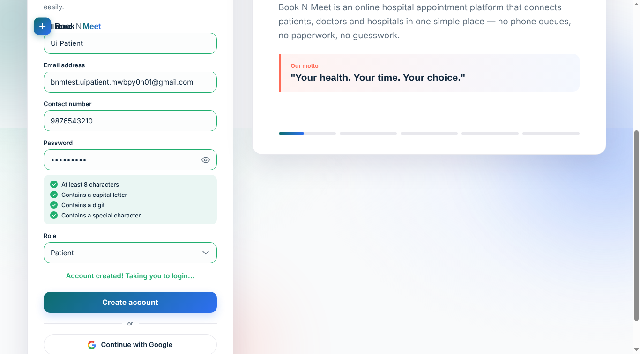
Figure 3: TC-UI-07 - patient sign up succeeds
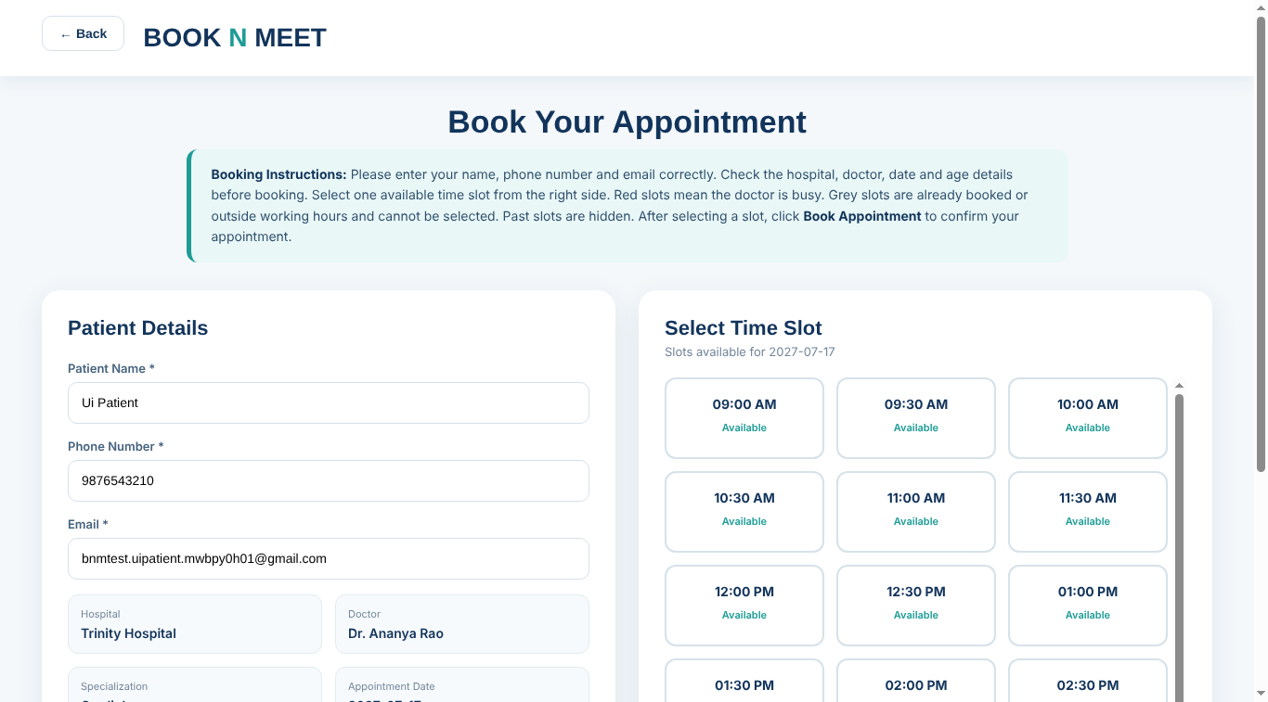
Figure 4: TC-UI-12 - booking page opened from the search results
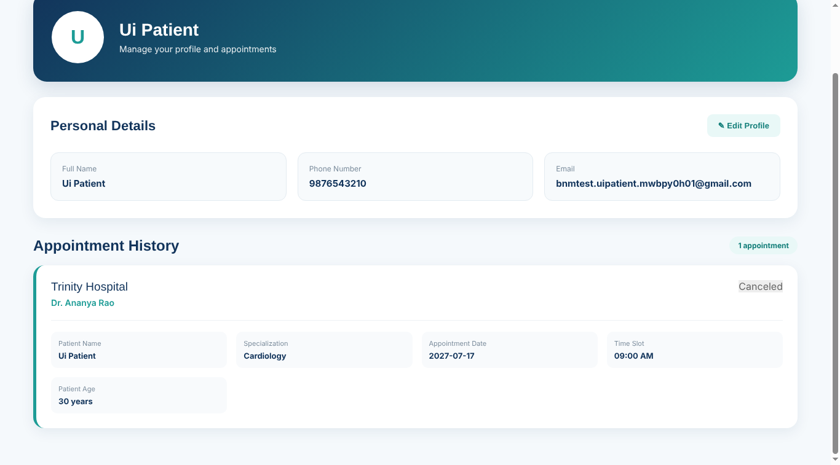
Figure 5: TC-UI-16 - appointment cancelled on the profile page
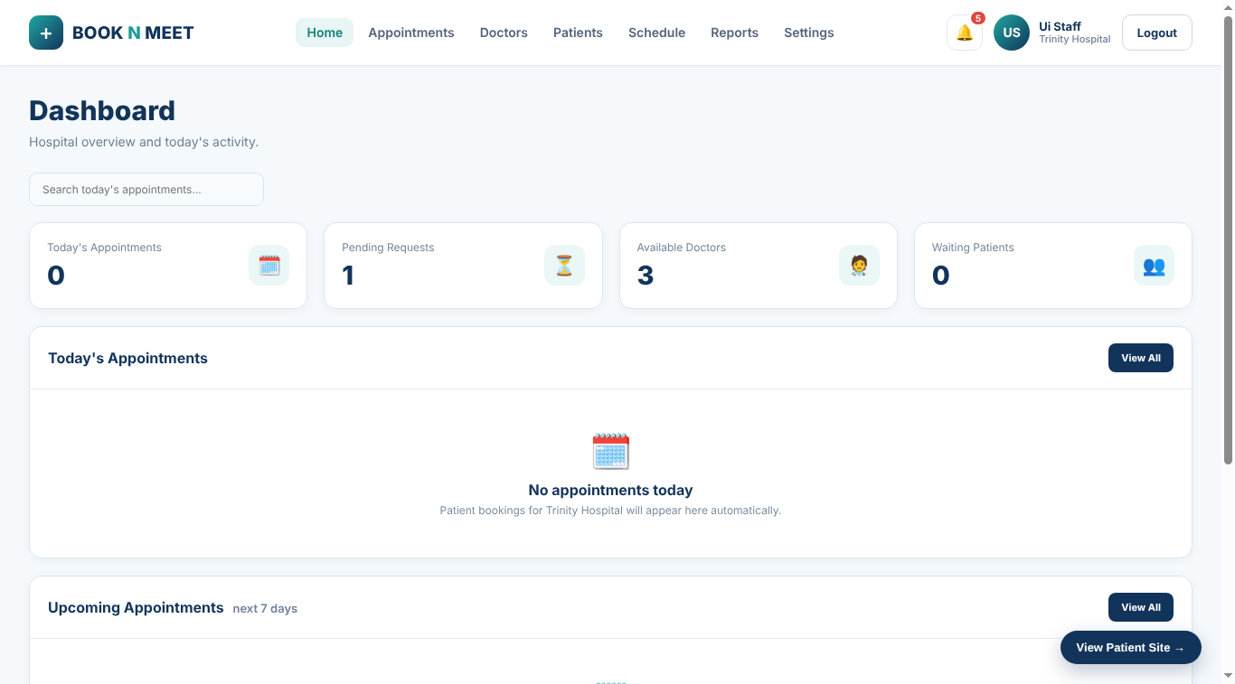
Figure 6: TC-UI-19 - hospital staff dashboard after login

10. Defects found and fixed during testing
No. | Defect found | Fix | Status
1 | Anyone could sign up as hospital staff and see patients' details. | Each hospital now has a secret join code that staff must type to sign up (TC-API-09 to 12, TC-UI-06). | Fixed
2 | Admin dashboard showed "No appointments today" even when appointments were booked for later days. | Added an Upcoming Appointments list for the next 7 days. | Fixed
3 | A staff member was taken to the patient home page after login. | Login now sends staff to the dashboard and patients to the home page; staff pages refuse patients (TC-UI-17, TC-UI-19). | Fixed
4 | Server could not reach the database when the Supabase address ended in /rest/v1. | Server now cleans the address before connecting. | Fixed
5 | Admin pages sometimes jumped to the home page when new data arrived. | Corrected how pages are told about new data. | Fixed
6 | Two patients could pick the same slot at the same moment. | Database rule allows only one active booking per doctor, date and time (TC-API-20). | Fixed
7 | Menu bar overflowed on small phone screens (profile and notifications pages). | Adjusted the page layout for small screens. | Fixed

11. Conclusion
The BOOK N MEET system was tested with 68 automated test cases using Selenium WebDriver for the website and Jest for the server. All test cases passed. The tests confirm that patients can sign up, search, book and cancel appointments, that hospital staff can manage appointments, doctors, schedules and settings for their own hospital only, that invalid input is refused with clear messages, and that patient details stay private. Because the tests are automated, the whole system can be checked again in about 25 seconds after any change.

