**Phase 2: Innovation**

**Introduction:**

Website traffic analysis is the process of monitoring and evaluating the data related to the visitors to a website. This analysis provides valuable insights into how users interact with your website, what content they consume, where they come from, and much more. The behavior pattern can be analyzed using the python.

**Libraries used for data analysis:**

**Pandas:** Pandas is a Python library used for working with data sets. It has functions for analyzing, cleaning, exploring, and manipulating data.

**NumPy:** NumPy is a Python library used for working with arrays. It also has functions for working in domain of linear algebra, Fourier transform, and matrices.

**Matplotlib Pyplot:** Matplotlib is a comprehensive library for creating static, animated, and interactive visualizations in Python.

**Seaborn:** Seaborn is a Python data visualization library based on matplotlib. It provides a high-level interface for drawing attractive and informative statistical graphics.

**Project explanation:**

The dataset is preprocessed using the python libraries mentioned above. Then the user behavior of the website can be determined.

In this phase 2 project a python code for behavior analysis is written to find the unique website users over a period of time

**Python code:**

import matplotlib.pyplot as plt

import pandas as pd

import seaborn as sns

import numpy as np

data=pd.read_csv("D:\Data Analytics\daily-website-visitors.csv")

data.head()

import plotly.express as px

px.histogram(data,x='Day',y='Unique.Visits',title='Sum of unique visits for each day over Time')

Output:

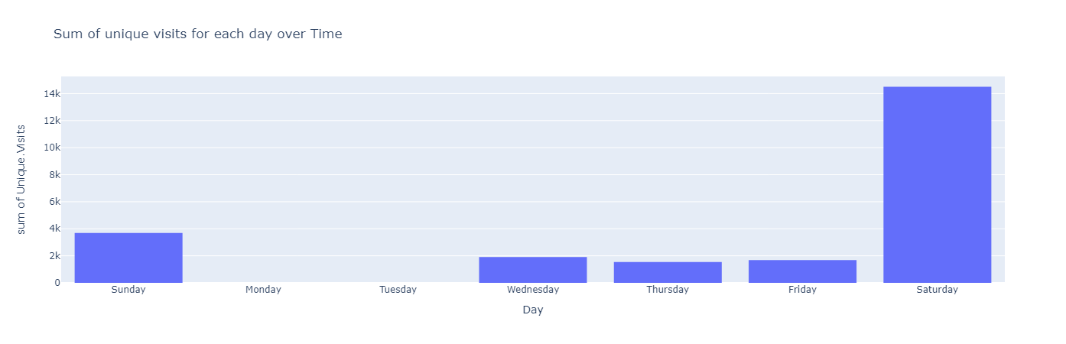

**Conclusion:**

By this analysis, the unique users of a website over a week can be predicted. From the given data Saturday has more unique visits. Monday and Tuesday have less unique visits.