Step 1: Prepare your data

We have a total of 24 unique labels and all the labels. And we have a approximately 1000 images for all the labels. So there is no bias in the distribution.

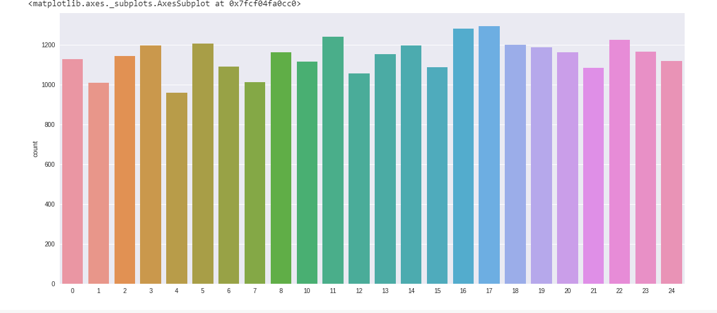

And now your dependent variables are images which are nothing but the array of 784 grayscale values.

So the first image is represented in this way and intotal there will 784 values for every image.

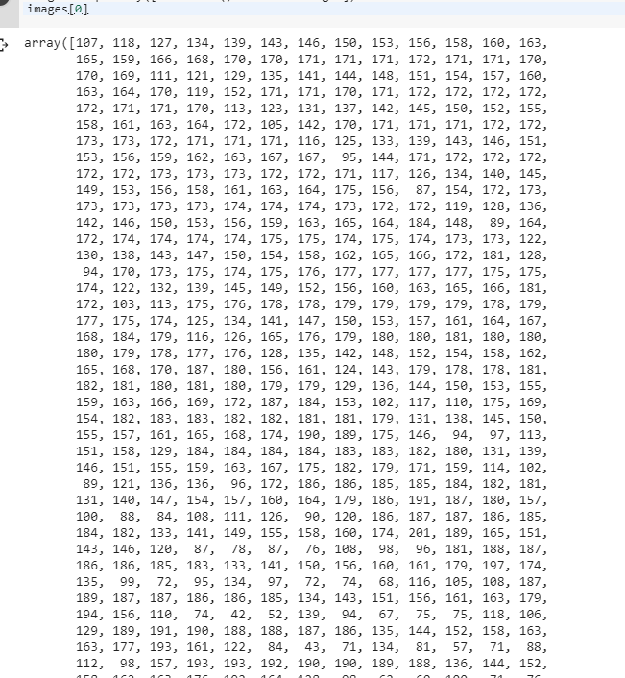

Now the data id ready to get used in the neural net. Now there will be two parts convolution block and classification block. And in evry covolution block three things happen namely convolution, activation and pooling and these things repeat in every block. Now lets see the first step of convolution block which it self is convolution

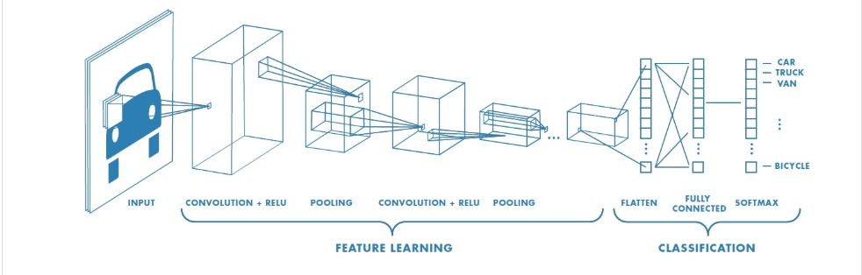

There atr two parts there is feature learning part and there is cassification part

feature learning: Three processes happens repeatedly. We first apply convolution and we apply activation function(relu) and then pooling these three operations are one convolution block. And there are four blocks like this in our modelblocks like this.

. Each of these points represent the pixel value we have two dimensions here 1st dimention is the length and the second dimention is the width. This is supervised learning so we have the target variable labels.

Step 1 prepare your data

Step 2 convolution

We are going to select a receptive field and we are going to select a kernel of some size in this example it is a 3*3 kernal or weights and we are going to multiply and add the values.

Step 3

Pooling reducing the spatial dimensions (Width x Height) of the Input Volume for the next Convolutional Layer.

The transformation is either performed by taking the maximum value from the values observable in the window (called ‘max pooling’), or by taking the average of the values. Max pooling has been favoured over others due to its better performance characteristics.

Step 4 – Activation (RELU in our case)

**Step 5 - Regularization**