**REPORT OF WEB DEVELOPMENT INTERNSHIP**

**ABSTRACT:**

The task was to create a multi-page responsive website. The website for an imaginary café called Caffeista has been developed using HTML, CSS and Javascript. The website contains 5 pages namely- Home page, Login/Signup page, Products page which redirects to the payment page and finally the thank you page. The website has 2 style sheets for designing the layout of the pages and a Javascript validation page.HTML 5, CSS are used in creating the final product.

The aim of this project is to create a website which is user friendly and is easy to use. The Caffeista is the website of an imaginary café and a bakery which provides online services of delivering orders of food and drinks such as coffee, cappuccino, tea, hot chocolate, cold coffee and so on. On the confectioneries, it provides sandwiches, cakes, pastries, muffins, waffles etc. The webpages have been designed to make the interface user friendly.

**TABLE OF CONTENTS**

* INTRODUCTION
* SYSTEM ARCHITECTURE
* METHODOLOGY
* IMPLEMENTATION
* CONCLUSION

The website contains:

* Home Page
* Login/Signup Page
* Products page
* Payment QR code
* Thank you page
* 5 HTML pages
* 2 Cascading Style Sheets
* 1 Javascript Validation form

**INTRODUCTION**

The goal of this project is to develop a user-friendly, simple-to-use website. The Caffeista is a website for a hypothetical café and bakery that offers online ordering and delivery of food and beverages like coffee, cappuccino, tea, hot chocolate, and other beverages. It offers sandwiches, cakes, pastries, muffins, waffles, and other sweets in the confectioneries. The interface of the webpages has been made user-friendly.

**SYSTEM ARCHITECTURE**

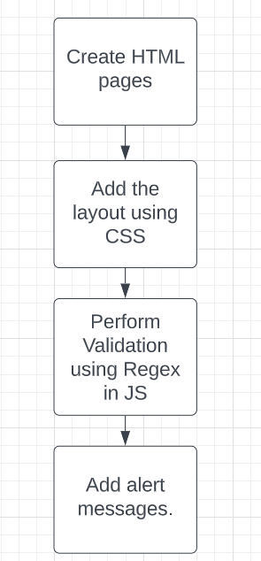

**METHODOLOGY**

The HTML pages have been created and linked with one another using anchor tags.The icons and fonts were referred from other sources.The validation of the login credentials has been carried out using Javascript.

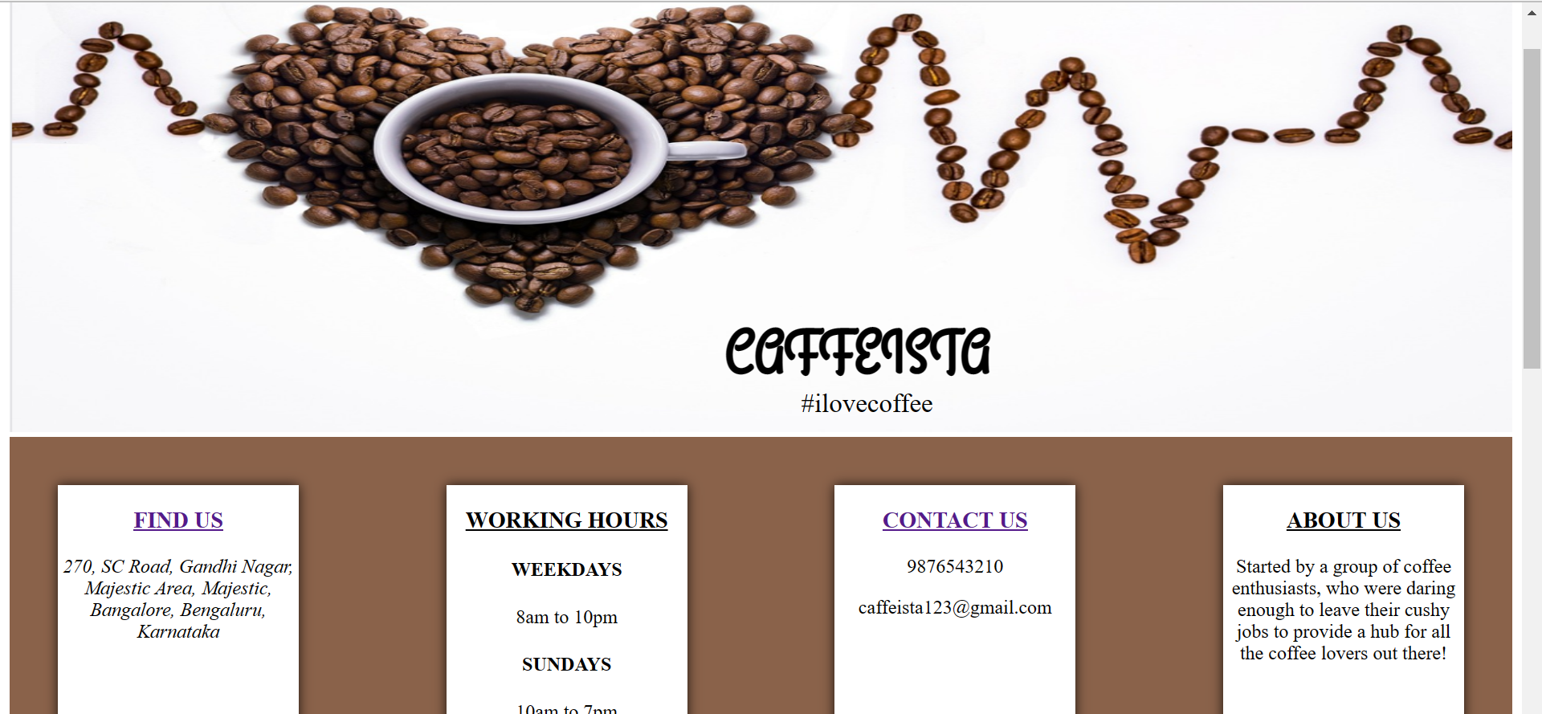

**IMPLEMENTATION**

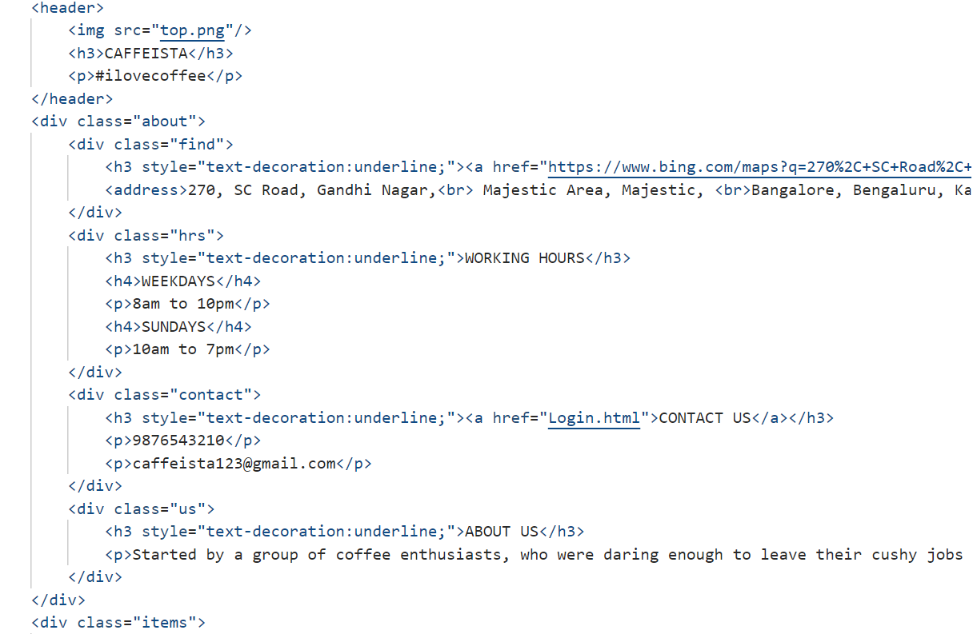

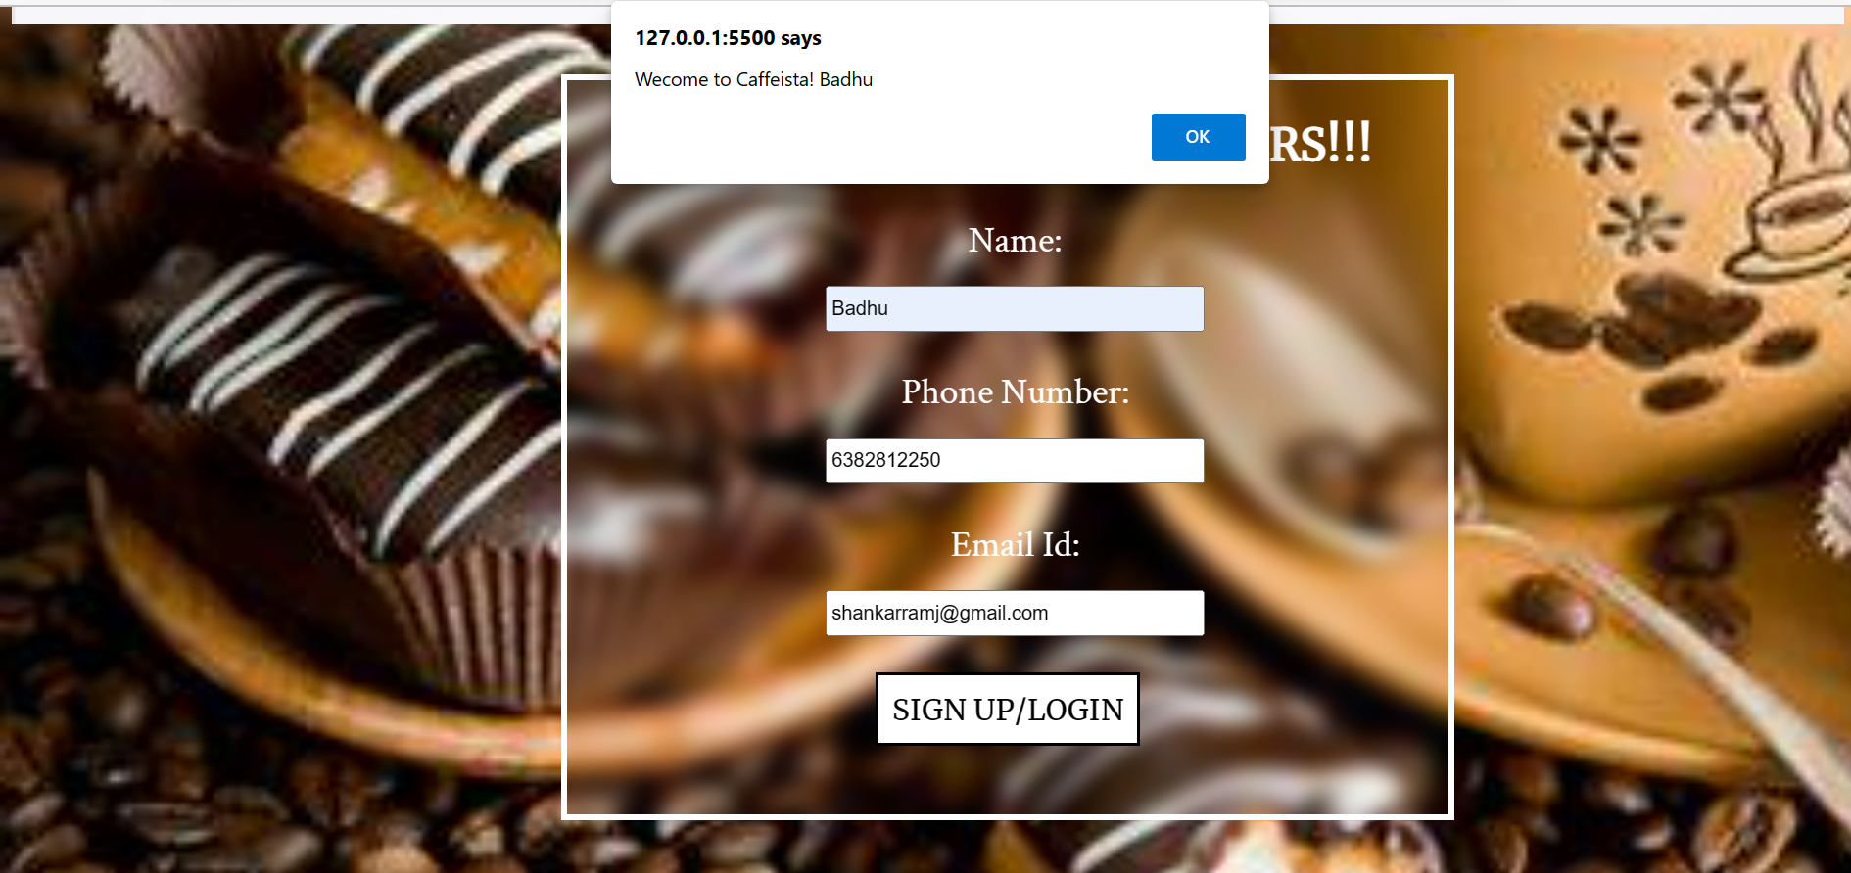

**CONCLUSION**

The multi page responsive website has been created using HTML, CSS and Javascript. The future works of this website includes working on validating in Javascript, creating payment interface and displaying orders of previous transactions. The future versions will include displaying total, connecting to a database to maintain records of orders and displaying food based on customer preferences. The payment interface is under development.