**LAB # 02**

**ArrayList and Vector in JAVA**

**OBJECTIVE:** To implement ArrayList and Vector.

## Lab Tasks

1. Write a program that initializes Vector with 10 integers in it. Display all the integers and sum of these integers.

**Code:**

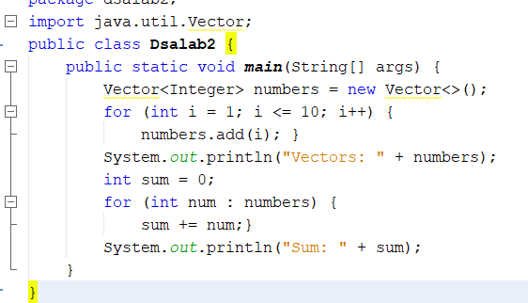

**Output:**

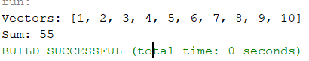

1. Create a ArrayList of string. Write a menu driven program which:
   * 1. Displays all the elements
     2. Displays the largest String

**Output:**

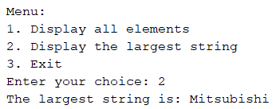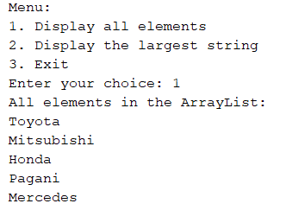A:

B:

**Code:**

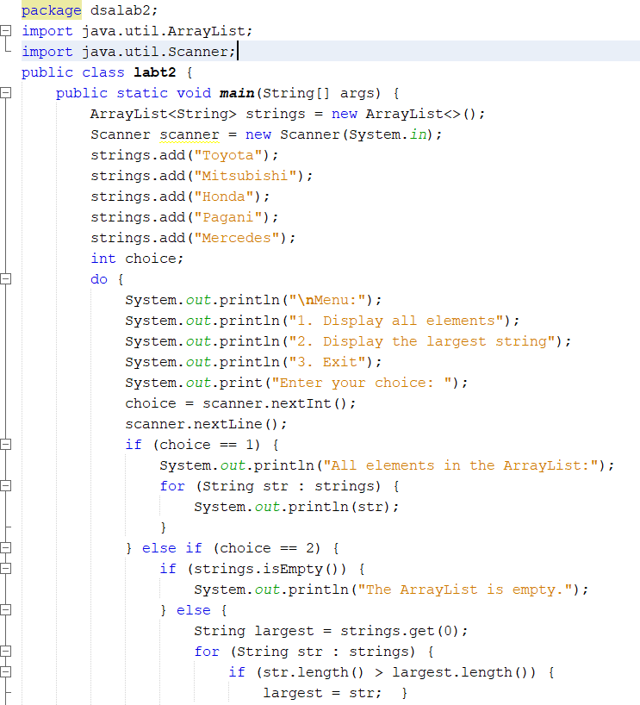

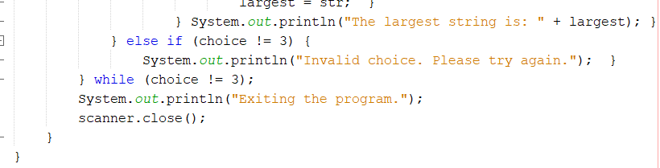

1. Create a Arraylist storing Employee details including Emp_id, Emp_Name, Emp_gender, Year_of_Joining (you can also add more attributes including these). Then sort the employees according to their joining year using Comparator and Comparable interfaces.

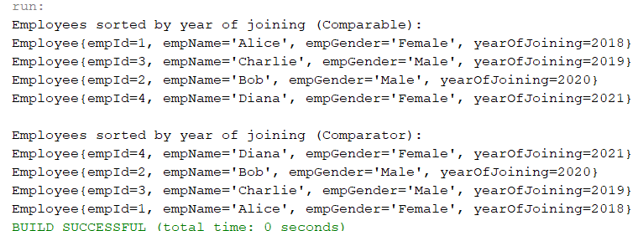**Output:**

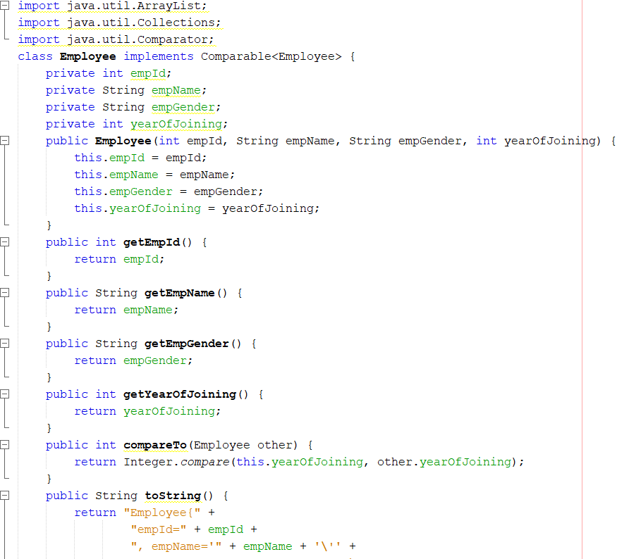

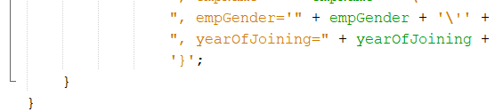

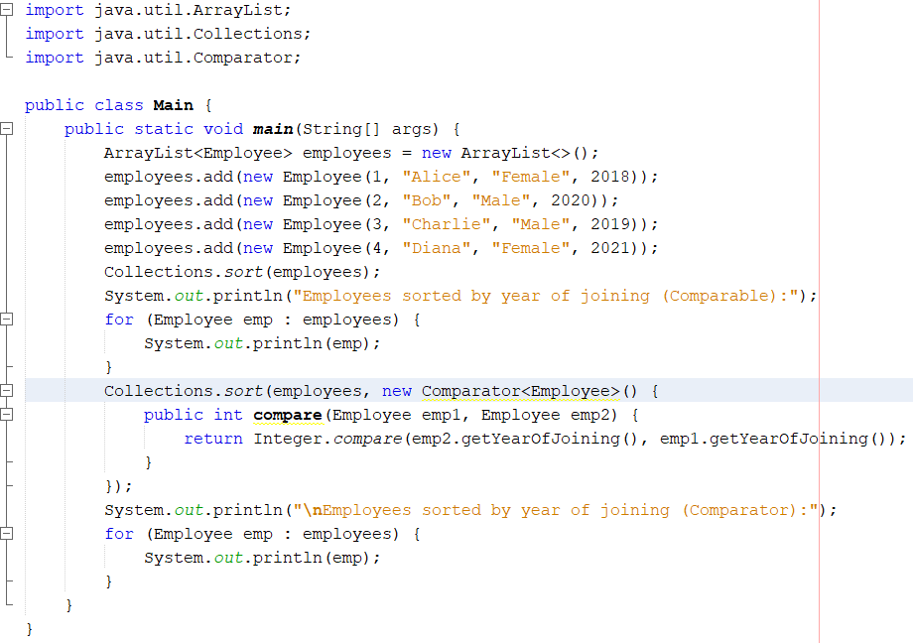

1. Write a program that initializes Vector with 10 integers in it.
   * Display all the integers • Sum of these integers.
   * Find Maximum Element in Vector

**Code:**

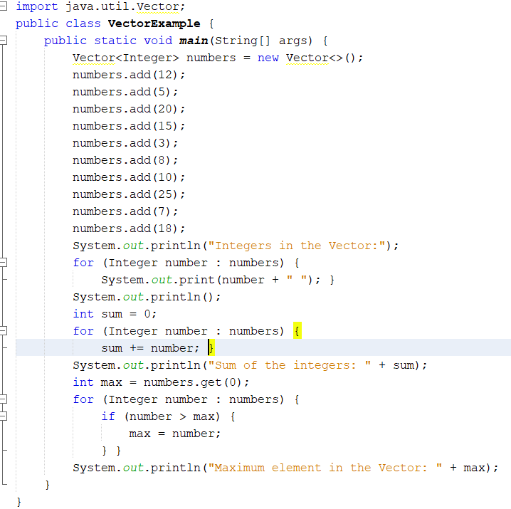

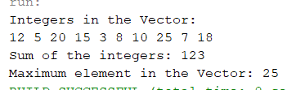**Output**

1. Find the k-th smallest element in a sorted ArrayList

**Code:**

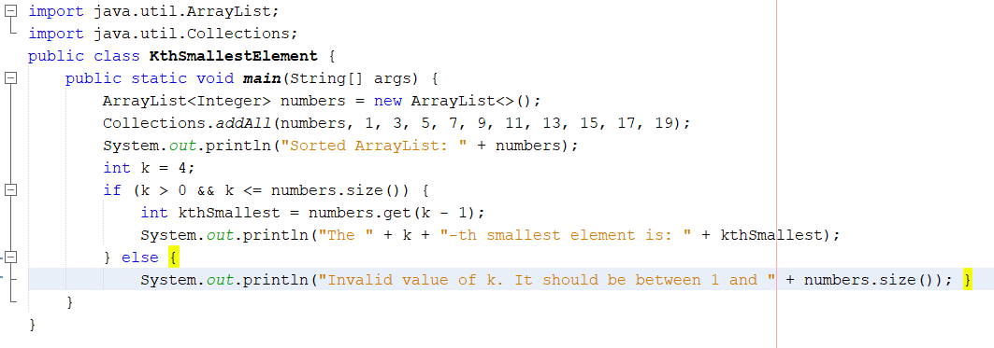

**Output:**

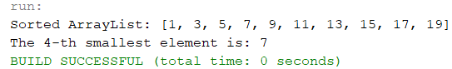

1. Write a program to merge two ArrayLists into one.

**Code:**

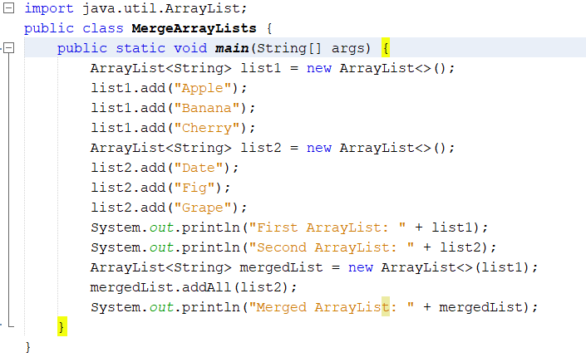

**Output:**

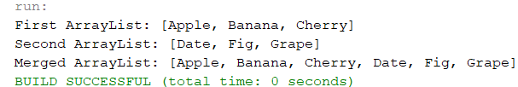

## Home Tasks

1. Create a Vector storing integer objects as an input.

A:Sort the vector B: Display largest number C:Display smallest number

**Code:**

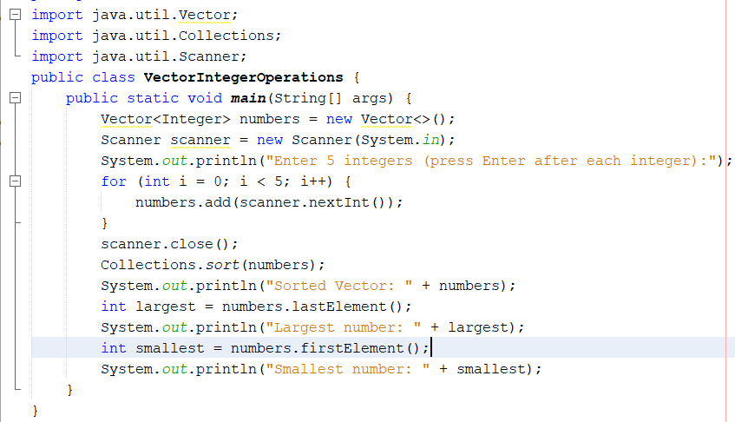

**Output:**

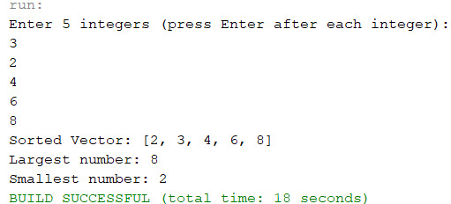

1. Write a java program which takes user input and gives hashcode value of those inputs using hashCode () method.

**Code:**

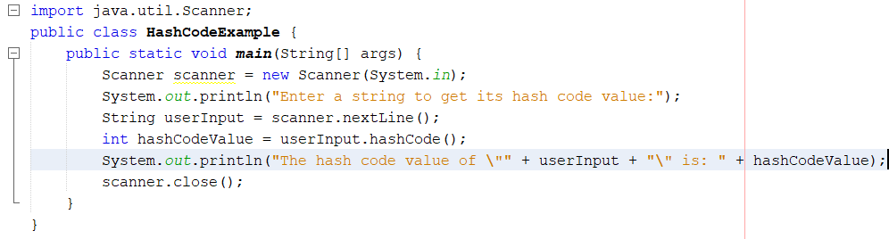

**Output:**

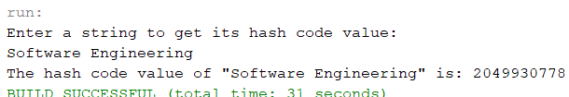

## 3. Scenario based: Create a java project, suppose you work for a company that needs to manage a list of employees. Each employee has a unique combination of a name and an ID. Your goal is to ensure that you can track employees effectively and avoid duplicate entries in your system.

**Output:**

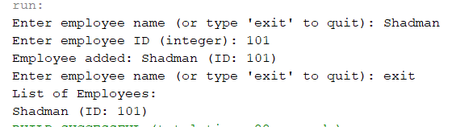

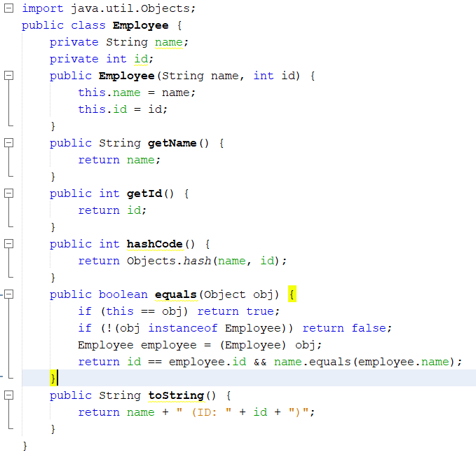

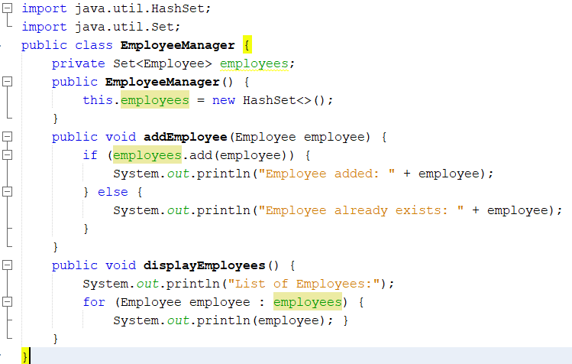

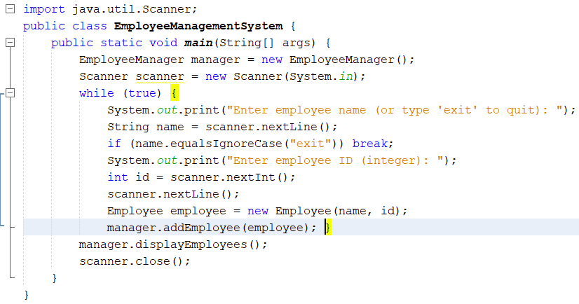

4.Create a Color class that has red, green, and blue values. Two colors are considered equal if their RGB values are the same

**Code:**

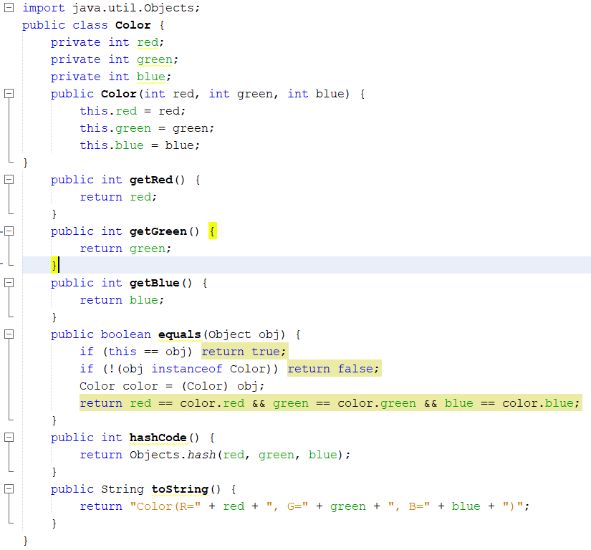

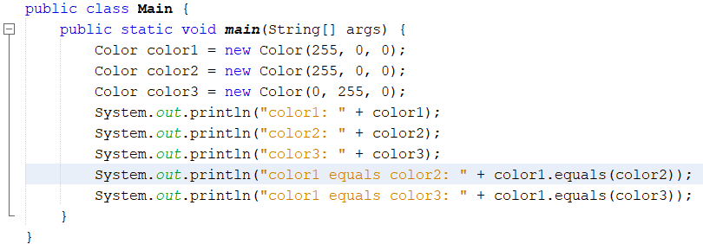

**Output:**

