NAME: Suhaib Irshad Baba

REGISTRATION NUMBER: 11904406

ROLL NUMBER: 16

Submitted to: Navjot kaur

**1. Introduction**

1.1 Objective of the Project: This project aims to capture and analyse browser history data using Autopsy tool, an open-source tool. In this project, bookmarks, cache data, visited websites, and cookies from a target system's browser history will be analyzed.

1.2 Description of the Project: Using Autopsy tool, the project captures and analyses browser history data to gain insight into browsing habits and activities. The captured data includes bookmarks, cache data, visited websites, and cookies.

1.3 Scope of the Project: The project focuses on capturing and analyzing browser history data using Autopsy tool. It does not involve any modifications to the tool or other additional functionalities beyond the data analysis.

**2. System Description**

2.1 Target System Description: The target system is a laptop running Windows 11 with Microsoft Edge as the default web browser.

2.2 Assumptions and Dependencies:

• Autopsy tool is installed and configured correctly on the target system.

• The target system is authorized and has the required permissions to capture and analyse browser history data.

• The target system has Microsoft Edge as the default web browser and contains relevant data in bookmarks, cache, visited websites, and cookies.

2.3 Functional/Non-Functional Dependencies:

• Functional dependencies: Autopsy Tool is functional and capable of capturing browser history data from Microsoft Edge.

• Non-functional dependencies: The quality and completeness of the data that was collected may affect the analysis's effectiveness and accuracy.

2.4 Data Set Used in Support of Your Project: The data set used in this project is the browser history data captured from Microsoft Edge using Autopsy tool.

3. Analysis Report

STEP 1: Open FTK Imager tool.

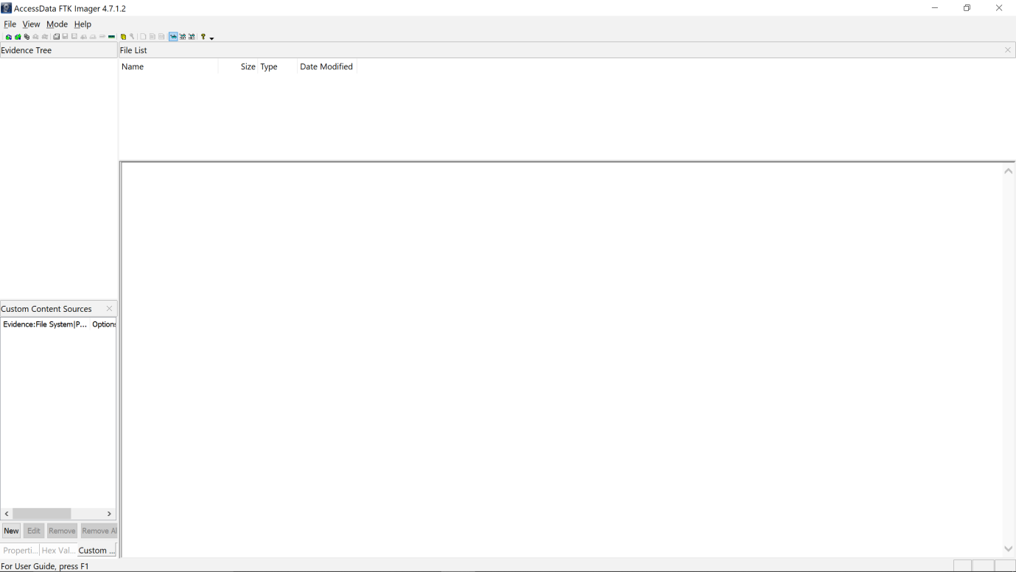

STEP 2: To create a hard disk image, select the file option and then select create disk image..

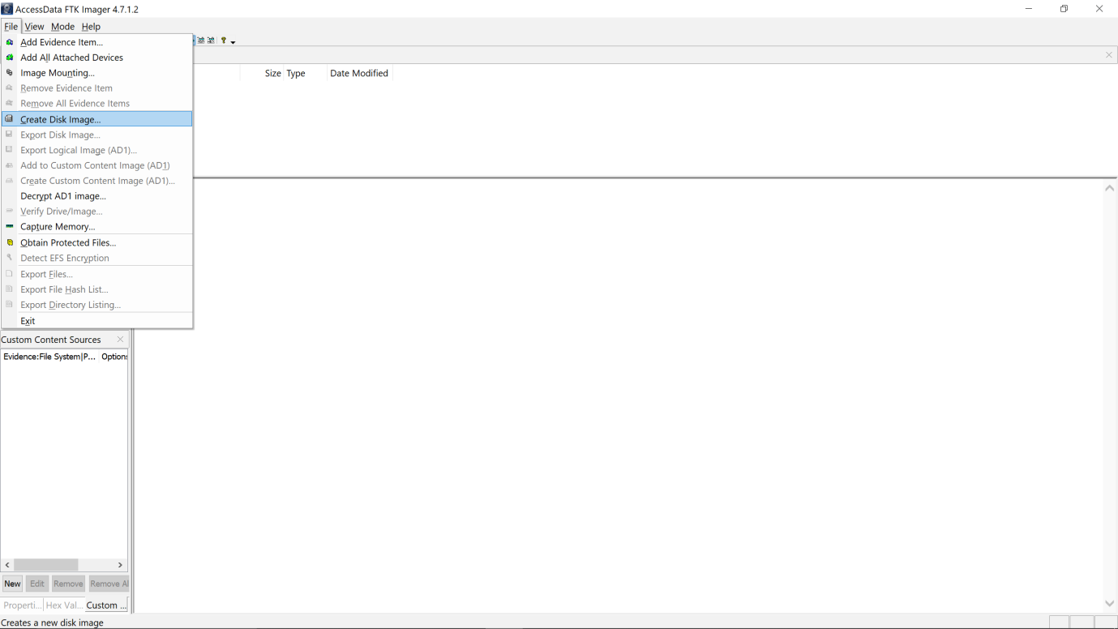STEP 3: A new pop-up window appears, allowing you to select the source of evidence as physical drive.And then select the next option. 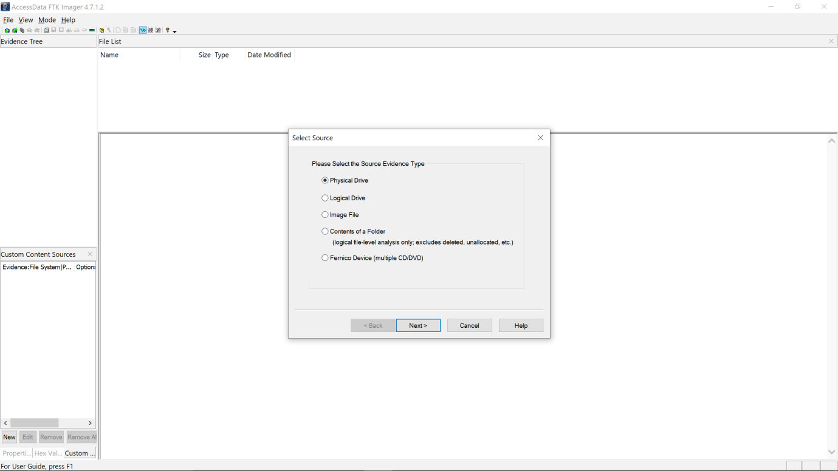STEP4: A new window appears, allowing you to select a disk to image and specify a destination location for the disk to be imaged. And then select the start option to begin the process.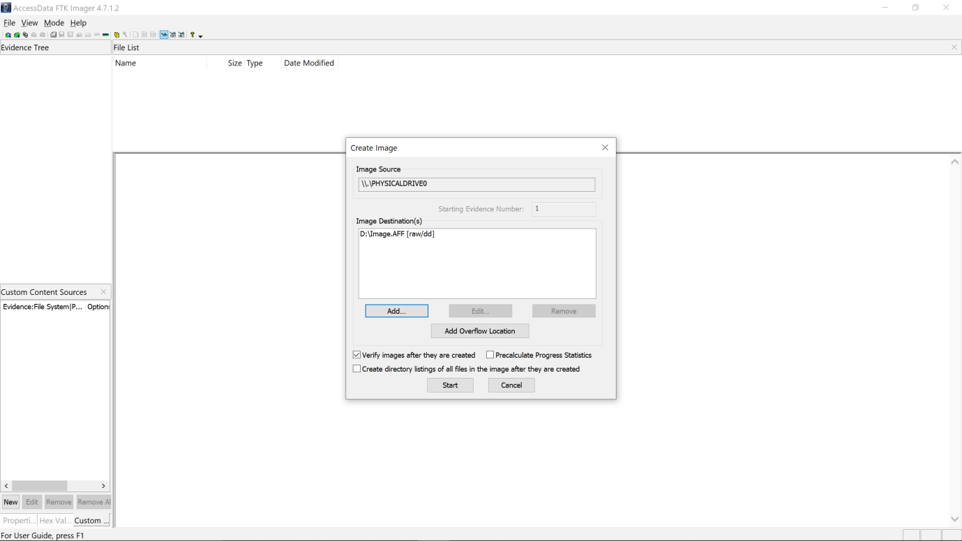STEP5: Disk image creation has begun after selecting the Start option.

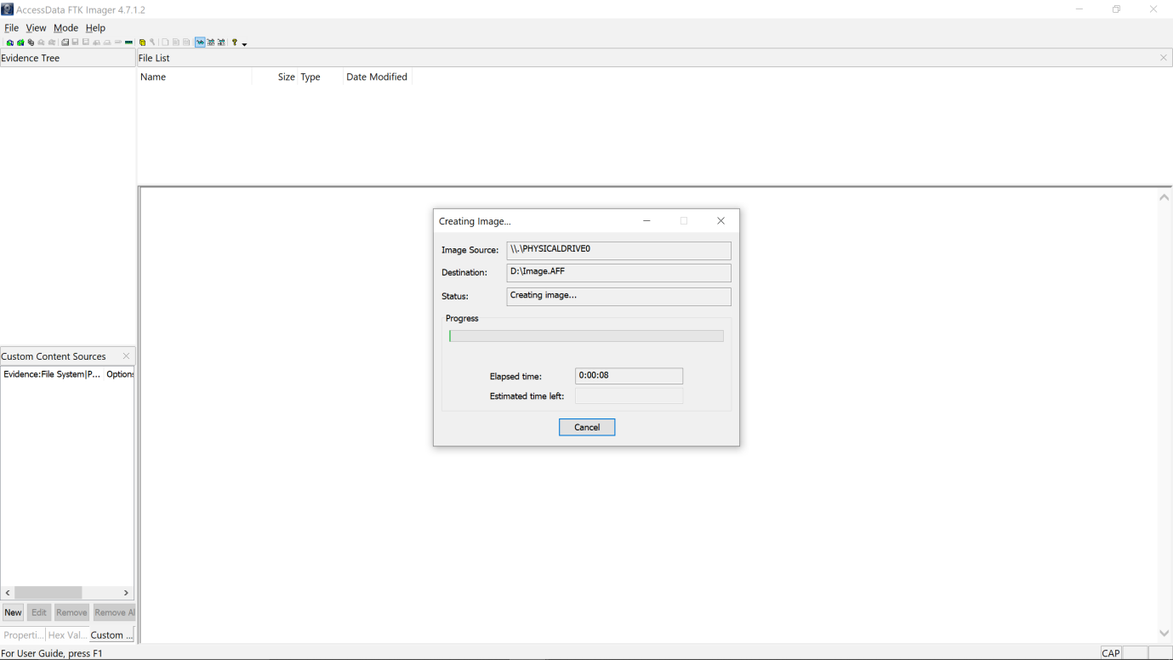

STEP 6: After creating the disk image, we must use the autopsy tool to capture and analyze the browser history, cache, bookmarks, and cookies. Now we must create a new case to collect data from an image file and add data like case name, case number, investigator name, email id, etc

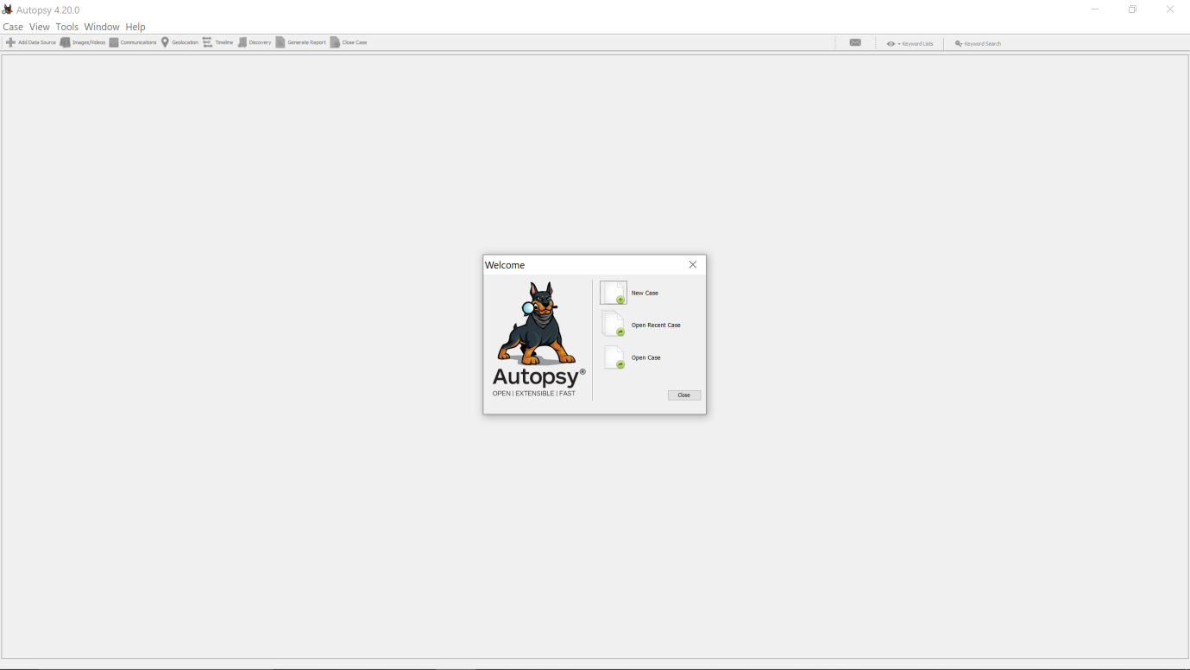

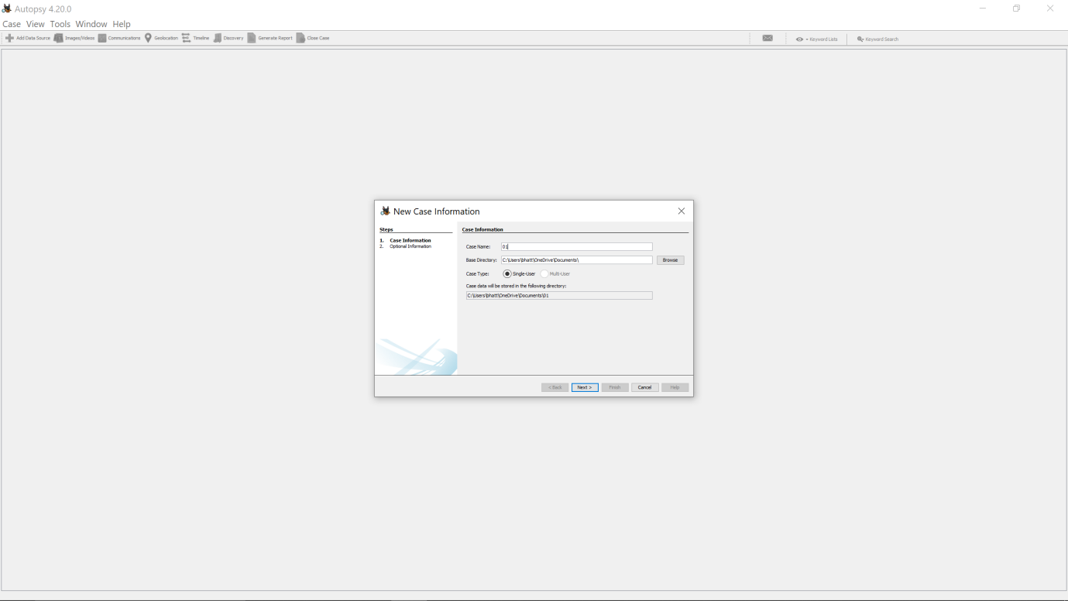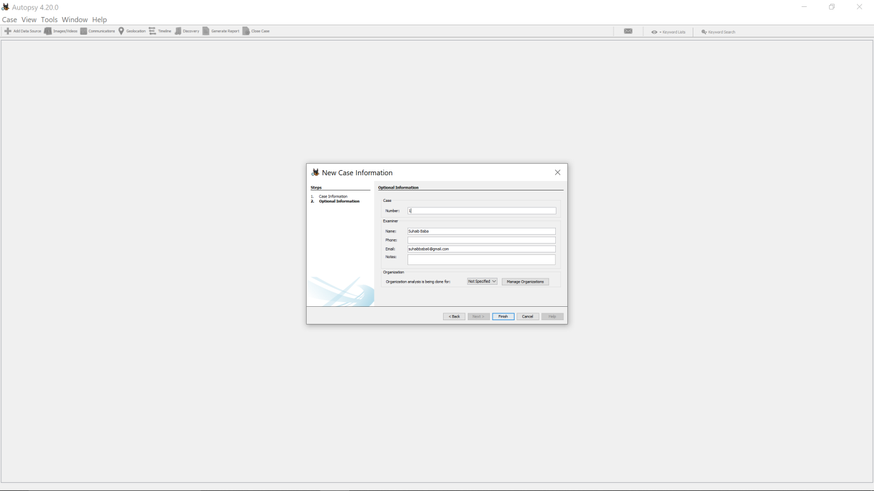

STEP7: After creating a new case, we must now add a data source.Now, click the next option to bring up a new window.

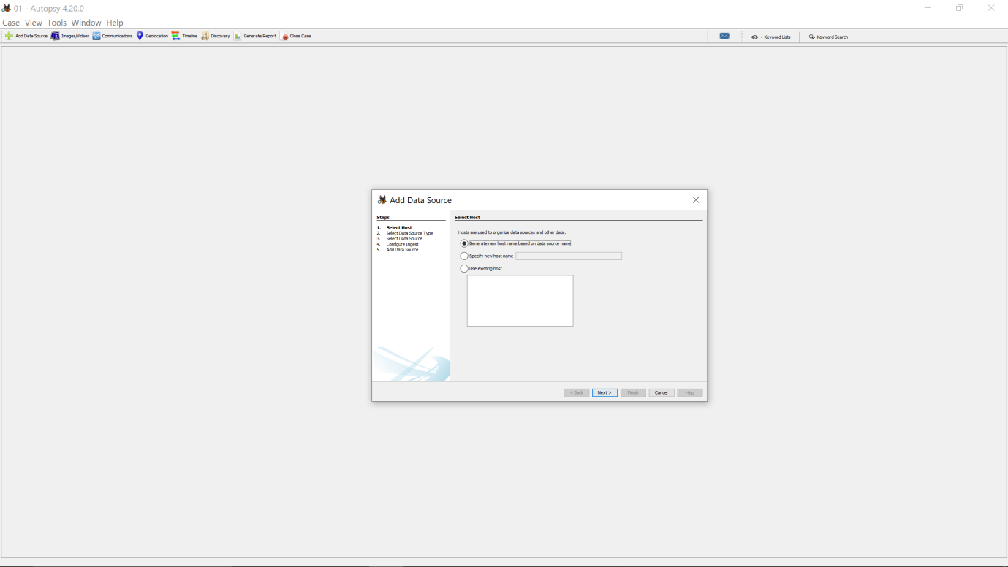STEP8:Select the disk image option and then click next. 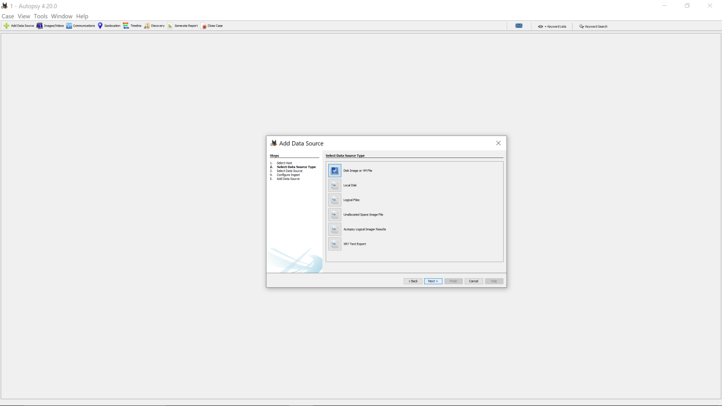STEP 9: Navigate to the disk image path and then click Next.

.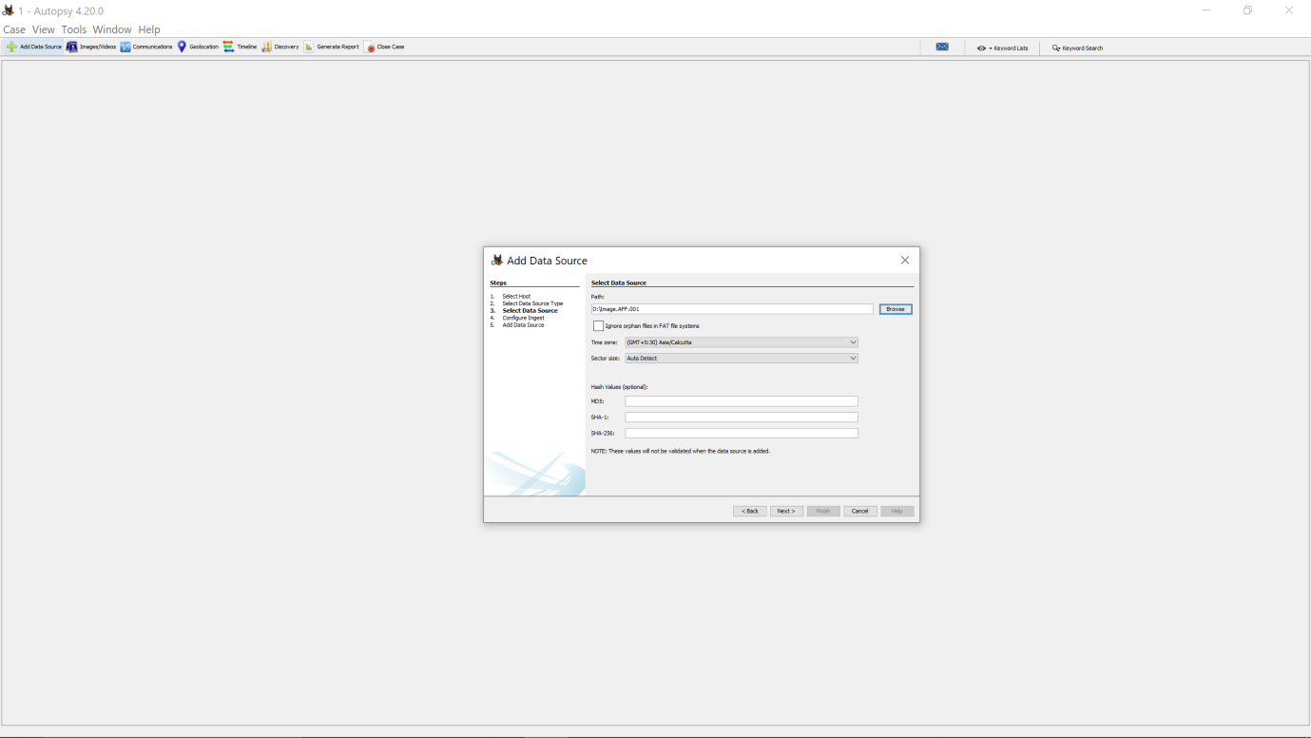

STEP10: Selecting the recent activity option to extract and analyze browser history, cache, cookies, and bookmarks. And then click next. 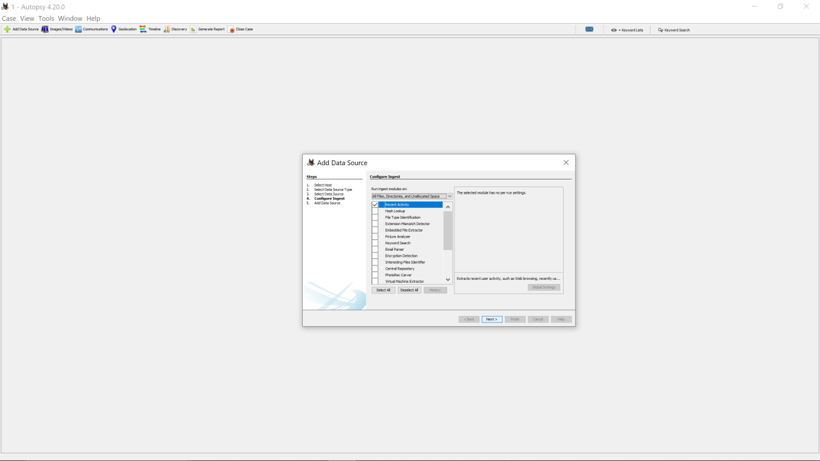STEP 11: Now that the data source is being processed and added to the local database then analysis will begin after it is completed.  After it is completed click on the finish option

.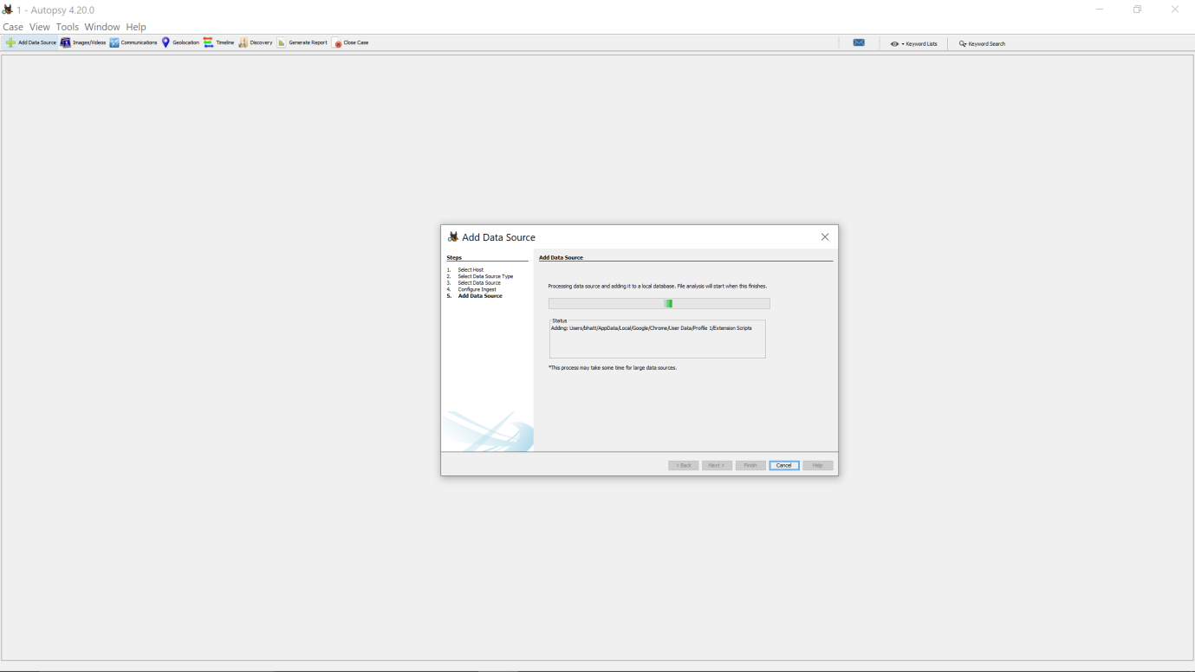STEP12:We can now examine all the artifacts we required.

.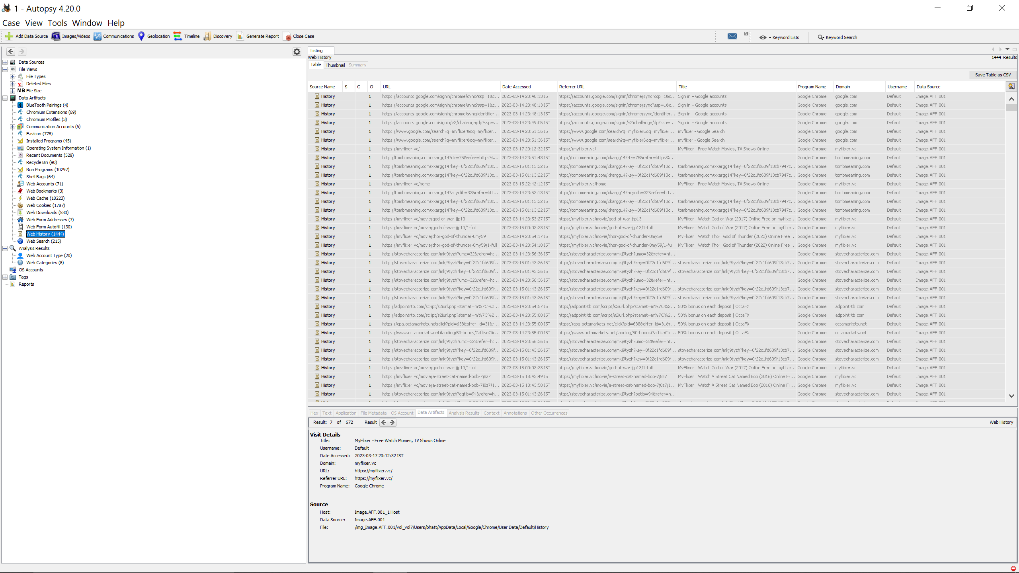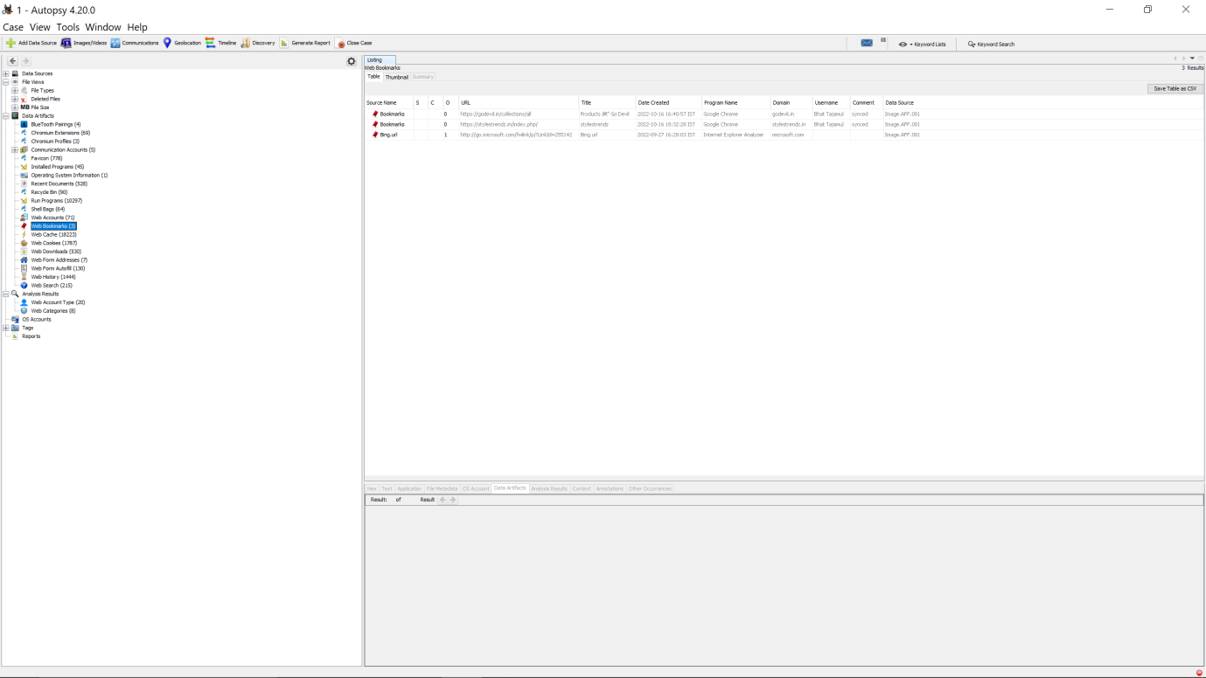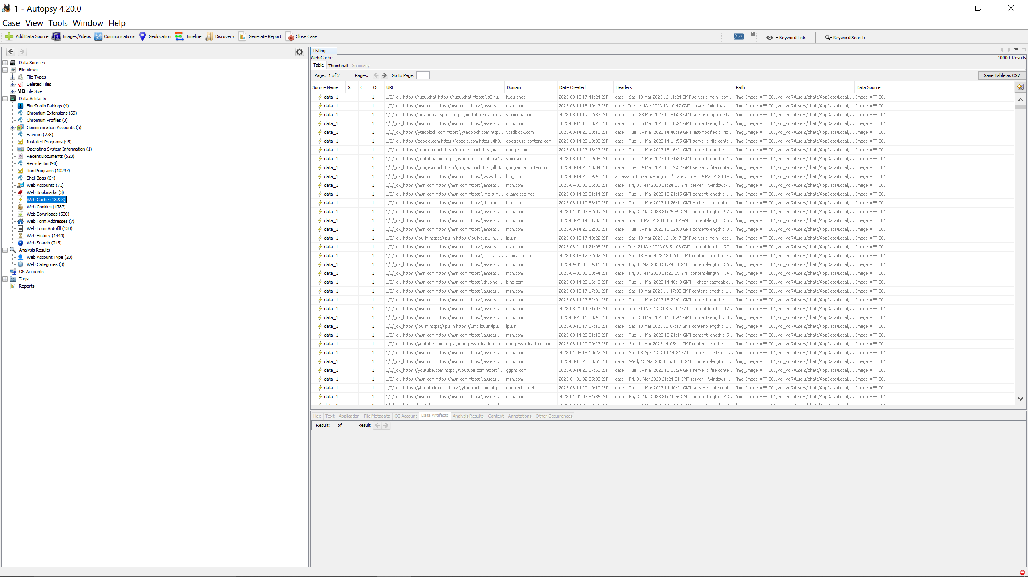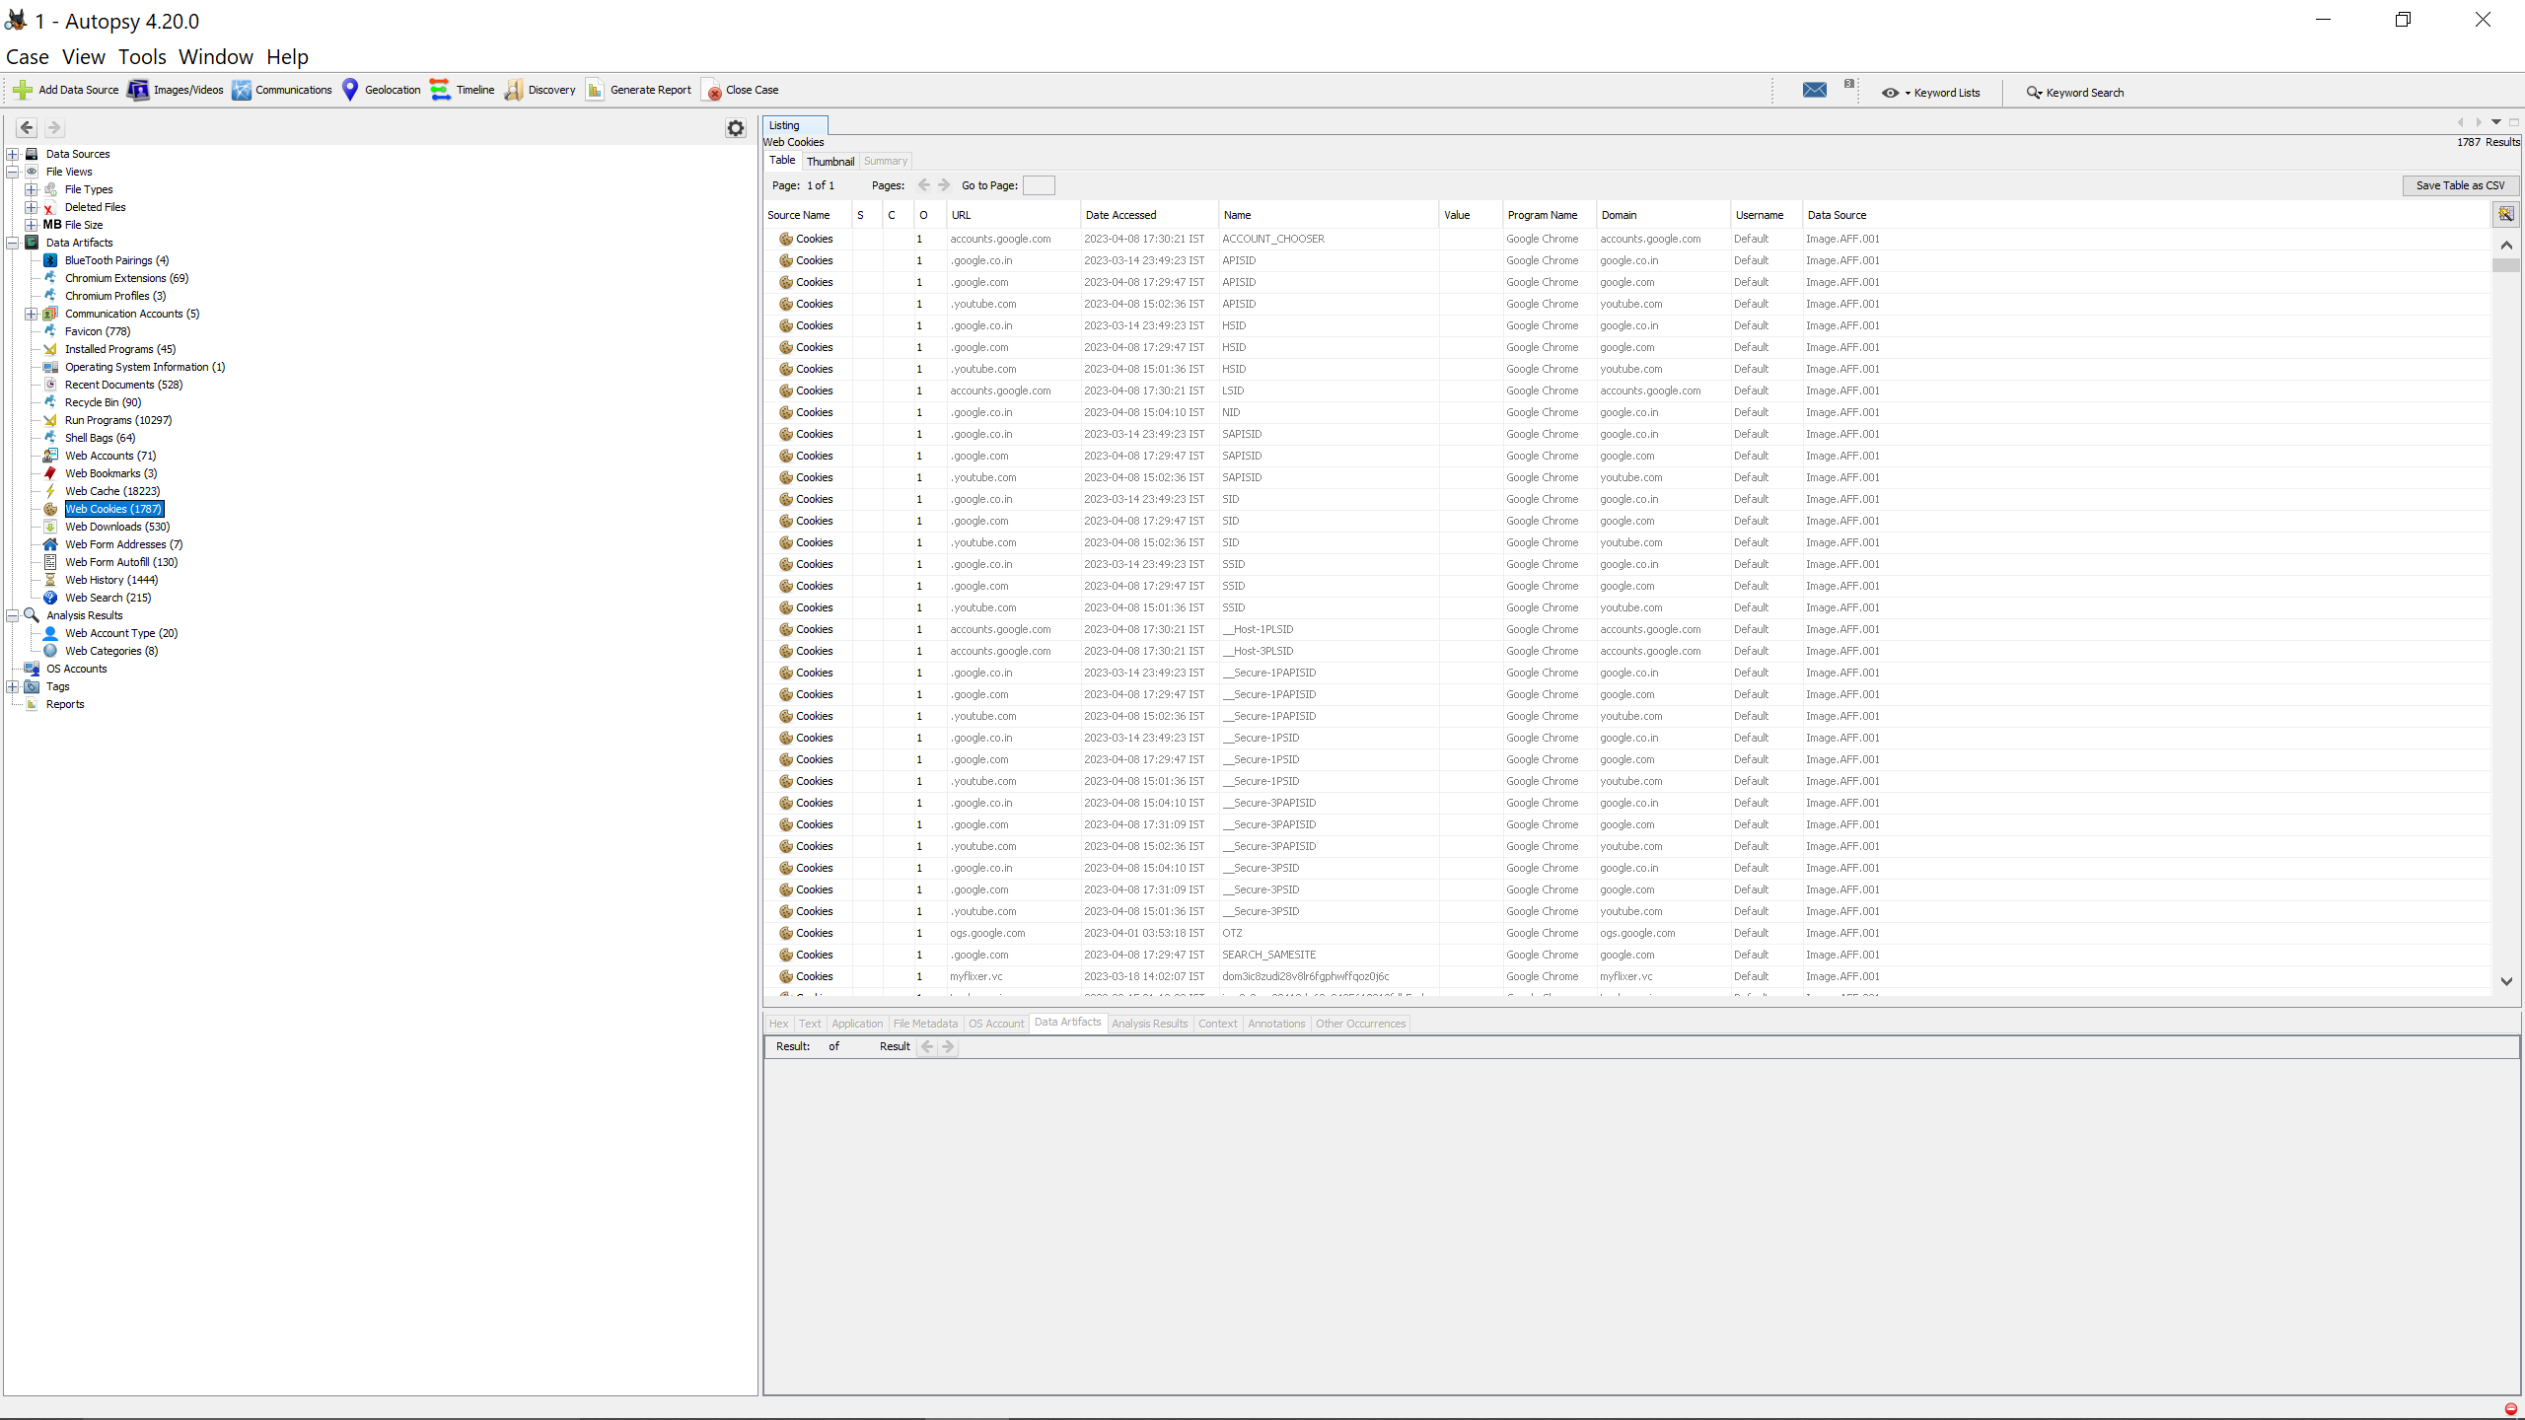STEP 12: To create the report file in the desired format, click the generate report option.Then click next option.

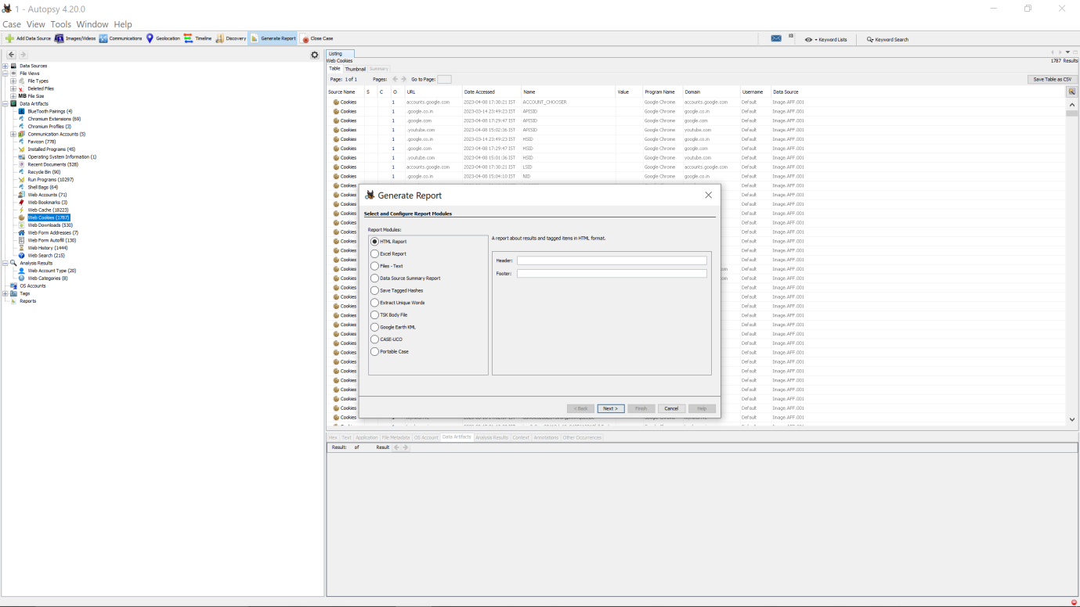STEP13: Click on the image file and then click next. 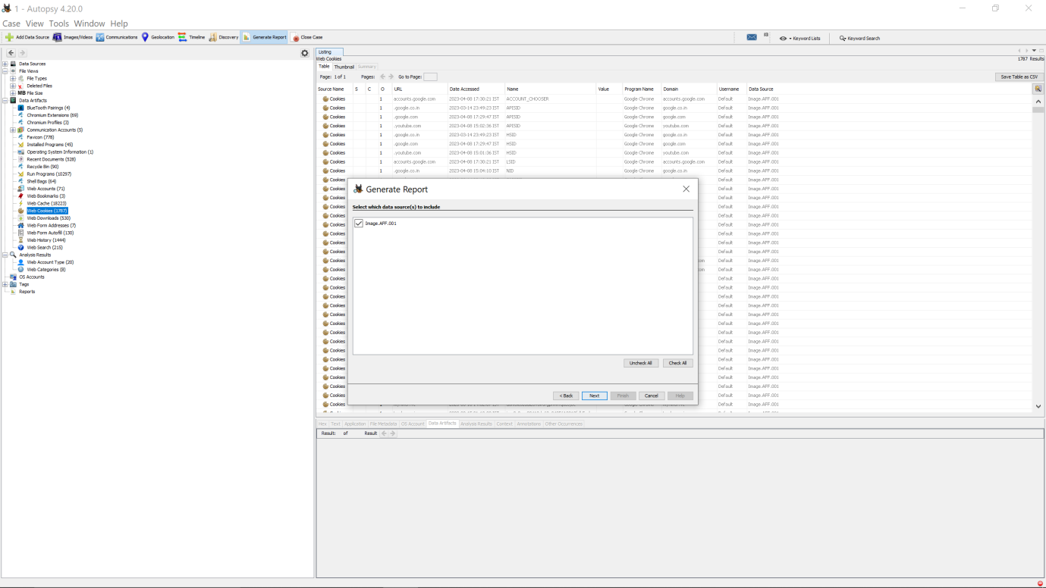STEP14: Click on all result option and then click on choose result types to select which result types we want on our report. 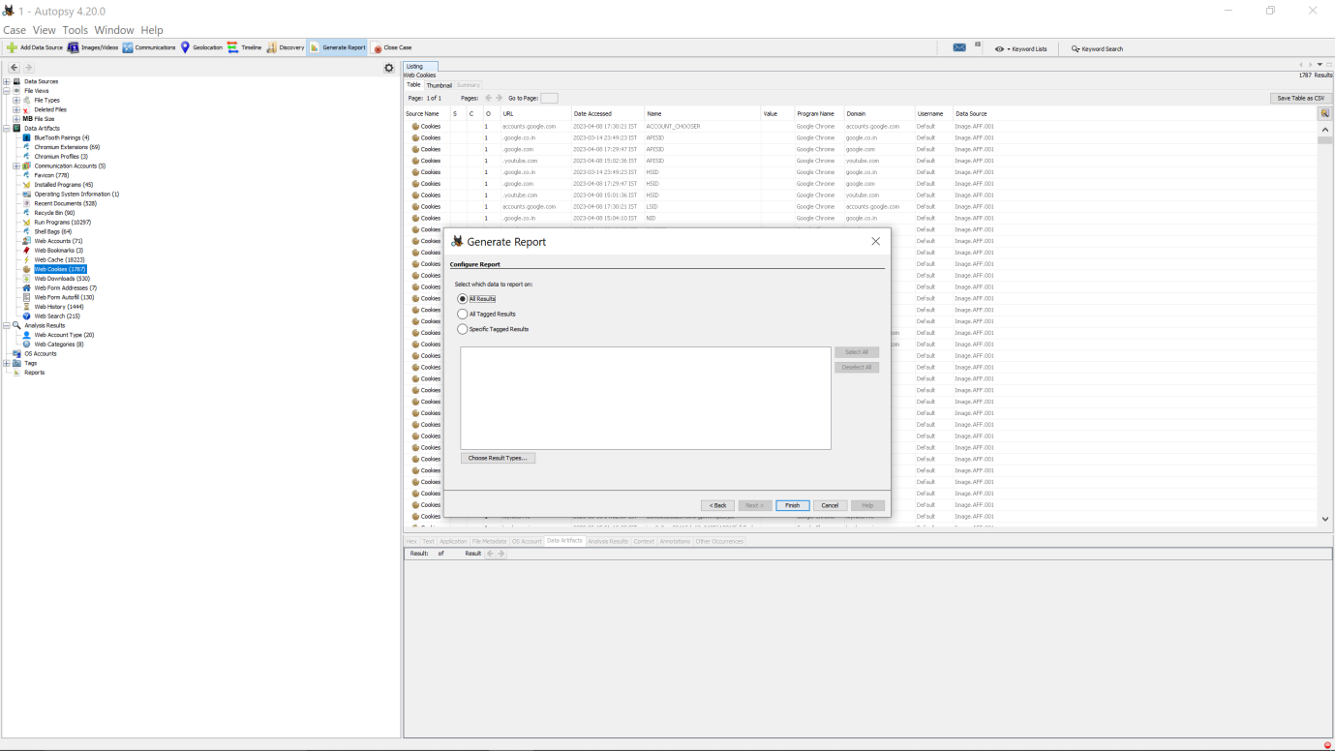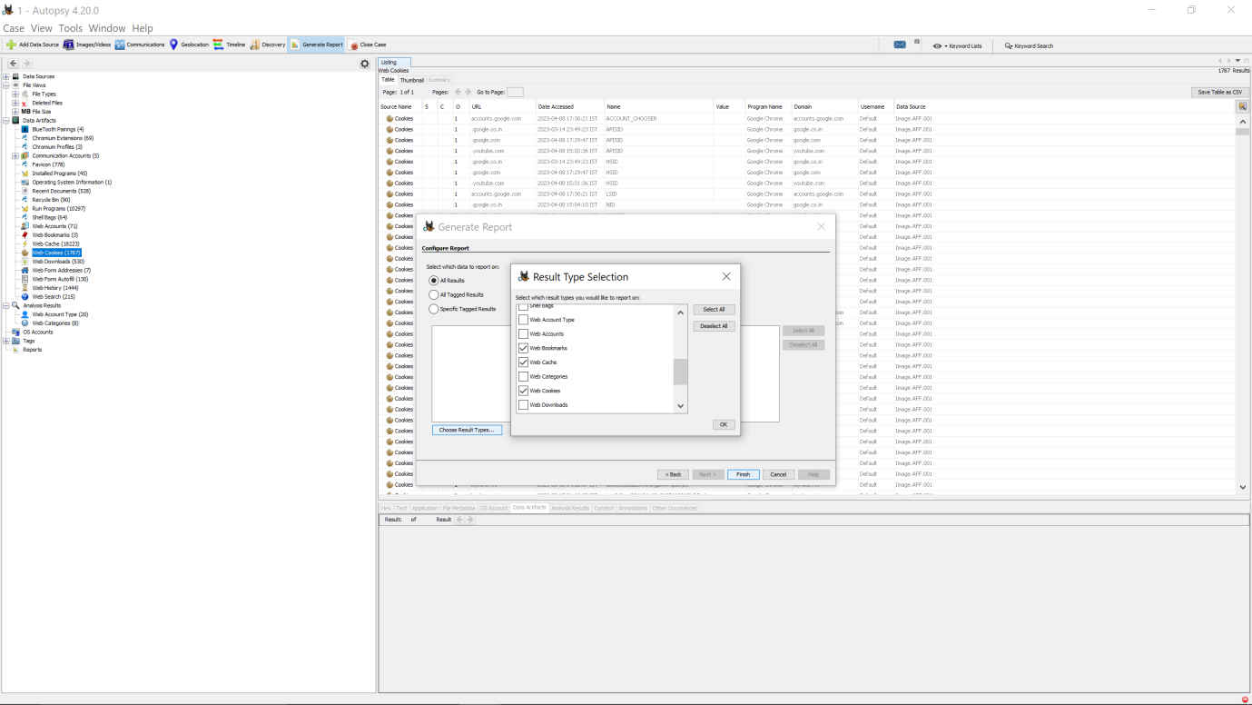STEP15: Finally, the report has been generated. 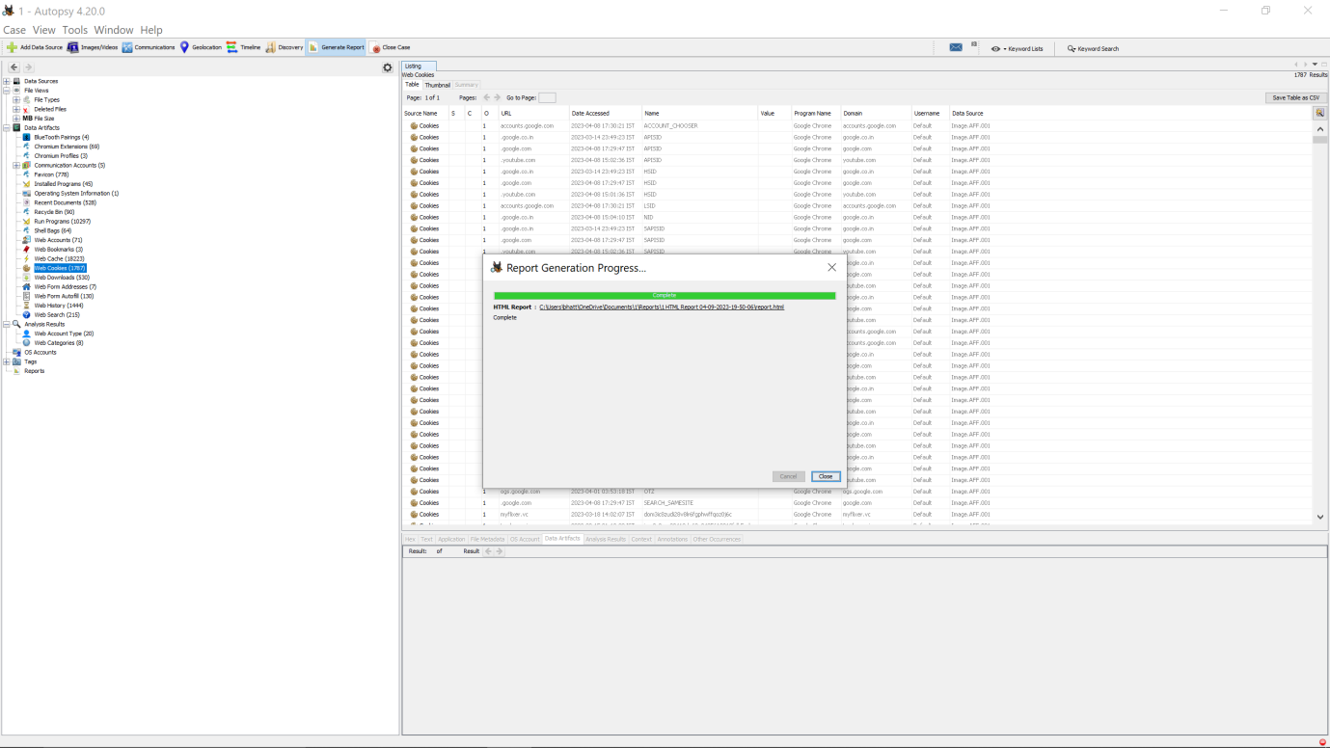

The analysis report generated using Autopsy tool includes the following information:

• Bookmarks: A list of bookmarks captured from the browser history, including the bookmarked URL, title, and date added.

• Cache Data: Information about the cache data, including the size, type, and date of the cached items.

• Visited Websites: A list of visited websites captured from the browser history, including the URL, title, visit count, and last visit time.

• Cookies: Information about the cookies captured from the browser history, including the

4. Reference/Bibliography:

• https://www.autopsy.com/

5. GitHub Link: https://github.com/Suhaib11904406/INT301-CA3.git