**FULL STACK DEVELOPMENT – WORKSHEET 2**

**Q1. Java method overloading implements the OOPS concept  
Answer: C. Polymorphism**

**Q2. Data members and member functions of a class are private by default.  
Answer: A. True**

**Q3. Which of the following functions can be inherited from the base class?  
Answer: D. None**

**Q4. Identify the feature, which is used to reduce the use of nested classes.  
Answer: C. Inheritance**

**Q5. Which concept of Java is achieved by combining methods and attributes into a class?  
Answer: A. Encapsulation**

**Q6. Which of the following declarations does not compile?  
Answer: A. double num1, int num2 = 0; (These are two different type of declarations hence need to be separated by “;”)**

**Q7. Which of these interfaces must contain a unique element?  
Answer: A. Set (Because it extends collection interface to handle sets)**

**Q8. Predict the output?**

**package main;**

**class T {**

**int t = 20;**

**}**

**class Main {**

**public static void main(String args[]) {**

**T t1 = new T();**

**System.out.println(t1.t);**

**}**

**}  
Answer: C. COMPILE ERROR (Exception in thread "main" java.lang.Error: Unresolved compilation problem:)**

**Q9. What is the output of the below Java program?**

**//bingo.java file**

**public class Hello**

**{**

**public static void main(String[] args)**

**{**

**System.out.println("BINGO");**

**}**

**}  
Answer: D. Compile Error (We are declaring file as bingo.java but naming the class as Hello)**

**Q10. What will be the output of the following Java program?**

**class variable_scope**

**{**

**public static void main(String args[])**

**{**

**int x;**

**x = 5;**

**{**

**int y = 6;**

**System.out.print(x + " " + y);**

**}**

**System.out.println(x + " " + y);**

**}**

**}  
Answer: A. Compilation Error (unable to find y as variable as it is declared with in the block and the program is trying to access out of the block)**

**Q11. What will be the output of the following Java code?**

**class String_demo**

**{**

**public static void main(String args[])**

**{**

**char chars[] = {'a', 'b', 'c'};**

**String s = new String(chars);**

**System.out.println(s);**

**}**

**}  
Answer: A. abc**

**Q12. What will be the output of the following Java program?**

**final class A**

**{**

**int i;**

**}**

**class B extends A**

**{**

**int j;**

**System.out.println(j + " " + i);**

**}**

**class inheritance**

**{**

**public static void main(String args[])**

**{**

**B obj = new B();**

**obj.display();**

**}**

**}  
Answer: D. Compilation Error**

**Q13.What is output of following program**

**public class Test**

**{**

**public int getData() //getdata() 1**

**{**

**return 0;**

**}**

**public long getData() //getdata 2**

**{**

**return 1;**

**}**

**public static void main(String[] args)**

**{**

**Test obj = new Test();**

**System.out.println(obj.getData());**

**}**

**}  
Answer: D. Compilation Error (If we are implementing method overloading, then the parameters must be different. If we are implementing method overriding then the class should be extended. Since none of the conditions are accomplished, the program throws a compile error)**

**Q14. What is the output of the following program?**

**public class Test{**

**static int start = 2;**

**final int end;**

**public Test(int x) {**

**x = 4;**

**end = x;**

**}**

**public void fly(int distance) {**

**System.out.println(end-start+" ");**

**System.out.println(distance);**

**}**

**public static void main(String []args){**

**new Test(10).fly(5);**

**}**

**}  
Answer: A. [2 5]**

**Q15.What is the output of the following program?**

**String john = "john";**

**String jon = new String(john);**

**System.out.println((john==jon) + " "+ (john.equals(jon)));  
Answer: C. false true**

**Q16. Given that Student is a class, how many reference variables and objects are created by the following code?**

**Student studentName, studentId;**

**studentName = new Student();**

**Student stud_class = new Student();  
Answer: A. Three reference variables and two objects are created.**

**Q17. Write a java program to check even or odd number**

import java.util.*;

public class Q17 {

    public static void main(String[] args) {

        try (Scanner input = new Scanner(System.in)) {

            int number;

            System.out.println("Enter the number to be validated");

            number= input.nextInt();

            if(number % 2 == 0) {

                System.out.println("Give number is even");

            }

            else {

                System.out.println("Given number is odd");

            }

        }

    }

}

**Output:**

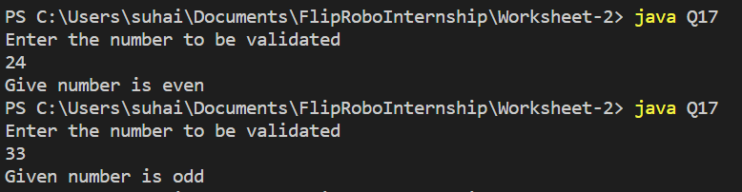

**Q18. Write a java program to find average of two numbers**

import java.util.*;

public class Q18 {

    public static void main(String[] args) {

        try (Scanner input = new Scanner(System.in)) {

            double num1, num2; //declaring as double in order to get the decimal value for average

            double avg;

            System.out.println("Enter the value of number 1");

            num1= input.nextInt();

            System.out.println("Enter the value of number 2");

            num2= input.nextInt();

            avg= (num1+num2)/2;

            System.out.println("Average of provided two numbers: "+avg);

        }

    }

}

**Output:**

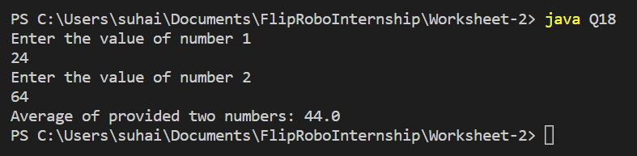

**Q19. Write a java program to swap two numbers**

import java.util.*;

public class Q19 {

    public static void main(String[] args) {

        try (Scanner input = new Scanner(System.in)) {

            int num1, num2, temp;

            System.out.println("Enter the value of number 1");

            num1= input.nextInt();

            System.out.println("Enter the value of number 2");

            num2= input.nextInt();

            System.out.println("Values before swapping: Number1:"+num1+" Number2: "+num2);

            temp= num1;

            num1= num2;

            num2= temp;

            System.out.println("Values after swapping: Number1:"+num1+" Number2: "+num2);

        }

    }

}

**Output:**

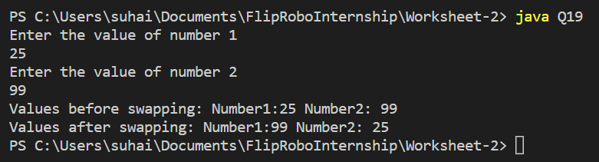

**Q20. Write a java program to check whether a number is prime or not**

import java.util.*;

public class Q20 {

    public static void main(String[] args) {

        try (Scanner input = new Scanner(System.in)) {

            int number, flag=0;

            System.out.println("Enter the numebr to be validated");

            number= input.nextInt();

            if(number==0 || number==1) {

                System.out.println("The given number is not a prime number");

            }

            else {

                for(int i=2; i< number; i++) {

                    if(number % i ==0) {

                        flag=1;

                    }

                }

                if(flag==0) {

                    System.out.println("The given number is a prime number");

                }

                else {

                    System.out.println("The given number is not a prime number");

                }

            }

        }

    }

}

**Output:**

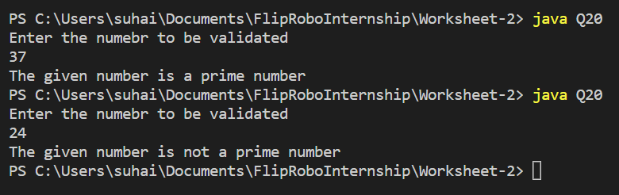

**Q21. Write a java program to find table of n**

import java.util.*;

public class Q21 {

    public static void main(String[] args) {

        try (Scanner input = new Scanner(System.in)) {

            int number, prod;

            System.out.println("Enter the number to find the table for:");

            number= input.nextInt();

            if(number==0) {

                System.out.println("Please enter a valid number");

                main(args);

            }

            else {

                System.out.println("The table for "+number+" is:");

                for(int i=1; i<=10; i++) {

                    prod= number * i;

                    System.out.println(number+"*"+i+"= "+prod);

                }

            }

        }

    }

}

**Output:**

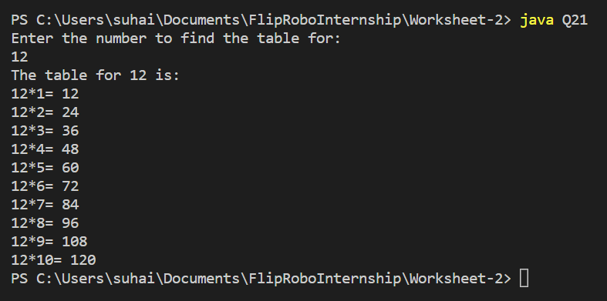

**Q22. Write a java program to find the largest of three numbers.**

import java.util.*;

public class Q22 {

    public static void main(String[] args) {

        try (Scanner input = new Scanner(System.in)) {

            int first, second, third, temp, largest;

            System.out.println("Enter the first number");

            first= input.nextInt();

            System.out.println("Enter the second number");

            second= input.nextInt();

            System.out.println("Enter the third number");

            third= input.nextInt();

            //using ternary operator

            temp =first>second?first:second;

            largest =third>temp?third:temp;

            System.out.println("The largest of the provided three numbers is: "+largest);

        }

    }

}

**Output:**

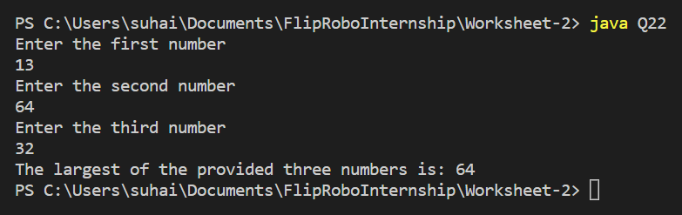

**Q23. Write a java program to calculate Simple Interest**

import java.util.*;

public class Q23 {

    public static void main(String[] args) {

        try (Scanner input = new Scanner(System.in)) {

            int principal, tenure;

            double simpleInterst, interest=2.14;

            System.out.println("Enter the principal amout: ");

            principal= input.nextInt();

            System.out.println("Enter the tenure in years");

            tenure= input.nextInt();

            simpleInterst= (principal*tenure*interest) / 100;

            System.out.println("The Simple Interest is: "+simpleInterst);

        }

    }

}

**Output:**

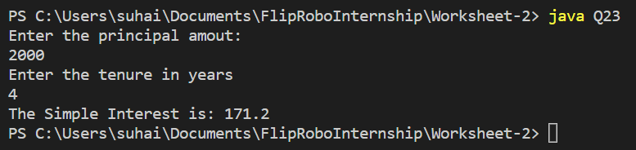

**Q24. Write a java program to calculate Area and perimeter of Rectangle**

import java.util.*;

public class Q24 {

    public static void main(String[] args) {

        try (Scanner input = new Scanner(System.in)) {

            double length, width;

            double area, perimeter;

            System.out.println("Enter the length of the rectangle");

            length= input.nextDouble();

            System.out.println("Enter the width of the rectangle");

            width= input.nextDouble();

            area= length*width;

            perimeter= 2 * (length+width);

            System.out.println("Area of the rectangle is: "+area);

            System.out.println("Perimeter of the rectangle is: "+perimeter);

        }

    }

}

**Output:**

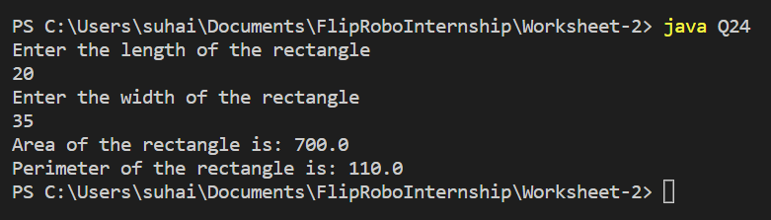

**Q25. Write a java program to check whether character is vowel or consonant**

import java.util.*;

public class Q25 {

    public static void main(String[] args) {

        try (Scanner input = new Scanner(System.in)) {

            String str;

            char character;

            System.out.println("Enter the character: ");

            str= input.nextLine();

            character= str.charAt(0);

            if(Character.isAlphabetic(character)) {

                switch (character) {

                    case 'a':

                    case 'e':

                    case 'i':

                    case 'o':

                    case 'u':

                        System.out.println(character+" is a vowel"); break;

                    default:

                        System.out.println(character+" is a consonant");

                }

            }

            else {

                System.out.println("Please enter the valid character");

                main(args);

            }

        }

    }

}

**Output:**

