**FULL STACK DEVELOPMENT – WORKSHEET 3**

**Q1. Which one of the following is not a Java feature?  
Answer: B. Use of pointers**

**Q2. Which of these cannot be used for a variable name in Java?  
Answer: C. keyword**

**Q3. Which of the following is a superclass of every class in Java?  
Answer: C. Object class**

**Q4. Which one is a valid declaration of a boolean?  
Answer: C. boolean b3 = false;**

**Q5. Which is the modifier when there is none mentioned explicitly?  
Answer: D. default**

**Q6. All the variables of interface should be?  
Answer: C. public, static and final**

**Q7. Which of these data types is used to store command line arguments?  
Answer: A. Array**

**Q8. How many arguments can be passed to main()?  
Answer: A. Infinite**

**Q9. What will be the output of the following Java program, Command line execution is done as – “java Output This is a command Line”?  
class Output**

**{**

**public static void main(String args[])**

**{**

**System.out.print(args[0]);**

**}**

**}  
Answer: A. java  
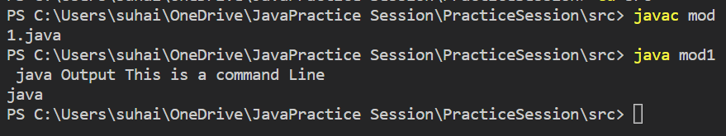**

**Q10. What is the value of “d” in the following Java code snippet?**

**double d = Math.round ( 2.5 + Math.random() );  
Answer: B. 3**

**Q11. Which of these methods is a rounding function of Math class?**

**Answer: D. all of the mentioned**

**Q12. Standard output variable ‘out’ is defined in which class?  
Answer: D. System**

**Q13.What will be the output of the following Java program?  
class main_class**

**{**

**public static void main(String args[])**

**{**

**int x = 9;**

**if (x == 9)**

**{**

**int x = 8;**

**System.out.println(x);**

**}**

**}**

**}  
Answer: C. Compilation error (As we are re-declaring the ‘x’ variable that is already declared and defined in main method)**

**Q14. Which of these is the method which is executed first before execution of any other thing takes place in a program?  
Answer: B. static method (because a static method invokes when the class is loaded. It does not require any object to be invoked)**

**Q15. Which of these can be used to differentiate two or more methods having the same name?  
Answer: D. All of the mentioned**

**Q16. What will be the output of the following Java program?  
class Output**

**{**

**static void main(String args[])**

**{**

**int x , y = 1;**

**x = 10;**

**if(x != 10 && x / 0 == 0)**

**System.out.println(y);**

**else**

**System.out.println(++y);**

**}**

**}  
Answer: B. 2 (As the if condition fails, y is incremented first and then printed with value 2)**

**Q17.What will be the output of the following Java program?  
class area**

**{**

**int width;**

**int length;**

**int height;**

**area()**

**{**

**width = 5;**

**length = 6;**

**height = 1;**

**}**

**void volume()**

**{**

**volume = width * height * length;**

**}**

**}**

**class cons_method**

**{**

**public static void main(String args[])**

**{**

**area obj = new area();**

**obj.volume();**

**System.out.println(obj.volume);**

**}**

**}**

**Answer: D. 30**

**Q18. Write Syntax to create/define java methods.**

**Answer:**

**Syntax:**

**<accessSpecifier> <returnType> <methodName> (arguments) {**

**//block of code;**

**}**

**Example:**

**public int sum (int a, int b) {**

**int sum= a + b;**

**return sum;**

**}**

**Q19. Write a java program following instructions**

**A. Make a class Addition**

**a. initialize sum as 0**

**b. make addTwoInt method taking two int parameters a,b. make sum = a+b.**

**Return Sum**

**B. define class as Method Call. Define main method**

**a. Create object of class Addition**

**b. call method using instance of object**

**c. Print sum  
Answer:**

import java.util.*;

class Addition {

    int sum=0;

    public int addTwoint(int a, int b) {

        sum = a + b;

        return sum;

    }

}

public class MethodCall {

    public static void main(String[] args) {

        try (Scanner input = new Scanner(System.in)) {

            int a, b;

            int sum;

            System.out.println("Enter the value of a");

            a= input.nextInt();

            System.out.println("Enter the value of b");

            b= input.nextInt();

            Addition obj = new Addition();

            sum = obj.addTwoint(a, b);

            System.out.println("The sum of provided two integers is: "+sum);

        }

    }

}

**Output:**

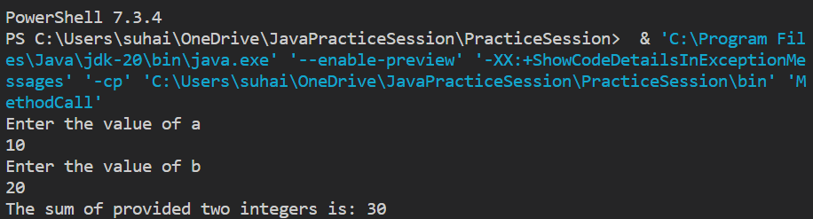

**Q20. Write a java program following instructions**

**A. Define a class Example**

**a. Define two instance variables number and name**

**b. Define accessor (getter) methods**

**c. Define mutator (setter) methods**

**d. define method printDetails —-> print name and number**

**B. Define public class Demo (Main Class)**

**a. Define main method**

**b. Make Instance/object of example class**

**c. set number and name using instance created as 123 and Your name.**

**d. call printDetails method using instance**

**Answer:**

class Example {

    private int number;

    private String name;

    public void setNumber(int number) {

        this.number= number;

    }

    public void setName(String name) {

        this.name= name;

    }

    public int getNumber() {

        return number;

    }

    public String getName() {

        return name;

    }

}

public class Demo {

    public static void main(String[] args) {

        Example obj= new Example();

        obj.setNumber(10);

        obj.setName("Suhail Ahmed");

        int number= obj.getNumber();

        String name= obj.getName();

        System.out.println("The number sent in argument is: "+number);

        System.out.println("The name sent in argument is: "+name);

    }

}

**Output:**

