Suhail Basalama - Machine Learning - D. Lu Zhang – HW2

Implementation of SVM via Gradient Descent

1. Equation for $∇_{b}J\left(w,b\right)$ is as follows:
$$\frac{∂J\left(w,b\right)}{∂b}=b+C\sum_{i=1}^{m}{\frac{∂L\left(x^{\left(i\right)}{,y}^{\left(i\right)}\right)}{∂b}}$$

$$\frac{∂L\left(x^{\left(i\right)}{,y}^{\left(i\right)}\right)}{∂b}=\left\{\begin{aligned}0, &if y^{\left(i\right)}\left(x^{\left(i\right)}w+b\right)≥1 \\ -y^{(i)}, &otherwise\end{aligned}\right.$$

2. Plot of cost vs iterations for the different algorithms:
3. 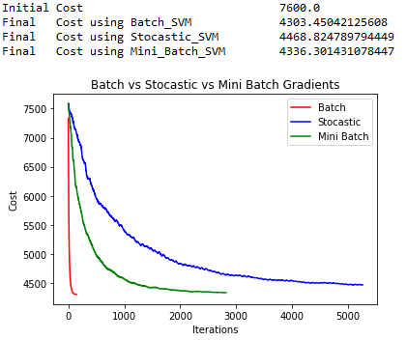With regularized data.
4. 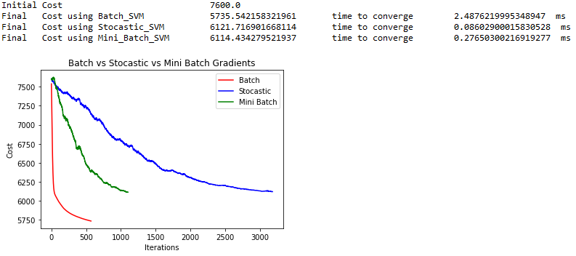With raw data:
5. Convergence times:

Initial Cost 7600.0

Final Cost using Batch_SVM 5735.5 time to converge 2.4876 ms

Final Cost using Stocastic_SVM 6075.4 time to converge 0.0860 ms

Final Cost using Mini_Batch_SVM 6084.3 time to converge 0.2765 ms

1. Source Code:

**import** numpy **as** np

**import** pandas **as** pd

**import** matplotlib**.**pyplot **as** plt

**import** timeit

my_data **=** pd**.**read_csv**(**'data.txt'**,** sep**=**'\t'**)**#,names=["f1","f2","f3","f4","f5","f6","f7","f8","f9","f10","f11","f12","f13","f14","f15","l"]) #read the data

#prepare X matrix

X **=** my_data**.**iloc**[:,**0**:**8**].**values

#ones = np.ones([X.shape[0],1])

#X = np.concatenate((ones,X),axis=1) #X = pd.DataFrame.from_records(X)

##prepare y matrix

y **=** my_data**.**iloc**[:,**8**:**9**].**values #.values converts it from pandas.core.frame.DataFrame to numpy.ndarray

##prepare w matrix

w **=** np**.**zeros**([**1**,**8**])**

b **=** 0

C **=** 10

#cost/loss function

**def** Cost**(**X**,**y**,**w**,**b**,**C**):**

sum1 **=** X *@* w**.**T **+** b

sum1 **=** y **\*** sum1

sum1 **=** 1**-**sum1

sum1 **=** sum1**.**clip**(**min**=**0**)**

sum2 **=** np**.**power**(**w**,**2**)**

**return** **(**np**.**sum**(**sum2**)/**2**)** **+** C**\***np**.**sum**(**sum1**)**

**print(**"Initial\tCost\t\t\t\t"**,**Cost**(**X**,**y**,**w**,**b**,**10**))**

**def** L_w**(**X**,**y**,**w**,**b**,**j**):**

z **=** X *@* w**.**T **+** b

z **=** y**\***z

v **=** np**.**zeros**([**760**,**1**])**

Xj **=** X**[:,**j**]**

Xj **=** Xj**.**reshape**(**len**(**X**),**1**)**

z **=** np**.**where**(**z**>=**1**,**v**,-**1**\***y**\***Xj**)**

**return** z

**def** L_b**(**y**,**w**,**b**):**

z **=** X *@* w**.**T **+** b

z **=** y**\***z

v **=** np**.**zeros**([**760**,**1**])**

z **=** np**.**where**(**z**>=**1**,**v**,-**1**\***y**)**

**return** z

**def** Batch_Gradient_w**(**X**,**y**,**w**,**b**,**j**):**

**return** w**[**0**,**j**]+**C**\***np**.**sum**(**L_w**(**X**,**y**,**w**,**b**,**j**))**

**def** Batch_Gradient_b**(**y**,**w**,**b**):**

**return** b **+** C**\***np**.**sum**(**L_b**(**y**,**w**,**b**))**

**def** Stocastic_Gradient_w**(**X**,**y**,**w**,**b**,**j**,**i**):**

Lw **=** L_w**(**X**,**y**,**w**,**b**,**j**)**

**return** w**[**0**,**j**]** **+** C**\***Lw**[**i**,**0**]**

**def** Stocastic_Gradient_b**(**y**,**w**,**b**,**i**):**

Lb **=** L_b**(**y**,**w**,**b**)**

**return** b **+** C**\***Lb**[**i**,**0**]**

**def** Mini_Batch_Gradient_w**(**X**,**y**,**w**,**b**,**j**,**batch_size**,**l**):**

i **=** int**(**l**\***batch_size**+**1**)**

n **=** int**(**min**(**len**(**X**),((**l**+**1**)\***batch_size**)))**

Lw **=** L_w**(**X**,**y**,**w**,**b**,**j**)**

batch_sum **=** np**.**sum**(**Lw**[**i**:**n**])**

**return** w**[**0**,**j**]+**C**\***batch_sum

**def** Mini_Batch_Gradient_b**(**y**,**w**,**b**,**batch_size**,**l**):**

i **=** int**(**l**\***batch_size**+**1**)**

n **=** int**(**min**(**len**(**X**),((**l**+**1**)\***batch_size**)))**

Lb **=** L_b**(**y**,**w**,**b**)**

batch_sum **=** np**.**sum**(**Lb**[**i**:**n**])**

**return** b **+** C**\***batch_sum

#helper function for the batch gradient and used in other svms too

**def** dCost**(**cost**,**k**):**

**if(**k **!=** 0**):**

**return** **(**abs**(**cost**[**k**-**1**]-**cost**[**k**])\***100**)/**cost**[**k**-**1**]**

**else:** **return** 1

**def** Batch_SVM**(**X**,**y**,**w**,**b**,**C**,**alpha**,**epsilon**):**

k**=**0

cost **=** **[]**

tempCost **=** 10

**while(**tempCost**>**epsilon**):**

#update weights and bias with batch gradient descent

**for** j **in** range**(**len**(**w**[**0**])):**

w**[**0**][**j**]** **=** w**[**0**][**j**]** **-** alpha**\***Batch_Gradient_w**(**X**,**y**,**w**,**b**,**j**)**

b **=** b **-** alpha**\***Batch_Gradient_b**(**y**,**w**,**b**)**

#calculate the cost criteria

cost**.**append**(**Cost**(**X**,**y**,**w**,**b**,**C**))**

tempCost **=** dCost**(**cost**,**k**)**

#increment loop parameters

k **+=** 1

**return** w**,**cost**,**k**,**b

**def** Stocastic_SVM**(**X**,**y**,**w**,**b**,**C**,**alpha**,**epsilon**):**

k**=**0

i**=**0

cost **=** **[]**

costk **=** **[**10**]**

tempCost **=** 10.0

m **=** len**(**X**)**

**while(**costk**[**k**]>**epsilon**):**

#update weights and bias with stocastic gradient descent

**for** j **in** range**(**len**(**w**[**0**])):**

w**[**0**][**j**]** **=** w**[**0**][**j**]** **-** alpha**\***Stocastic_Gradient_w**(**X**,**y**,**w**,**b**,**j**,**i**)**

b **=** b **-** alpha**\***Stocastic_Gradient_b**(**y**,**w**,**b**,**i**)**

#calculate the cost criteria

cost**.**append**(**Cost**(**X**,**y**,**w**,**b**,**C**))**

tempCost **=** dCost**(**cost**,**k**)**

costk**.**append**(**0.5**\***costk**[**k**-**1**]+**0.5**\***tempCost**)**

#increment loop parameters

i **=** **(**i**+**1**)%**m

k **+=** 1

**return** w**,**cost**,**k**,**b

**def** Mini_Batch_SVM**(**X**,**y**,**w**,**b**,**C**,**alpha**,**epsilon**):**

l **=** 0

k **=** 0

batch_size **=** 4

cost **=** **[]**

costk **=** **[**10**]**

**while(**costk**[**k**]>**epsilon**):**

#update weights and bias with mini batch gradient descent

**for** j **in** range **(**len**(**w**[**0**])):**

w**[**0**][**j**]** **=** w**[**0**][**j**]** **-** alpha**\***Mini_Batch_Gradient_w**(**X**,**y**,**w**,**b**,**j**,**batch_size**,**l**)**

b **=** b **-** alpha**\***Mini_Batch_Gradient_b**(**y**,**w**,**b**,**batch_size**,**l**)**

#calculate the cost criteria

cost**.**append**(**Cost**(**X**,**y**,**w**,**b**,**C**))**

tempCost **=** dCost**(**cost**,**k**)**

costk**.**append**(**0.5**\***costk**[**k**-**1**]+**0.5**\***tempCost**)**

#increment loop parameters

l **=** **(**l**+**1**)** **%** **((**len**(**X**)+**batch_size**-**1**)/**batch_size**)**

k **=** k**+**1

**return** w**,**cost**,**k**,**b

w **=** np**.**zeros**([**1**,**8**])**

b **=** 0

alpha **=** 0.000000001

epsilon **=** 0.004

start **=** timeit**.**timeit**()**

w_**,**cost1**,**count1**,**b_ **=** Batch_SVM**(**X**,**y**,**w**,**b**,**C**,**alpha**,**epsilon**)**

end **=** timeit**.**timeit**()**

**print(**"Final\tCost using Batch_SVM\t\t"**,**Cost**(**X**,**y**,**w_**,**b_**,**C**),**"\t time to converge\t"**,**1000**\*(**start **-** end**),**" ms"**)**

my_data **=** pd**.**read_csv**(**'data.txt'**,** sep**=**'\t'**)**#,names=["f1","f2","f3","f4","f5","f6","f7","f8","f9","f10","f11","f12","f13","f14","f15","l"]) #read the data

my_data **=** my_data**.**sample**(**frac**=**1**)**

X **=** my_data**.**iloc**[:,**0**:**8**].**values

y **=** my_data**.**iloc**[:,**8**:**9**].**values

w **=** np**.**zeros**([**1**,**8**])**

b **=** 0

alpha **=** 0.00000001

epsilon **=** 0.0003

start **=** timeit**.**timeit**()**

w_**,**cost2**,**count2**,**b_ **=** Stocastic_SVM**(**X**,**y**,**w**,**b**,**C**,**alpha**,**epsilon**)**

**print(**"Final\tCost using Stocastic_SVM\t"**,**Cost**(**X**,**y**,**w_**,**b_**,**C**),**"\t time to converge\t"**,**1000**\*(**start **-** end**),**" ms"**)**

end **=** timeit**.**timeit**()**

my_data **=** pd**.**read_csv**(**'data.txt'**,** sep**=**'\t'**)**#,names=["f1","f2","f3","f4","f5","f6","f7","f8","f9","f10","f11","f12","f13","f14","f15","l"]) #read the data

my_data **=** my_data**.**sample**(**frac**=**1**)**

X **=** my_data**.**iloc**[:,**0**:**8**].**values

y **=** my_data**.**iloc**[:,**8**:**9**].**values

w **=** np**.**zeros**([**1**,**8**])**

b **=** 0

alpha **=** 0.00000001

epsilon **=** 0.004

start **=** timeit**.**timeit**()**

w_**,**cost3**,**count3**,**b_ **=** Mini_Batch_SVM**(**X**,**y**,**w**,**b**,**C**,**alpha**,**epsilon**)**

**print(**"Final\tCost using Mini_Batch_SVM\t"**,** Cost**(**X**,**y**,**w_**,**b_**,**C**),**"\t time to converge\t"**,**1000**\*(**start **-** end**),**" ms"**)**

end **=** timeit**.**timeit**()**

#plot the costs

fig**,** ax **=** plt**.**subplots**()**

ax**.**plot**(**np**.**arange**(**count1**),** cost1**,** color **=** 'r'**,** label **=** 'Batch'**)**

ax**.**plot**(**np**.**arange**(**count2**),** cost2**,** color **=** 'b'**,** label **=** 'Stocastic'**)**

ax**.**plot**(**np**.**arange**(**count3**),** cost3**,** color **=** 'g'**,** label **=** 'Mini Batch'**)**

ax**.**set_xlabel**(**'Iterations'**)**

ax**.**set_ylabel**(**'Cost'**)**

ax**.**set_title**(**'Batch vs Stocastic vs Mini Batch Gradients'**)**

plt**.**legend**(**loc**=**'best'**)**