CUSTOMER SHOPPING
BEHAVIOR ANALYSIS
Comprehensive Data Report · April 2026

3,900  Total Customers | $59.76  Avg Purchase (USD) | 3.75 / 5  Avg Review Rating | 3,900  Total Transactions

Dataset: 3,900 rows · 18 columns · Tools: Python · MySQL · Power BI

PART A — DATA ANALYSIS METHODOLOGY

1. Project Overview
This project analyzes customer shopping behavior using transactional data from 3,900 purchases spanning multiple product categories, demographics, and seasonal patterns. The objective is to surface actionable insights into spending behavior, customer segmentation, product performance, and subscription dynamics to support strategic retail decision-making.

2. Dataset Summary
Attribute | Detail
Total Records | 3,900 rows
Features | 18 columns
Demographics | Age, Gender, Location, Subscription Status
Purchase Data | Item, Category, Amount (USD), Season, Size, Color
Behaviour Data | Discount Applied, Frequency, Review Rating, Shipping Type
Missing Data | 37 null values in Review Rating column (imputed via category median)

3. Exploratory Data Analysis (Python)
The following preprocessing steps were applied to ensure data quality and analytical readiness:

- Data Loading: Imported dataset with pandas; used df.info() and .describe() for initial structural review.
- Missing Data Handling: Identified 37 nulls in Review Rating via df.isnull().sum(). Imputed using category-level mean.
- Column Standardisation: Renamed all columns to snake_case for consistent referencing.
- Feature Engineering: Created age_group (quartile bins: Young, Adult, Middle-Aged, Senior) and purchase_frequency_days (mapped text frequency to numeric days).
- Redundancy Check: Verified that discount_applied and promo_code_used were identical; dropped promo_code_used.
- Database Integration: Loaded cleaned DataFrame into MySQL via SQLAlchemy for structured SQL analysis.

Key code snippets used in preprocessing:

# Column standardisation
df.columns = df.columns.str.lower().str.replace(' ', '_')

# Age group binning
labels = ["Young", "Adult", "Middle-Aged", "Senior"]
df["age_group"] = pd.qcut(df["age"], q=4, labels=labels)

# Purchase frequency mapping
freq_map = {"Weekly": 7, "Fortnightly": 14, "Monthly": 30, "Quarterly": 90, "Annually": 365}
df["purchase_frequency_days"] = df["frequency_of_purchases"].map(freq_map)

# Missing value imputation
df["review_rating"] = df.groupby("category")["review_rating"].transform(lambda x: x.fillna(x.mean()))

4. SQL Business Queries & Findings
Ten structured queries were executed in MySQL to answer key business questions. Below are the queries, results, and interpretations:

Query 1 — Revenue by Gender
SELECT gender, SUM(purchase_amount_usd) AS revenue
FROM customers GROUP BY gender;

Gender | Total Revenue (USD)
Male | 157,890
Female | 75,191

✔ Interpretation
- Male customers generate ~67.7% of total revenue vs. 32.3% for Female customers.
- This disparity could reflect a gender skew in the customer base (2,652 Male vs. 1,248 Female in the dataset) rather than a spending difference.
- Female customer acquisition and targeted campaigns represent a significant untapped revenue opportunity.

Query 2 — High-Spending Discount Users
SELECT customer_id, purchase_amount_usd
FROM customers
WHERE discount_applied = 'Yes'
AND purchase_amount_usd >= (SELECT AVG(purchase_amount_usd) FROM customers);

✔ Interpretation
- A meaningful subset of discount users still spends above the average ($59.76), disproving the assumption that discounts only attract low-spend shoppers.
- These customers represent ideal upsell targets — they respond to incentives but maintain high basket values.
- Consider exclusive early-access or premium tier offers for this high-value discount segment.

Query 3 — Top 5 Products by Average Rating
SELECT item_purchased, ROUND(AVG(review_rating), 2) AS avg_product_rating
FROM customers GROUP BY item_purchased
ORDER BY AVG(review_rating) DESC LIMIT 5;

Item Purchased | Avg Rating
Sandals | 3.82
Boots | 3.79
Gloves | 3.78
Hat | 3.78
Handbag | 3.78

✔ Interpretation
- The highest-rated products span Footwear (Sandals, Boots) and Accessories (Gloves, Hat, Handbag).
- Notably, even the top-rated products score below 3.9 — indicating a systemic quality perception gap across the catalogue.
- These items should be featured prominently in marketing as social proof anchors.
- Investment in quality improvements for low-rated Clothing items could lift the overall 3.75 average significantly.

Query 4 — Shipping Type Comparison (Express vs Standard)
SELECT shipping_type, ROUND(AVG(purchase_amount_usd), 2) AS avg_purchase
FROM customers WHERE shipping_type IN ('Express', 'Standard')
GROUP BY shipping_type;

Shipping Type | Avg Purchase (USD)
Express | 60.48
Standard | 58.46

✔ Interpretation
- Express shipping users spend ~3.5% more on average ($60.48 vs $58.46).
- This positive correlation suggests Express customers may be more impulsive or time-sensitive, creating an upsell opportunity.
- Promoting Express shipping at checkout for carts above a value threshold could simultaneously boost AOV and fulfilment revenue.

Query 5 — Subscribers vs. Non-Subscribers
SELECT subscription_status, COUNT(customer_id) AS total_customers,
ROUND(AVG(purchase_amount_usd), 2) AS avg_spent,
ROUND(SUM(purchase_amount_usd), 2) AS total_revenue
FROM customers GROUP BY subscription_status;

Status | Customers | Avg Spend (USD) | Total Revenue (USD)
Yes | 1,053 | 59.49 | 62,645
No | 2,847 | 59.87 | 170,436

✔ Interpretation
- Non-subscribers outnumber subscribers 2.7:1, yet average spend is nearly identical ($59.87 vs $59.49).
- This means subscriptions do not currently drive higher spend — the value of subscriptions must come from frequency and retention, not basket size.
- The 73.26% unsubscribed population represents a loyalty programme gap — with 2,847 potential converts who already spend as much as subscribers.
- Focus subscription strategy on purchase frequency incentives rather than spend-based rewards.

Query 6 — Discount-Dependent Products (Top 5)
SELECT item_purchased,
ROUND(100 * SUM(CASE WHEN discount_applied='Yes' THEN 1 ELSE 0 END) / COUNT(*), 2) AS discount_rate
FROM customers GROUP BY item_purchased ORDER BY discount_rate DESC LIMIT 5;

Item | Discount Rate (%)
Hat | 50.00
Sneakers | 49.66
Coat | 49.07
Sweater | 48.17
Pants | 47.37

✔ Interpretation
- Nearly 50% of Hat and Sneaker purchases involve a discount — indicating these products may be price-perceived as overvalued at full price.
- High discount dependency erodes margins; these items need a pricing strategy review.
- Consider reducing list price marginally to maintain sales volume without constant discounting.
- Coat and Sweater (cold-weather items) on this list also suggests seasonal discount over-reliance.

Query 7 — Customer Segmentation (New / Returning / Loyal)
WITH customer_type AS (
SELECT customer_id, previous_purchases,
CASE WHEN previous_purchases = 1 THEN 'New'
WHEN previous_purchases BETWEEN 2 AND 10 THEN 'Returning'
ELSE 'Loyal' END AS customer_segment FROM customers)
SELECT customer_segment, COUNT(*) AS no_of_cust FROM customer_type GROUP BY customer_segment;

Segment | Count | Share (%)
Loyal | 3,116 | 79.9%
Returning | 701 | 18.0%
New | 83 | 2.1%

✔ Interpretation
- An overwhelming 79.9% of customers are classified as Loyal (>10 previous purchases) — a strong foundation for retention-focused strategy.
- Only 2.1% are New customers, highlighting a critical customer acquisition gap.
- The pipeline from New to Returning to Loyal needs investment — currently very few new customers are entering the funnel.
- Acquisition campaigns via digital channels should be a top priority to diversify the customer base.

Query 8 — Top 3 Products per Category
WITH items_count AS (
SELECT category, item_purchased, COUNT(customer_id) AS total_orders,
ROW_NUMBER() OVER(PARTITION BY category ORDER BY COUNT(customer_id) DESC) AS item_rnk
FROM customers GROUP BY category, item_purchased)
SELECT item_rnk, category, item_purchased, total_orders FROM items_count WHERE item_rnk <= 3;

Rank | Category | Item | Orders
1 | Accessories | Jewelry | 171
2 | Accessories | Sunglasses | 161
3 | Accessories | Belt | 161
1 | Clothing | Blouse | 171
2 | Clothing | Pants | 171
3 | Clothing | Shirt | 169
1 | Footwear | Sandals | 160
2 | Footwear | Shoes | 150
3 | Footwear | Sneakers | 145
1 | Outerwear | Jacket | 163
2 | Outerwear | Coat | 161

✔ Interpretation
- Jewelry leads Accessories (171 orders), tying with Blouse and Pants for the most-ordered items overall.
- Clothing has three near-equal top sellers, suggesting broad demand across styles rather than a single dominant item.
- Jacket edges out Coat in Outerwear despite both having low category revenue — indicating both items are under-promoted relative to demand.
- Sandals leading Footwear aligns with Summer being the weakest sales season — a targeting opportunity.

Query 9 — Repeat Buyers & Subscription Correlation
SELECT subscription_status, COUNT(customer_id) AS repeat_buyers
FROM customers WHERE previous_purchases > 5
GROUP BY subscription_status;

Subscription Status | Repeat Buyers (>5 purchases)
Yes | 958
No | 2,518

✔ Interpretation
- Even among customers with >5 previous purchases, 72.4% (2,518) are not subscribed — loyalty and subscription are currently decoupled.
- This is a missed retention mechanic: the most loyal repeat buyers are not being converted into subscribers.
- Targeted subscription nudges sent specifically to customers with >5 purchases could significantly boost subscription rate with minimal friction.

Query 10 — Revenue by Age Group
SELECT age_group, SUM(purchase_amount_usd) AS revenue
FROM customers GROUP BY age_group ORDER BY revenue DESC;

Age Group | Revenue (USD) | Share (%)
Young | 62,143 | 26.6%
Middle-Aged | 59,197 | 25.3%
Adult | 55,978 | 23.9%
Senior | 55,763 | 23.8%

✔ Interpretation
- Young customers are the highest-revenue segment at $62,143 — yet only marginally ahead of Middle-Aged ($59,197).
- The near-equal spread across all four groups (only ~$6,400 gap from top to bottom) confirms strong cross-generational product appeal.
- Senior customers contributing 23.8% of revenue is notable and often overlooked in retail marketing strategies.
- Age-targeted campaigns can be layered on top of this broad baseline to squeeze additional per-segment value.

PART B — DASHBOARD INSIGHTS (POWER BI)

The following section presents business insights derived from the interactive Power BI Customer Behaviour Dashboard, which visualises the same 3,900-customer dataset across subscription status, category sales, seasonal patterns, age segments, and shipping preferences.

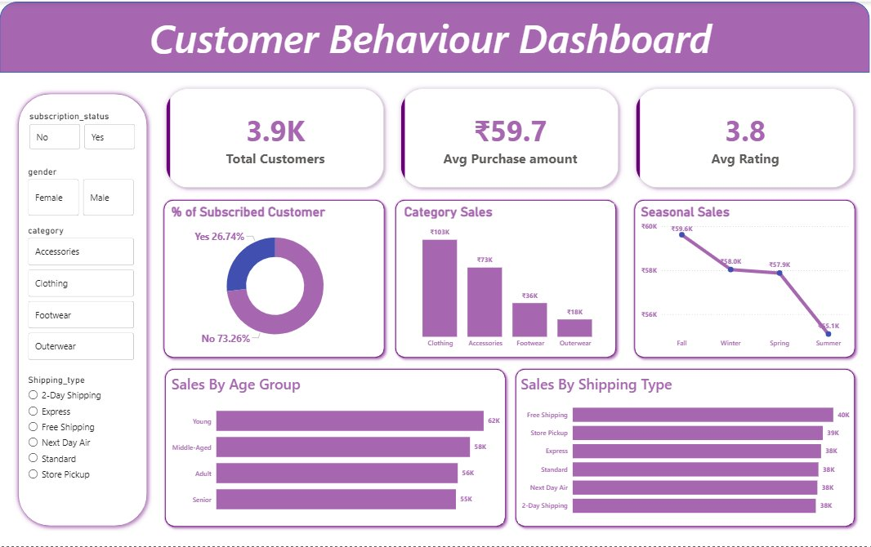
Figure 1: Customer Behaviour Dashboard (Power BI) — 3,900 customers across all categories, seasons and demographics
1. Subscription & Customer Loyalty
Only 26.74% of customers are subscribed versus 73.26% unsubscribed — a significant loyalty gap confirmed by both the dashboard donut chart and SQL Query 5.

✔ Key Insights
- 73.26% of the customer base is unsubscribed, representing the single largest retention opportunity in the dataset.
- SQL data confirms average spend is nearly identical between subscribed ($59.49) and unsubscribed ($59.87) customers — meaning subscriptions must be driven by frequency incentives, not spend.
- Among repeat buyers (>5 purchases), 72.4% are still unsubscribed — a clear signal that loyalty and subscription are currently disconnected.

- Loyalty Programme: Introduce tiered subscriber benefits — early access, free returns, exclusive SKUs.
- Nudge Campaign: Target customers with >5 previous purchases with a personalised subscription offer.
- Checkout Conversion: A/B test subscription prompts at the post-purchase confirmation stage.

2. Category Sales Performance
Clothing leads at ₹103K, followed by Accessories (₹73K), Footwear (₹36K), and Outerwear (₹18K). SQL Query 8 reveals Jewelry and Blouse as category-leading SKUs.

₹103K  Clothing | ₹73K  Accessories | ₹36K  Footwear | ₹18K  Outerwear

✔ Key Insights
- Clothing accounts for ~44% of category revenue — a healthy lead but also a concentration risk.
- Accessories (₹73K) are a strong secondary category and ideal cross-sell target given Jewelry's leading order count.
- Outerwear (₹18K) is critically underperforming; SQL shows Jacket leads the category in orders (163), suggesting pricing or visibility issues rather than lack of demand.
- Footwear discount dependency (Sneakers at 49.66% discount rate) is suppressing margin in the third-largest category.

- Bundle Strategy: Pair top Clothing SKUs (Blouse, Pants) with Accessories (Jewelry, Belt) via 'Complete the Look' promotions.
- Outerwear Pricing Review: Audit Jacket/Coat pricing — high order counts suggest demand exists but revenue is low.
- Footwear Discount Reduction: Test reducing Sneaker list price by 10-15% to maintain volume without full-price discounting.

3. Seasonal Sales Trends
Revenue peaks in Fall (₹59.6K) and Winter (₹58K), holds in Spring (₹57.9K), then collapses in Summer (₹5.1K) — a 91% seasonal drop.

Season | Revenue | vs. Fall Peak
Fall | ₹59,600 | Baseline
Winter | ₹58,000 | -2.7%
Spring | ₹57,900 | -2.8%
Summer | ₹5,100 | -91.4%

✔ Key Insights
- Summer's near-zero revenue (₹5.1K) is anomalous and suggests either a product mix gap or a complete absence of summer-appropriate marketing.
- Discount-dependent Outerwear items (Coat, Sweater) inflating Fall/Winter sales may mask fragile category health.
- Spring performance is healthy — sustained momentum into early Summer via seasonal transition campaigns is feasible.

- Summer Product Line: Introduce lightweight Clothing and Accessories ranges specifically for warm-weather shopping.
- Seasonal Campaign Calendar: Plan and fund Summer promotional events 2 months in advance using Fall/Winter surplus.
- Outerwear Margin Fix: Reduce seasonal discount depth on Coats and Sweaters; shift to volume-based promotions instead.

4. Customer Age Segments
Young customers lead revenue at $62,143 with all four segments contributing within a narrow $6,400 range — confirming broad demographic appeal.

✔ Key Insights
- Young customers top revenue despite representing just one quartile — digital acquisition and social commerce should be prioritised for this segment.
- The $6,400 gap between Young and Senior is narrow for a dataset of 3,900 customers — Seniors are a commercially viable, often under-served segment.
- Middle-Aged ($59,197) aligns with higher disposable income profiles — premium product lines may resonate strongly here.

- Youth Social Commerce: Invest in Instagram and TikTok shopping formats targeted at Young segment.
- Senior UX: Simplify checkout flow and increase font sizes in digital touchpoints; design senior-specific promotions.
- Premium Mid-Life Tier: Develop a premium product or membership tier tailored to Middle-Aged buyers.

5. Shipping Preferences
Free Shipping leads at ₹40K, Store Pickup at ₹39K, with Express, Standard, Next Day Air, and 2-Day Shipping all clustering at ₹38K — a remarkably flat paid-shipping distribution.

✔ Key Insights
- Free Shipping's top position confirms strong price sensitivity — zero delivery cost functions as a purchase trigger.
- Store Pickup at ₹39K demonstrates healthy omnichannel adoption and offers the lowest fulfilment cost for the business.
- The flat distribution across paid tiers ($38K each) shows customers are indifferent to delivery speed when paying — suggesting poor speed-to-value communication at checkout.
- SQL Query 4 shows Express users spend 3.5% more on average — a premium delivery upsell lever currently being left on the table.

- Free Shipping Threshold: Implement minimum order value for free shipping (e.g., $75+) to protect margins while meeting expectations.
- Express Upsell: Add a clear value proposition for Express at checkout (e.g., 'Upgrade for $4.99 — arrives tomorrow').
- Store Pickup Push: Actively promote Store Pickup in urban markets as a cost-saving, same-day fulfilment option.

PART C — STRATEGIC RECOMMENDATIONS & PRIORITY MATRIX

The following initiatives are ranked by business impact and implementation timeline, synthesising insights from both the Python/SQL analysis and the Power BI dashboard.

# | Initiative | Focus Area | Impact | Timeline
1 | Summer Product & Campaign Strategy | Revenue Recovery | Critical | Immediate
2 | Subscription Conversion for Repeat Buyers | Retention & LTV | High | 0–3 Months
3 | Free Shipping Threshold Policy | Margin Protection | High | 0–1 Month
4 | Discount Policy Review (Hat, Sneakers) | Margin Improvement | High | 1–2 Months
5 | New Customer Acquisition Campaigns | Growth | High | 1–3 Months
6 | Express Shipping Upsell at Checkout | AOV Increase | Medium | 1–2 Months
7 | Outerwear Pricing & Visibility Fix | Revenue Diversification | Medium | 3–6 Months
8 | Senior & Female Customer Experience | Acquisition & Retention | Medium | 3–6 Months
9 | Top-Rated Products in Marketing | Brand Trust | Medium | Ongoing
10 | Customer Rating Improvement Programme | Brand Equity | Medium | Ongoing

Conclusion
This analysis reveals a business with a loyal, broad-demographic customer base but meaningful gaps in seasonal resilience, subscription conversion, new customer acquisition, and discount margin management. The data consistently shows that the highest-leverage opportunities are: recovering the Summer revenue trough, converting the 73% unsubscribed loyal base into subscribers, and fixing discount dependency in high-volume products. Addressing these three priorities alone could materially improve both revenue and profitability within one financial quarter.

— End of Report —
Customer Shopping Behavior Analysis · April 2026

