MASLD Ultrasound AI Pipeline
Segmentation, Grading, Fibrosis Staging and Steatosis Staging
Experimental Results Report

1. Project Overview
This project builds an AI pipeline that analyzes liver ultrasound images for patients with MASLD (Metabolic dysfunction-Associated Steatotic Liver Disease). The pipeline has three clinical goals:
- Detect the disease Grade (Grade 1 / Grade 2 / Grade 3).
- Stage liver Fibrosis (F0-F1, F2-F3, F3-F4) — how much scarring has built up in the liver.
- Stage liver Steatosis (S0, S1, S2, S3) — how much fat has built up in the liver.
Alongside the images, a segmentation model was built to automatically locate the liver region inside each ultrasound frame, and the resulting liver mask was used as extra input for the classification models.
Total images | 2,031 ultrasound images
Total patients | 143 patients
Imaging modality | B-mode liver ultrasound
Additional data | Clinical / lab tabular data + FibroScan reports (text extracted from images into Excel)
Tasks | Segmentation • Grade classification • Fibrosis staging • Steatosis staging

2. Overall Pipeline
The pipeline was built and tested step by step, moving from a simple single-input model toward a more complex multi-modal model:
- Step 1 — Segmentation: An Attention U-Net locates the liver region in the raw ultrasound image and produces a liver mask.
- Step 2 — Grade classification: A DenseNet121 model trained on the raw image predicts the MASLD Grade (1/2/3).
- Step 3 — Fibrosis & Steatosis staging (image-only): The ultrasound image is combined with its predicted liver mask (image + mask) and fed into DenseNet121 to predict the fibrosis stage and, separately, the steatosis stage.
- Step 4 — Fibrosis & Steatosis staging (image + tabular fusion): Patient clinical/lab data (age, BMI, ALT, AST, lipid profile, etc.) is fused with the DenseNet121 image features before the final classification layer, to test whether clinical data improves the prediction.
- Step 5 — Partial fine-tuning: The last 50 layers of the DenseNet121 backbone are unfrozen and fine-tuned on top of the fused model, to test whether letting the CNN adapt further to this dataset helps.
- Step 6 — Tabular-only baseline (XGBoost): The clinical/lab data alone (no image) is used to train an XGBoost classifier, to isolate how much predictive power the tabular data has on its own.
This step-by-step design lets us compare, task by task, whether adding the mask, the clinical data, or fine-tuning actually improves results — rather than assuming more inputs is always better.

3. Preprocessing
3.1 Image Preprocessing
Data Augmentation — on-the-fly random horizontal flip:
- A random horizontal flip is applied to each ultrasound image and to its corresponding segmentation mask using the same random seed, so the image and its mask stay perfectly aligned after the flip.
- The flip is generated on-the-fly during training (not saved to disk), so no extra image files are created and no extra storage is used.
- Because the flip is re-applied randomly every epoch, the model still sees a different variation of the data each pass, which helps reduce overfitting — while keeping the technique simple and lightweight.
Pipeline speed — tf.data.AUTOTUNE:
- TensorFlow's tf.data.AUTOTUNE was used when building the data-loading pipeline (mapping, batching, prefetching), letting TensorFlow automatically choose the optimal number of parallel calls/buffer size for the current hardware, which reduced training time by removing CPU/GPU idle time between batches.
3.2 Tabular (Clinical/Lab Data) Preprocessing
- Label Encoding: categorical clinical columns (e.g. Gender, DM, HTN, virology) were converted into numeric codes with scikit-learn's LabelEncoder so they could be used by the models.
- Standard Scaling: numeric lab/clinical columns (BMI, ALT, AST, triglyceride, HDL, cholesterol, FBG, HBA1C, etc.) were standardized with StandardScaler (zero mean, unit variance) so that columns on very different scales (e.g. age vs. lab values) contribute fairly to the model.
- Class-balancing augmentation: because some fibrosis/steatosis stages had far fewer patients than others, extra synthetic rows were generated for the minority classes by resampling existing patients and adding small Gaussian noise to their numeric columns — increasing minority-class representation without duplicating identical rows.
- Feature selection: clinical columns were reviewed for relevance/importance to the target stage, so that only clinically meaningful features (e.g. ALT, AST, BMI, lipid profile, etc.) were kept for the tabular and fusion models rather than every column in the patient sheet.

4. Experiment 1 — Liver Segmentation (Attention U-Net)
An Attention U-Net was trained to automatically segment the liver region from the raw ultrasound frame. Attention gates were added at the skip connections so the model focuses more on the liver region and less on irrelevant background/text overlays typical of ultrasound machine screens.
Architecture | Attention U-Net (Conv2D encoder/decoder + attention gates on skip connections)
Loss function | Binary cross-entropy
Metrics | Accuracy, Mean IoU (Intersection over Union)
Final Training Loss | 0.0915
Final Validation Loss | 0.1068
Final Training Accuracy | 96.22%
Final Validation Accuracy | 95.59%
The close gap between training accuracy (96.2%) and validation accuracy (95.6%) indicates the model generalizes well to unseen ultrasound frames rather than memorizing the training set.
Predicted Masks vs. Ground Truth
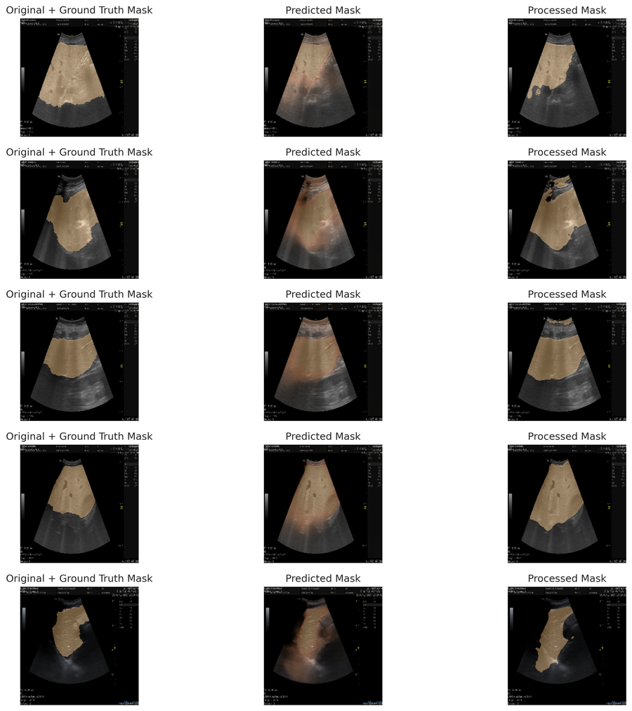
Figure 1. Five sample ultrasound frames — original image with ground-truth liver mask (left), the model's raw predicted mask (middle), and the post-processed mask after cleanup (right). Predicted masks closely follow the true liver boundary in most cases, with small boundary errors visible in a couple of harder frames.

5. Experiment 2 — MASLD Grade Classification (DenseNet121, image-only)
Notebook reviewed: masald-classification-densenet121-grades. This model predicts the disease Grade (1, 2 or 3) directly from the ultrasound image using a DenseNet121 backbone.
Input | Ultrasound image only
Backbone | DenseNet121
Train / Test split | 1,827 / 204 images
Class balance (train) | Grade 1: 65.0% • Grade 2: 27.7% • Grade 3: 7.3%
Class balance (test) | Grade 1: 64.7% • Grade 2: 27.9% • Grade 3: 7.4%
Class | Precision | Recall | F1-score | Support
Grade_1 | 1.00 | 0.98 | 0.99 | 132
Grade_2 | 0.97 | 1.00 | 0.98 | 57
Grade_3 | 1.00 | 1.00 | 1.00 | 15
Accuracy |  |  | 0.99 | 204
Macro avg | 0.99 | 0.99 | 0.99 | 204
Weighted avg | 0.99 | 0.99 | 0.99 | 204
Overall Accuracy: 99.02%

6. Experiment 3 — Fibrosis Staging (Image + Mask, DenseNet121)
Notebook reviewed: masald-classification-stage-fibrosis-onlyimage. The fibrosis stage label was built by extracting FibroScan results (text inside FibroScan report images) into an Excel sheet, then merging that with the ultrasound images and their masks per patient to create the final stage_fibrosis target. The model input here is the ultrasound image combined with its predicted liver mask (no clinical data yet).
Input | Ultrasound image + liver mask
Backbone | DenseNet121
Train / Test split | 1,827 / 204 images
Class balance (train) | F0-F1: 58.6% • F2-F3: 21.3% • F3-F4: 20.1%
Class balance (test) | F0-F1: 58.8% • F2-F3: 21.1% • F3-F4: 20.1%
Class | Precision | Recall | F1-score | Support
F0-F1 (No/minimal) | 0.99 | 1.00 | 1.00 | 120
F2-F3 (Significant) | 1.00 | 0.98 | 0.99 | 43
F3-F4 (Advanced) | 1.00 | 1.00 | 1.00 | 41
Accuracy |  |  | 1.00 | 204
Macro avg | 1.00 | 0.99 | 0.99 | 204
Weighted avg | 1.00 | 1.00 | 1.00 | 204
Overall Accuracy: 99.51%

7. Experiment 4 — Steatosis Staging (Image + Mask, DenseNet121)
Notebook reviewed: MASALD Classification (stage_steatosis). Same setup as the fibrosis model above (image + mask input, DenseNet121), but the target here is the steatosis stage (S0-S3).
Input | Ultrasound image + liver mask
Backbone | DenseNet121
Train / Test split | 1,827 / 204 images
Class balance (train) | S0: 72.5% • S1: 5.7% • S2: 4.0% • S3: 17.7%
Class balance (test) | S0: 72.5% • S1: 5.9% • S2: 3.9% • S3: 17.6%
Class | Precision | Recall | F1-score | Support
S0 (Normal) | 1.00 | 0.99 | 1.00 | 148
S1 (Mild) | 1.00 | 1.00 | 1.00 | 12
S2 (Moderate) | 0.89 | 1.00 | 0.94 | 8
S3 (Severe) | 1.00 | 1.00 | 1.00 | 36
Accuracy |  |  | 1.00 | 204
Macro avg | 0.97 | 1.00 | 0.98 | 204
Weighted avg | 1.00 | 1.00 | 1.00 | 204
Overall Accuracy: 99.51%

8. Understanding Precision, Recall and F1-score (in simple terms)
These three metrics all come from comparing the model's predictions against the true labels, class by class:
- Precision — "Of everything the model labeled as this class, how much was actually correct?" High precision means few false alarms: when the model says 'Grade 2', it is usually right.
- Recall — "Of everything that is truly this class, how much did the model manage to catch?" High recall means few misses: the model rarely lets a real case of this class slip past undetected.
- F1-score — the balance between precision and recall (their harmonic mean). It is high only when both precision and recall are high, and it is the metric to trust most when classes are imbalanced (as here, where Grade_3 or S2 have very few samples).
- Support — simply the number of true samples of that class in the test set (not a performance score).
- Accuracy — the percentage of all test samples the model got right overall, across every class combined.
- Macro avg — the plain average of precision/recall/f1 across classes, treating every class equally regardless of how many samples it has (this is the more honest number to look at with imbalanced classes).
- Weighted avg — the average across classes weighted by how many samples each class has, so it leans toward the performance on the majority class.
Practical reading: for the Grade / Fibrosis / Steatosis image-only models above, precision, recall and f1 are all ≥0.89 for every class — including the rare classes (Grade_3, S2) — which is a strong result and suggests the image+mask input carries very strong signal for these tasks on this dataset.

9. Experiment 5 — Multi-Modal Fusion (Image + Mask + Clinical Tabular Data)
To test whether adding patient clinical/lab information improves the model, the DenseNet121 image branch was fused with a tabular branch built from the patient sheet (Gender, Age, DM, HTN, BMI, waist circumference, triglyceride, HDL, cholesterol, INR, FBG, HBA1C, ALT, AST, Albumin, Bilirubin, weight, height, virology, etc.). The two feature vectors are concatenated (feature_fusion), passed through a fusion dense layer + dropout, and then into the final classification layer.
9.1 Steatosis Staging — Fusion Model
Notebook reviewed: MASALD Classification (stage_steatosis) Tabular.
Class | Precision | Recall | F1-score | Support
S0 (Normal) | 0.91 | 0.95 | 0.93 | 142
S1 (Mild) | 0.90 | 0.75 | 0.82 | 12
S2 (Moderate) | 0.67 | 0.25 | 0.36 | 8
S3 (Severe) | 0.81 | 0.83 | 0.82 | 36
Accuracy |  |  | 0.89 | 198
Macro avg | 0.82 | 0.70 | 0.73 | 198
Weighted avg | 0.88 | 0.89 | 0.88 | 198
Overall Accuracy: 88.89% (DenseNet frozen, only fusion head trained)
After Partial Fine-Tuning (last 50 layers of DenseNet121 unfrozen):
Result: identical to the frozen-backbone run above (accuracy 88.89%, same per-class scores) — partial fine-tuning gave no measurable improvement for this task on this dataset.
9.2 Fibrosis Staging — Fusion Model
Notebook reviewed: masald-classification-stage-fibrosis.
Class | Precision | Recall | F1-score | Support
F0-F1 (No/minimal) | 0.75 | 0.98 | 0.85 | 114
F2-F3 (Significant) | 0.92 | 0.56 | 0.70 | 43
F3-F4 (Advanced) | 0.91 | 0.51 | 0.66 | 41
Accuracy |  |  | 0.79 | 198
Macro avg | 0.86 | 0.68 | 0.73 | 198
Weighted avg | 0.82 | 0.79 | 0.78 | 198
Overall Accuracy: 79.29% (DenseNet frozen, only fusion head trained)
After Partial Fine-Tuning (last 50 layers of DenseNet121 unfrozen):
Result: identical to the frozen-backbone run above (accuracy 79.29%, same per-class scores) — again, no measurable improvement from partial fine-tuning.
Key observation: adding tabular fusion clearly reduced performance compared with the image+mask-only models (Steatosis: 99.5% → 88.9%; Fibrosis: 99.5% → 79.3%), and recall dropped sharply on the minority classes (e.g. Fibrosis F2-F3 recall fell from 0.98 to 0.56). This suggests the tabular branch, as fused here, added noise or made optimization harder rather than adding useful signal — most likely because the tabular data is patient-level (one row per patient) while training was done at the image level, and/or because the fusion diluted the very strong image signal found in Experiments 3–4.

10. Experiment 6 — Tabular-Only Baseline (XGBoost, no images)
To isolate how predictive the clinical/lab data is by itself, the tabular branch was separated from the image branch entirely and trained as a standalone XGBoost classifier (with the preprocessing in Section 3.2: label encoding, standard scaling, Gaussian-noise class balancing, and feature selection).
10.1 Steatosis Staging — XGBoost (tabular only)
Notebook: stage_steatosis.
Class | Precision | Recall | F1-score | Support
Class 0 | 0.89 | 0.80 | 0.84 | 10
Class 1 | 0.89 | 0.89 | 0.89 | 9
Class 2 | 0.89 | 0.80 | 0.84 | 10
Class 3 | 0.83 | 1.00 | 0.91 | 10
Accuracy |  |  | 0.87 | 39
Macro avg | 0.88 | 0.87 | 0.87 | 39
Weighted avg | 0.87 | 0.87 | 0.87 | 39
Overall Accuracy: 87%
10.2 Fibrosis Staging — XGBoost (tabular only)
Notebook: Stage fibrosis Classifier.
Class | Precision | Recall | F1-score | Support
Class 0 | 0.67 | 1.00 | 0.80 | 8
Class 1 | 0.83 | 0.56 | 0.67 | 9
Class 2 | 0.75 | 0.67 | 0.71 | 9
Accuracy |  |  | 0.73 | 26
Macro avg | 0.75 | 0.74 | 0.72 | 26
Weighted avg | 0.75 | 0.73 | 0.72 | 26
Overall Accuracy: 73%
Note the much smaller test-set sizes here (39 and 26 samples) versus the image models (198-204 samples) — the tabular-only experiments used the reduced, de-duplicated patient-level table rather than the full image-level dataset, so these numbers are less statistically stable and should be read as directional rather than final.

11. Summary Comparison Across All Experiments
Experiment | Input | Model | Test size | Accuracy
Segmentation | Image | Attention U-Net | — | 95.6% (val. acc.)
Grade classification | Image only | DenseNet121 | 204 | 99.0%
Fibrosis staging | Image + Mask | DenseNet121 | 204 | 99.5%
Steatosis staging | Image + Mask | DenseNet121 | 204 | 99.5%
Steatosis staging (fusion) | Image + Mask + Tabular | DenseNet121 + fusion | 198 | 88.9%
Steatosis staging (fusion, fine-tuned) | Image + Mask + Tabular | DenseNet121 (partial FT) + fusion | 198 | 88.9%
Fibrosis staging (fusion) | Image + Mask + Tabular | DenseNet121 + fusion | 198 | 79.3%
Fibrosis staging (fusion, fine-tuned) | Image + Mask + Tabular | DenseNet121 (partial FT) + fusion | 198 | 79.3%
Steatosis staging (tabular only) | Clinical/lab data only | XGBoost | 39 | 87%
Fibrosis staging (tabular only) | Clinical/lab data only | XGBoost | 26 | 73%

12. Key Findings
- The Attention U-Net segmentation model reaches 95.6% validation accuracy and visually produces liver masks that closely follow the ground truth, making it reliable enough to feed downstream classification models.
- Image + mask input with DenseNet121 gives excellent results for all three clinical tasks: Grade (99.0%), Fibrosis stage (99.5%) and Steatosis stage (99.5%) — including strong performance on the rare classes (Grade_3, S2), which is important since these tend to be the hardest and most clinically significant cases.
- Fusing clinical/tabular data with the image branch did not help — it clearly hurt performance versus the image+mask-only models (Steatosis 99.5%→88.9%, Fibrosis 99.5%→79.3%), with the biggest damage on recall for minority classes.
- Partial fine-tuning of the last 50 DenseNet121 layers on the fusion model gave no change at all versus the frozen backbone — the bottleneck is not backbone adaptation, it is more likely the tabular fusion strategy itself or the patient-level vs image-level mismatch in the tabular data.
- The tabular-only XGBoost baseline (clinical/lab data with no image) reaches a moderate 87% for steatosis and 73% for fibrosis on very small held-out test sets, showing the clinical data does carry real signal on its own, but it is best used as its own model rather than blindly concatenated with image features.

13. Conclusion & Recommendation
The strongest, most reliable pipeline configuration found in these experiments is: Attention U-Net for liver segmentation, followed by DenseNet121 trained on image + predicted mask (no tabular fusion) for Grade, Fibrosis stage and Steatosis stage classification. This configuration achieved 99%+ accuracy across all three classification tasks. The clinical/tabular data does contain useful information on its own (as shown by the XGBoost baseline), so a promising next step would be to explore ensembling the image-only model with the tabular-only model at the decision level (e.g. averaging/stacking predicted probabilities) instead of feature-level fusion, which is what caused the performance drop observed in Experiment 5.

