1a). To install Flutter SDK and Dart SDK, and configure the development environment.
Procedure:
Step 1: Download Flutter SDK & Dart SDK
- Visit the official Flutter website.
- Download the latest Flutter SDK.
- Save the ZIP file to the local system.

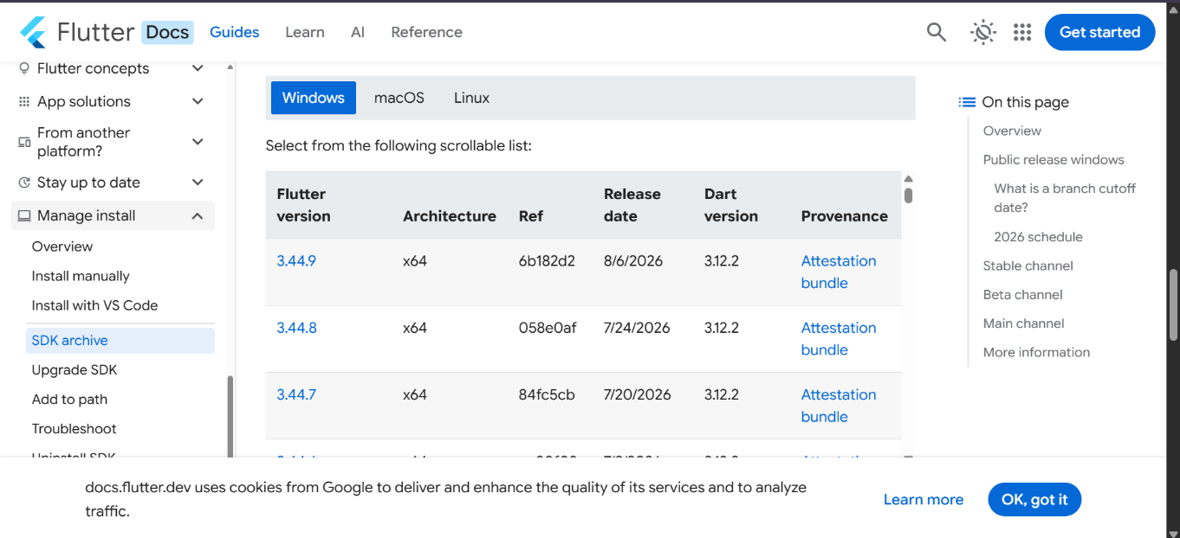

Step 2: Extract Flutter SDK & Dart SDK
- Extract the downloaded ZIP file.
- Move the extracted Flutter folder to a suitable location.

Step 3: Configure Environment Variables
- Open System Properties → Environment Variables.
- Edit the Path variable under System Variables.
- Add the Flutter\bin directory and Dart\bin directory.
- Click OK.
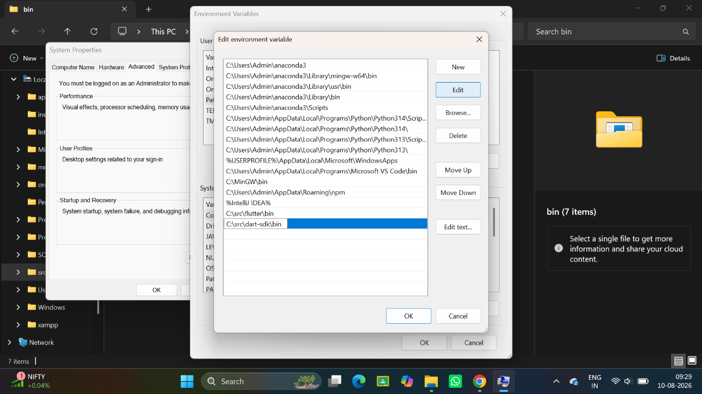

Step 4: Install Android Studio
- Download and install Android Studio.
- During installation, ensure that the following are selected:
- Android SDK
- SDK Platform
- SDK Tools
- AVD
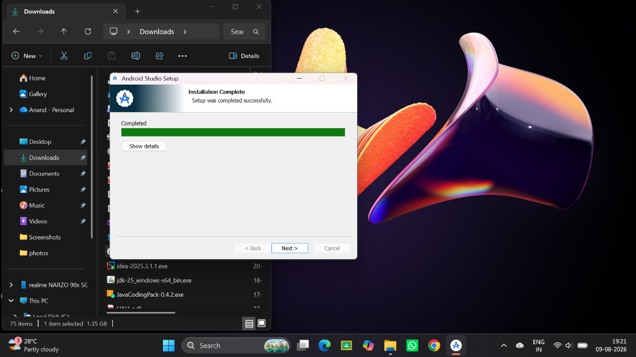
Step 5: Install Flutter, Dart & Dart Plugins
- Open Android Studio.
- Go to Settings → Plugins.
- Search for Flutter and install it.
- The Dart plugin will be installed automatically.
- Restart Android Studio.
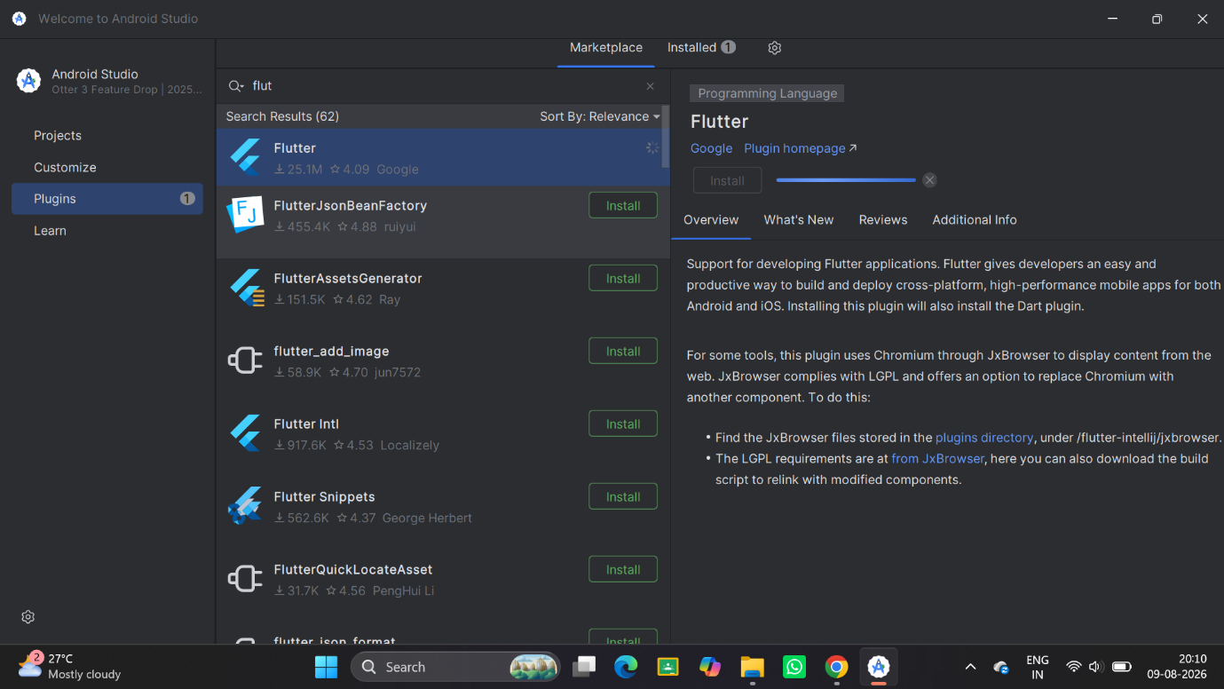

Final Output:-

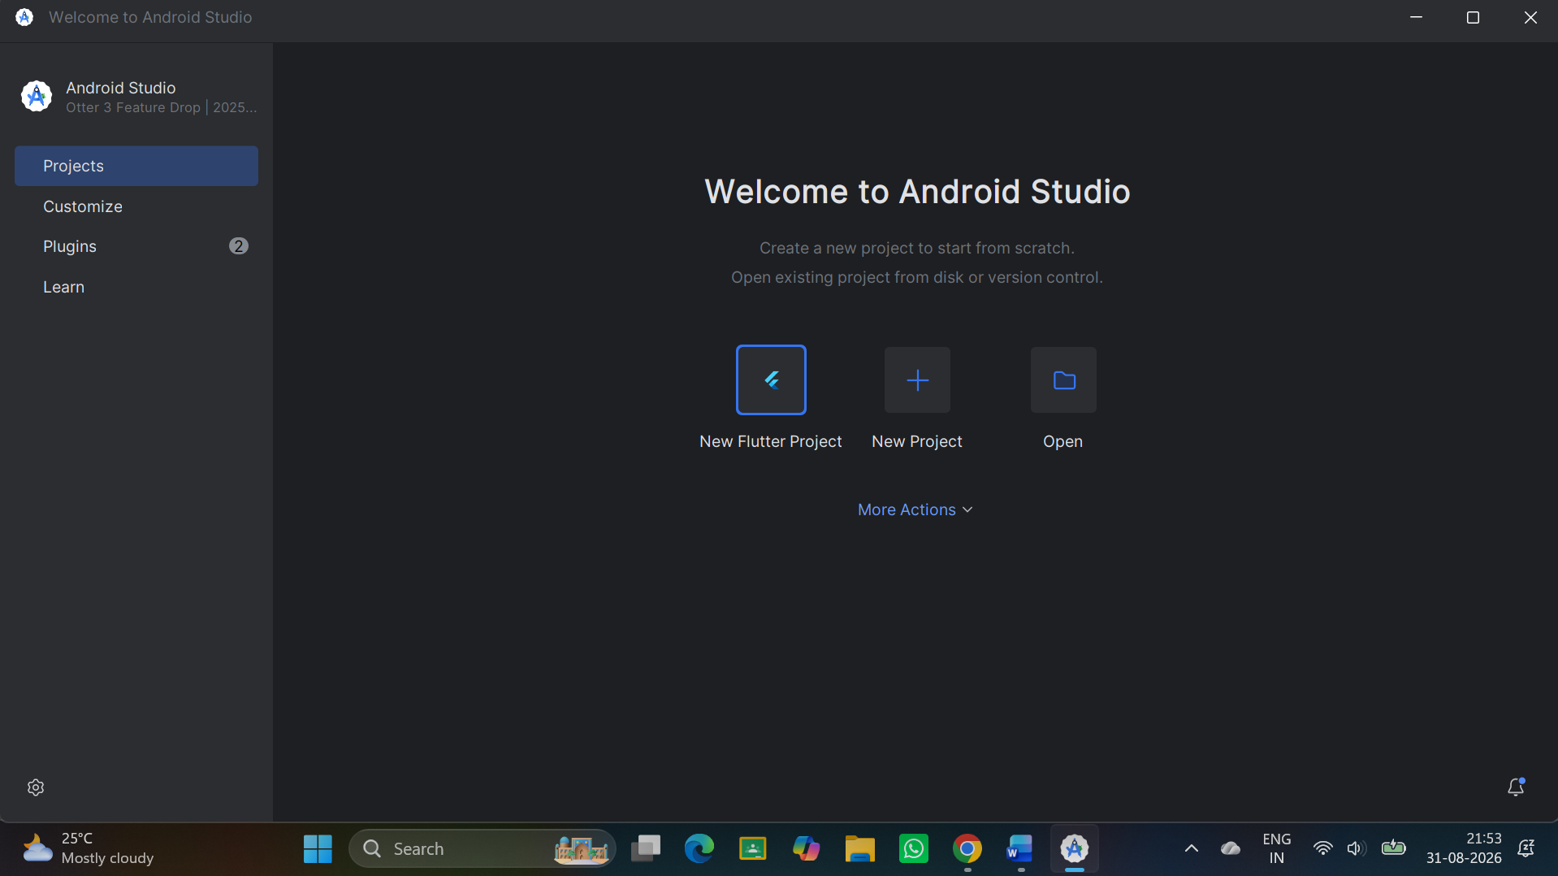
Result:
The Flutter SDK and Dart SDK were successfully installed and configured. The development environment was successfully set up, and a sample Flutter application was created and executed successfully.

1 b) Write a simple Dart program to understand the language basics
void main() {
int num1 = 10;
int num2 = 20;
int num3 = 30;
int sum = num1 + num2 + num3;
print('The sum of $num1, $num2, and $num3 is $sum.');
}
Final Output:-

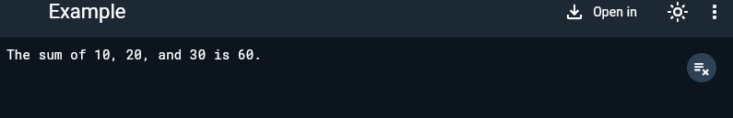

2a) Explore various Flutter widgets (Text, Image, Container, etc.).
import 'package:flutter/material.dart';
void main() {
runApp(MyApp());
}
class MyApp extends StatefulWidget {
const MyApp({super.key});
@override
State<MyApp> createState() => _MyAppState();
}
class _MyAppState extends State<MyApp> {
@override
Widget build(BuildContext context) {
return MaterialApp(
home: Scaffold(
appBar: AppBar(
title: Text('Image'),
),
body: Center(
child: Container(
height: 200,
width: 300,
child: Image.network('img_src'),
),
),
));
}
}

Final Output:-
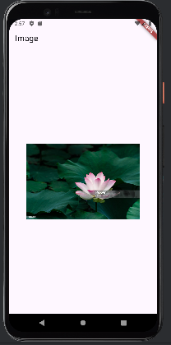

2 b) Implement different layout structures using Row, Column, and Stack widgets.

import 'package:flutter/material.dart';
void main() {
runApp(MyApp());
}
class MyApp extends StatelessWidget {
@override
Widget build(BuildContext context) {
return MaterialApp(
home: Scaffold(
appBar: AppBar(title: Text('Combined Layout Example')),
body: Center(
child: Column(
children: <Widget>[
Row(
children: <Widget>[
Container(color: Colors.red, width: 50, height: 50),
Container(color: Colors.green, width: 50, height: 50),
Container(color: Colors.blue, width: 50, height: 50),
],
),
SizedBox(height: 20),
Stack(
alignment: Alignment.center,
children: <Widget>[
Container(color: Colors.red, width: 200, height: 200),
Container(color: Colors.green, width: 150, height: 150),
Container(color: Colors.blue, width: 100, height: 100),
],
),
],
),
),
),
);
}
Final Output:-
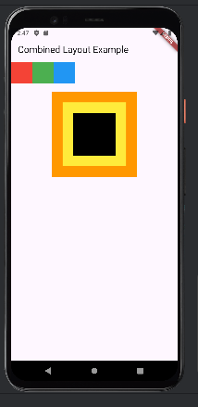

3 a) Design a responsive UI that adapts to different screen sizes
import 'package:flutter/material.dart';
void main() {
runApp(MyApp());
}
class MyApp extends StatelessWidget {
const MyApp({super.key});
@override
Widget build(BuildContext context) {
return SafeArea(
child: MaterialApp(
home: Text('AIML'),
),
);
}
}
Final Output:-

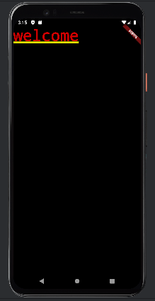

3 b) Implement media queries and breakpoints for responsiveness.
import 'package:flutter/material.dart';
void main() {
runApp(MyApp());
}
class MyApp extends StatelessWidget {
@override
Widget build(BuildContext context) {
return MaterialApp(
home: ResponsiveLayout(),
);
}
}
class ResponsiveLayout extends StatelessWidget {
@override
Widget build(BuildContext context) {
var mediaQueryData = MediaQuery.of(context);
var screenWidth = mediaQueryData.size.width;
if (screenWidth < 600) {
return Scaffold(
appBar: AppBar(title: Text('Mobile Layout')),
body: _buildNarrowContainers(),
);
} else if (screenWidth < 1200) {
return Scaffold(
appBar: AppBar(title: Text('Ta blet Layout')),
body: _buildMediumContainers(),
);
} else {
return Scaffold(
appBar: AppBar(title: Text('Desktop Layout')),
body: _buildWideContainers(),
);
}
}
Widget _buildNarrowContainers() {
return Column(
mainAxisAlignment: MainAxisAlignment.center,
children: <Widget>[
Container(color: Colors.red, width: 100, height: 100),
Container(color: Colors.green, width: 100, height: 100),
Container(color: Colors.blue, width: 100, height: 100),
],
);
}
Widget _buildMediumContainers() {
return Row(
mainAxisAlignment: MainAxisAlignment.center,
children: <Widget>[
Container(color: Colors.red, width: 100, height: 100),
Container(color: Colors.green, width: 100, height: 100),
Container(color: Colors.blue, width: 100, height: 100),
],
);
}
Widget _buildWideContainers() {
return GridView.count(
crossAxisCount: 3,
mainAxisSpacing: 10,
crossAxisSpacing: 10,
children: <Widget>[
Container(color: Colors.red, width: 100, height: 100),
Container(color: Colors.green, width: 100, height: 100),
Container(color: Colors.blue, width: 100, height: 100),
],
);
}
}
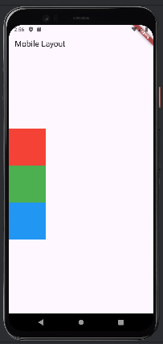

4 a) Set up navigation between different screens using Navigator.
import 'package:flutter/material.dart';
void main() {
runApp(MyApp());
}
class MyApp extends StatelessWidget {
const MyApp({super.key});
@override
Widget build(BuildContext context) {
return MaterialApp(
home: HomeScreen(),
);
}
}
class HomeScreen extends StatelessWidget {
const HomeScreen({super.key});
@override
Widget build(BuildContext context) {
return Scaffold(
appBar: AppBar(
title: Text('Home screen'),
),
body: Center(
child: ElevatedButton(
onPressed: () {
Navigator.push(
context,
MaterialPageRoute(builder: (context) => SecondScreen()),
);
},
child: Text('Go to Second Screen'),
),
),
);
}
}
class SecondScreen extends StatelessWidget {
const SecondScreen({super.key});
@override
Widget build(BuildContext context) {
return Scaffold(
appBar: AppBar(
title: Text('Second screen'),
),
body: ElevatedButton(
onPressed: () {
Navigator.pop(context);
},
child: Text('Go back to Home screen'),
),
);
}
}
Final Output:-
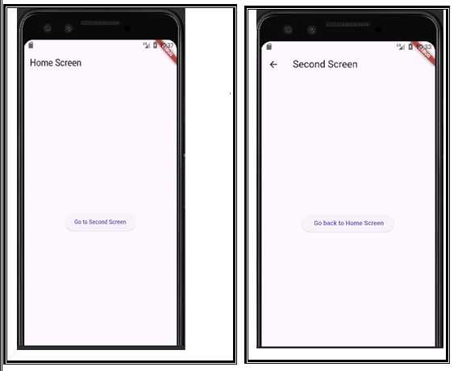

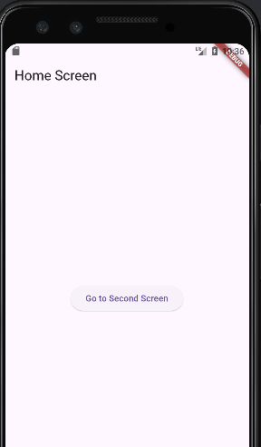

4 b) Implement navigation with named routes.
import 'package:flutter/material.dart';
void main() {
runApp(MyApp());
}
class MyApp extends StatelessWidget {
const MyApp({super.key});
@override
Widget build(BuildContext context) {
return MaterialApp(
initialRoute: '/',
routes: {
'/': (context) => HomeScreen(),
'/second': (context) => SecondScreen(),
},
);
}
}
class HomeScreen extends StatelessWidget {
const HomeScreen({super.key});
@override
Widget build(BuildContext context) {
return Scaffold(
appBar: AppBar(
title: Text('Home screen'),
),
body: Center(
child: ElevatedButton(
onPressed: () {
Navigator.pushNamed(context, '/second');
},
child: Text('Go to Second Screen'),
),
),
);
}
}
class SecondScreen extends StatelessWidget {
const SecondScreen({super.key});
@override
Widget build(BuildContext context) {
return Scaffold(
appBar: AppBar(
title: Text('Second screen'),
),
body: ElevatedButton(
onPressed: () {
Navigator.pop(context);
},
child: Text('Go back to Home screen'),
),
);
}
}
Final Output:-

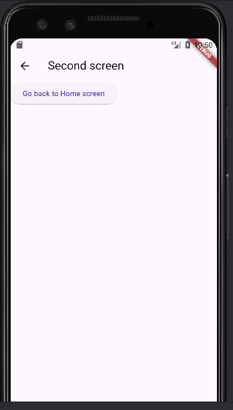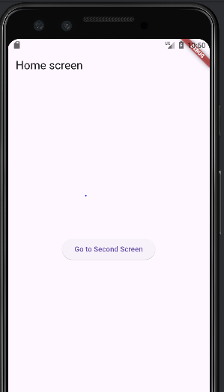

5 a) Learn about stateful and stateless widgets
import 'package:flutter/material.dart';
void main() {
runApp(MyApp());
}
class MyApp extends StatefulWidget {
const MyApp({super.key});
@override
State<MyApp> createState() => _MyAppState();
}
class _MyAppState extends State<MyApp> {
@override
Widget build(BuildContext context) {
return MaterialApp(
home: Column(
children: [Text('data-1'), Text('data-2'), Text('data-3')],
),
);
}
}
Final Output:-
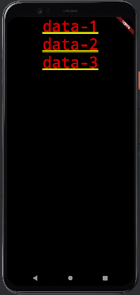

5 (A) (2)
import 'package:flutter/material.dart';
void main() {
runApp(MyApp());
}
class MyApp extends StatelessWidget {
const MyApp({super.key});
@override
Widget build(BuildContext context) {
return MaterialApp(
home: Text('FDP'),
);
}
}

Final Output:-

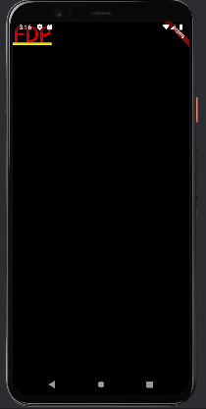

5 b) Implement state management using set State and Provider.

import 'package:flutter/material.dart';
void main() {
runApp(MyApp());
}
class MyApp extends StatefulWidget {
const MyApp({super.key});
@override
State<MyApp> createState() => _MyAppState();
}
class _MyAppState extends State<MyApp> {
String value = "Test"; //variable initialized
void clickMe() {
setState(() {
value = "Test done";
});
}
@override
Widget build(BuildContext context) {
return MaterialApp(
home: Scaffold(
appBar: AppBar(
title: Text('simple Flutter app'),
),
body: Center(
child: Column(
children: [
Text('$value'),
],
),
),
floatingActionButton: FloatingActionButton(
child: Icon(Icons.add),
onPressed: clickMe,
),
),
);
}
}

Final Output:-

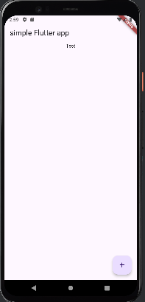

6 a) Create custom widgets for specific UI elements.
import 'package:flutter/material.dart';

void main() {
runApp(MyApp());
}

class MyApp extends StatelessWidget {
const MyApp({super.key});
@override
Widget build(BuildContext context) {
return MaterialApp(
home: HomeScreen(),
);
}
}

//Home screen - class
class HomeScreen extends StatelessWidget {
const HomeScreen({super.key});

@override
Widget build(BuildContext context) {
return Scaffold(
appBar: AppBar(
title: Text("Custom Widget Example"),
),
body: Center(
child: IconTextButton(
icon: Icons.thumb_up, //variable 1
text: 'Like', //variable 2
onPressed: () {
//variable 3
print('Button Pressed!');
}),
),
);
}
}
//IconTextButton- class
class IconTextButton extends StatelessWidget {
//variable declarations
final IconData icon; //var-1 declaration
final String text; //var-2 declration
final VoidCallback onPressed; //var-3 declaration
//constructor
IconTextButton({
required this.icon,
required this.text,
required this.onPressed,
});
@override
Widget build(BuildContext context) {
return ElevatedButton.icon(
onPressed: onPressed,
icon: Icon(icon),
label: Text(text),
);
}
}
Final Output:-
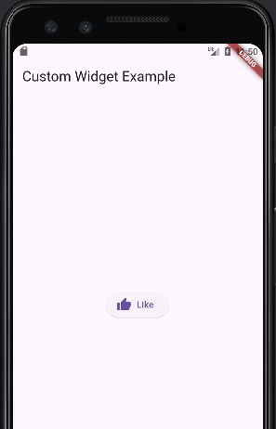
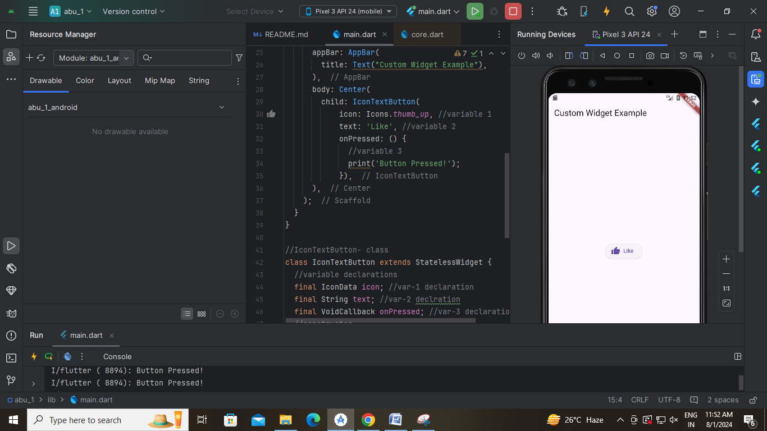

6 b) Apply styling using themes and custom styles.
import 'package:flutter/material.dart';

void main() {
runApp(MyApp());
}
class MyApp extends StatelessWidget {
const MyApp({super.key});
@override
Widget build(BuildContext context) {
return MaterialApp(
home: HomeScreen(),
);
}
}
//Home screen - class
class HomeScreen extends StatelessWidget {
const HomeScreen({super.key});
@override
Widget build(BuildContext context) {
return Scaffold(
appBar: AppBar(
title: Text("Custom Widget Example"),
),
body: Center(
child: IconTextButton(
icon: Icons.thumb_up, //variable 1
text: 'Like', //variable 2
onPressed: () {
//variable 3
print('Button Pressed!');
}),
),
);
}
}
//IconTextButton- class
class IconTextButton extends StatelessWidget {
//variable declarations
final IconData icon; //var-1 declaration
final String text; //var-2 declration
final VoidCallback onPressed; //var-3 declaration
//constructor
IconTextButton({
required this.icon,
required this.text,
required this.onPressed,
});
@override
Widget build(BuildContext context) {
return ElevatedButton.icon(
onPressed: onPressed,
icon: Icon(icon),
label: Text(text),
style: ElevatedButton.styleFrom(
backgroundColor: Colors.pink,
foregroundColor: Colors.black,
),
);
}
}
Final Output:-
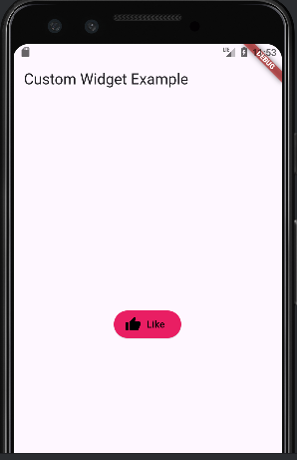
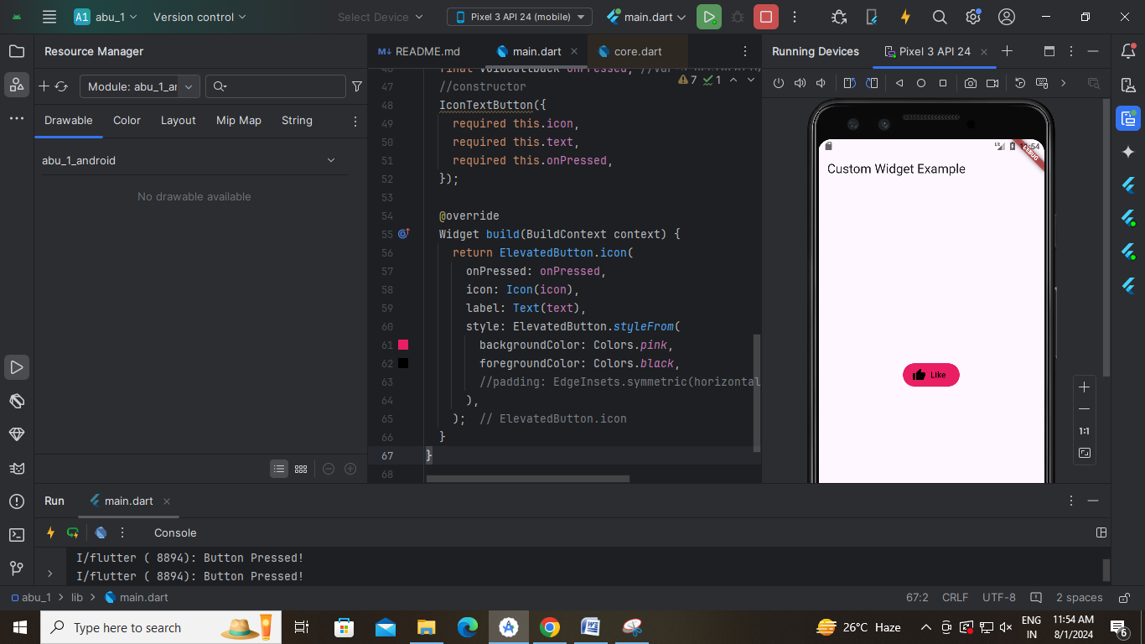

7 a) Design a form with various input ields.

import 'package:flutter/material.dart';
void main() {
runApp(MyApp());
}

class MyApp extends StatelessWidget {
@override
Widget build(BuildContext context) {
return MaterialApp(
home: Scaffold(
appBar: AppBar(
title: Text('Simple Form Example'),
),
body: Padding(
padding: const EdgeInsets.all(16.0),
child: SimpleForm(),
),
),
);
}
}

class SimpleForm extends StatefulWidget {
@override
_SimpleFormState createState() => _SimpleFormState();
}

class _SimpleFormState extends State<SimpleForm> {
final _nameController = TextEditingController();
final _ageController = TextEditingController();

@override
Widget build(BuildContext context) {
return Column(
crossAxisAlignment: CrossAxisAlignment.start,
children: <Widget>[
TextField(
controller: _nameController,
decoration: InputDecoration(labelText: 'Name'),
),
TextField(
controller: _ageController,
decoration: InputDecoration(labelText: 'Age'),
keyboardType: TextInputType.number,
),
SizedBox(height: 20),
ElevatedButton(
onPressed: () {
// Action on button press
final name = _nameController.text;
final age = _ageController.text;
print('Name: $name, Age: $age');
},
child: Text('Submit'),
),
],
);
}

Final Output:-
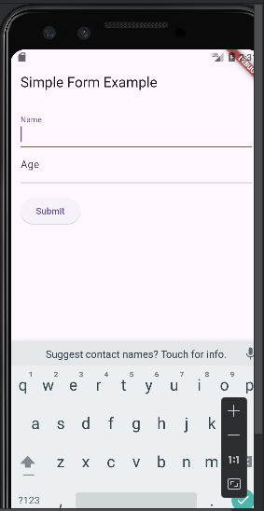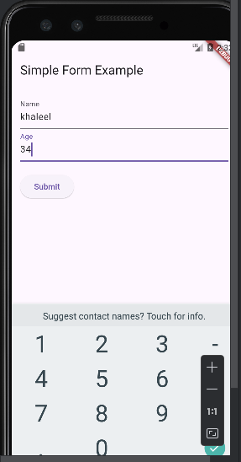

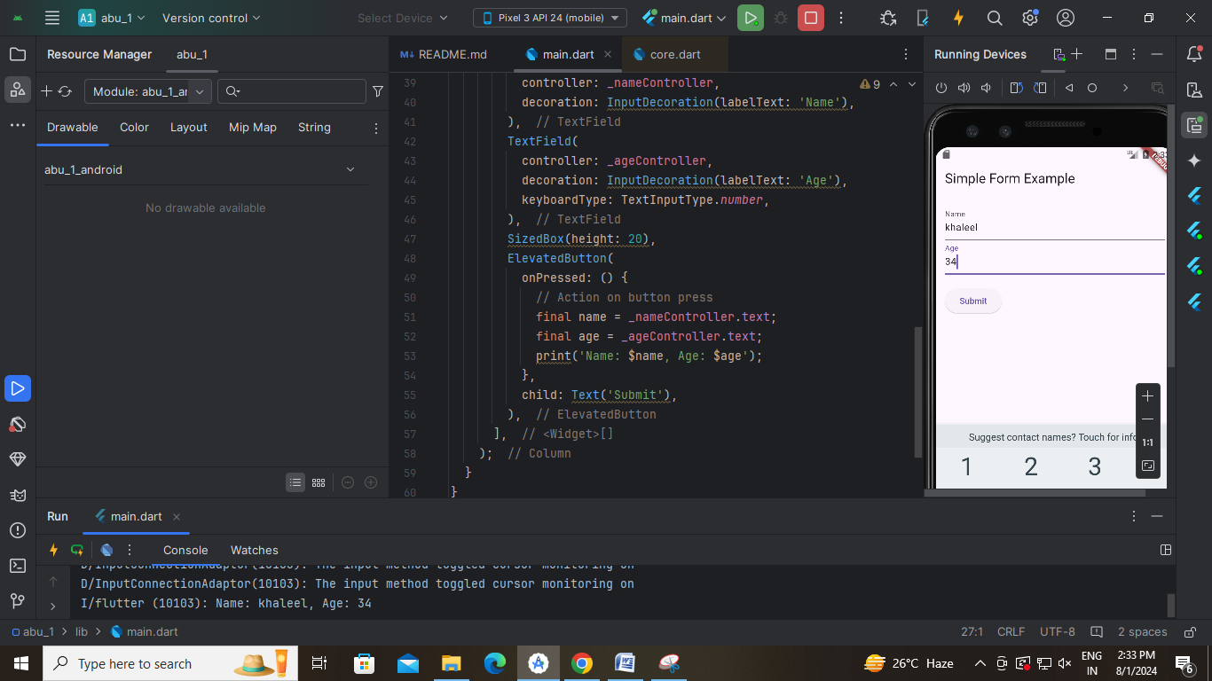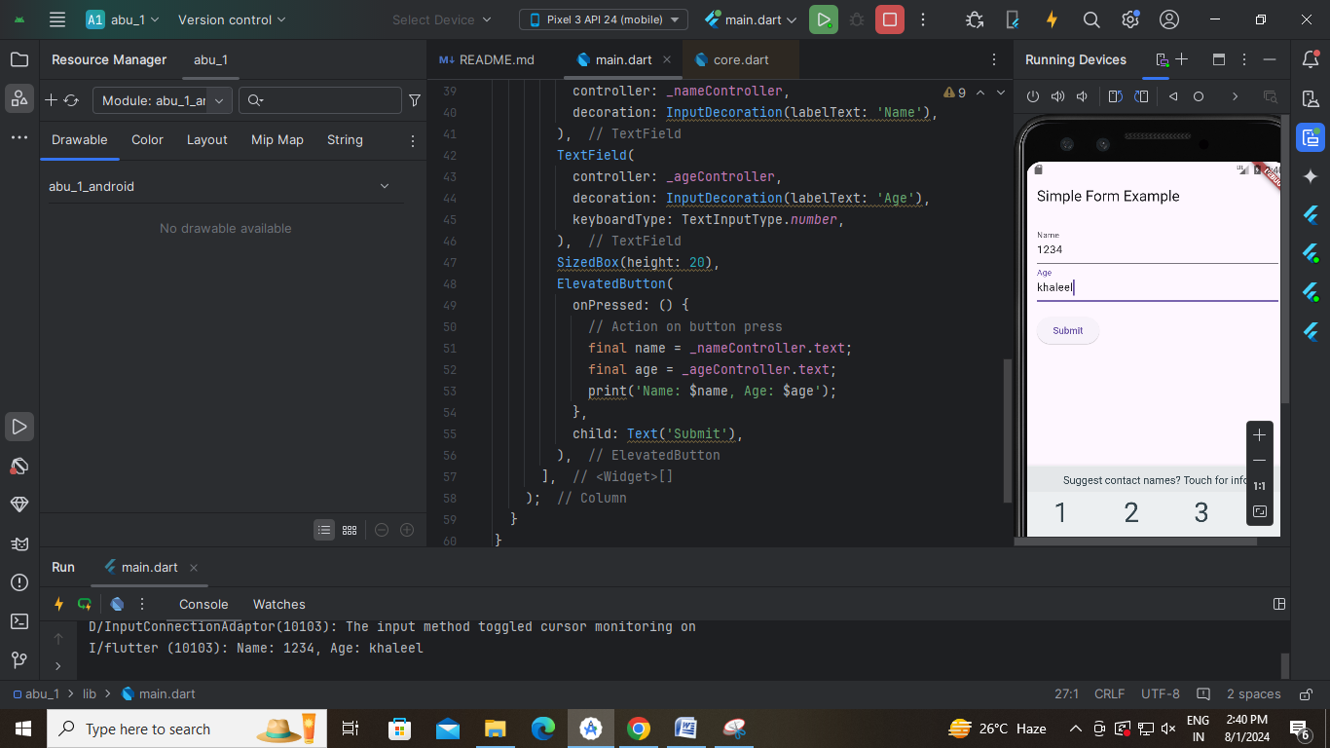

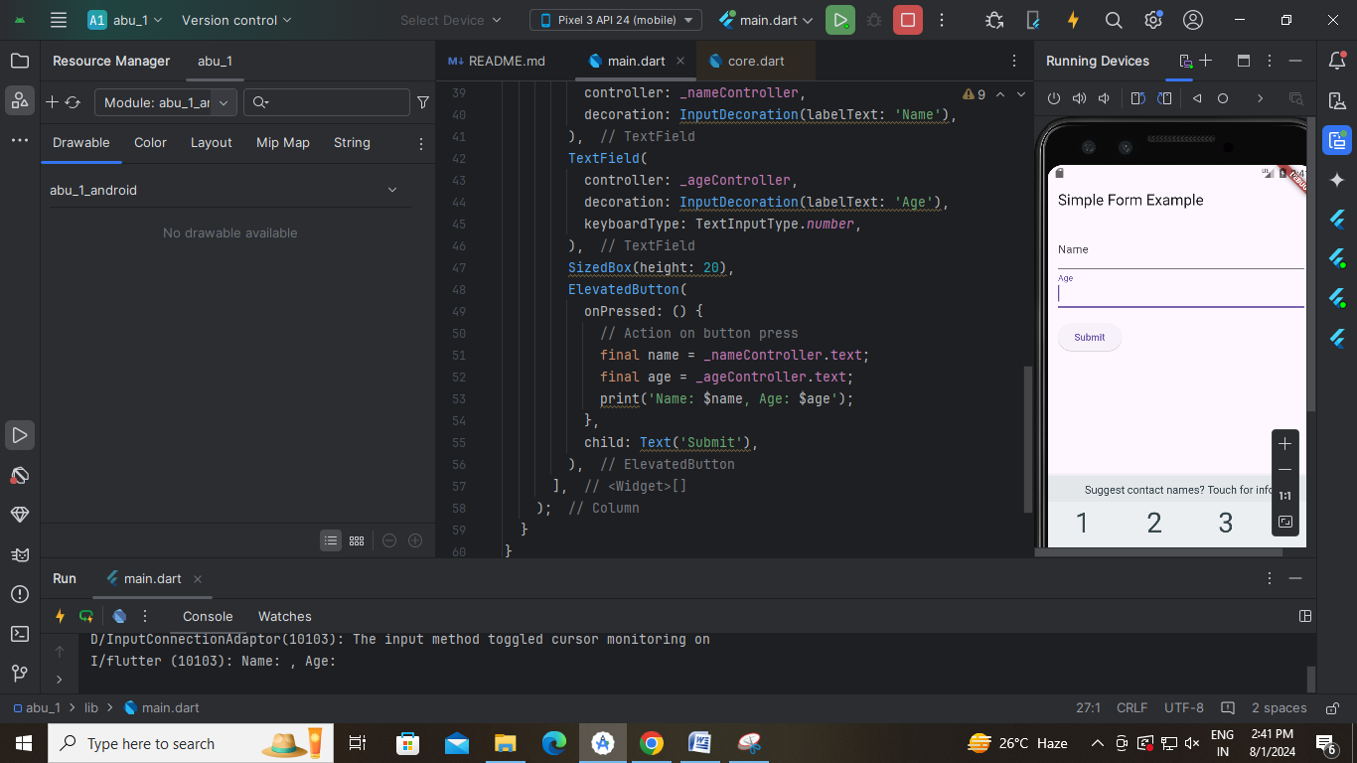

7 b) Implement form validation and error handling.
import 'package:flutter/material.dart';

void main() (
runApp(MyApp());
}

class MyApp extends StatelessWidget {
@override
Widget build(BuildContext context) {
return MaterialApp(
home: Scaffold(
appBar: AppBar(
title: Text('Simple Form with Validation'),
),
body: Padding(
padding: const EdgeInsets.all(16.0),
child: SimpleForm(),
),
),
);
}
}

class SimpleForm extends StatefulWidget {
@override
_SimpleFormState createState() => _SimpleFormState();
}

class _SimpleFormState extends State<SimpleForm> {
final _formKey = GlobalKey<FormState>();

final _nameController = TextEditingController();
final _ageController = TextEditingController();
@override
Widget build(BuildContext context) {
return Form(
key: _formKey,
child: Column(
crossAxisAlignment: CrossAxisAlignment.start,
children: <Widget>[
TextFormField(
controller: _nameController,
decoration: InputDecoration(labelText: 'Name'),
validator: (value) {
if (value == null || value.isEmpty) {
return 'Please enter your name';
}
return null;
},
),
TextFormField(
controller: _ageController,
decoration: InputDecoration(labelText: 'Age'),
keyboardType: TextInputType.number,
validator: (value) {
if (value == null || value.isEmpty) {
return 'Please enter your age';
}
final age = int.tryParse(value);
if (age == null || age <= 0) {
return 'Please enter a valid age';
}
return null;
},
),
SizedBox(height: 20),
ElevatedButton(
onPressed: () {
if (_formKey.currentState?.validate() ?? false) {
// If the form is valid, display a snackbar.
final name = _nameController.text;
final age = _ageController.text;
ScaffoldMessenger.of(context).showSnackBar(
SnackBar(content: Text('Name: $name, Age: $age')),
);
}
},
child: Text('Submit'),
),
],
),
);
}
}
Final Output:-
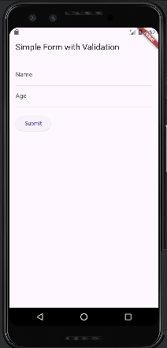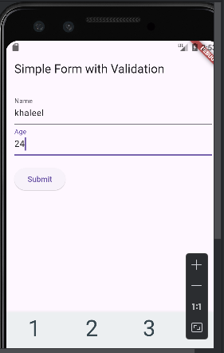
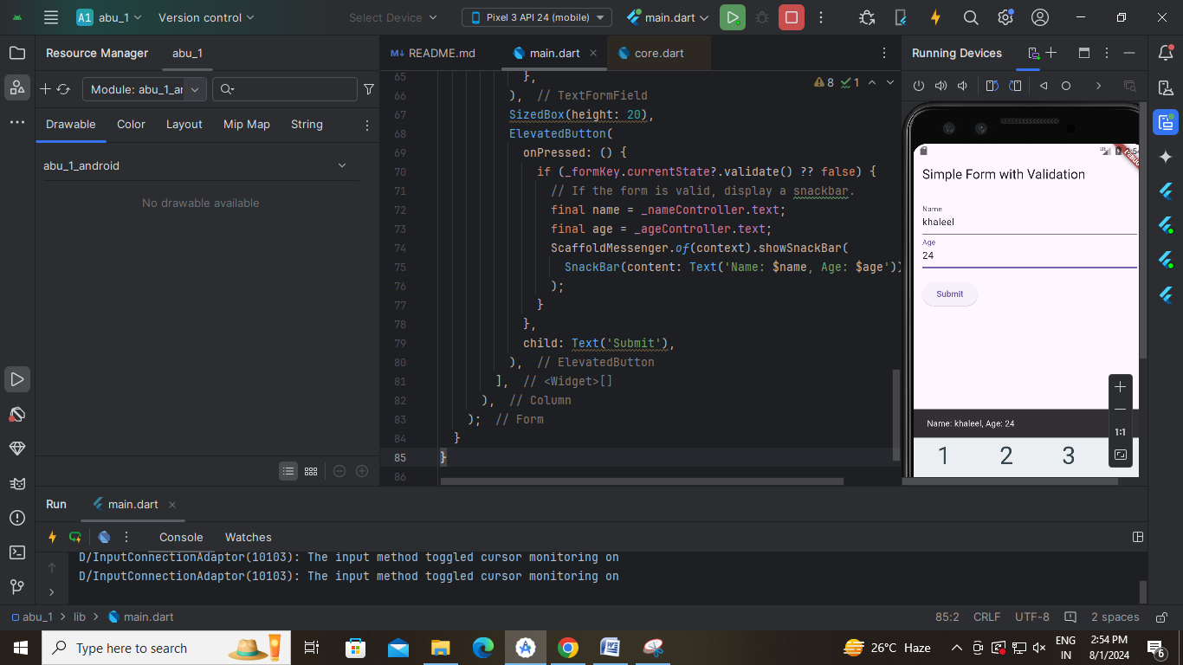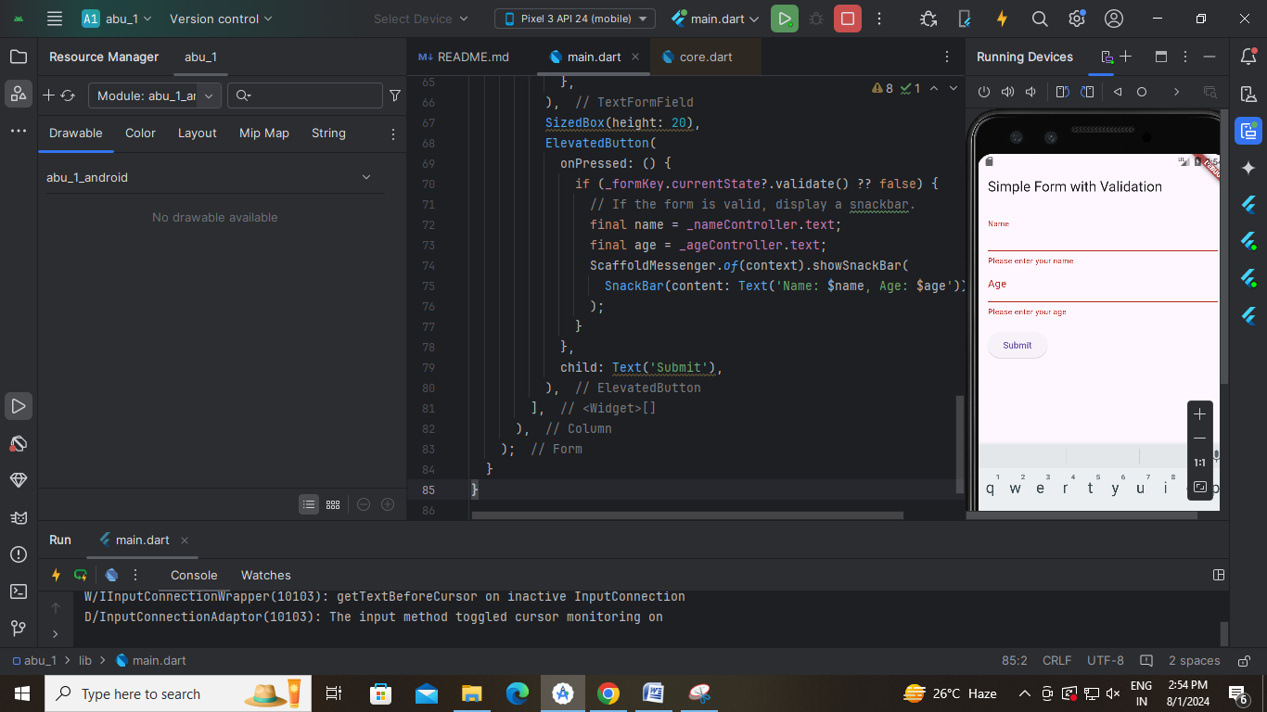

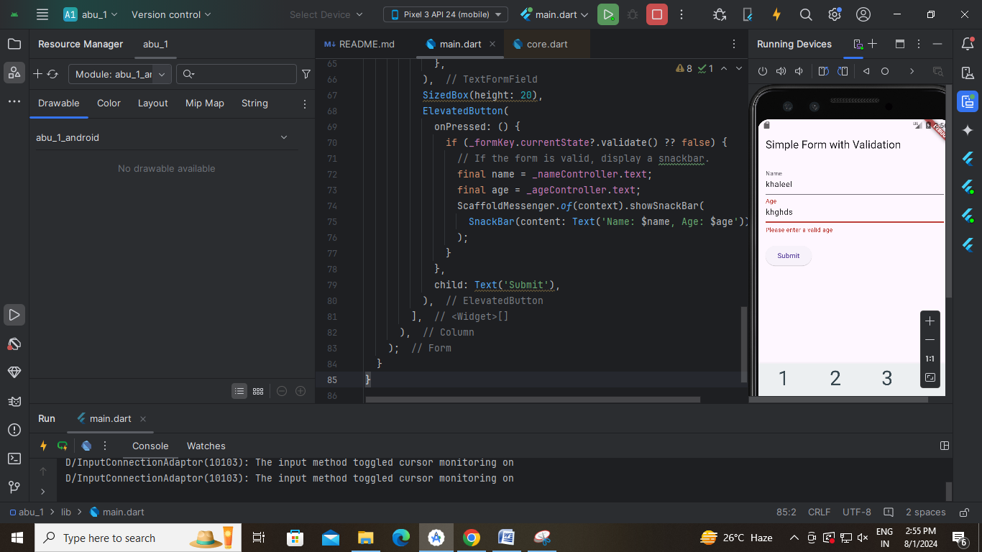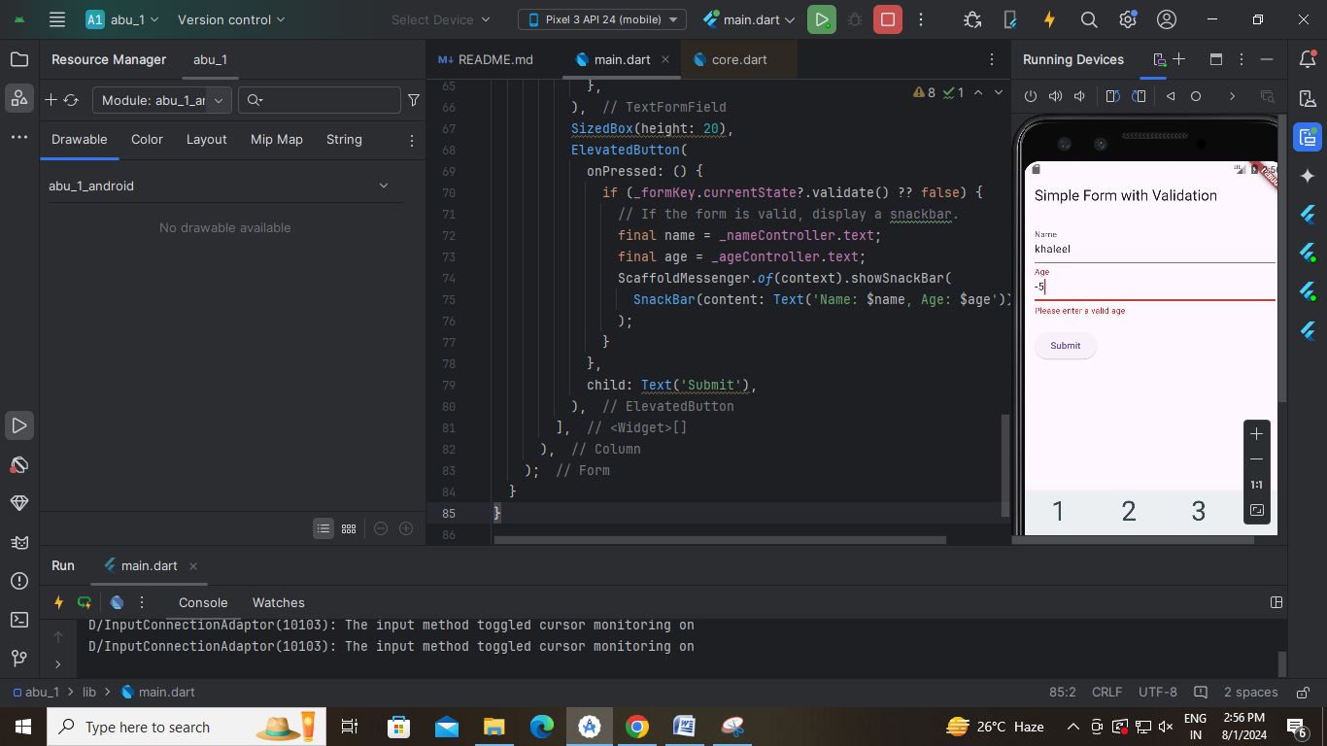

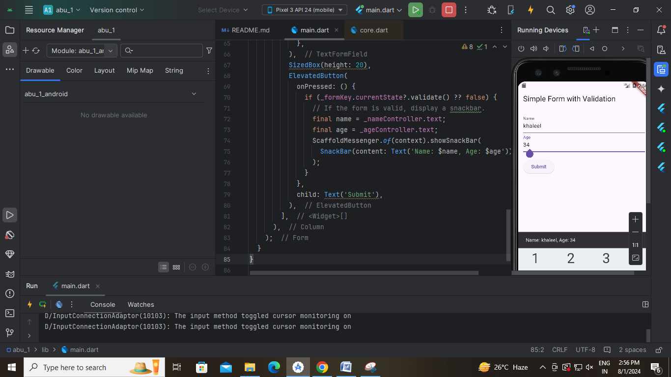

8 a) Add animations to UI elements using Flutter's animation framework.
import 'package:flutter/material.dart';

void main() {
runApp(MyApp());
}
class MyApp extends StatelessWidget {
const MyApp({super.key});

@override
Widget build(BuildContext context) {
return MaterialApp(
home: HomeScreen(),
);
}
}

class HomeScreen extends StatelessWidget {
const HomeScreen({super.key});

@override
Widget build(BuildContext context) {
return Scaffold(
appBar: AppBar(
title: Text("Custon widget with animation"),
),
body: Center(
child: AnimatedIconTextButton(
icon: Icons.thumb_up,
text: 'Like',
onPressed: () {
print("Button Pressed!");
}),
),
);
}
}

class AnimatedIconTextButton extends StatefulWidget {
final IconData icon;
final String text
final VoidCallback onPressed;
//constructors
const AnimatedIconTextButton({
Key? key,
required this.icon,
required this.text,
required this.onPressed,
}) : super(key: key);
@override
State<AnimatedIconTextButton> createState() => _AnimatedIconTextButtonState();
}
class _AnimatedIconTextButtonState extends State<AnimatedIconTextButton> {
bool _isPressed = false;
void _handlePress() {
setState(() {
_isPressed = !_isPressed; //on->off//off->on
});
widget.onPressed();
}
@override
Widget build(BuildContext context) {
return AnimatedContainer(
duration: Duration(milliseconds: 300),
width: _isPressed ? 200 : 150,
height: _isPressed ? 100 : 70,
child: ElevatedButton.icon(
onPressed: _handlePress,
icon: Icon(widget.icon),
label: Text(widget.text),
style: ElevatedButton.styleFrom(
backgroundColor: Colors.blue,
foregroundColor: Colors.green,
),
),
); } }
Final Output:-
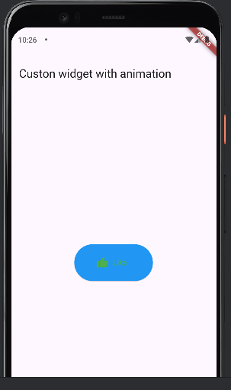
8 b) Experiment with different types of animations (fade, slide)
import 'package:flutter/material.dart';

void main() {
runApp(MyApp());
}

class MyApp extends StatelessWidget {
const MyApp({super.key});

@override
Widget build(BuildContext context) {
return MaterialApp(
home: HomeScreen(),
);
}
}

class HomeScreen extends StatelessWidget {
const HomeScreen({super.key});

@override
Widget build(BuildContext context) {
return Scaffold(
appBar: AppBar(
title: Text("Custon widget with animation"),
),
body: Center(
child: FadeIconTextButton(
icon: Icons.thumb_up,
text: 'Like',
onPressed: () {
print("Button Pressed!");
}),
),
);
}
}

class FadeIconTextButton extends StatefulWidget {
final IconData icon;
final String text;
final VoidCallback onPressed;
//constructors
const FadeIconTextButton({
Key? key,
required this.icon,
required this.text,
required this.onPressed,
}) : super(key: key);

@override
State<FadeIconTextButton> createState() => _FadeIconTextButtonState();
}
class _FadeIconTextButtonState extends State<FadeIconTextButton>
with SingleTickerProviderStateMixin {
late AnimationController _controller;
late Animation<double> _animation;
@override
void initState() {
super.initState();
_controller = AnimationController(
duration: const Duration(milliseconds: 500),
vsync: this,
);
_animation = CurvedAnimation(
parent: _controller,
curve: Curves.easeInOut,
);
}

void _handlePress() {
if (_controller.isCompleted) {
_controller.reverse();
} else {
_controller.forward();
}
widget.onPressed();
}

@override
void dispose() {
_controller.dispose();
super.dispose();
}

@override
Widget build(BuildContext context) {
return FadeTransition(
opacity: _animation,
child: ElevatedButton.icon(
onPressed: _handlePress,
icon: Icon(widget.icon),
label: Text(widget.text),
style: ElevatedButton.styleFrom(
backgroundColor: Colors.amber,
foregroundColor: Colors.black,
),
),
);
}
}
Final Output:-
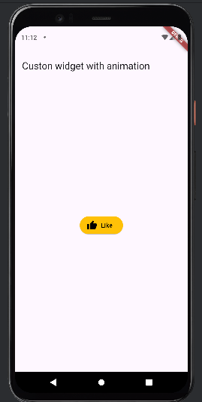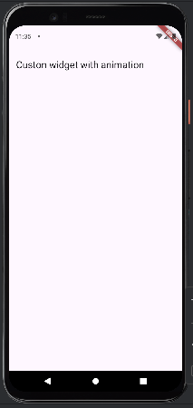

9 a) Fetch data from a REST API.
b) Display the fetched data in a meaningful way in the UI.

import 'package:flutter/material.dart';
import 'package:http/http.dart' as http;
import 'dart:convert';
void main() {
runApp(MyApp());
}
class MyApp extends StatelessWidget {
Widget build(BuildContext context) {
return MaterialApp(
home: HomeScreen(),
);
}
}
class HomeScreen extends StatefulWidget {
@override
_HomeScreenState createState() => _HomeScreenState();
}
class _HomeScreenState extends State<HomeScreen> {
late Future<List<Post>> _futurePosts;
@override
void initState() {
super.initState();
_futurePosts = fetchPosts();
}
Future<List<Post>> fetchPosts() async {
final response =
await http.get(Uri.parse('https://jsonplaceholder.typicode.com/posts'));
if (response.statusCode == 200) {
List jsonResponse = json.decode(response.body);
return jsonResponse.map((post) => Post.fromJson(post)).toList();
} else {
throw Exception('Failed to load posts');
}
}
@override
Widget build(BuildContext context) {
return Scaffold(
appBar: AppBar(
title: Text('Fetch Data Example'),
),
body: Center(
child: FutureBuilder<List<Post>>(
future: _futurePosts,
builder: (context, snapshot) {
if (snapshot.connectionState == ConnectionState.waiting) {
return CircularProgressIndicator();
} else if (snapshot.hasError) {
return Text('${snapshot.error}');
} else if (snapshot.hasData) {
List<Post>? posts = snapshot.data;
return ListView.builder(
itemCount: posts!.length,
itemBuilder: (context, index) {
return ListTile(
title: Text(posts[index].title),
subtitle: Text(posts[index].body),
);
},
);
} else {
return Text('No data found');
}
},
),
),
);
}
}
class Post {
final int id;
final String title;
final String body;
Post({required this.id, required this.title, required this.body});
factory Post.fromJson(Map<String, dynamic> json) {
return Post(
id: json['id'],
title: json['title'],
body: json['body'],
);
}}
Final Output:-
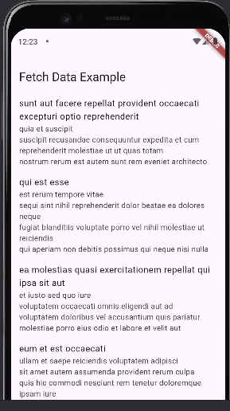

10 a) Write unit tests for UI components.
import 'package:flutter/material.dart';

void main() {
runApp(MyApp());
}

class MyApp extends StatelessWidget {
@override
Widget build(BuildContext context) {
return MaterialApp(
title: 'Flutter Demo',
theme: ThemeData(
primarySwatch: Colors.blue,
),
home: HomeScreen(),
);
}
}

class HomeScreen extends StatefulWidget {
@override
_HomeScreenState createState() => _HomeScreenState();
}

class _HomeScreenState extends State<HomeScreen> {
String _displayText = 'Hello';

void _updateText() {
setState(() {
_displayText = 'Button Pressed';
});
}

@override
Widget build(BuildContext context) {
return Scaffold(
appBar: AppBar(
title: Text('Home Screen'),
),
body: Center(
child: Column(
mainAxisAlignment: MainAxisAlignment.center,
children: <Widget>[
Text(_displayText),
SizedBox(height: 20),
ElevatedButton(
onPressed: _updateText,
child: Text('Press Me'),
),
],
),
),
);
}
}
import 'package:flutter/material.dart';
import 'package:flutter_test/flutter_test.dart';
import 'package:untitled/main.dart'; //url might change
void main() {
testWidgets('text changes', (WidgetTester tester) async {
//build the app
await tester.pumpWidget(MyApp());
//test-1 verifying the initial text'Hello
expect(find.text("Hello"), findsOneWidget);
expect(find.text("Button Pressed"), findsNothing);
//test-2 to tap the button
await tester.tap(find.byType(ElevatedButton));
await tester.pump();
//test-3 verify the text
expect(find.text("Hello"), findsNothing);
expect(find.text("Button Pressed"), findsOneWidget);
});
}
Final Output:-

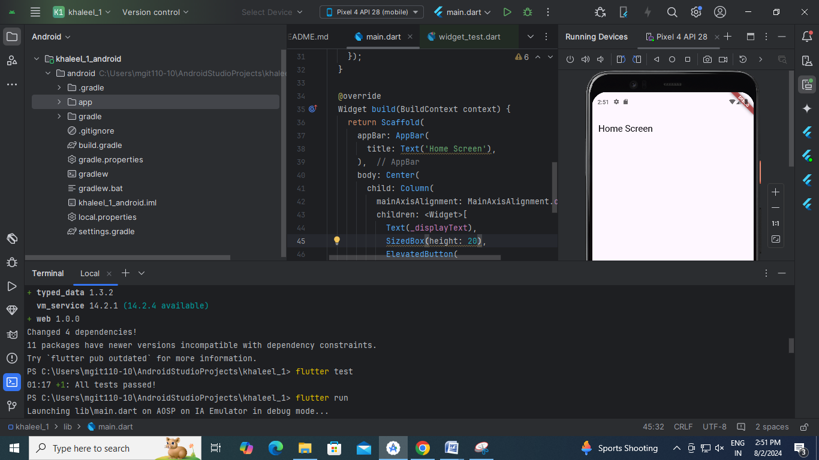

10 b) Use Flutter's debugging tools to identify and fix issues.

import 'package:flutter/material.dart';
void main() {
runApp(MyApp());
}
class MyApp extends StatelessWidget {
@override
Widget build(BuildContext context) {
return MaterialApp(
title: 'Flutter Demo',
theme: ThemeData(
primarySwatch: Colors.blue,
),
home: HomeScreen(),
);
}
}
class HomeScreen extends StatefulWidget {
@override
_HomeScreenState createState() => _HomeScreenState();
}
class _HomeScreenState extends State<HomeScreen> {
String _displayText; // Variable declared but not initialized
@override
Widget build(BuildContext context) {
return Scaffold(
appBar: AppBar(
title: Text('Home Screen'),
),
body: Center(
child: Column(
mainAxisAlignment: MainAxisAlignment.center,
children: <Widget>[
Text(_displayText), // Error: _displayText is used before being initialized
SizedBox(height: 20),
ElevatedButton(
onPressed: () {
setState(() {
_displayText = 'Button Pressed';
});
},
child: Text('Press Me'),
),
],
),
),
);
}
}
//corrected code
import 'package:flutter/material.dart';
void main() {
runApp(MyApp());
}
class MyApp extends StatelessWidget {
@override
Widget build(BuildContext context) {
return MaterialApp(
title: 'Flutter Demo',
theme: ThemeData(
primarySwatch: Colors.blue,
),
home: HomeScreen(),
);
}
}
class HomeScreen extends StatefulWidget {
@override
_HomeScreenState createState() => _HomeScreenState();
}
class _HomeScreenState extends State<HomeScreen> {
String _displayText="; // Variable declared and initialized
@override
Widget build(BuildContext context) {
return Scaffold(
appBar: AppBar(
title: Text('Home Screen'),
),
body: Center(
child: Column(
mainAxisAlignment: MainAxisAlignment.center,
children: <Widget>[
Text(_displayText), // Error: _displayText is used before being initialized
SizedBox(height: 20),
ElevatedButton(
onPressed: () {
setState(() {
_displayText = 'Button Pressed';
});
},
child: Text('Press Me'),
),
],
),
),
);
}
}

Final Output:-


