Insert your name, centre number and candidate number into the header above.
Save this evidence document as evidence_ followed by your centre number_ candidate number. For example: evidence_ zz999_9999.doc
Screenshots or program listings must be copied into appropriate cells in the following tables.
Examiners must be able to read the contents including any screenshots without the use of a magnifying glass. Answers that are not readable or missing will not be awarded any marks.
Save this evidence document at regular intervals, for example, every 10 minutes.
Question 1
Part 1(a)
(a
DataStored = [''] * 20 #ARRAY [0:19]
NumberItems = 0 # integer variable is defined

Part 1(b)
(b
def Initialise():
global DataStored
global NumberItems
NumberItems = int(input("how many numbers would you like to input? "))
while NumberItems < 1 or NumberItems > 20:
NumberItems = int(input("how many numbers would you like to input? "))
for x in range(NumberItems):
DataStored[x] = int(input("Write the number to insert in array "))

Part 1(c)(i)
(c)(i
def main():
global DataStored
global NumberItems
NumberItems = 0
Initialise()
for x in range(20):
print(DataStored[x] , end=" ")

Part 1(c)(ii)
{Copy and paste screenshot for question 1(c)(ii

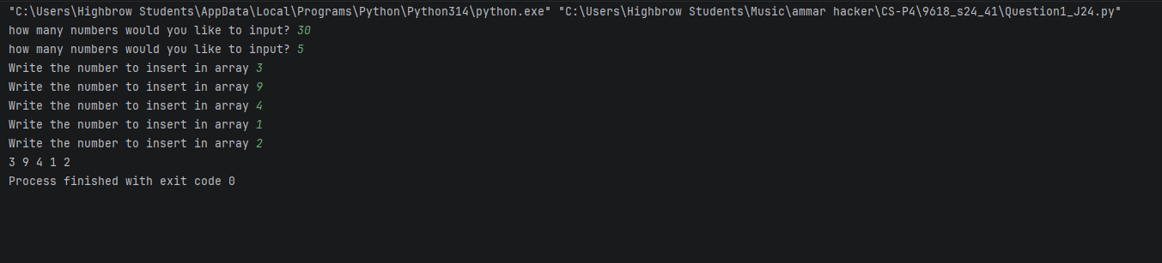

Part 1(d)(i)
(d)(i
def BubbleSort():
global DataStored
global NumberItems
for t in range(NumberItems):
for x in range(NumberItems-1):
if DataStored[x] > DataStored[x+1]:
temp = DataStored[x]
DataStored[x] = DataStored[x+1]
DataStored[x+1] = temp

Part 1(d)(ii)
BubbleSort()
print()
for x in range(20):
print(DataStored[x] , end=" ")

Part 1(d)(iii)
{Copy and paste screenshot for question 1(d)(iii
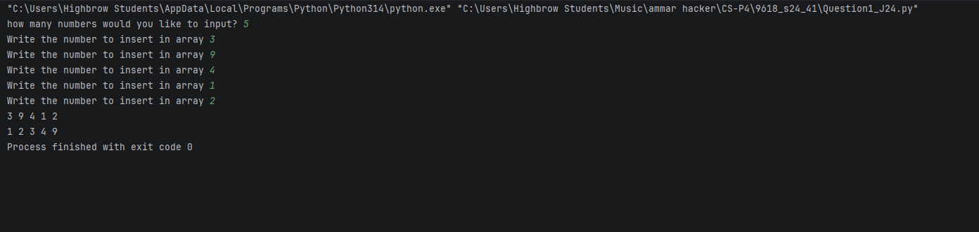

Part 1(e)(i)
#e(i)
def BinarySearch(DataToFind):
global DataStored
global NumberItems
ub = NumberItems
lb = 0
midp = int((lb+ub)/2)
found = False
while not found and lb <= ub:
if DataStored[midp] == DataToFind:
found = True
if DataToFind < DataStored[midp]:
ub = midp-1
else:
lb = midp+1
midp = int((lb + ub) / 2)
if found == True:
return midp
elif found == False:
return -1

Part 1(e)(ii)
DataToFind = int(input("Enter the number you would like to find: "))
bs = BinarySearch(DataToFind)
print(bs)

Part 1(e)(iii)
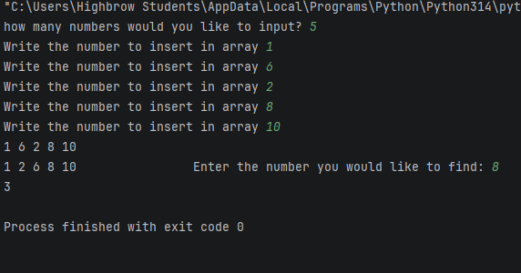

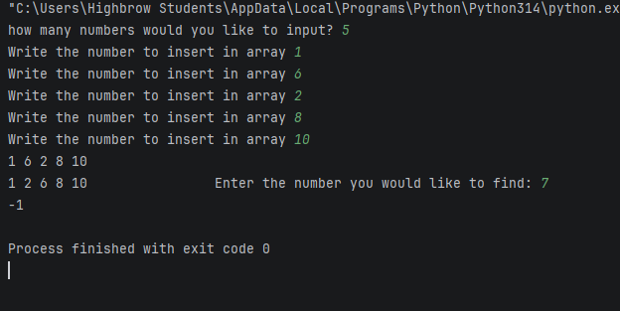

Question 2
Part 2(a)(i)
{Copy and paste program code listing for question 2(a)(i

Part 2(a)(ii)
{Copy and paste program code listing for question 2(a)(ii

Part 2(b)
{Copy and paste program code listing for question 2(b

Part 2(c)
{Copy and paste program code listing for question 2(c

Part 2(d)(i)
{Copy and paste program code listing for question 2(d)(i

Part 2(d)(ii)
{Copy and paste screenshot for question 2(d)(ii

Part 2(e)(i)
{Copy and paste program code listing for question 2(e)(i

Part 2(e)(ii)
{Copy and paste program code listing for question 2(e)(ii

Part 2(e)(iii)
{Copy and paste screenshot for question 2(e)(iii

Question 3
Part 3(a)
{Copy and paste program code listing for question 3(a

Part 3(b)
{Copy and paste program code listing for question 3(b

Part 3(c)
{Copy and paste program code listing for question 3(c

Part 3(d)(i)
{Copy and paste program code listing for question 3(d)(i

Part 3(d)(ii)
{Copy and paste program code listing for question 3(d)(ii

Part 3(d)(iii)
{Copy and paste screenshot for question 3(d)(iii

