Insert your name, centre number and candidate number into the header above.
Save this evidence document as evidence_ followed by your centre number_ candidate number. For example: evidence_ zz999_9999
Screenshots or program listings must be copied into appropriate cells in the following tables.
Examiners must be able to read the contents including any screenshots without the use of a magnifying glass. Answers that are not readable or missing will not be awarded any marks.
Save this evidence document at regular intervals, for example, every 10 minutes.
Question 1
Part 1(a)
def Unknown(x,y):
if(x < y):
print(x + y)
return (Unknown(x + 1, y) * 2)
elif(x == y):
return 1
else:
print(x + y)
return (Unknown(x - 1, y) // 2)

Part 1(b)(i)
def main():

print("----------------")
print(f"x: 10, y: 15")
print(Unknown(10, 15))
print("----------------")
print(f"x: 10, y: 10")
print(Unknown(10, 10))
print("----------------")
print(f"x: 15, y: 10")
print(Unknown(15, 10))
print("----------------")

main()

Part 1(b)(ii)
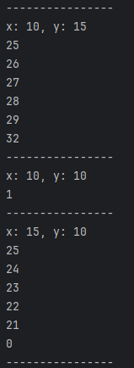

Part 1(c)
def IterativeUnknown(x, y):
Sum = 1
while (x == y):
return 1

while (x != y):
if (x > y):
print(x + y)
x -= 1
Sum //= 2
else:
print(x + y)
x += 1
Sum *= 2

return Sum

Part 1(d)(i)
def main():
print("---iterative---")
print("----------------")
print(f"x: 10, y: 15")
print(IterativeUnknown(10, 15))
print("----------------")
print(f"x: 10, y: 10")
print(IterativeUnknown(10, 10))
print("----------------")
print(f"x: 15, y: 10")
print(IterativeUnknown(15, 10))
print("----------------")

main()

Part 1(d)(ii)
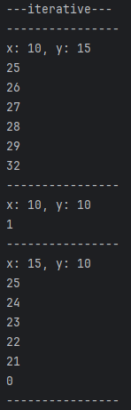

Question 2
Part 2(a)
{Copy and paste program code listing for question 2(a) here}

Part 2(b)(i)
{Copy and paste program code listing for question 2(b)(i) here}

Part 2(b)(ii)
{Copy and paste program code listing for question 2(b)(ii) here}

Part 2(b)(iii)
{Copy and paste the screenshots for question 2(b)(iii) here}

Part 2(c)
{Copy and paste program code listing for question 2(c) here}

Question 3
Part 3(a)
{Copy and paste program code listing for question 3(a) here}

Part 3(b)
{Copy and paste program code listing for question 3(b) here}

Part 3(c)(i)
{Copy and paste program code listing for question 3(c)(i) here}

Part 3(c)(ii)
{Copy and paste program code listing for question 3(c)(ii) here}

Part 3(c)(iii)
{Copy and paste program code listing for question 3(c)(iii) here}

Part 3(c)(iv)
{Copy and paste program code listing for question 3(c)(iv) here}

Part 3(c)(v)
{Copy and paste screenshots of the two tests for question 3(c)(v) here}

