ATMega32A

Make sure that the internal clock of the ATMega32A is set to 8 MHz  
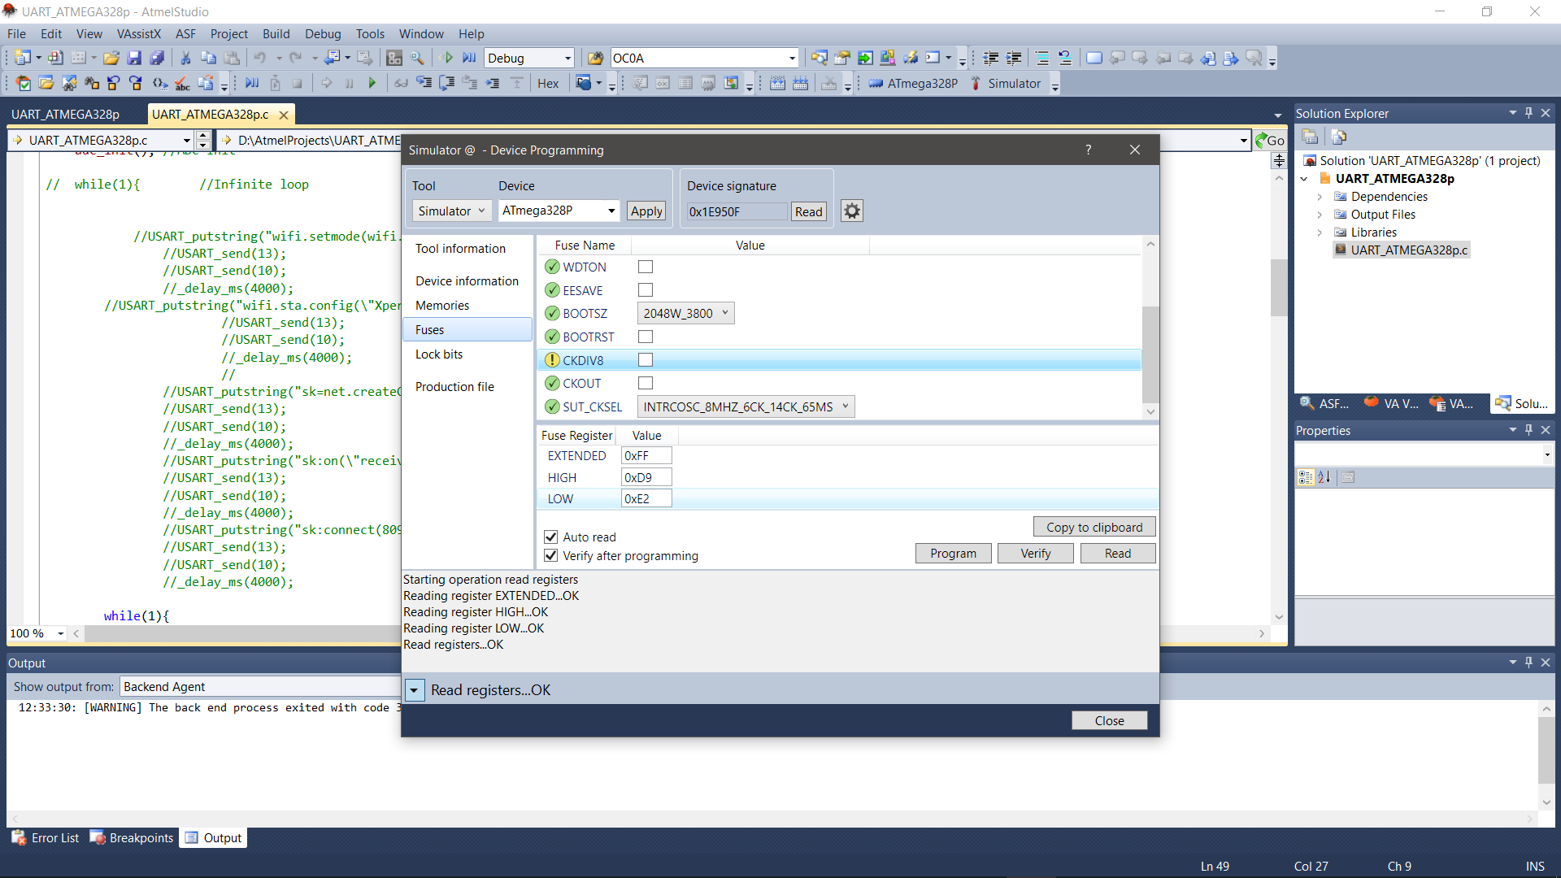

Baud rate must be 9600 with provided code.