Language Detective
Identifying Languages from Text Using NLP

1. Objective
The goal of this project is to build a system that identifies which language a given piece of text is written in, across 10 languages, and to compare two different NLP techniques for solving this task. Rather than treating the classifier as a black box, the system also reports the specific evidence (character sequences) it used to reach its conclusion -- similar to a detective presenting clues.

2. Dataset
A parallel dataset of 300 sentences (30 per language) was created across 10 languages: English, French, Spanish, German, Italian, Portuguese, Dutch, Swedish, Turkish, and Indonesian. Each language covers the same 30 everyday topics (greetings, weather, family, hobbies, etc.), so the classifier must rely on genuine linguistic signal rather than topic differences.

3. Methodology: Two Competing Approaches

3.1 Approach A - Character N-gram Fingerprinting + Naive Bayes
Every language has distinctive short letter sequences: German frequently uses "sch" and "ch", French and English share "tion", Turkish has unique characters like "s-cedilla" and "g-breve". This approach extracts overlapping sequences of 1 to 3 characters from each sentence and trains a Multinomial Naive Bayes classifier on their frequency patterns. This is a classic technique used in real-world language identification tools.

3.2 Approach B - Word-level TF-IDF + Logistic Regression
This approach instead looks at whole words and weighs them by TF-IDF (how distinctive a word is), then trains a Logistic Regression classifier. This mirrors the technique used in typical text classification projects (e.g. sentiment analysis).

4. Results: Head-to-Head Comparison
Approach | Accuracy | Macro F1
Character n-grams + Naive Bayes | 0.947 | 0.946
Word TF-IDF + Logistic Regression | 0.893 | 0.892

The character n-gram approach outperformed the word-level approach. This makes sense: with short sentences and only 30 examples per language, many test-set words were never seen during training, so a word-based model has little to work with. Character n-grams, however, generalize well because letter patterns repeat constantly within a language even when exact words differ.

4.1 Confusion Matrix (Character N-gram Model)
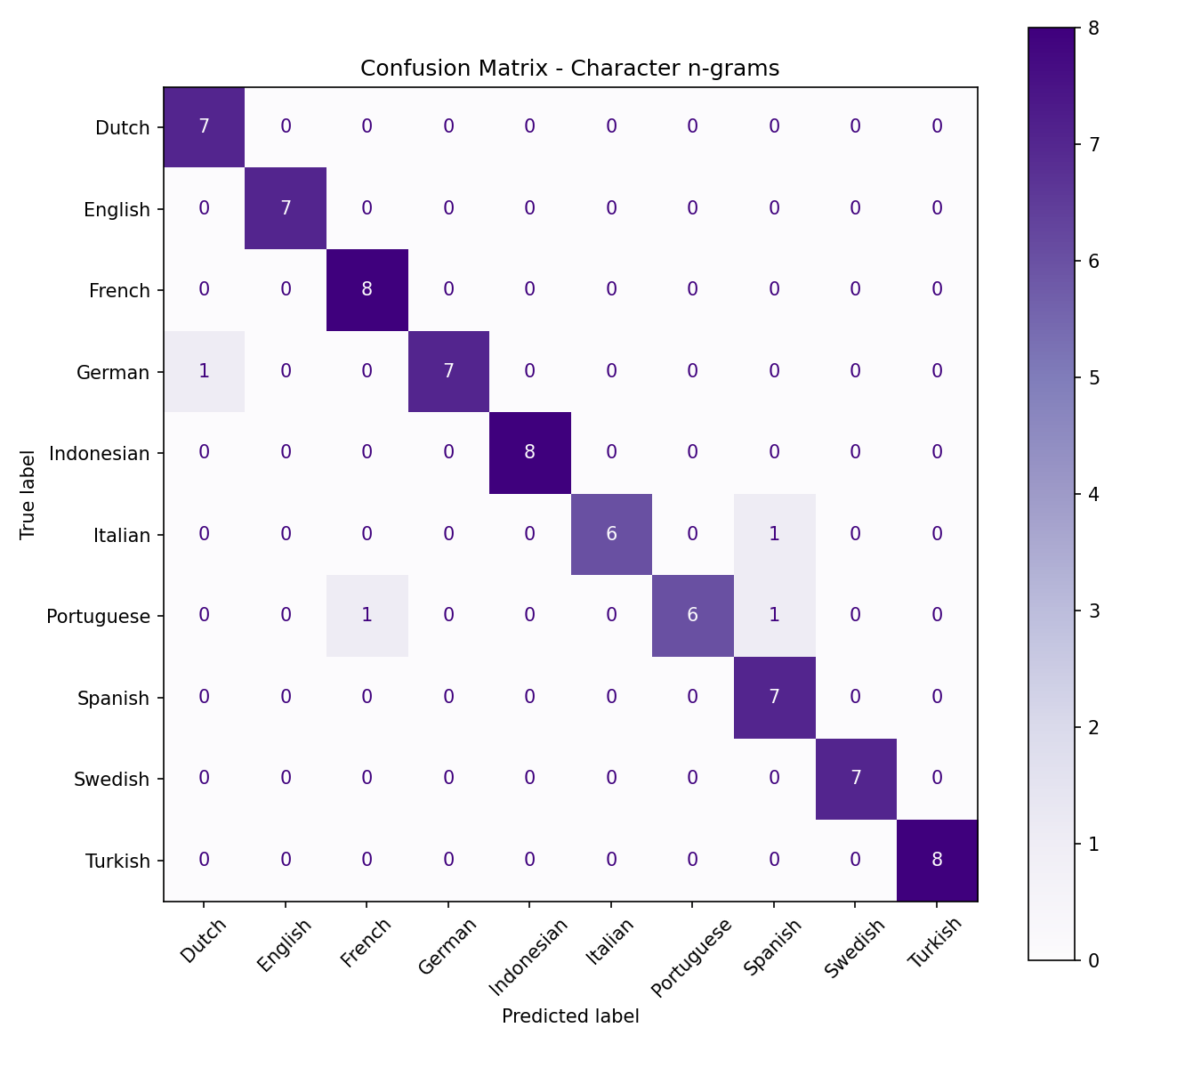
Nearly all misclassifications occurred between closely related Romance languages (Italian mistaken for Spanish, Portuguese mistaken for French). This is a meaningful finding rather than a flaw: these languages genuinely share many character sequences, and even human readers can sometimes confuse short sentences in these languages.

5. Case Files: Solving New Sentences
The system was tested on five brand-new sentences (not in the training data) and asked to name the language plus its top supporting clues:
- "I really love traveling to new countries." -> English (100%) - clues: "ing", "tion"-family patterns
- "Der Himmel ist heute wunderschoen blau." -> German (100%) - clues: "sch", "und"
- "Buongiorno, oggi voglio andare al mare." -> Italian (100%) - clues: "ggi", "og"
- "Estoy muy feliz de verte otra vez." -> French (79.8%), Spanish (19.3%) runner-up
The last example is a genuine misclassification and is worth discussing in a presentation: it demonstrates the model's honest confidence scoring (79.8% instead of 100%) and shows how closely related languages remain genuinely hard to separate from short text -- a well-known limitation in real language identification systems.

6. Conclusion
This project shows that simple character-level statistical patterns can identify languages with high accuracy (94.7%) even from short sentences, outperforming word-based methods on this dataset. Comparing two techniques side by side, rather than building just one model, highlights an important NLP lesson: the right feature representation often matters more than the choice of algorithm.

7. Future Scope
- Add more languages, including non-Latin scripts (Arabic, Russian, Hindi, Chinese)
- Test on longer, real-world text (news articles, tweets) rather than short sentences
- Compare against production libraries like langdetect or fastText's language identifier
- Build a live web demo where users can paste text and see the clues in real time

