**1.Table to Store all The Chats.**

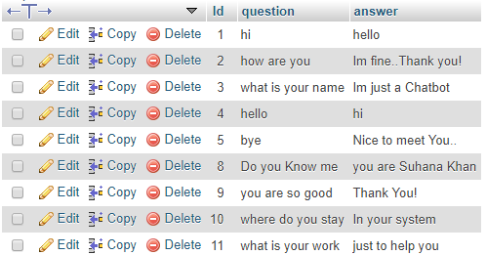

**2.Table that stores all chats History.**

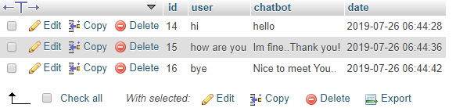

**3.ChatBot layout**

