A Project Proposal
On
Movie Ticket Booking System

Tribhuvan University
Faculty of Humanities and Social Sciences

Submitted to
Department of Computer Application
Padmakanya Multiple Campus
Bagbazaar, Kathmandu

Submitted by
Suhana Shakya Sarina Gole
BCA 4th Sem (Batch 2024) BCA 4th Sem (Batch 2024)
TU Regno: 6-2-38-62-2024 TU Regno: 6-2-38-54-2024

Introduction
In recent years, the entertainment industry has seen significant growth in the demand for movies, leading to increased customers at cinema halls. This project, titled Movie Ticket Booking System, is a web-based system designed to allow users to browse movie, choose cinema halls, view showtimes, select seats, and book tickets online through a simple and user-friendly interface. The system also includes administrative features that allow theater staff to manage movies, schedules, and bookings from a centralized platform.
The system will be developed using HTML and CSS for the front-end interface, PHP for server-side processing, and MySQL as the database to store and manage information related to movies, users, bookings, and payments.

Problem Statement
Traditional movie ticket booking methods require customers to visit cinema halls physically or rely on separate booking systems for different cinema which can be time-consuming and inconvenient. Customers may face difficulties in checking movie availability, comparing showtimes across cinemas, and reserving seats efficiently.
The proposed Online Movie Ticket Booking System provides a centralized platform where users can browse movies, view showtimes from multiple cinema halls, select seats, and book tickets online. The system aims to improve convenience, reduce booking errors, and streamline ticket management for both customers and cinema administrators.

Objectives
- To provide a centralized platform for multiple cinema halls.
- To allow favourable seat booking.

Scope
The system will:
- Support multiple cinema halls.
- Allow users to browse available movies.
- Display show schedules and ticket prices.
- Provide seat selection functionality.
- Provide an administrator panel for managing movies, halls, and show schedules.

Literature Review
Several studies and existing systems have explored the development of online ticket booking platforms. Popular platforms such as BookMyShow, Fandango provide users with online access to movie schedules, seat availability, and ticket purchasing services which reduce waiting time and improve customer convenience.
One project describes that the online movie booking system had been in operation for approximately fifteen years but gained significant popularity after 2004, with its reach increasing several times over in the six to ten years following, due to the rapid growth of internet accessibility. In their comparative study, the authors identified increased web traffic, server strain as the major recurring problems in the system. To address these issues, the authors proposed the use of Node.js and MongoDB as a backend stack to improve server reliability and handle concurrent users more effectively, and also introduced additional features such as emailing movie reviews and trailers to users at the time of booking, displaying the seating view from different screen orientations.\cite{roy2019comparative}
In a more recent case study, Acharya (2024) \cite{acharya2024case} described the design and implementation of an online movie ticket booking system as a web-based application that allows users to purchase cinema tickets through a portal, requiring them to register or log in before making a booking. The system was built using PHP and JavaScript for the backend and HTML and CSS for the frontend, and was organized into two distinct panels: one for administrators and one for customers. Acharya's case study is particularly relevant to this project because it shares the same core technology stack, namely PHP, HTML, and CSS, and demonstrates that a clean two-panel separation between administrator and customer functions is a practical and effective architectural choice for systems of this scope.
Taken together, these two studies highlight both the long-standing relevance of web-based movie booking systems and the technical and user experience challenges that continue to shape their development.

Requirement Analysis

6.1 Functional Requirements
User Module
- User registration and login.
- View movie details and cinema halls showing selected movies.
- Select showtimes and available seats.
- Book movie tickets.
Administrator Module
- Manage user accounts.
- Add, update, and delete movies.
- Manage cinema halls and show schedules.
- Monitor bookings.
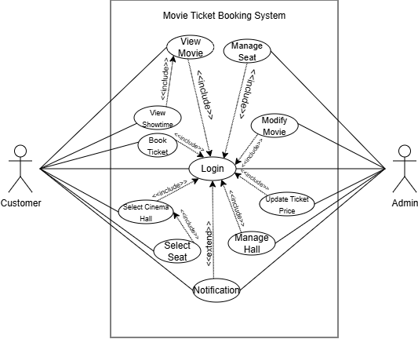
Fig 1. Use Case Diagram of Movie Ticket Booking System

Non-Functional Requirements
Performance
- The system should respond to user requests within a few seconds.
Security
- User passwords should be stored securely.
- Authentication should be required for booking operations.
Usability
- The interface should be simple and user-friendly.
Maintainability
- The system should support future enhancements and modifications.
Availability
- The system should be accessible whenever users need to book tickets.

Feasibility Study

Technical Feasibility
The Movie Ticket Booking System can be developed using technologies such as:
- Frontend: HTML, CSS, JavaScript
- Backend: PHP
- Database: MySQL
- Server: XAMPP
These technologies are well documented, mature, suitable for academic projects and open source. These tools do not require expensive licensing, runs on commonly available web servers such as Apache, and are compatible with standard hosting environments like XAMPP.

Economic Feasibility
Since the project relies entirely on open-source and freely available technologies, there are no software licensing fees involved in development. As this is a one-time development effort with minimal recurring costs, the long-term benefits, with relatively low investment required, the project becomes economically feasible.

Operational Feasibility
Since most users today are already familiar with basic web navigation and similar e-commerce style booking, user adoption is expected to be straightforward. Also, the system reduces manual workload for staff rather than replacing their role entirely.

Schedule Feasibility
The project has been broken down into distinct phases, including requirement analysis, literature review, system analysis, database design, interface design, coding & development, testing, and documentation. And is expected to be completed within a semester through proper planning.

Gantt Chart
Activities | Asadh |  |  |  | Shrawan |  |  |  | Bhadra |  | Asoj
 | 1st Week | 2nd Week | 3rd Week | 4th Week | 1st Week | 2nd Week | 3rd Week | 4th Week | 1st & 2nd Week | 3rd & 4th Week | 1^{st 2nd & 3rd} Week
Requirement Gathering | ✓
Literature Review |  | ✓
System Analysis |  |  | ✓ | ✓
Database Design |  |  |  |  | ✓ | ✓
Interface Design |  |  |  |  |  |  | ✓ | ✓
Coding & Testing |  |  |  |  |  |  |  |  | ✓ | ✓
Documentation |  |  |  |  |  |  |  |  |  |  | ✓

High-Level Design of Proposed System

System Analysis and Design
i. Proposed Model
The proposed Movie Ticket Booking System follows a three-tier architecture, presentation layer, application layer, and database layer. This separation improves maintainability, allows each layer to be developed and modified independently.
In this model, the system consists of two main actors: the customer and the administrator. The customer can register or log in to the system, browse movies, view details such as genre, duration, and showtime, and select seats based on availability. Once the seats are selected, the system temporarily reserves them to avoid double booking. The user can then proceed to confirm the booking and receive a ticket confirmation.
The administrator is responsible for managing the system by adding, updating, or removing movies, scheduling showtimes, and monitoring bookings. The system maintains a database that stores information about customers, movies, cinema halls, seat availability, and ticket records.
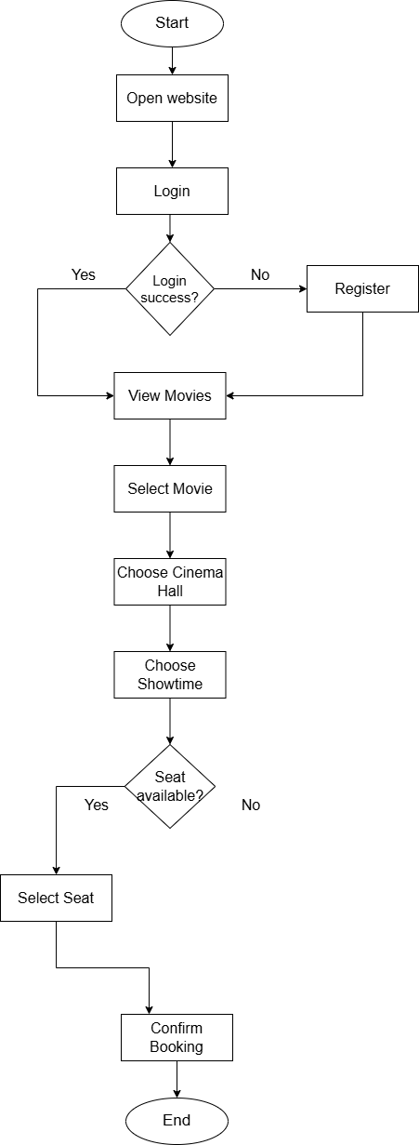
Fig 2. Flow Chart of Movie Ticket Booking System
ii. Data Modelling (ER Diagram)
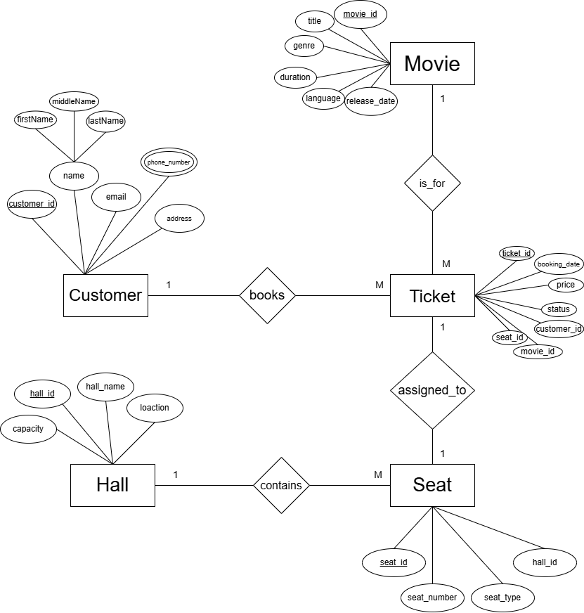
Fig 3. Entity Relation Diagram of Movie Ticket Booking System

iii. Process Modelling (DFD)

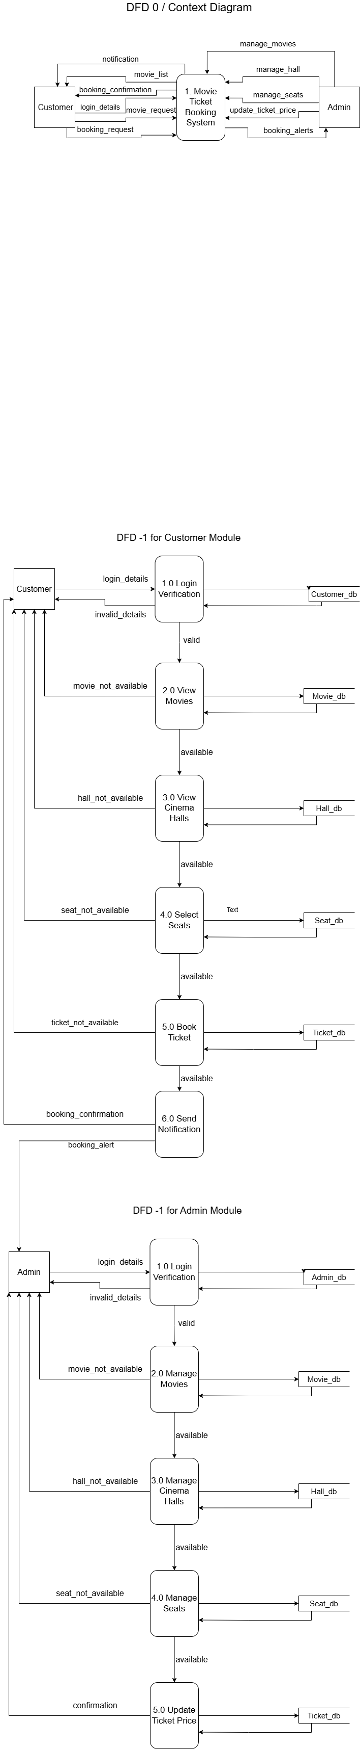
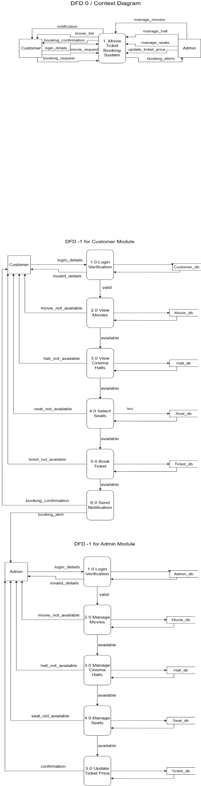
Fig 4. Context Diagram & DFD-1 of Movie Ticket Booking System

System Development Tools
i. Front End Development
The front-end will be developed using HTML for structuring web pages and CSS for styling and layout. HTML will be used to build the structural components of the interface, such as movie listing pages, seat selection layouts, and login/registration pages, while CSS will handle the visual presentation, including colors, fonts, and spacing.
ii. Back End Development
The backend of the system will be developed using PHP, a widely used server-side scripting language well suited for web applications that interact with relational databases. PHP will handle core functionalities including user authentication and session management, validating user input, implementing booking logic (such as checking seat availability before confirming a booking), and connecting to the MySQL database to retrieve and store data.
iii. Database
MySQL will store all persistent data related to users, admins, movies, theaters, shows, seats, bookings, and payments, structured according to the ER model described above. MySQL was chosen because it is open-source, integrates seamlessly with PHP, supports standard SQL queries for data manipulation, and is capable of handling the relational structure required for managing bookings, seat reservations

Expected Outcome
The proposed Online Movie Ticket Booking System will provide a centralized platform for booking movie tickets across multiple cinema halls. Users will be able to view movies, compare showtimes, select seats, and book tickets efficiently. Cinema administrators will be able to manage movies, schedules, and booking records through a dedicated administration panel.
The system is expected to reduce manual booking efforts, improve customer convenience, and demonstrate practical implementation of database-driven web applications.
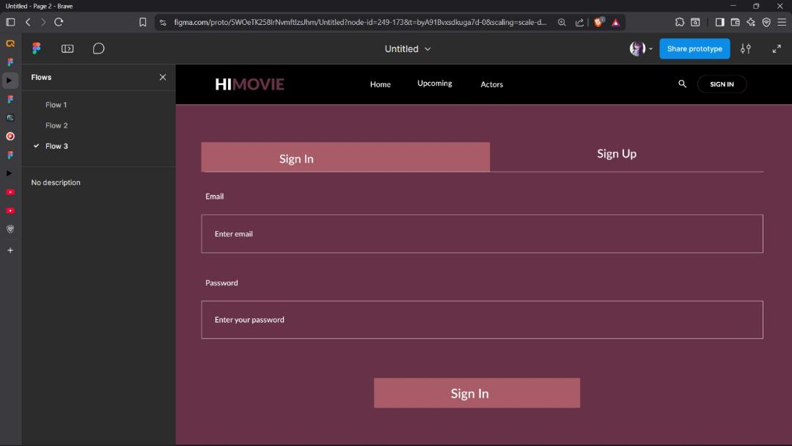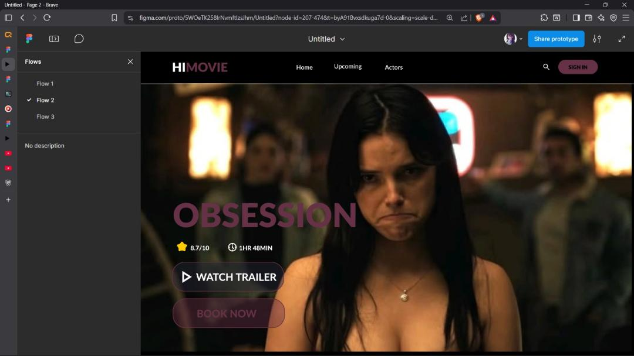
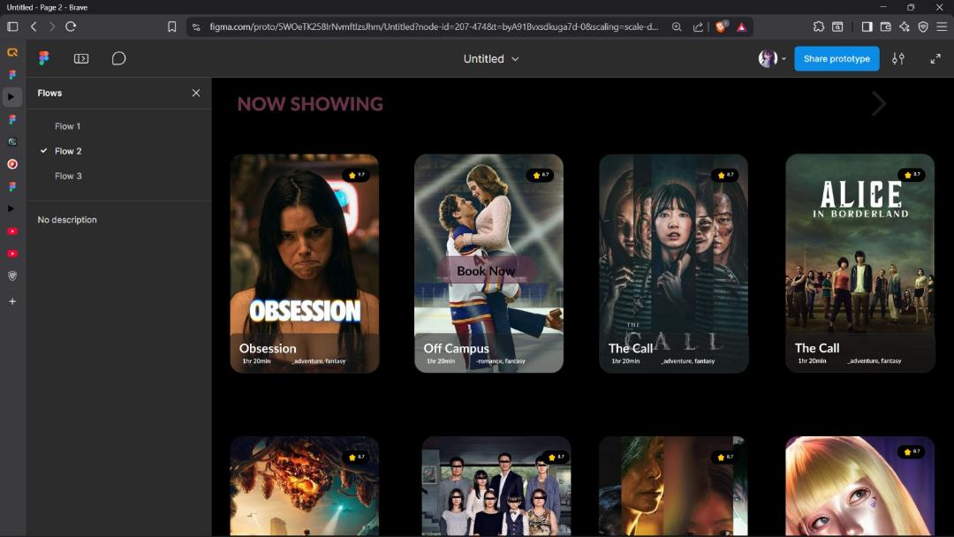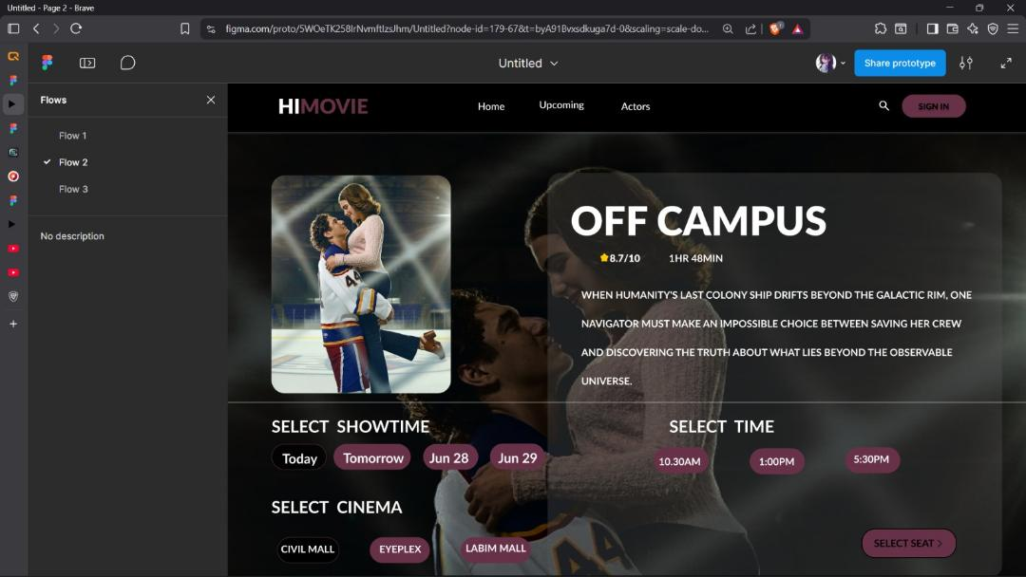
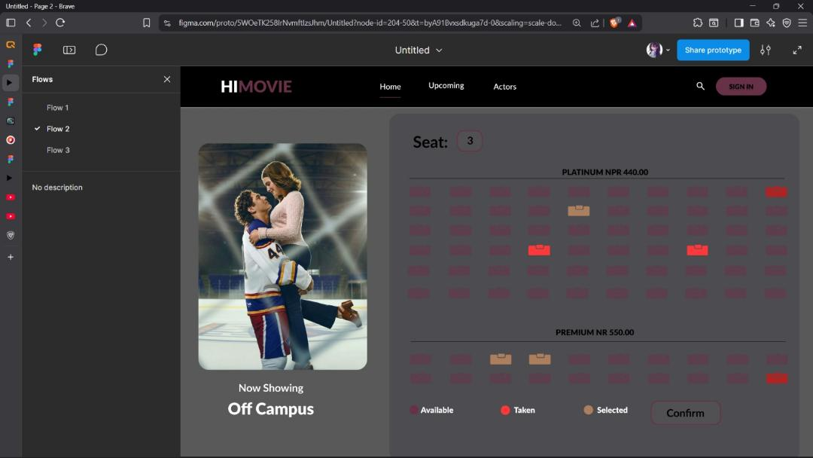

References
- Acharya, K. (2024). A case study on online ticket booking system project. SSRN.
- Roy, A., Shahdeo, V., & Kaluri, R. (2019). A comparative study in online movie ticket booking system. Research Journal of Engineering and Technology, 10(1), 16–20.

