ASSIGNMENT- 1
Probability and Statistics: MA 202
__________________________________________________________________

- If there is a war in every 15 years on average, find the probability that there will be no war in 25 years.
- If a die is thrown n times, show that the probability of an even number of sixes is 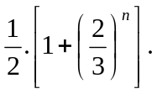
- A and B alternately throw a pair of dice. A starts the game. A wins if he throws six before B throws seven, and B wins if he throws seven before A throws six. What is the probability of A’s winning?
- A radioactive source emits on an average 2.5 particles per second. Calculate the probability that 2 or more particles will be emitted in an interval of 4 seconds.
- For the Poisson distribution with parameter , prove that 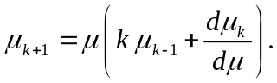 Hence calculate 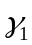 and 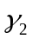 .
- If X is uniformly distributed in 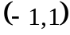, find the distribution of 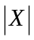.
- If  is 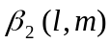 variate, then show that 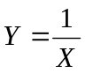 is 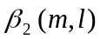 variate.
- Find the mean and variance of the Pascal distribution which is defined by
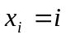 (i=0,1,2,3……..)
and 

