Trader Performance vs. Bitcoin Market Sentiment
An analysis of Hyperliquid trader behavior across Fear & Greed regimes

Executive Summary
This analysis joins 211,224 Hyperliquid trade fills from 32 accounts (May 2023 – May 2025) to the daily Bitcoin Fear & Greed Index to test whether trader performance, risk-taking, and directional bias vary systematically with market sentiment. The relationship is real but more nuanced than the common “buy fear, sell greed” heuristic: performance is bimodal, peaking during Fear and Extreme Greed and dipping during Extreme Fear and moderate Greed, and traders in this dataset scale their position size up during Fear and down during Extreme Greed — a disciplined, contrarian pattern rather than FOMO-driven behavior.

Data & Methodology
- Realized vs. all trades: Realized performance metrics (win rate, profit factor, avg PnL) use only trades with Closed PnL ≠ 0, i.e. fills that actually closed a position.
- Sizing & bias: Position sizing and directional bias use all 211,224 fills, since risk is taken on every execution, not just closes.
- Data quality flag: Trades were matched to sentiment by calendar date using the reliable “Timestamp IST” field; the numeric “Timestamp” column in the source file was found to contain only 7 distinct values across 211k+ rows and was discarded as corrupted.
- Match rate: 211,218 of 211,224 trades (99.997%) matched to a sentiment reading; the remainder fell just outside the sentiment index's date coverage.
- Significance testing: Statistical comparisons use the Mann-Whitney U test and Kruskal-Wallis H test (non-parametric, appropriate given the heavy-tailed, non-normal PnL distribution).

1. Performance by Sentiment Regime
Win rate and profit factor were computed for every sentiment class. The pattern is bimodal — strongest at “Fear” and “Extreme Greed”, weakest at “Extreme Fear” and plain “Greed”:
Sentiment | Trades | Win Rate | Profit Factor | Avg PnL/trade | Avg Position ($)
Extreme Fear | 10,406 | 76.2% | 2.16 | $71.03 | $5,468
Fear | 29,808 | 87.3% | 6.66 | $112.63 | $8,041
Neutral | 18,159 | 82.4% | 4.32 | $71.20 | $5,556
Greed | 25,176 | 76.9% | 3.03 | $85.40 | $5,439
Extreme Greed | 20,853 | 89.2% | 11.02 | $130.21 | $2,780
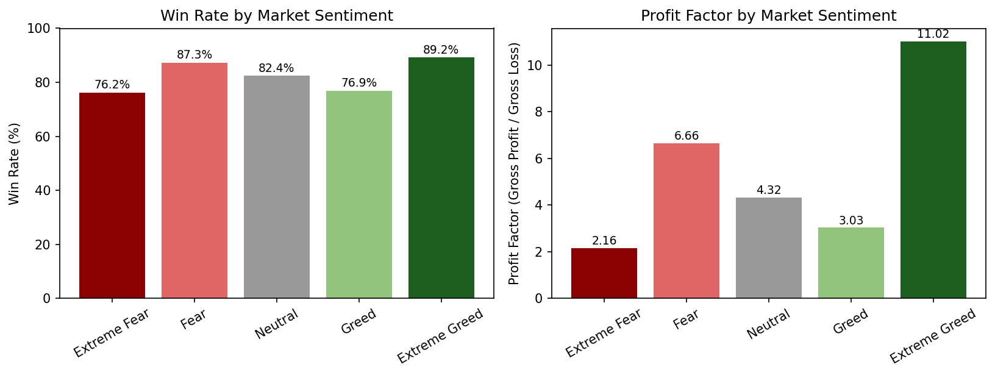
Figure 1. Win rate and profit factor by sentiment class.
A Kruskal-Wallis test comparing Extreme Fear, Neutral, and Extreme Greed confirms the differences are highly significant (H = 510.6, p < 0.0001). A follow-up one-sided test shows trading during sentiment extremes (either direction) significantly outperforms trading during Neutral sentiment (avg PnL $110.51 vs $71.20 per trade). By contrast, a simple binary split of “all Fear” vs “all Greed” trades is not statistically significant (p = 0.53, Mann-Whitney U) — the signal lives specifically at the extremes, not on a linear fear–greed axis.

2. Position Sizing: Contrarian, Not FOMO-Driven
Average position size (Size USD) tells an unexpected story: traders size up during Fear and size down as Extreme Greed builds — the opposite of retail FOMO chasing into euphoria.
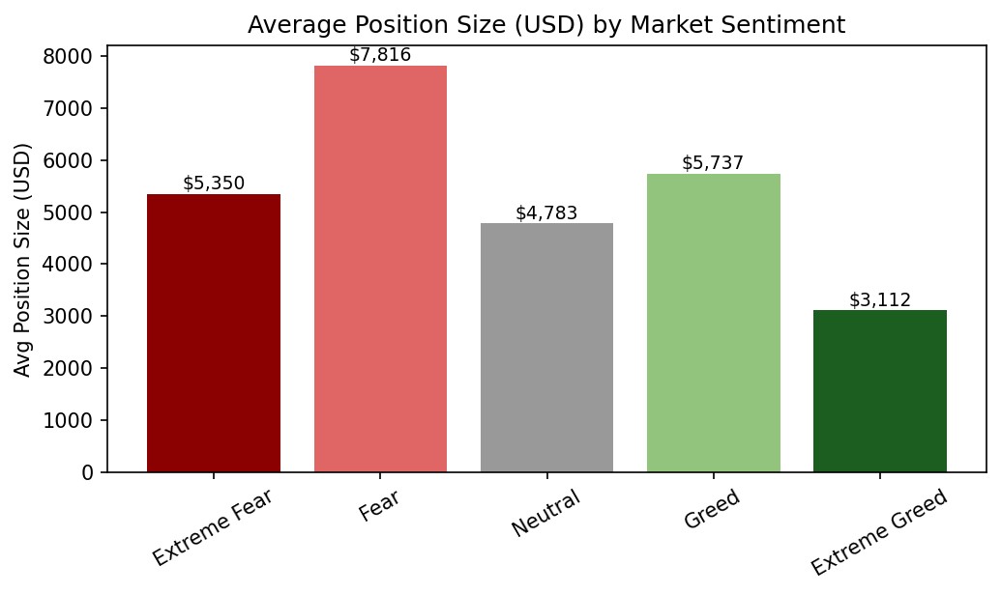
Figure 2. Average position size by sentiment class.
Fear-regime trades average $7,182 in size vs. $4,574 for Greed-regime trades, a highly significant difference (Mann-Whitney U, p < 0.0001). This is consistent with disciplined, conviction-based sizing — adding exposure when others are fearful, trimming exposure as euphoria peaks.

3. Directional Bias Shifts With Sentiment
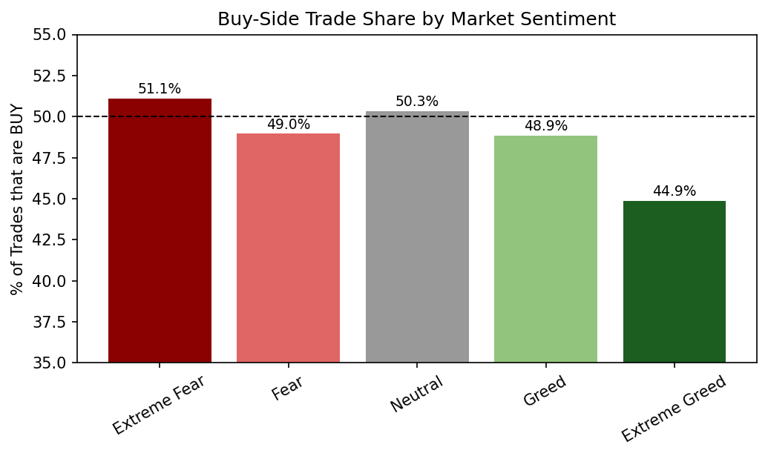
Figure 3. Share of buy-side trades by sentiment class.
The share of buy-side trades falls steadily from 51.1% in Extreme Fear to 44.9% in Extreme Greed — traders lean net-buy during panic and net-sell during euphoria, reinforcing the sizing pattern above.

4. Cumulative Performance Over Time
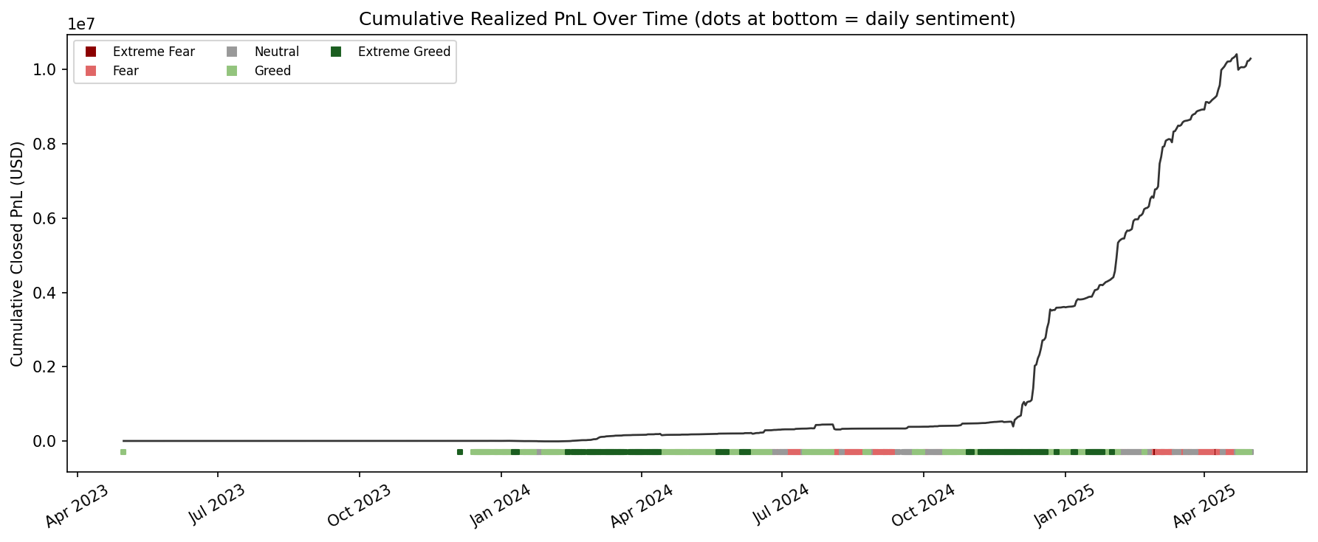
Figure 4. Cumulative realized PnL over the full sample period, with daily sentiment class marked along the bottom.
Same-day correlation between the raw 0–100 sentiment score and daily aggregate PnL is weak (r ≈ -0.08), as is the lag-1 (yesterday's sentiment vs. today's PnL) correlation (r ≈ -0.11). This is expected given the bimodal shape found above: a linear correlation coefficient cannot capture a relationship that is strong at both ends of the scale and weak in the middle. The sentiment index is more useful as a regime filter than as a linear predictor.

5. Not All Traders Are the Same
Splitting sentiment into a combined “Fear regime” (Fear + Extreme Fear) and “Greed regime” (Greed + Extreme Greed), and restricting to the 32 accounts with 50+ realized trades for a meaningful sample, reveals two distinct trader archetypes:
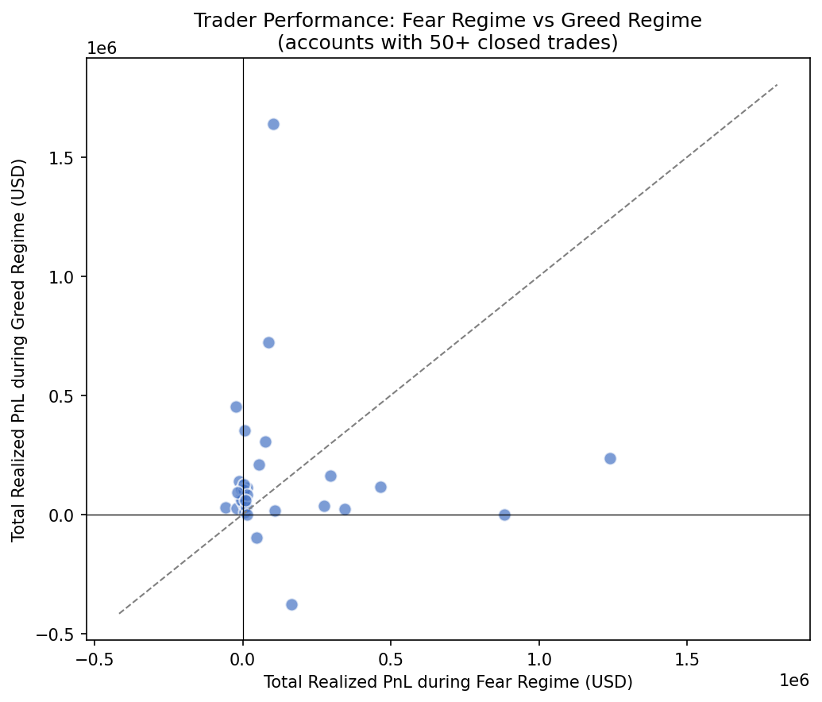
Figure 5. Each point is one account: total realized PnL during Fear regime days (x-axis) vs. Greed regime days (y-axis). Points above the dashed line profited more during Greed; points below profited more during Fear.
- ~69% of active accounts profit more during Greed regimes — likely momentum/trend-following strategies.
- ~31% of active accounts profit more during Fear regimes — likely contrarian/value-oriented strategies.
- Concentration: Overall PnL is highly concentrated: the top account realized ~$2.14M in profit while the weakest lost ~$168K, suggesting position-sizing discipline (Section 2) differentiates winners from losers more than raw directional accuracy alone.

Strategy Recommendations
- Use sentiment as a regime filter, not a linear signal. Flag Extreme Fear and Extreme Greed days for higher-conviction setups; treat Neutral and moderate-Greed days as lower-edge, reduce-size periods.
- Size against the crowd, within limits. The data supports scaling exposure up incrementally as fear deepens (within risk limits) and down as euphoria peaks — mirroring the better-performing accounts in this sample.
- Segment strategies by regime affinity. Given the ~69/31 split between Greed-favoring and Fear-favoring accounts, a copy-trading or strategy-allocation product could route capital to the archetype suited to the current regime rather than assuming one strategy works everywhere.
- Prioritize risk management alongside signal. Because aggregate PnL is dominated by a few large accounts, risk controls (position limits, drawdown caps) matter as much as signal generation for the median trader.

Limitations
- 32 accounts is a small, non-random sample (traders active on Hyperliquid during this window) — findings may not generalize to the broader market.
- No leverage field was present in the source data (despite the assignment brief mentioning one); “Size USD” and “Start Position” were used as risk-appetite proxies instead.
- Sentiment is a single daily market-wide reading (BTC-based) applied to all trades that day, regardless of the specific coin traded or intraday sentiment swings.
- Correlation-based findings describe association, not causation — skilled traders may simply be good at reading the same conditions the index measures.

