DEPARTMENT OF BACHELOR COMPUTER APPLICATION

BCA Vᵗʰ Semester
SRS On Minor Project
Project Title : Subscription Renewal Eligibility Register
Submited by
Name : Preeti B 01FE24ICA014
Name : Sneha V 01FE24ICA038
Name : Suhani G 01FE24ICA041
Name: Shreya R 01fe24ica064
UNDER THE GUIDANCE OF
Prof: Prajna Bhat

KLE TECHNOLOGICAL UNIVERSITY
B. V. B COLLEGE VIDYANAGAR
HUBBALLI-580031

1. INTRODUCTION

1.1 Purpose
The purpose of this project is to develop a web-based Subscription Renewal Eligibility Register. The system maintains subscription details and checks whether a subscription is eligible for renewal by applying predefined rules. It provides a clear eligibility status and the reason for the decision.

1.2 Scope
The system allows an authorized user to add, view, update, and search subscription records. Each record may contain subscriber details, subscription type, start date, expiry date, payment status, and current status. The system checks the stored information against the renewal conditions configured for the project and displays whether the subscription is eligible, not eligible, or requires correction of missing or invalid information.
The basic system focuses on maintaining records and applying rule-based eligibility checks. Automatic payment collection, integration with external subscription providers, and automatic renewal are outside the basic scope unless separately implemented.

1.3 Objectives
The main objectives of the project are:
- To provide a simple interface for maintaining subscription records.
- To store and retrieve subscription details from a database.
- To validate the details entered by the user.
- To apply predefined rules to check renewal eligibility.
- To display an eligible or not-eligible status with a suitable reason.
- To help users identify subscriptions that are expired, inactive, unpaid, or approaching renewal, according to configured rules.
- To maintain consistent and traceable eligibility decisions.
- To test the correctness of record validation and rule checking.

1.4 Intended Audience
- Users or staff who maintain subscription information and check renewal eligibility.
- Students and project evaluators who want to understand the system.
- Developers who may maintain or improve the application in the future.

1.5 Document Overview
This document explains the purpose, scope, objectives, intended audience, foundational concepts, functional requirements, non-functional requirements, business rules, system constraints, data flow diagrams, hardware and software requirements, references, future enhancements, and conclusion of the Subscription Renewal Eligibility Register.

1.6 Foundational Concepts Used
- Database Management: Stores and retrieves subscriber and subscription records.
- Data Validation: Checks whether required fields are present and correctly entered.
- Rule-Based Processing: Applies predefined renewal conditions to each subscription.
- Conditional Logic: Determines the eligibility result based on the rule-checking outcome.
- Web Technologies: Provides the interface for entering and viewing records.
- Software Testing: Verifies that validation and eligibility decisions work correctly.

Architecture diagram
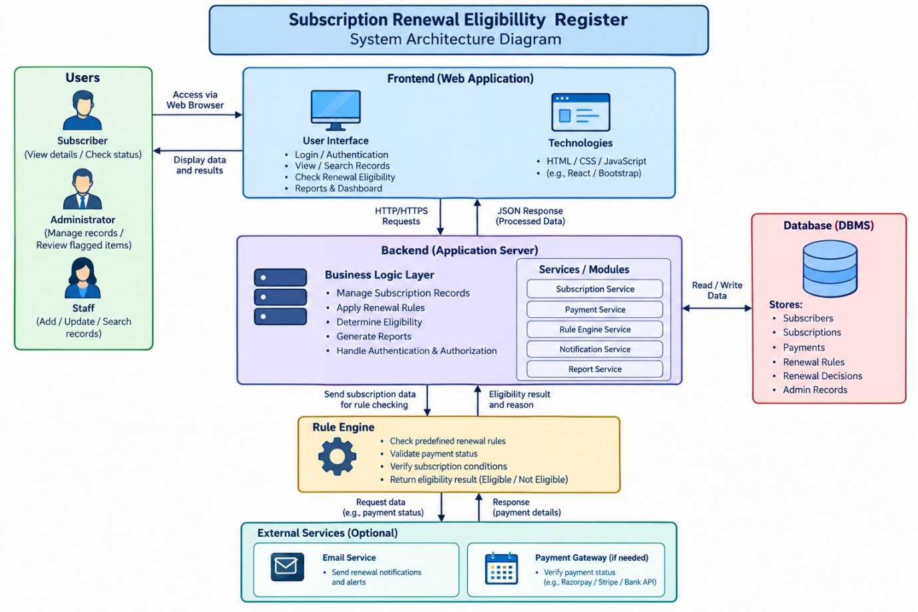

2. SPECIFIC REQUIREMENTS

2.1 Functional Requirements
The system shall:
- Display a home page or dashboard with options to add, view, search, and check subscription records.
- Allow an authorized user to enter subscriber and subscription details.
- Store subscription records in the database.
- Retrieve and display an existing subscription record using a suitable identifier or search condition.
- Allow authorized users to update incorrect or changed subscription details.
- Validate required fields and date values before saving or checking a record.
- Retrieve the applicable renewal rules for the selected subscription.
- Check the subscription details against the configured renewal conditions.
- Determine and display the eligibility status as Eligible or Not Eligible; where applicable, show that the record needs correction because information is missing or invalid.
- Display the reason or rule outcome supporting the eligibility decision.
- Display a suitable message when a record is not found or no decision can be made.
- Allow the user to perform another check or clear the entered data.
- Prevent incomplete or invalid records from being treated as eligible.

2.2 Non-Functional Requirements
- Performance: The system should retrieve a subscription record and complete the eligibility check within a reasonable time.
- Usability: The interface should be simple, clear, and easy to understand.
- Reliability: The same record and same rule settings should produce a consistent eligibility result.
- Accuracy: Eligibility decisions should follow the configured rules and the stored subscription data.
- Maintainability: The project team should be able to update subscription fields and renewal rules when required.
- Compatibility: The application should work in commonly used web browsers.
- Security: User inputs should be validated, and database access should follow safe practices. Only authorized users should be allowed to modify records or rules.
- Data Integrity: Subscription dates and status information should be stored consistently and should not be silently altered during checking.
2.3 Business Rules and System Constraints

Business Rules
- Only subscription records stored in the database can be checked by the system.
- A record must contain the required information before an eligibility decision is made.
- Each subscription is checked against the renewal rules configured for the project.
- A subscription is marked Eligible only when all mandatory renewal conditions are satisfied.
- A subscription is marked Not Eligible when one or more mandatory conditions fail.
- If required information is missing or invalid, the system displays a validation message instead of treating the record as eligible.
- The renewal date/window, payment status, active status, and other conditions are considered only if they are included in the rules configured by the project team.
- The system should display the reason for the eligibility outcome so that the user can understand the decision.
- Only authorized users should add, update, or delete subscription records and change renewal rules.

System Constraints
- Eligibility results depend on the accuracy and completeness of the subscription details stored in the database.
- The result depends on the renewal rules defined and implemented by the project team.
- The system is limited to the features implemented in the project.
- The basic system does not automatically collect payments or renew subscriptions unless such integrations are separately implemented.
- The system depends on the selected hardware, software, web browser, and database.
- External subscription-provider data is not automatically verified unless an external integration is added

ER diagram-subscription renewal eligiblity register
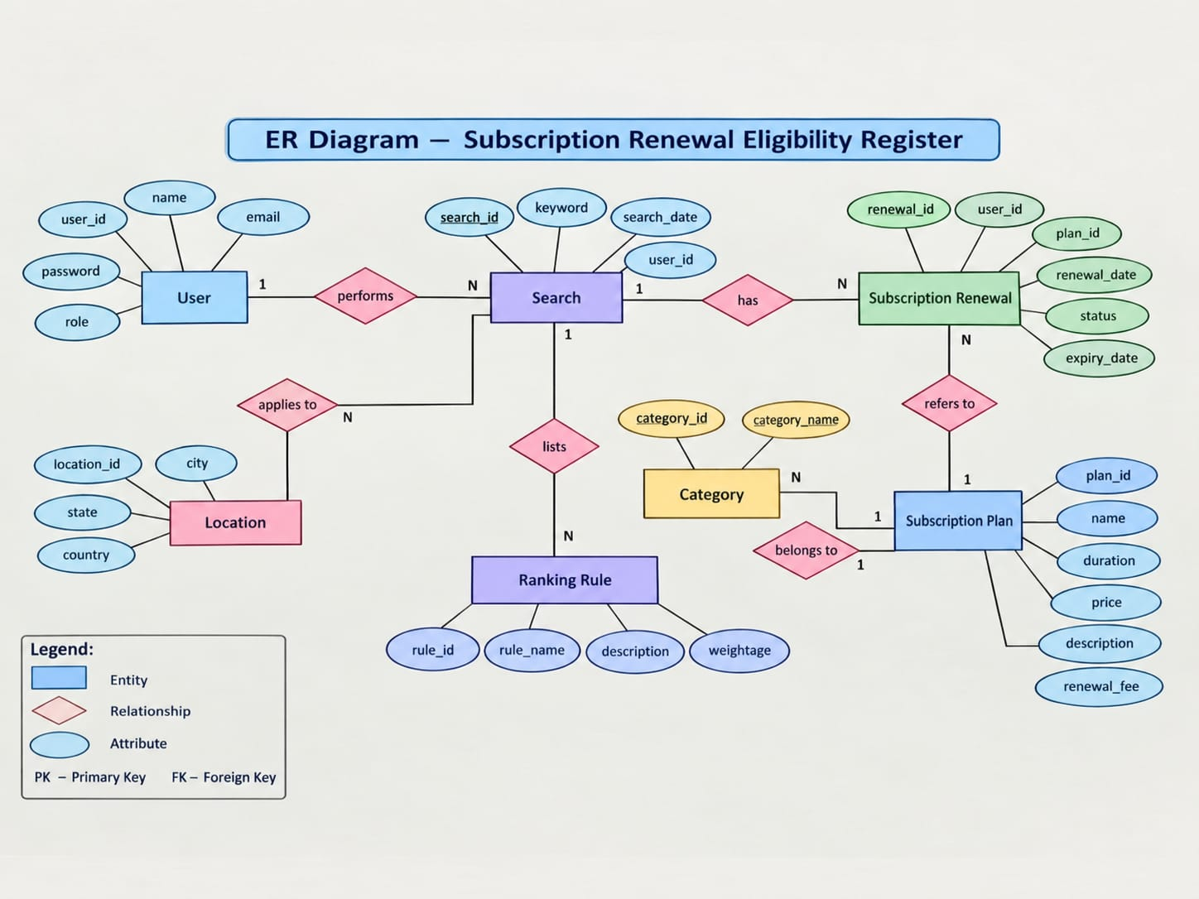

2.4 Data Flow Diagrams (DFD)
The following diagrams show how subscription details move through the Subscription Renewal Eligibility Register, how the database and renewal rules are used, and how the eligibility result is returned to the user.

1. Level 1 DFD — Subscription Renewal Eligibility Register
Diagram 1: Main flow of subscription data through the system.
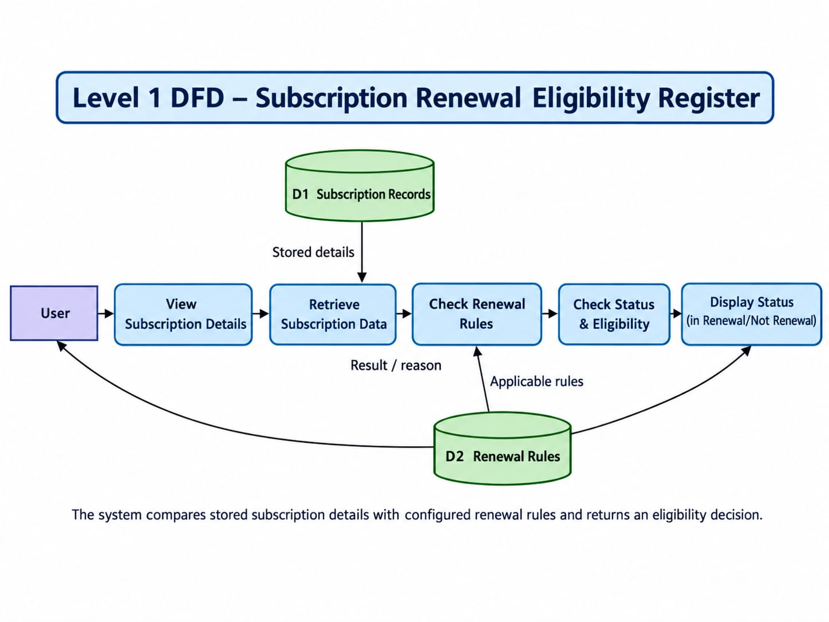
2. Level 2 DFD — Detailed Eligibility Checking Process
Diagram 2: Detailed breakdown of input validation, record retrieval, rule checking, eligibility determination, and result display.
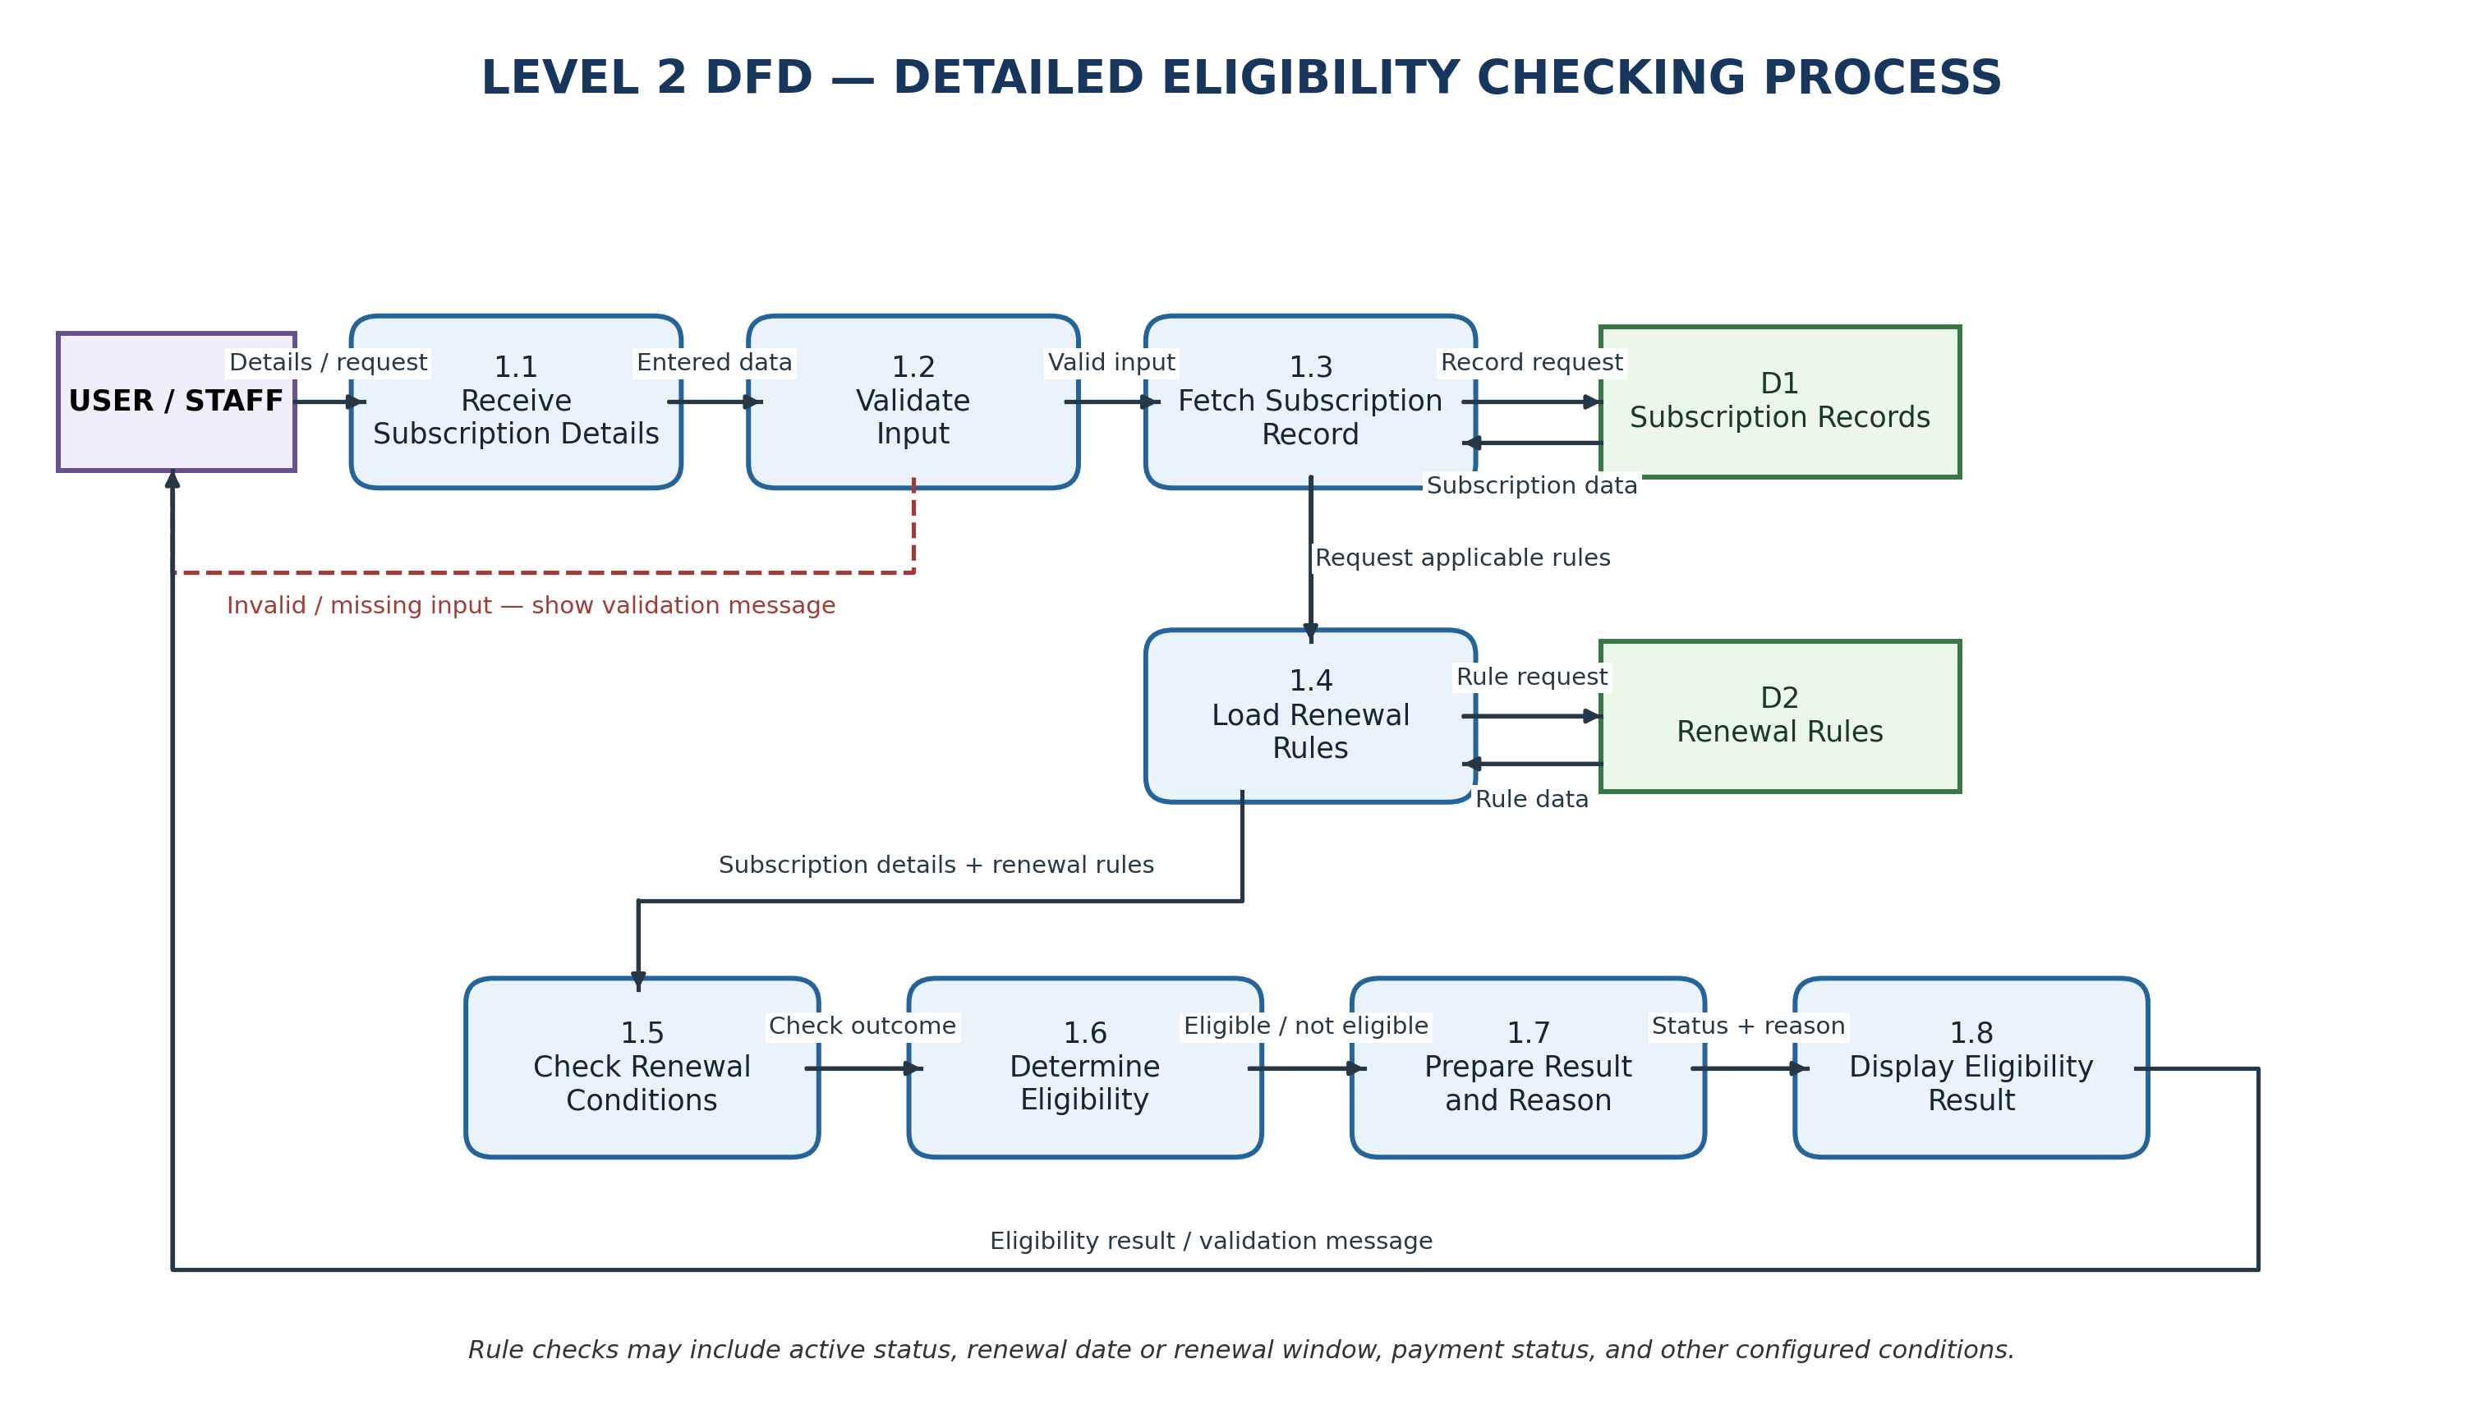
3. use case diagram-
• User/Staff: Add, view, search, update subscriptions and check eligibility.
• Administrator: Manage renewal rules and user access, along with subscription operations.
• Include relationships: Validate subscription details and retrieve subscription records during eligibility checking.
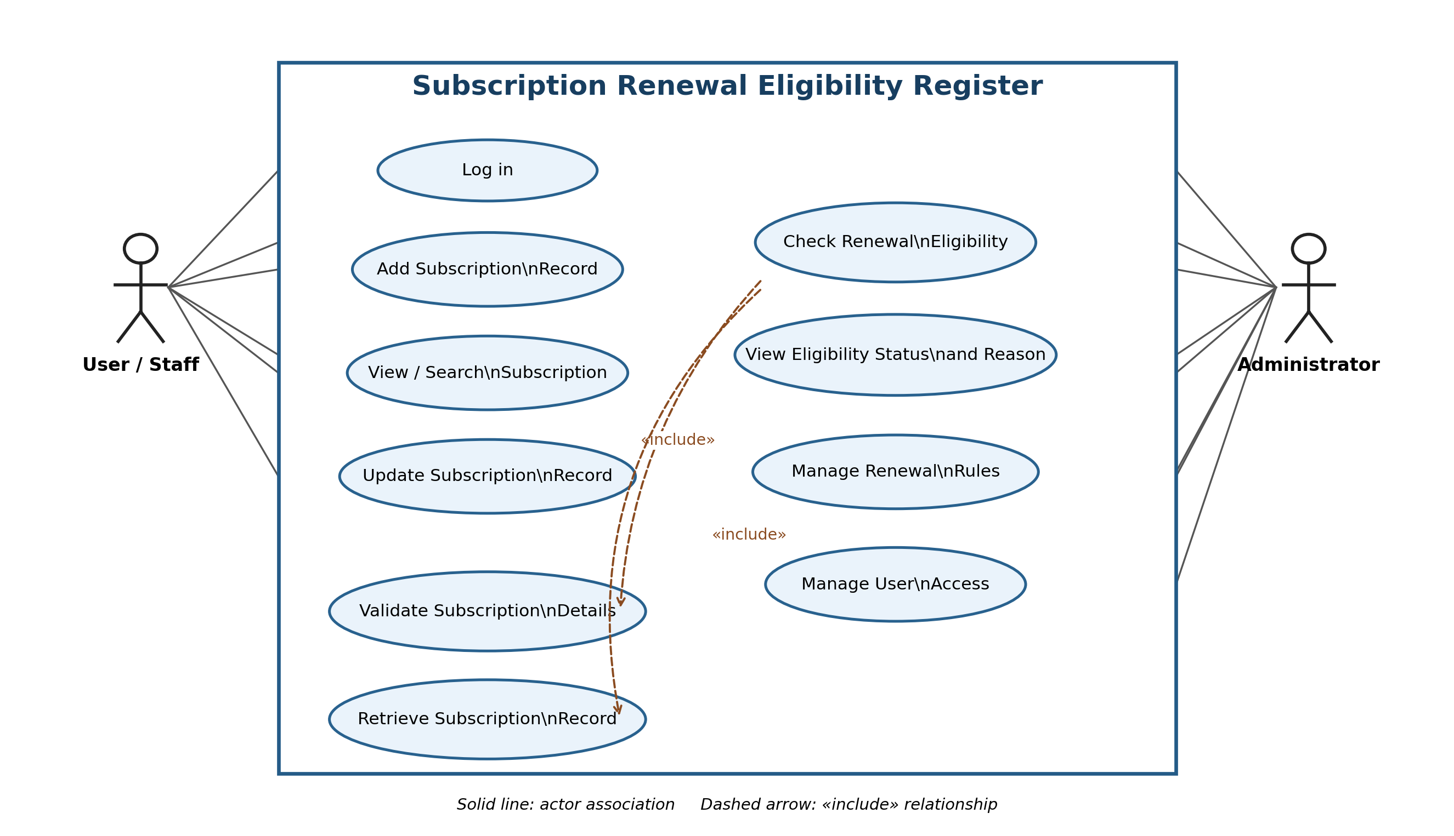
4. Class Diagram – Subscription Renewal Eligibility Register
- The Class Diagram illustrates the classes, attributes, methods, and relationships involved in managing subscription records.
- It shows how subscribers, subscriptions, renewal rules, and eligibility checks interact to determine renewal eligibility.
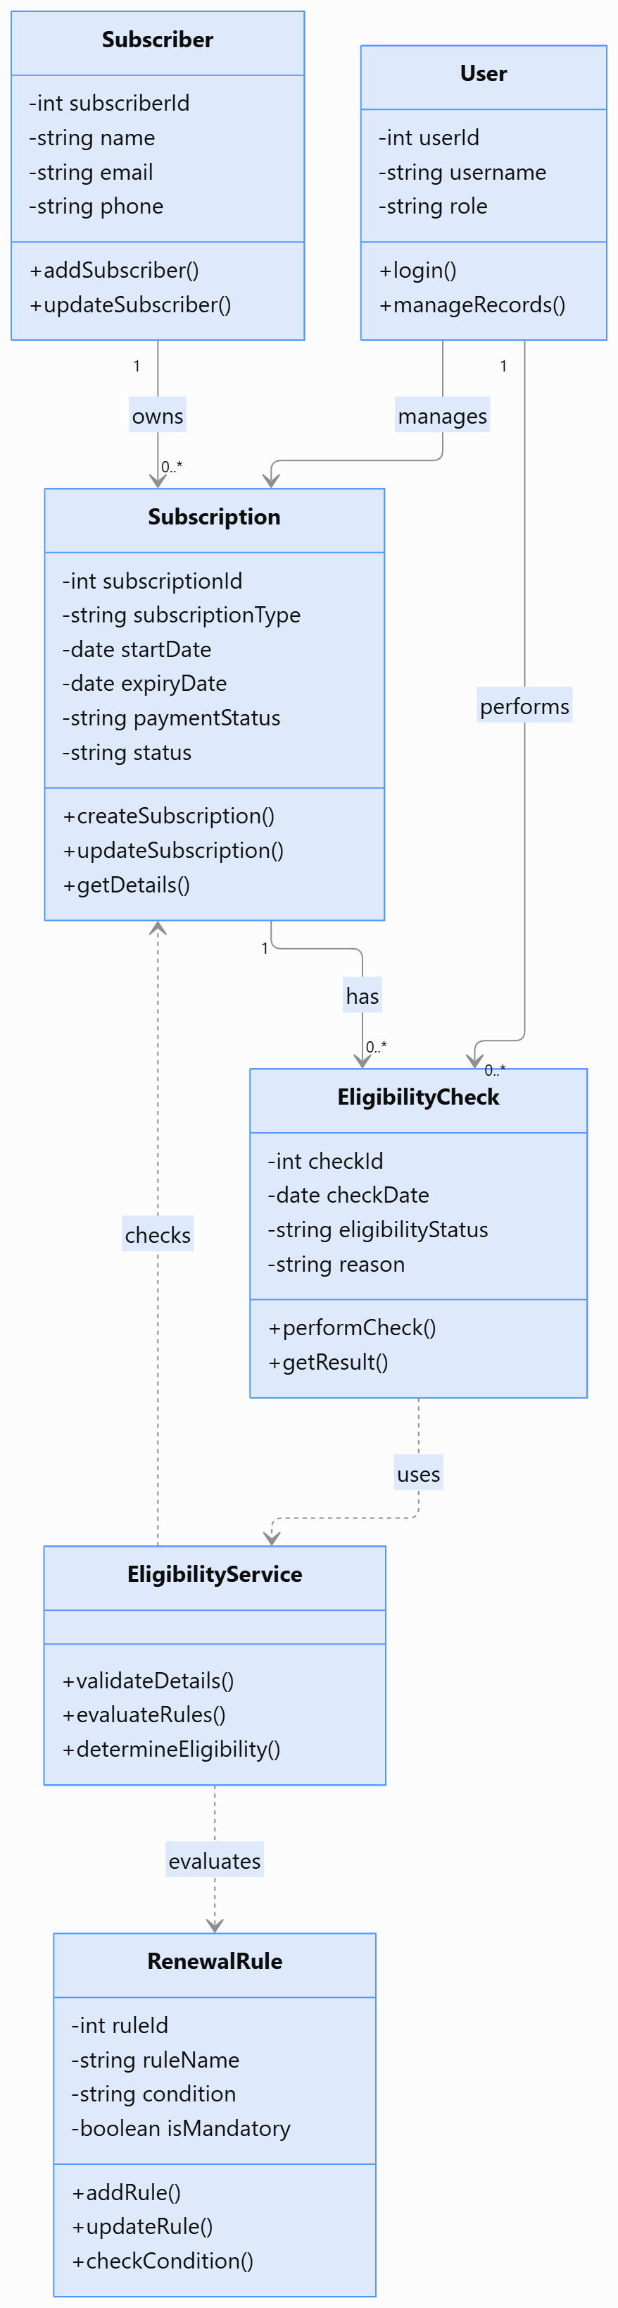

5. Sequence Diagram – Subscription Renewal Eligibility Register:
- The Sequence Diagram illustrates the step-by-step interaction between the user, web interface, eligibility service, database, and renewal rules.
- It shows how subscription details are validated, renewal conditions are evaluated, and the final eligibility status is displayed to the user.
- 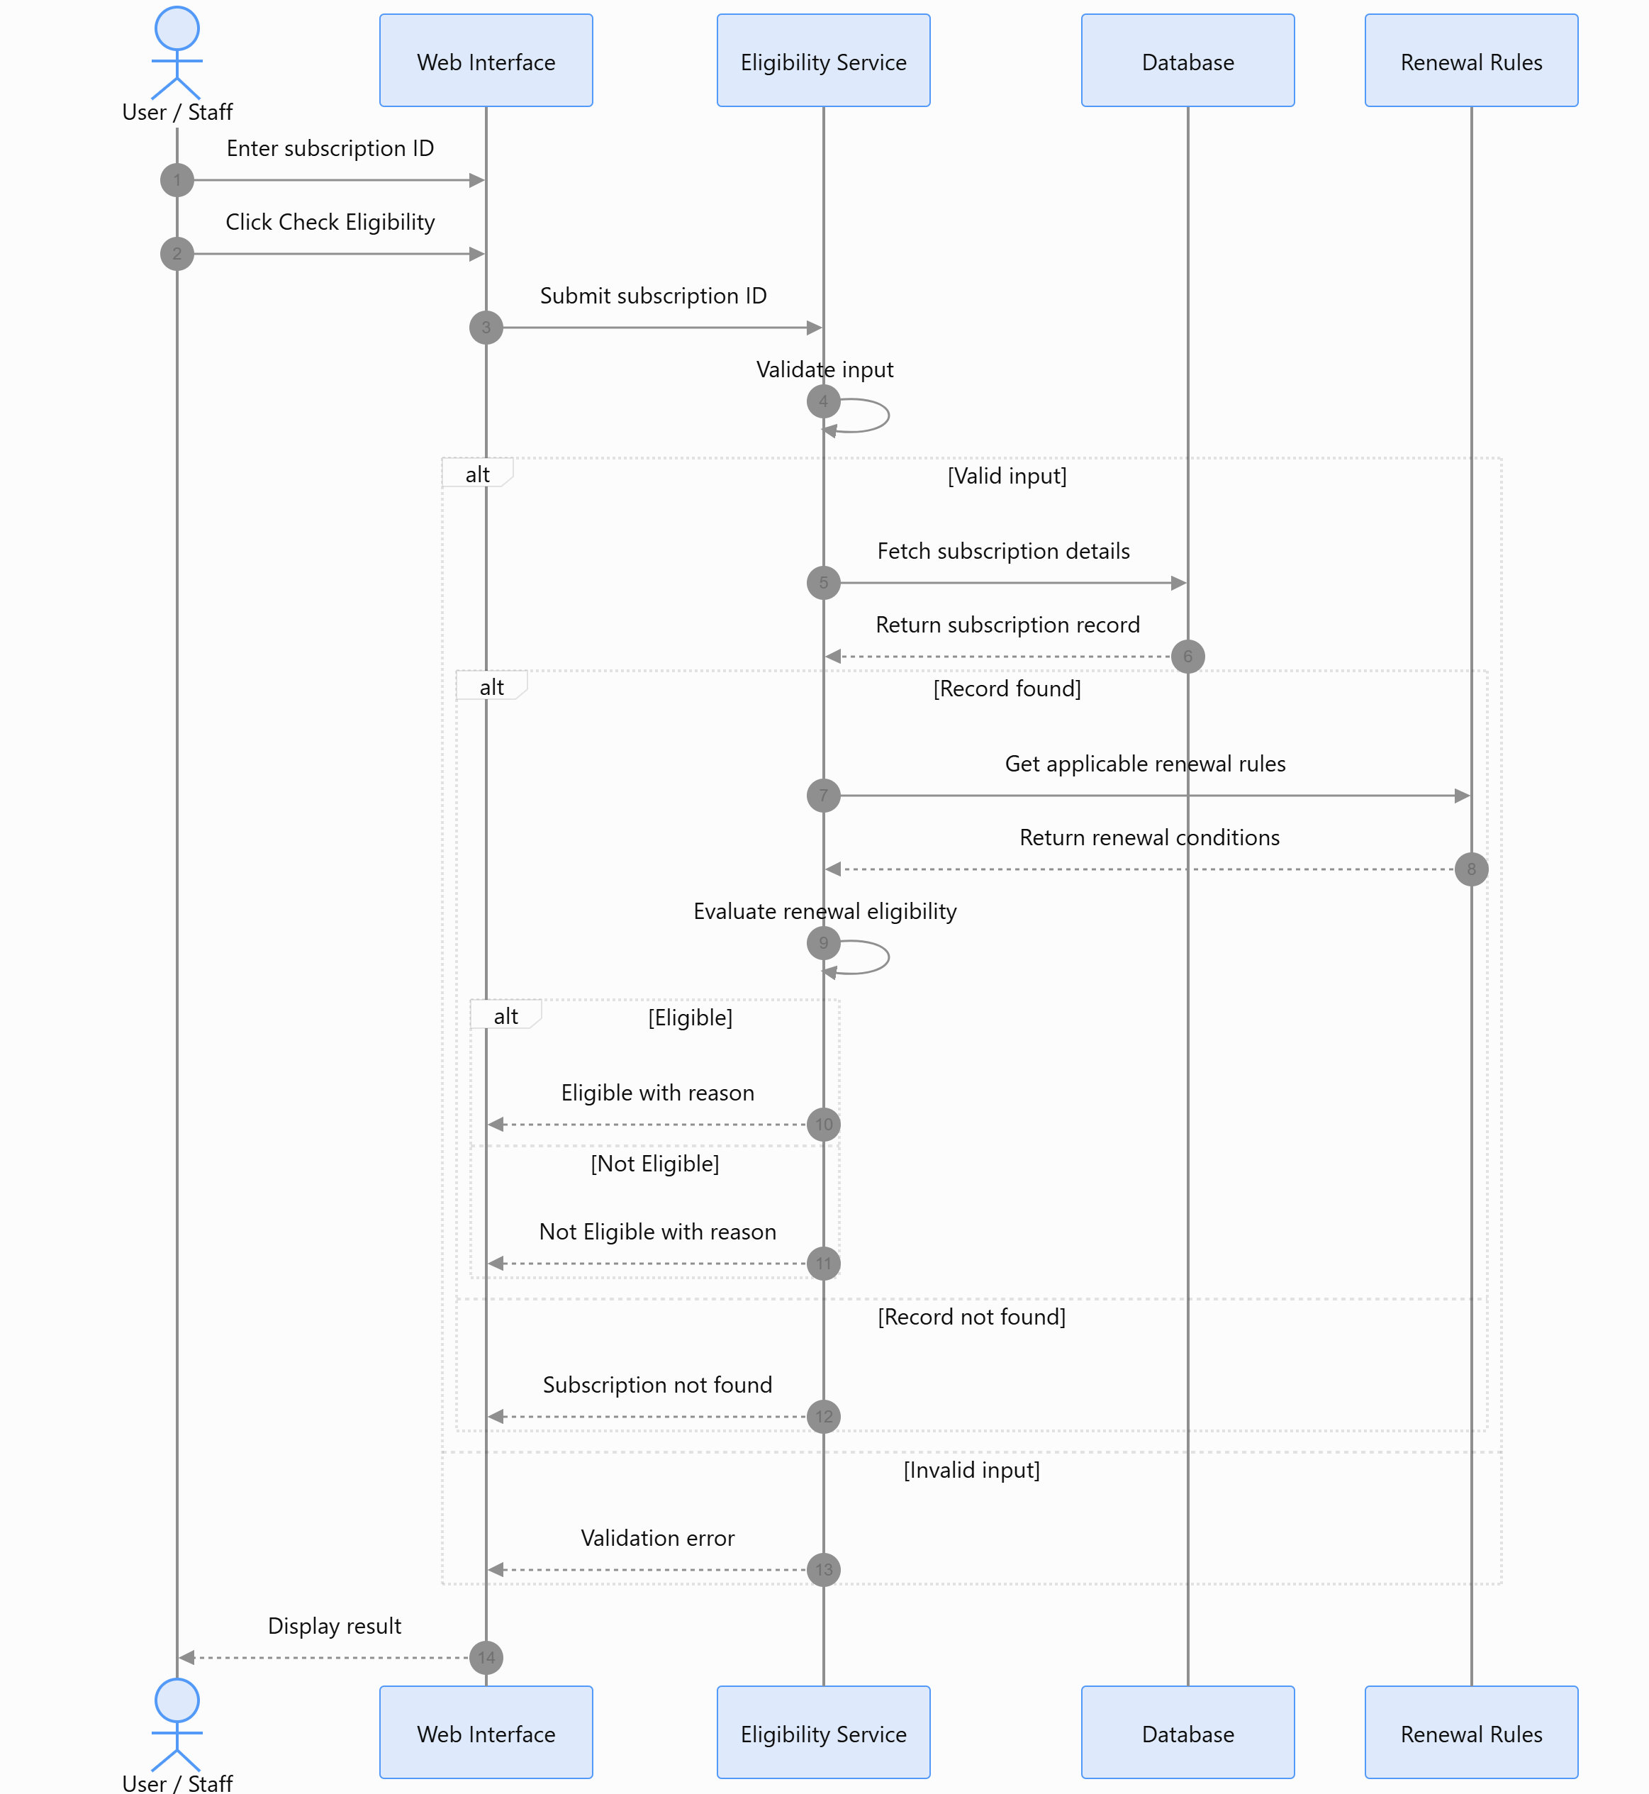
3. HARDWARE AND SOFTWARE REQUIREMENTS

3.1 Hardware Requirements
- Computer or laptop.
- Dual-core processor or equivalent.
- Minimum 4 GB RAM.
- At least 1 GB of free storage for project files and database.
- Keyboard and mouse or touchpad.
- Internet connection if the application is hosted or online tools are required.

3.2 Software Requirements
- Operating System: Windows, Linux, or macOS.
- Frontend: HTML, CSS, and JavaScript.
- Frontend Framework: React, if selected by the team.
- Backend: Node.js and Express.js, or another suitable backend technology selected by the team.
- Database: MySQL or MongoDB, based on the project implementation.
- Web Browser: Google Chrome, Microsoft Edge, or Firefox.
- Code Editor: Visual Studio Code or another suitable editor.
- Testing: Sample subscription records and test cases to verify input validation and eligibility outcomes.
Note: The exact frontend, backend, and database technologies should be finalized according to the tools actually used to implement the project.
4. REFERENCES
- KLE Technological University, Department of Computer Applications, BCA Mini Project Orientation Material.
- Software Engineering course materials covering Software Requirements Specification and Data Flow Diagrams.
- Database Management System course materials.
- Official documentation for the selected frontend technology.
- Official documentation for the selected backend technology, if used.
- Official documentation for the selected database.

5. FUTURE ENHANCEMENT
The system can be improved in the future by:
- Adding automatic reminders for subscriptions approaching their renewal date.
- Providing a dashboard showing eligible, not-eligible, expired, and upcoming-renewal subscriptions.
- Adding user login and role-based access for administrators and staff.
- Maintaining an audit history of changes made to subscription records and renewal rules.
- Adding report generation and export options.
- Integrating a payment gateway to verify payment status, if required.
- Supporting email or SMS notifications for renewal reminders.
- Making the application more suitable for mobile devices.

6. CONCLUSION
The Subscription Renewal Eligibility Register is designed to maintain subscription records and determine whether a subscription satisfies the renewal conditions defined by the project team. It stores and retrieves subscription information, validates user input, applies predefined rules, and displays an eligibility result with a reason. The project applies database management, data validation, conditional logic, rule-based processing, web technologies, and software testing. It provides a structured way to check renewal eligibility and can be enhanced in the future with reminders, reports, audit history, and external service integrations.

