🛒 E-Commerce Business Analytics & Visualization Report
Internship Project Report (Week 1 – Week 4)
Submitted by: Suhani Bisht
Project Duration: Week 1 – Week 4

Project Duration
Week 1 – Week 4
- Week 1: Project Understanding & Data Preparation
- Week 2: Data Cleaning & Exploratory Data Analysis (EDA)
- Week 3: Power BI Dashboard Development
- Week 4: Final Business Pack, Business Insights & AI Assistance

Tools Used
- Power BI
- SQL
- Excel
- Google Docs
- AI Insights (Optional)

Internship Organization

DS Group

Submitted To

Ms. Shruti Jha

Submission Date

30-06-26

Table of Contents
1. Introduction3

2. Problem Statement3

3. Project Objectives3

4. Data Analytics Process4

5. Dataset Description4

6. Exploratory Data Analysis (EDA)5

7. Dashboard Explanation6

8. Data Handling, Exploratory Data Analysis (EDA) and Power BI Visualization Process13

9.Key Business Insights 13

10. Business Recommendations13

1. Introduction
In today's digital era, e-commerce businesses generate large amounts of transactional data every day. Analyzing this data is essential to understand customer behavior, sales performance, operational efficiency, and business growth opportunities.
The purpose of this project is to transform raw e-commerce data into meaningful business insights using data analytics and interactive visualizations. The project focuses on cleaning, analyzing, and visualizing business data to support data-driven decision-making.
Power BI was used to build an interactive dashboard that helps stakeholders monitor performance and identify trends efficiently.

2. Problem Statement
E-commerce companies collect vast amounts of data from customers, sellers, products, payments, and deliveries. However, without proper analysis, this data remains difficult to interpret and utilize for business decisions.
The major challenge is to convert raw and complex datasets into easy-to-understand visual representations that provide actionable insights.
This project aims to solve this challenge by performing Exploratory Data Analysis (EDA) and creating interactive Power BI dashboards to answer important business questions.
The project focuses on:
- Understanding sales trends
- Analyzing customer purchasing behavior
- Monitoring delivery performance
- Identifying top-performing states and categories
- Evaluating seller performance
- Studying payment behavior
- Analyzing customer reviews

3. Project Objectives
The objectives of this project are:
- Analyze sales and revenue performance.
- Understand customer purchasing patterns.
- Evaluate delivery operations.
- Identify top-performing states and categories.
- Analyze customer satisfaction through reviews.
- Study payment preferences.
- Build interactive dashboards for decision-making.
- Generate business recommendations.

4. Data Analytics Process
The project was completed using the following workflow:

Step 1: Data Collection
Multiple e-commerce datasets were collected, including customer, order, payment, review, seller, and product information.

Step 2: Data Cleaning
Data cleaning was performed to improve data quality by:
- Removing duplicate records
- Handling missing values
- Standardizing data formats
- Correcting inconsistencies
- Converting date columns

Step 3: Exploratory Data Analysis (EDA)
EDA was performed to identify:
- Sales trends
- Customer patterns
- Revenue distribution
- Delivery performance
- Payment preferences
- Seller performance

Step 4: Data Modeling
A Calendar table was created, and relationships between tables were established in Power BI.

Step 5: Dashboard Visualization
Interactive dashboards were created using Power BI to convert analytical findings into easy-to-understand visual insights.

5. Dataset Description
The project uses multiple interconnected tables.
Table Name | Description
Orders | Contains order details, purchase dates, and order status
Customers | Contains customer information and locations
Products | Contains product category details
Sellers | Contains seller information and locations
Payments | Contains payment types and payment values
Reviews | Contains customer review scores
Geolocation | Contains city and state information
Calendar | Custom table created for date analysis

6. Exploratory Data Analysis (EDA)
Exploratory Data Analysis (EDA) was performed to understand, clean, and analyze the e-commerce dataset before developing the Power BI dashboards. The primary objective was to identify patterns, trends, and relationships within the data to support data-driven business decisions.
During this process, the dataset was examined for missing values, duplicate records, and data inconsistencies. Relationships were established between different tables, including Orders, Customers, Products, Sellers, Payments, Reviews, Geolocation, and the Calendar table created for date-based analysis.
The following analyses were performed during EDA:
- Sales trend analysis to identify yearly and monthly order patterns.
- Customer analysis to understand purchasing behavior and customer distribution across different states and cities.
- Product and category analysis to identify top-performing product categories.
- Delivery analysis to evaluate delivery performance and average delivery time.
- Payment analysis to identify the most preferred payment methods and payment value patterns.
- Customer review analysis to measure customer satisfaction levels.
- Seller analysis to evaluate seller performance and geographical distribution.
The findings obtained from EDA were used to build seven interactive Power BI dashboard pages: Executive Overview, Detailed Analysis, Sales & Category Analysis, Customer Reviews, Delivery Operations, Seller & Geography, and Payment Behavior. These dashboards helped convert raw business data into meaningful visual insights and supported the generation of business recommendations.

7. Dashboard Explanation

📊 Page 1: Executive Overview
The Executive Overview dashboard provides a high-level summary of the overall business performance. It presents key performance indicators (KPIs) such as total orders, total customers, total revenue, and delivered orders. This page helps stakeholders quickly understand the current business performance and identify overall sales trends and order distribution patterns.
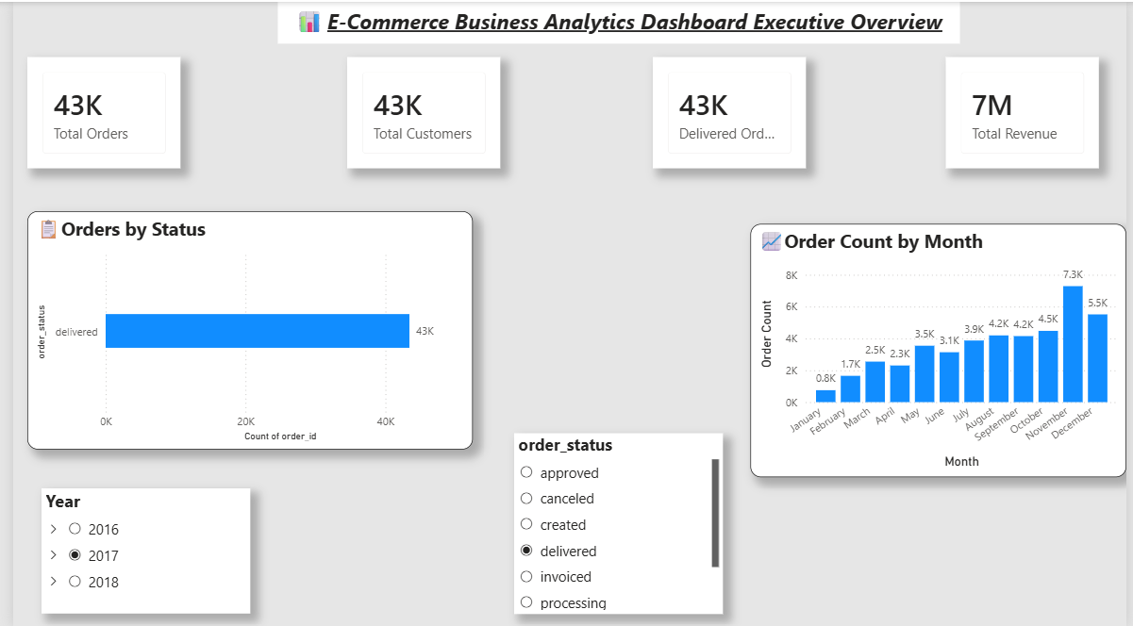
Figure 1 — Executive Overview

🔎 Page 2: Detailed Analysis
The Detailed Analysis dashboard focuses on geographical business performance. It analyzes orders, customers, and revenue across different states and cities. This dashboard helps identify high-performing and low-performing regions, enabling better business planning and market expansion strategies.
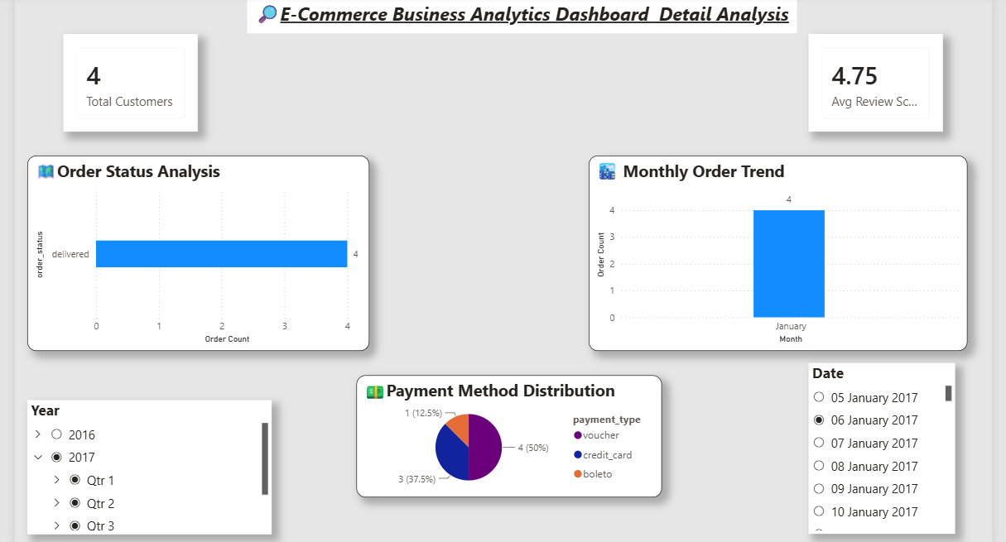
Figure 2 — Detailed Analysis

🛍️ Page 3: Sales & Category Analysis
The Sales & Category Analysis dashboard evaluates product and category performance. It identifies top-selling product categories and their contribution to overall revenue. This analysis helps businesses understand customer preferences and optimize product offerings.
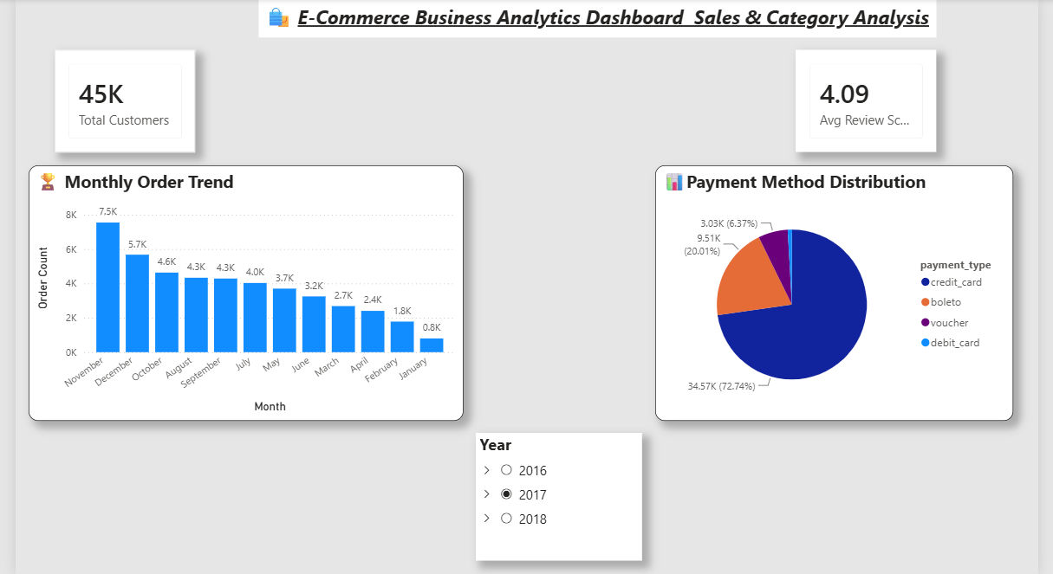Figure 3 — Sales & Category Analysis

⭐ Page 4: Customer Reviews Analysis
The Customer Reviews dashboard analyzes customer satisfaction using review scores and feedback patterns. It helps identify how customer experiences vary based on order status and highlights areas where service quality can be improved.
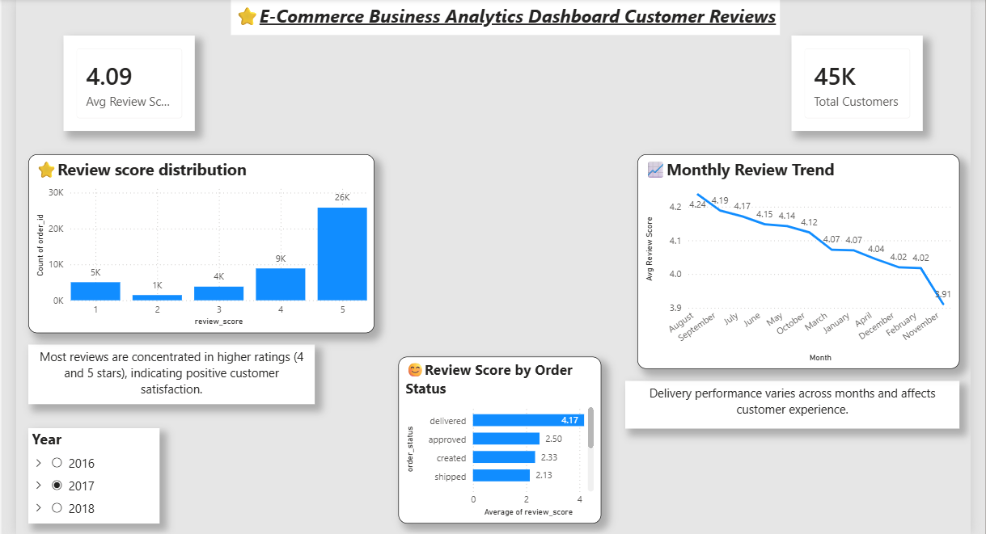
Figure 4 — Customer Reviews Analysis

🚚 Page 5: Delivery Operations
The Delivery Operations dashboard focuses on delivery efficiency and operational performance. It analyzes delivery times, delivery trends, and overall delivery performance. This dashboard helps identify delays and opportunities to improve logistics operations.
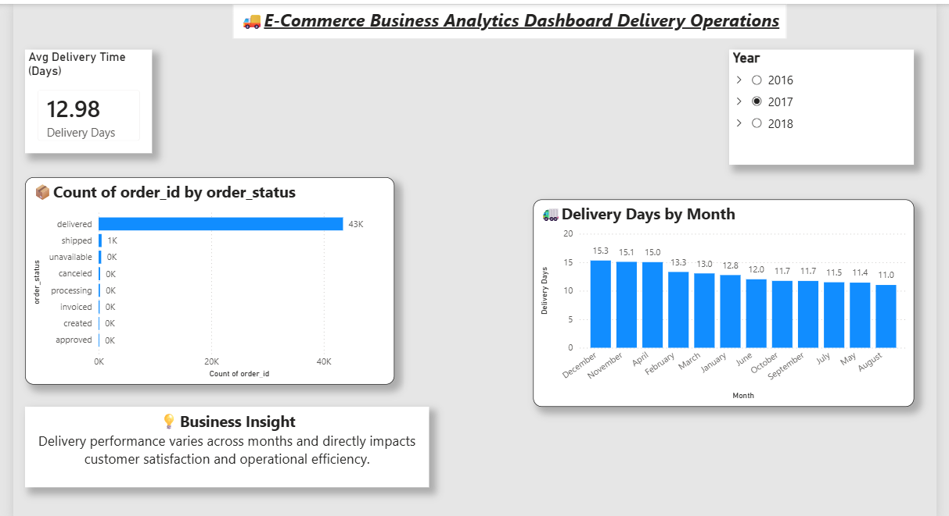
Figure 5 — Delivery Operations

🌍 Page 6: Seller & Geography Analysis
The Seller & Geography dashboard evaluates seller performance and geographical distribution. It identifies top-performing sellers and states with high seller activity, helping businesses understand regional seller contributions.
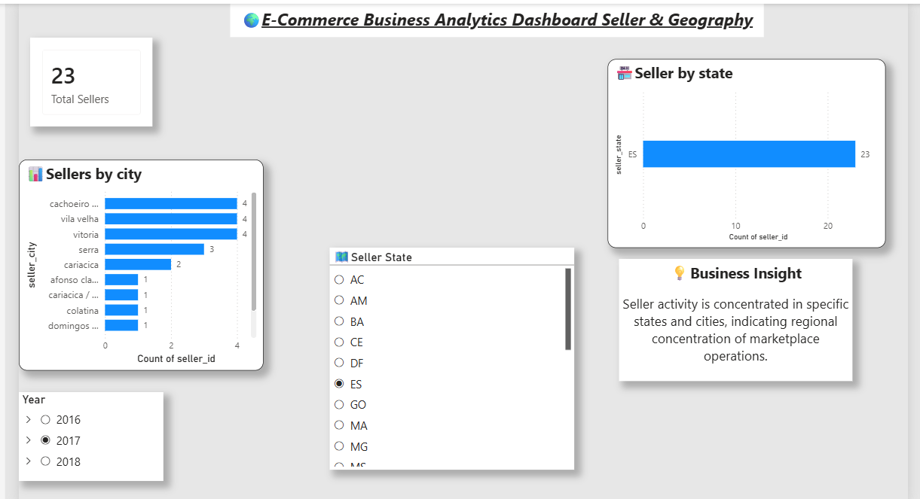
Figure 6 — Seller & Geography Analysis

💳 Page 7: Payment Behavior Analysis
The Payment Behavior dashboard analyzes customer payment preferences and payment value trends. It helps businesses understand which payment methods are most commonly used and supports better financial planning and customer experience strategies.
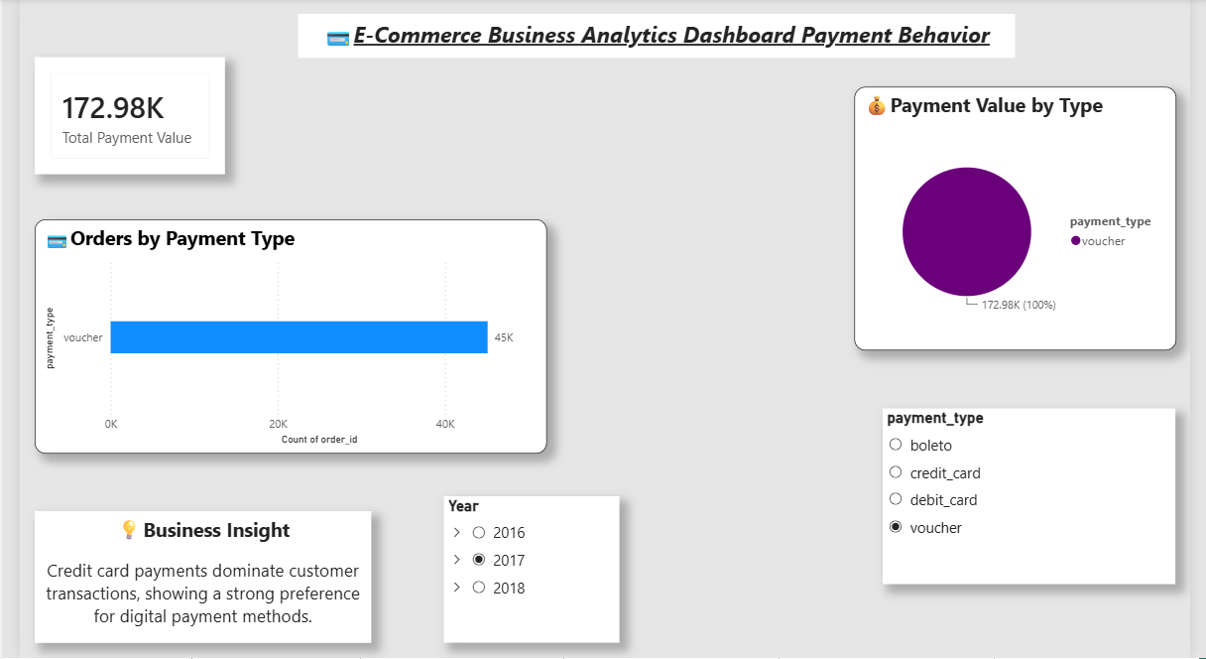
Figure 7 — Payment Behavior Analysis

8. Data Handling, Exploratory Data Analysis (EDA) and Power BI Visualization Process
This project followed a structured data analytics workflow to transform raw e-commerce data into meaningful business insights. The process involved data handling, Exploratory Data Analysis (EDA), and interactive dashboard creation using Power BI.

1. Data Handling
The first step involved understanding and preparing the dataset for analysis. Multiple datasets, including Orders, Customers, Products, Sellers, Payments, Reviews, and Geolocation data, were collected and examined.
The following data handling activities were performed:
- Checked the dataset structure and data types.
- Identified and handled missing values.
- Removed duplicate records.
- Corrected inconsistencies in the data.
- Standardized date and text formats.
- Created relationships between different tables.
2. Exploratory Data Analysis (EDA)
EDA was performed to understand patterns, trends, and relationships within the dataset before building the dashboards.
The following analyses were conducted:
- Analyzed yearly and monthly sales trends.
- Studied customer purchasing behavior and geographical distribution.
- Identified top-performing product categories.
- Evaluated delivery performance and average delivery time.
- Analyzed customer review scores and satisfaction levels.
- Studied payment preferences and payment value patterns.
- Evaluated seller performance across different regions.
The insights obtained during EDA helped identify important business trends and supported data-driven decision-making.

3. Power BI Visualization Process
After completing EDA, Power BI was used to convert analytical findings into interactive visual dashboards.
The following activities were performed in Power BI:
- Imported and transformed the dataset.
- Built data models and established table relationships.
- Created measures and calculated fields.
- Added interactive slicers and filters.
- Designed KPI cards to display key metrics.
- Developed seven dashboard pages to visualize business performance.
- Applied consistent formatting, themes, and visual elements for better readability.
The dashboards were developed to provide clear, interactive, and easy-to-understand insights that help stakeholders monitor business performance and make informed decisions.
Overall Project Workflow
Raw Dataset
↓
Data Handling
↓
Data Cleaning
↓
Exploratory Data Analysis (EDA)
↓
Power BI Data Modeling
↓
Dashboard Visualization
↓
Business Insights
↓
Recommendations
↓
Final Report & Presentation

9. Key Business Insights
The analysis generated several important business insights:
- Most orders were placed during 2017.
- Delivered orders account for the majority of transactions.
- Credit cards are the most preferred payment method.
- Certain states generate significantly higher revenue.
- Customer review scores are generally positive.
- Delivery performance directly impacts customer satisfaction.

10. Business Recommendations
Based on the analysis, the following recommendations are suggested:
- Improve delivery efficiency in low-performing regions.
- Increase marketing efforts in top-performing states.
- Promote high-performing product categories.
- Improve seller performance through monitoring.
- Introduce customer loyalty programs.
- Continuously monitor customer feedback.

