5. Performing basic CRUD operation (create, update, read, delete) on DB records.
1.CRUD Operation in SQL:
use english1;
show databases;
create table user4(
id integer primary key,
name text,
email text
);
desc user;


CREATE(Insert a record):
insert into user(id,name,email)
values(1,'suhani','suhani@gmail.com');

READ(Retrive data):
select*from user;
select*from user where id=1;
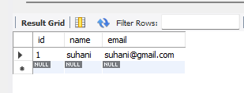

UPDATE(Modify existing record):
update user
set name='suhani Dehankar',email='suhanidehankar@gmail.com'
Where id=1;
select*from user;
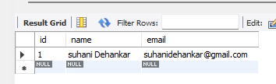

DELETE(Remove a record):
delete from user where id=1;
select*from user;


