11.Record and execute a test case for Google Account login.
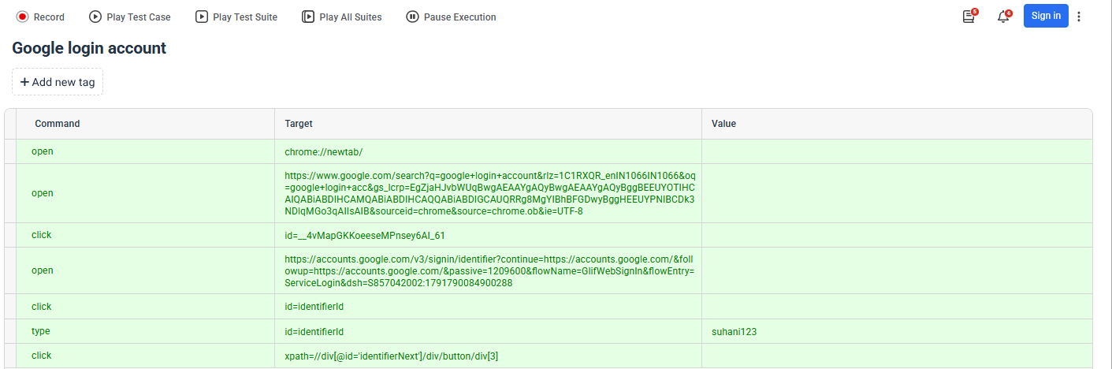
Output:
[info] Playing test case account / Untitled Test Case
[info] Time: Mon Oct 12 2026 12:58:20 GMT+0530 (India Standard Time) Timestamp: 1791790100307
[info] OS: Windows Version: 10
[info] Browser: Chrome Version: 154.0
[info] If the test cannot start, please refresh the active browser tab
[info] Executing: | open | chrome://newtab/ | |
[info] Executing: | open | https://www.google.com/search?q=google+login+account&rlz=1C1RXQR_enIN1066IN1066&oq=google+login+acc&gs_lcrp=EgZjaHJvbWUqBwgAEAAYgAQyBwgAEAAYgAQyBggBEEUYOTIHCAIQABiABDIHCAMQABiABDIHCAQQABiABDIGCAUQRRg8MgYIBhBFGDwyBggHEEUYPNIBCDk3NDlqMGo3qAIIsAIB&sourceid=chrome&source=chrome.ob&ie=UTF-8 | |
[info] Executing: | click | id=__4vMapGKKoeeseMPnsey6AI_61 | |
[info] Wait until the element is found
[info] Cannot find element id=__4vMapGKKoeeseMPnsey6AI_61 after 1000ms switch to id=__4vMapGKKoeeseMPnsey6AI_61
[info] Executing: | click | id=__4vMapGKKoeeseMPnsey6AI_61 | |
[info] Wait until the element is found
[info] Cannot find element id=__4vMapGKKoeeseMPnsey6AI_61 after 1000ms switch to xpath=//h3[@id='__4vMapGKKoeeseMPnsey6AI_61']
[info] Executing: | click | xpath=//h3[@id='__4vMapGKKoeeseMPnsey6AI_61'] | |
[info] Wait until the element is found
[info] Cannot find element xpath=//h3[@id='__4vMapGKKoeeseMPnsey6AI_61'] after 1000ms switch to xpath=//div[@id='rso']/div/div/div/div/div/div/div/span/a/h3
[info] Executing: | click | xpath=//div[@id='rso']/div/div/div/div/div/div/div/span/a/h3 | |
[info] Executing: | open | https://accounts.google.com/v3/signin/identifier?continue=https://accounts.google.com/&followup=https://accounts.google.com/&passive=1209600&flowName=GlifWebSignIn&flowEntry=ServiceLogin&dsh=S857042002:1791790084900288 | |
[info] Executing: | click | id=identifierId | |
[info] Executing: | type | id=identifierId | suhani123 |
[info] Executing: | click | xpath=//div[@id='identifierNext']/div/button/div[3] | |
[info] Time: Mon Oct 12 2026 12:58:37 GMT+0530 (India Standard Time) Timestamp: 1791790117993
[info] Test case passed

