11.Applying databases normalization techniques to eliminate redundancy and improve data integrity in workbech querry.
use english1;
show databases;
1:Create unnormalized table:
CREATE TABLE students_courses(
student_id INT,
student_name VARCHAR(50),
course_id INT,
course_name VARCHAR(50),
PRIMARY KEY(student_id,course_id)
);

INSERT INTO students_courses VALUES
(1,'Aachal',201,'Math'),
(1,'Aachal',202,'Physics'),
(3,'Rohit',201,'Math'),
(3,'shyam',203,'Computer');
SELECT*FROM STUDENTS_COURSES;
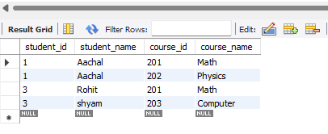
2: (Normalize to 1NF,2 NF, and 3NF)-
Create Students Table (Remove redundant student info).

