12.Record and execute a test case for adding a produt into the shopping cart.

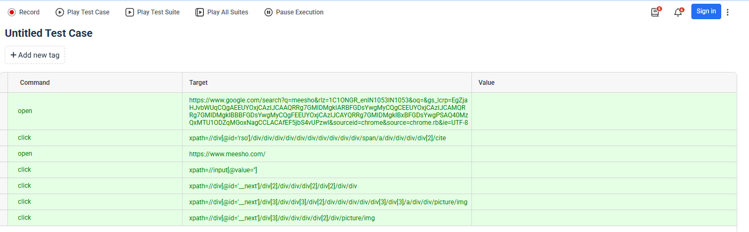
Output:

[info] Playing test case Untitled Test Suite / Untitled Test Case

[info] Time: Mon Oct 12 2026 13:44:51 GMT+0530 (India Standard Time) Timestamp: 1791792891576

[info] OS: Windows Version: 10

[info] Browser: Chrome Version: 154.0

[info] If the test cannot start, please refresh the active browser tab

[info] Executing: | open | https://www.google.com/search?q=meesho&rlz=1C1ONGR_enIN1053IN1053&oq=&gs_lcrp=EgZjaHJvbWUqCQgAEEUYOxjCAzIJCAAQRRg7GMIDMgkIARBFGDsYwgMyCQgCEEUYOxjCAzIJCAMQRRg7GMIDMgkIBBBFGDsYwgMyCQgFEEUYOxjCAzIJCAYQRRg7GMIDMgkIBxBFGDsYwgPSAQ40MzQxMTU1ODZqMGoxNagCCLACAfEF5jbS4vUPzwI&sourceid=chrome&source=chrome.rb&ie=UTF-8 | |

[info] Executing: | click | xpath=//div[@id='rso']/div/div/div/div/div/div/div/div/div/div/span/a/div/div/div/div[2]/cite | |

[info] Executing: | open | https://www.meesho.com/ | |

[info] Executing: | click | xpath=//input[@value=''] | |

[info] Executing: | click | xpath=//div[@id='__next']/div[2]/div/div/div[2]/div[2]/div/div | |

[info] Executing: | click | xpath=//div[@id='__next']/div[3]/div/div[3]/div[2]/div/div/div/div/div[3]/div[3]/a/div/div/picture/img | |

[info] Wait until the element is found

[info] Time: Mon Oct 12 2026 13:45:03 GMT+0530 (India Standard Time) Timestamp: 1791792903909

[info] Test case passed

