2. Creating and manipulating database table using SQLDDL commands.

Create a database
create database english1;
use english1;
show databases;

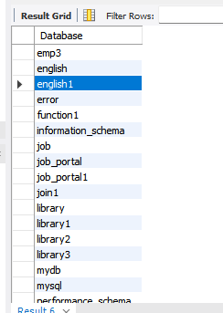

Create a table

create table employees(
emp_id int,
emp_name varchar(100),
city varchar(50));
select*from employees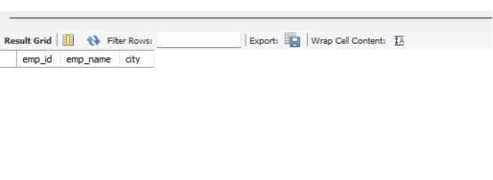

Alter a table-Add column
alter table employees add department varchar(50);
select*from employees;

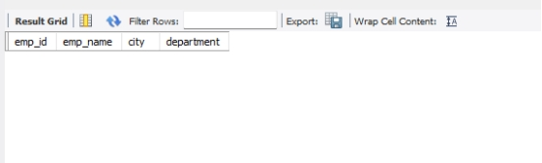

Rename column
alter table employees rename column emp_name to full_name;
select*from employees;

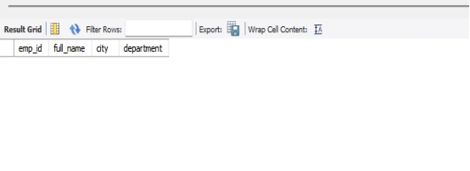

Truncate table
truncate table employees;
select*from employees;
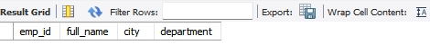

Drop table
drop table employees;
show tables;

