6.Write a SQL Queries to fitter and from single table.

Create a table:
use english1;
show databases;
create table employees(
id int primary key,
name varchar(100),
department varchar(50),
age int,
salary decimal(10,2)
);
select *from employees;
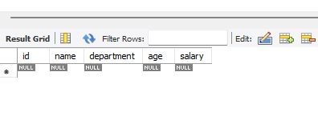
Insert Some Sample Data:
insert into employees (id,name,department,age,salary)values
(1,'suhani', 'HR', 36, 7000),
(2,'payal', 'TT', 35,6000),
(3,'ishu', 'IT', 12, 4000),
(4,'anu', 'MARKETING', 40, 6700),
(5,'shravi', 'IT', 13, 4500);
select*from employees;

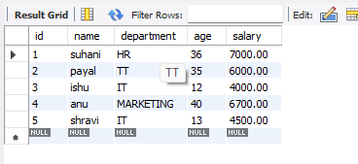

Filter Record Using WHERE:
select*from employees
WHERE department='TT';
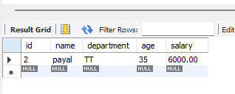

Sort Records Using ORDER BY :
select*from employees
ORDER BY salary DESC;
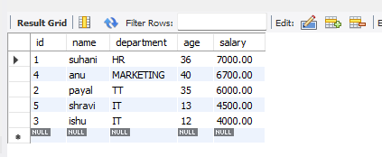

Combine Filtering and Sorting:
select*from employees
WHERE age>34
ORDER BY age ASC;
