10.Implementing transactions to ensure data integrity and consistency.(use BEGINTRANSACTION/STARTTRANSACTION, COMMIT,ROLLBACK along with other sql queries).

use english1;
show databases;
start transaction;
COMMIT;
ROLLBACK;
create database job2;
show databases;
use job2;

CREATE TABLE account(
account_id INT PRIMARY KEY,
name VARCHAR(50),
balance DECIMAL(10,2)
);

INSERT INTO account VALUES
(1,'Anjali',1000.00),
(2,'Neha',500.00);
SELECT*FROM account;
start transaction;
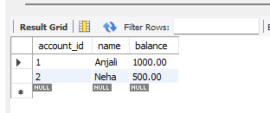

UPDATE account
SET balance=balance-200
WHERE account_id=1;
SELECT*FROM account;
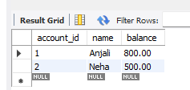
UPDATE account
SET balance=balance+200
WHERE account_id=2;
SELECT* From account;
COMMIT;
