7. Joining multiple tables using various types of joins(Inner join,Outer join).
use english1;
show databases;
create table employees3(
id int primary key,
name VARCHAR(100),
department_id int
);
select*from employee3;
Insert into employees3(id,name,department_id)values
(1,'ram',342),
(2,'anu',890),
(3,'rohit',null),
(4,'komal',980),
(5,'vivek',780);
select*from employees3;
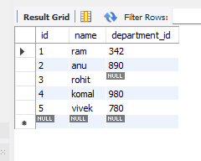

CREATE TABLE2 2:
insert into departments(id,dept_name)values
(111,'DBMT'),
(112,'ST'),
(113,'Finance');
select *from departments;
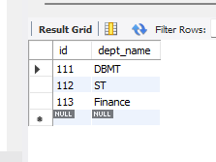

INNER JION AND OUTER JOIN:
select e.id,e.name,d.dept_name
from employees3 e
inner join departments d on e.department_id=d.id;
select e.id,e.name,d.dept_name
from employees3 e
left join departments d on e.department_id=d.id
union
select e.id,e.name,d.dept_name
from employees3 e
right join departments d on e.department_id=d.id;
